Tulare County: Data Notebook 2014
for California
Mental Health Boards and Commissions
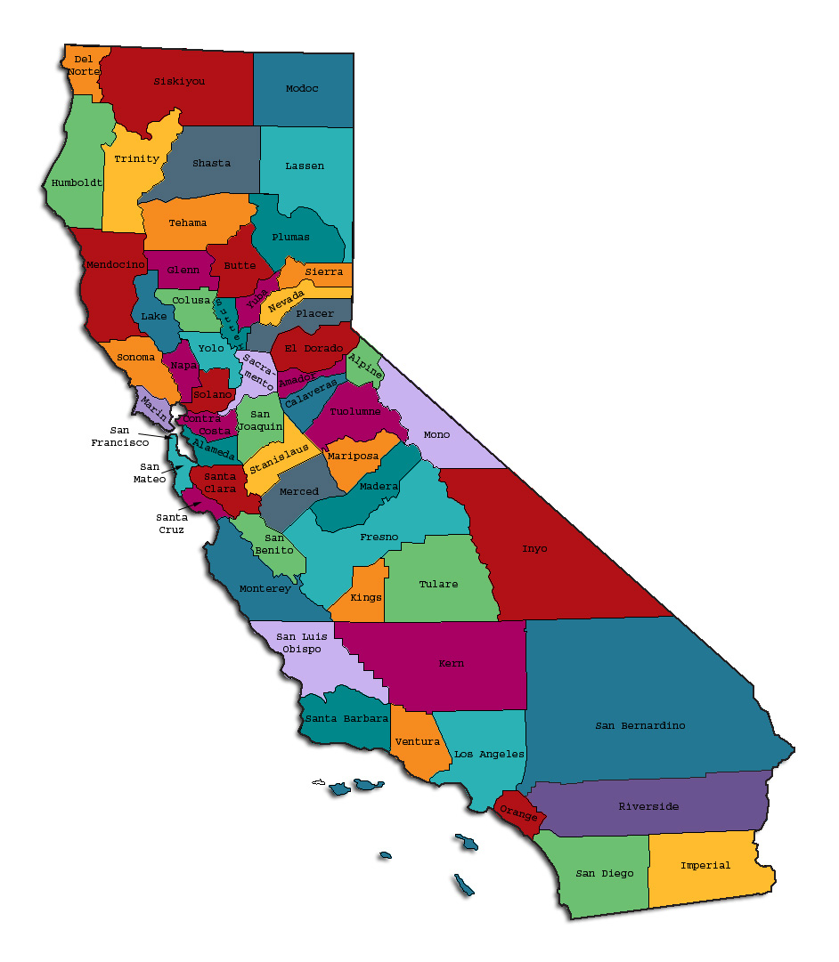
Prepared by California Mental Health Planning Council, in collaboration with: California Association of Mental Health Boards/Commissions, and APS Healthcare/EQRO
This Page Intentionally Left Blank.
Date: April 20, 2014
To: Chairpersons and/or Directors
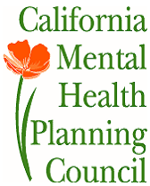
Local Mental Health Boards and Commissions
From: California Mental Health Planning Council
Subject: Instructions for Data Notebook 2014

We ask that this report be prepared by the MH Board or Commission members. You are the most important resources for identifying program strengths and needs in your community.
On the first page, please fill in the requested information for your county websites:
- Department of Behavioral Health/ Mental Health
- Public reports about your county’s MH services.
Please send a copy of the filled-in first page to the Planning Council along with your final report which contains your answers to the questions in the Data Notebook. Please submit your report within 60 days by email to:
DataNotebook@cmhpc.ca.gov.
Or, you may mail a printed copy of your report to:
- Data Notebook Project
- California Mental Health Planning Council
- 1501 Capitol Avenue, MS 2706
- P.O. Box 997413 Sacramento, CA 95899-7413
Please examine the enclosed information, which will help you discuss the questions in the Data Notebook. We provide examples of recent mental health data for your county. In some figures, the term “MHP” is used to refer to your county’s Mental Health Plan.
Some data comes from APS Healthcare/EQRO, which gave permission to use their figures and tables, prepared for review of each county’s Medi-Cal Specialty Mental Health services. Data in this packet came from the following review cycle:
__X__ Fiscal Year 2013 -- 2014: http://caeqro.com/webx/.ee85675/
_____ Fiscal Year 2012 -- 2013: http://caeqro.com/webx/.ee851c3/
For some questions, you will need to consult your local county Quality Improvement Coordinator, and/or Mental Health Director. If you are not able to address all of the questions, just answer the ones you can.
Thank you for your participation in the Data Notebook Project.
This Page Intentionally Left Blank
Tulare County: Data Notebook 2014
for California
Mental Health Boards and Commissions
County Name: Tulare Population (2013): 456,347
Website for County Department of Mental Health (MH) or Behavioral Health: www.tchhsa.org
Website for Local County MH Data and Reports: This information is not online.
Website for local MH Board/Commission Meeting Announcements and Reports:
http://www.tchhsa.org/hhsa/index.cfm/the-hhsa-community/mental-health-board/description/
Specialty MH Data from review Year 2013-2014: http://caeqro.com/webx/.ee85675
Total number of persons receiving Medi-Cal in your county (2012): 209,687
Average number Medi-Cal eligible persons per month: 175,772
Percent of Medi-Cal eligible persons who were:
Children, ages 0-17: 51.5 %
Adults, ages 18-59: 39.7 %
Adults, Ages 60 and Over: 8.8 %
Total persons with SMI or SED who received Specialty MH services (2012): 7,480
Percent of Specialty MH service recipients who were:
Children 0-17: 60.6 %
Adults 18-59: 35.2 %
Adults 60 and Over: 4.2 %
This Page Intentionally Left Blank
INTRODUCTION: Purpose, Goals, and Data Resources
This Data Notebook has been developed for the use by the local mental health (MH) boards and commissions by a yearlong workgroup comprised of members from:
- California Mental Health Planning Council (CMHPC)
- California Association of Local Mental Health Boards and Commissions (CALMHB/C)
- APS Healthcare/ EQRO (External Quality Review Organization)
Our plan is for the Data Notebook to meet these goals:
- assist local boards to meet their mandates to review the local county mental health systems, identify unmet needs, and recommend improvements.
- provide a professional format for submitting reports to their local Board of Supervisors, and/or their county Director of Mental Health Services.
- function as an educational tool for local boards, whose members have varying levels of skills, frequent turnover, and need ‘refresher’ training about using data.
- help the CMHPC fulfill its mandates to review and report on the public mental health system in California, which also helps provide evidence for advocacy.
Data reporting drives policy, and policy drives funding for programs. But the data must be both recent and available to the public, or else it is not useful. So, the CMHPC will provide examples of local data from current public reports. We focus on two broad areas: (1) evaluation of program performance, and (2) indicators of client outcomes.
We recognize that each county has a unique population, resources, strengths, and needs. Thus, there is no single perfect data source to answer all the important questions one might ask about mental health services. However, the following data resources will help board members answer questions in this Data Notebook:
- experience and opinions of the local mental health board members
- recent reports about county MH programs from APS Healthcare/EQRO
- data you request from your county QI Coordinator and/or Mental Health Director (because CMHPC does not have that data, and it’s not in other public reports)
- client outcomes data provided by California Institute of Mental Health (CiMH) in their analysis of the most recent Consumer Perception Survey.
Some of our data comes from APS Healthcare/EQRO, which kindly gave permission to use their figures and tables, prepared for review of each county’s Medi-Cal Specialty Mental Health services. Those reviews are at: www.CAEQRO.com. You may find the full-length EQRO reports helpful because they summarize key programs and quality improvement efforts for each county. They also describe strengths, opportunities for improvement, and changes in mental health programs since the last year.
Understanding changes in local programs can help consumers because of the massive re-organization of mental health services statewide. Some changes have been confusing to clients. The old state Department of Mental Health was eliminated in 2012 and many functions were moved to the Department of Health Care Services. Other changes due to federal health care reform and the Affordable Care Act affect how mental health services are provided, funded, and linked to primary health care or substance use treatment. Also, local counties have adjusted to major challenges.
Remember, this report is about your community, and what you and your stakeholders choose to discuss. Examining the data can indeed “Tell a Human Story.” But quantitative data (numbers) provides only part of the picture, for example:
- measures of whether the quality of program services improve over time
- whether more people from different groups are receiving services
- how many clients got physical healthcare or needed substance use treatment.
The other part of the story gives human context to the numbers. Such qualitative data (narrative, descriptions, or stories) tells more of the story, because we can:
- describe special programs targeted for outreach to specific groups
- examine how the programs are actually implementing their goals
- list concrete steps that are taken to improve services, and
- tell what is being done to increase client engagement with continued treatment.
We hope this project contributes to ongoing quality improvement (QI) in mental health services. We seek constant improvement in our approach to quality because:
- needs change over time,
- all human endeavors are by nature imperfect,
- creativity gives rise to new ideas, and
- we can share examples of successful programs to help other communities.
One question is whether local boards are permitted to provide additional information, besides that requested in this Notebook. We always welcome supplemental reports about successful projects, or which the county administration uses to inform the public. Any additional reports may be attached in an “Appendix,” with the website address (if available). However, we emphasize such extra reports are not required.
Thank you for participating in this project. We hope this Data Notebook serves as a springboard for your discussion about all areas of the mental health system, not just those topics highlighted by our questions.
TREATING THE WHOLE PERSON:
Integrating Behavioral and Physical Health Care
Studies have shown that individuals with serious mental illness die, on average, 25 years earlier than the general population. This information makes improving the physical health of clients of great importance and should be a goal of county mental health departments along with providing effective and appropriate mental health services. Coordination of care for mental health, substance abuse and physical health is one way of accomplishing the goal.
The California Mental Health Planning Council does not have any data to provide to show how your county’s programs connect clients of mental health services with necessary physical health care. We ask that the local mental health board request information from your county mental health department for any data on numbers (or percent) of total mental health clients who are referred to, or connected with, physical health providers to assess, treat and monitor physical health issues.
If your county has data on numbers or percentages of clients who are also receiving physical health care, please include it in your Data Notebook you submit to the Council.
___ Check here if your county does not have such data or information.

1) Please describe any efforts in your county to improve the physical health of clients.
When the Substance Abuse and Mental Health Services Administration (SAMHSA) implemented the 10x10 Wellness Campaign (http://www.promoteacceptance.samhsa.gov/10by10/default.aspx) as an action related to the studies that have shown individuals with serious mental illness die, on average, 25 years earlier than the general population; the Tulare County Department of Mental Health took the SAMHSA Wellness pledge. The pledge, per SAMHSA website, is as follows:
- Empower people with mental and substance abuse disorders to take action through wellness activities to improve their quality of life and increase years of life.
- Provide needed resources, such as smoking cessation tools, if applicable.
- Explore with providers about how peers and persons in recovery are integrating the Eight Dimensions of Wellness into their daily lives.
- Recognize and reward providers who address aspects of the Eight Dimensions of Wellness with patients.
- Educate providers that wellness is not the absence of disease, illness, or stress, but the presence of purpose in life, active involvement in satisfying work and play, joyful relationships, a healthy body and living environment, and happiness.
- Promote an internal structure that encourages employees, peers, and persons in recovery to integrate wellness into their own lives.
Each SAMHSA Wellness Week, starting with the first one in 2012, Tulare County Department of Mental Health has promoted SAMHSA’s 10x10 Wellness campaign and Wellness pledge via social media (Tulare County Health & Human Services Agency’s (HHSA) Facebook, Twitter, and website), posting SAMHSA Wellness posters throughout the MHP provider sites, and distributing education materials such as the SAMHSA Wellness pamphlets to a broad audience including the Mental Health Board, providers in MHP and health centers, consumers, peer volunteers, community outreach events, and more. Data is not available for the SAMHSA Wellness Campaign participation, as it is an outreach campaign which is far-reaching through various outlets not feasible for measurement (i.e. social media, posters, etc.).
Other activities for which Tulare County Department of Mental Health promotes the integration of physical health and mental health include, but are not limited to:
- Chronic Disease Self-Management Program (CDSMP), an evidence-based program for adults with a chronic health condition or living with someone with a chronic health condition. Through the Healthier Living Workshops which are held at both the Visalia Adult Integrated Clinic and Porterville Adult Clinic, participants attend six 2.5-hour workshops and learn techniques including strategies to reduce pain, stress, etc.; healthy eating and physical activity; and communication skills when communicating with doctors.
  - There have been two CDSMP workshops offered to date, with 19 individuals who have graduated from (completed) the full CDSMP workshop. Two more workshops are being developed at this time, one in English and the other in Spanish.
- Mental Health Services Act (MHSA) Innovation Component, Integrated Health Clinic program, which places a pod of mental health professionals at the County’s Visalia Health Care Center and a pod of health professionals at the County’s Visalia Adult Integrated Clinic. These pods are not to create mini-clinics within the setting of the opposite discipline, rather they are to provide a coordinated care experience for both the consumer and the providers by providing assistance to the opposite discipline with brief assessment and consultation, coordinated treatment planning, warm linkages, and education regarding physical health and mental health services and integration topics.
  - The business process is currently under development and has been ongoing for 2 years due to the nature of the innovation of this program. As the business process is being completed, an evaluation plan is also being developed to identify where the business process will lend itself to data collection and outcome measurement. Upon completion and implementation, data and outcome information will follow; no data or outcomes are available at this time.
- Building Bridges program which is a community-based program provided through the various Family Resource Centers throughout Tulare County to identify and provide early intervention services to women who are pregnant or up to 1-year postpartum and are experiencing perinatal mood and anxiety disorder (PMAD).
  - The Building Bridges program began in July 2014; therefore, data and outcomes are in the process of being collected.
- Groups within the MHP which encompass physical health and socialization include, but are not limited to: Illness Management; Wellness and Recovery Action Plan (WRAP); Mindfulness; Family Champions; Bowling; Autumn Oaks Health and Wellness Group; Senior Exercise, Relaxation, and Nutrition Program; and Weight Loss Group.
  - Many of these groups were under development January through July 2014; therefore, data and outcomes are not yet available.
- Groups within the MHP that address body image, hormonal changes and how that can impact diet and metabolism, eating disorders, eating habits, personal hygiene and self-care: LGBTQ, and Women’s and Adolescent Females group.
  - Many of these groups were under development January through July 2014; therefore, data and outcomes are not yet available.
2) How does your county address wellness programs to engage and motivate clients to take charge of improving their physical health?
Examples:
- Exercise
- Nutrition
- Healthy cooking
- Stress management
- Quitting smoking
- Managing chronic disease
- Maintaining social connectedness

In addition to the CDSMP and groups and activities mentioned in #1 above, Tulare County Department of Mental Health hosts a robust peer volunteer program which facilitates many activities that engage and motivate clients to take charge of improving their physical health. Activities include, but are not limited to:
- Women’s Yoga Group, teaching stretching and focusing on techniques while emphasizing healthy activity.
- Transitional Living Center Wellness & Recovery Center Recreation Group which focuses on socializing and building peer support. During this group time, there is access to recreation equipment such as a ping pong table and Wii game system, as well as access to exercise equipment.
- Community of Wellness Gardening Project designed to teach clients proper planting and care of gardens, to include harvesting and cooking with those fruits and vegetables.
- Social Activities League which is a committee comprised of peers who plan low-cost local activities for peers to attend. The committee's goal is to plan community functions/activities to bring awareness of local low-cost activities and culture simultaneously promoting peer socialization, collaboration, and community integration. Events thus far have included: holiday dances, gift exchanges, trip to the local planetarium, public transportation scavenger hunt, movie outing, karaoke party, picnics at the local parks, and bowling outing.

- Transitional Age Youth Recreation Group which conducts a variety of activities such as softball, basketball, walking, tennis, etc. These activities are done in teams to build and maintain social connectedness among transitional age youth.
- Cooking Groups which focuses on minimizing fast food, microwavable food, and junk foods; replacing those options with healthy choices.
NEW CLIENTS: One Measure of Access
One way to evaluate the quality of mental health services outreach is to measure how many clients receive services who have never been part of the service system before (“brand new” clients). Another measure is how many clients return for services after a period of time with no services (“new” clients).
The California Mental Health Planning Council is exploring how each county mental health department defines “new” clients, and how a client is labeled when they return for additional services. This information is important in determining whether your county has a “revolving door,” that is, clients who are in and out of mental health services repeatedly. This data is one indicator of the success of your county’s programs in closing cases appropriately and providing adequate discharge planning to clients.
This data is not currently reported by the counties to the state. The Council does not have data to provide to you. This information should be requested from your county mental health department.
____ Check here if your county does not have this information.
3. How does your county define 'new' client for those individuals who have previously received services, but who have not received services for a while? (e.g., 6 months, 12 months, 2 years?)
Tulare County defines "new" client as any previous consumer who has been discharged from services within the past 90 days.

4. Please provide any data your county has on the number of 'new' clients last year. And if you have it, how many of those new clients were brand new clients? You may need to ask your county mental health department for this data.
All new and “brand new” consumers admitted during the time reported (Fiscal Year 07/01/2013-06/30/2014):
Number of new clients: 6,073
Of these, how many (or %) are “brand new” clients: 3,002 (49%)
REDUCING RE-HOSPITALIZATION: Access to Follow-up Care
Sometimes, an individual experiences acute symptoms of mental illness or substance abuse which can result in a brief stay in an acute care hospital. Receiving follow-up services after discharge from a short-term (3-14 day) hospitalization can be critical to preventing a return to the hospital.
The chart below shows the percentage of people discharged in your county who received at least one service within 7 days of discharge. Also shown is the percentage of those same people who were readmitted to the hospital. The chart also shows the same information for receiving services and being readmitted to the hospital within 30 days. Red indicates the numbers for your county and the blue indicates the percentage for the state of California.
Tulare County:
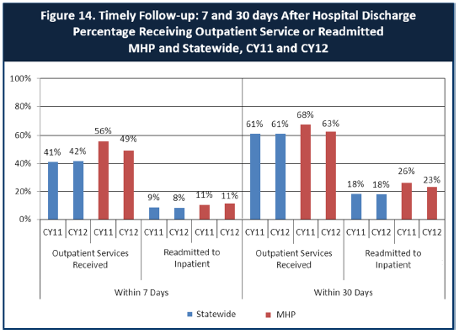
6. Looking at the chart, is your county doing better or worse than the state? Discuss why (e.g., your county has programming available that specifically ensures a warm handoff for follow-up services).
Tulare County, in comparison to the State, is doing better with serving clients 7 and 30 days post-hospitalization, but has higher rates of those same clients being readmitted to inpatient services. Tulare County Department of Mental Health has an Inpatient Unit which assists inpatient facilities with discharge planning of Tulare County clients to ensure timely access to post-discharge services and medication continuity, if applicable.
7. Do you have any suggestions on how your county can improve follow-up and reduce re-hospitalizations?
Tulare County Department of Mental Health is in the process of implementing an outpatient clinical coordination process which includes Outreach & Engagement Clinicians and Case Managers whose primary role is to work in coordination with the Inpatient Unit to contact clients upon discharge to ensure timely engagement into outpatient services using a "whatever it takes" approach. These clients are being contacted by the Outreach & Engagement Team every few days with a goal of contact and visits every 48 hours during the fragile post-hospitalization period. This process has been shown to reduce hospitalizations and we believe that, over time, it will impact our overall numbers. Additionally, we have begun to use Office Assistant (OA) support services to help with screening and improved clinic communication to identify, flag/post alerts in our electronic health record, and track high-risk and hospitalized clients so clinical staff can more promptly provide needed supports for these clients.
8. What are the three most significant barriers to service access? Examples:
- Transportation
- Child care
- Language barriers or lack of interpreters
- Specific cultural issues
- Too few child or adult therapists
- Lack of psychiatrists or tele-psychiatry services
- Delays in service
- Restrictive time window to schedule an appointment

As part of the Fiscal Year 2013/2014 Mental Health Services Act (MHSA) Planning Process, Tulare County Department of Mental Health partnered with diverse community stakeholders to conduct an MHSA Community Assessment. The aim of the MHSA Community Assessment was to advance participation and collaboration of diverse community leaders (i.e., stakeholders) in the MHSA planning process; and to develop a mechanism (i.e., focus group & survey) to support the voices of diverse community members in shaping MHSA programs and services.
Through the engagement of over 38 diversely representative MHSA stakeholders on the MHSA Stakeholder Team, a total of 599 community participants took part in the mixed-method community assessment- 457 participants completed a survey and 142 individuals participated in the 15 focus groups.
In the survey, the top three main barriers to accessing mental health services among participants were:
  - Lack of transportation (23%; consistent with focus group finding)
  - Appointment availability (19%)
  - Cost of services (15%; consistent with focus group finding)
ACCESS BY UNSERVED AND UNDER-SERVED COMMUNITIES
One goal of the Mental Health Services Act (MHSA) is to reach unserved and underserved communities, especially communities of color. The MHSA promotes outreach to engage these communities in services. If individuals and families in these communities are not accessing services, then we may need to explore new ways of reaching them. Or, we may need to change our programs to meet their mental health needs in ways that better complement their culture.
From data the counties report to the state, we can see how many individuals living in your county are eligible for Medi-Cal, and of those individuals, how many received mental health services. Are you serving the Medi-Cal clients who need your services?
Tulare County Data:
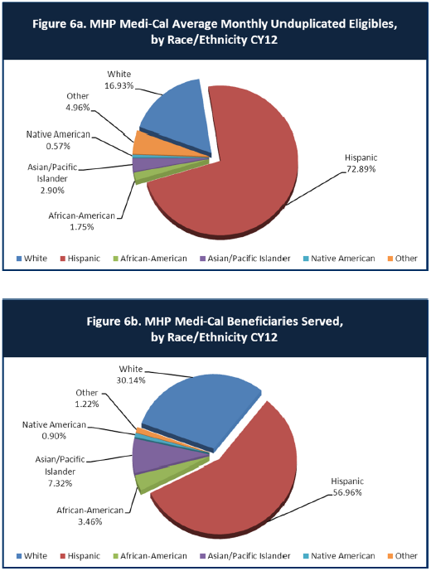
9. Is there a big difference between the race/ethnicity breakdown on the two charts? Do you feel that the group(s) that need services in your county are receiving services?
The distribution of race/ethnicity within the consumer population that Tulare County Department of Mental Health serves correlates with the County race/ethnicity census data; there are no glaring disparities. However, Tulare County Department of Mental Health understand that there are sub-population groups within Tulare County which are not reflected in the data above which are targeted for outreach and service delivery. These groups, such as the rural and geographically isolated communities, receive services via non-traditional means such as:
- Mobile Mental Health Units which read “United for Health” on the mobile unit and provide mental health, physical health, and safety-net services targeting the rural and geographically-isolated communities of north and south county regions.
- Prevention and Early Intervention (PEI) programs primarily delivered through the Tulare County school system, and the five local Family Resource Centers which are in many instances the community and cultural brokers within that region of the County.
- One-Stop Transitional Age Youth Centers located in the north, south, and central county regions.
10. What outreach efforts are being made to reach minority groups in your community?
The outreach efforts, not already mentioned above in question #9, that are being made to reach minority groups in Tulare County include participation in health fairs and community events; Mental Health Services Act Community Planning Process (CPP); community outreach and collaboration with emphasis on community and cultural brokers including faith-based organizations; and Mental Health Cultural Competency Committee which include staff, consumers, family members, and community partners.
Tulare County Department of Mental Health has participated in the following community health fairs and events (not an inclusive list):
- Farm Workers Women’s Conference
- Foster Farms and Eagle Mountain Health and Resource Fair
- Tulare County Fair
- Step Up events which target at-risk high school groups
- Tulare County Mental Health Cultural Competency Symposium which included consumers, family members, community members and Health & Human Services Agency staff
Faith-based community outreach includes collaborations with Tule River Prevention Team, Lighthouse Rescue Mission, Visalia Rescue Mission, Brooks Chapel, New Life Worship Center.
In addition to community outreach through collaboration and resource fair participation, Tulare County Department of Mental Health addresses outreach through education programs and activities that reduce stigma and encourage self determination to include the Tulare County No Stigma Speakers Bureau, My Voice Media Center, and NAMI Ending the Silence.

11. Do you have suggestions for improving outreach to and/or programs for underserved groups?
Suggestions for exploring improvement in outreach to and/or programs for un/underserved groups are to increase data review and subsequent strategic direction by the Tulare County Mental Health Cultural Competency Committee, and to improve outreach and engagement for older adult programs via Senior Citizen Centers throughout Tulare County.

CLIENT ENGAGEMENT IN SERVICES
One MHSA goal is to connect individuals to services they need to be successful. Clients who stop services too soon may not achieve much improvement, nor is it likely to last. So it is important to measure not only who comes in for treatment, but also how long they stay in services. Here we are considering individuals with high service needs, not someone who just needs a ‘tune-up.’ Although not every individual needs the same amount of services, research shows that when someone with severe mental illness continues to receive services over time, their chances of recovery increase.
Engagement in services, also called ‘retention rate’, is important to review. If individuals come in, receive only one or two services and never come back, it may mean the services were not appropriate, or that the individual did not feel welcome, or some other reason that should be explored. Again, we recognize that some individuals only need minimal services, but here we are looking at those with severe mental illness. Ultimately, the goal is to ensure they are getting needed services and are on the road to recovery. But we would not know that unless we look at how many services individuals received over time.
The chart below shows the number of Medi-Cal beneficiaries in your county who received 1, or 2, or 3, or 4, or 5, or more than15 mental health services during the year. For individuals experiencing severe mental illness, the more engaged they are in services, the greater the chance for lasting improvements in mental health.

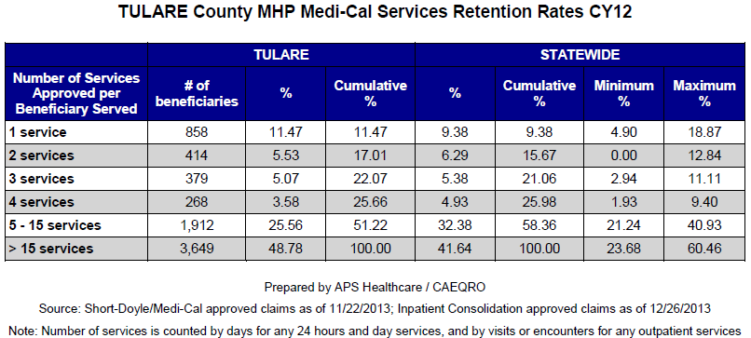
12. Do you think your county is doing a good job at keeping clients engaged in services? If yes, how? If not, why?
Yes, Tulare County is doing well in keeping clients engaged in services, and has a higher percentage (48.78) of clients receiving 15+ services in a year than the State (41.64). A primary reason for strong engagement would be the use of a myriad of evidence-based treatments, along with the increase of many peer-to-peer activities commencing in 2011.
Tulare County Department of Mental Health supports the provision of ongoing evidence-based training such as, but not limited to: Dialectical Behavioral Therapy (DBT), Cognitive Behavioral Therapy (CBT), Eye Movement Desensitization & Reprocessing (EMDR) therapy, Wellness & Recovery Action Plan (WRAP), Motivational Interviewing, Parent Child Interactive Therapy (PCIT), and Hazeldon Co-Occurring Disorder Program. These evidence-based trainings assist clinicians in providing a wide array of treatment options to meet the needs of the client.
Additionally, starting with eight peer volunteers and an estimated four peers employed within the MHP in 2011, and evolving to over 190 peer volunteers and more than 20 peers employed within the MHP in 2014; Tulare County Department of Mental Health has the ability to better provide peer-to-peer engagement, socialization and support to clients to include peer-run Orientation group for new clients, WRAP groups to clients throughout the MHP, and a Transition 12-session group for clients preparing to transition from the system.
13. For those clients receiving less than 5 services, what is your county doing to follow-up and re-engage those individuals for further mental health services?
In calendar year 2014, the largest of the Tulare County Mental Health clinics, Visalia Adult Integrated Clinic (VAIC), implemented a redesigned service delivery model hereafter referred to as the Redesign. The redesign restructured the clinic from a traditional service delivery model wherein clients are expected to come to the clinic if they are in need of services, are assessed by the next available Clinician, and from there forward, if eligible for services, are most likely seen by that Clinician and/or assigned Case Manager for the duration of the treatment; to a service delivery model that aligns with the principles of the Mental Health Services Act.
The Redesign restructured the clinic into teams which focus on meeting the client where they are in their wellness and recovery journey. There is:
- an Outreach and Engagement Team which assists in engaging those clients who are high-risk and might be newly engaging into services such as those being discharged from inpatient services;
- a Welcoming & Accessibility Team which specializes in welcoming those newly accessing services to ensure they are assessed for services in a timely manner and transitioned to an appropriate service delivery team most applicable to their needs;
- a Peer Delivered Services (PDS) Team which is comprised solely of peers specializing in providing peer to peer services and engagement throughout the entire service delivery model;
- an Assertive Community Treatment (ACT) Team which specializes in servicing those clients experiencing intensive and nearly daily services due to lack of or barriers to engagement;
- a Full Service Partnership (FSP) Team which specialized in serving those clients experiencing barriers to engagement but do not need the intensity of services provided by the ACT Team; and
- a Recovery Oriented Service (ROS) Team which specialized in servicing those clients who are engaged, but poorly self coordinating.
This Redesign will assist in better identifying and re-engaging those clients who are experiencing barriers to engagement.
14. Looking at the previous chart of who is being served by race/ethnicity in your county, do you have any thoughts or ideas to share regarding your county’s engagement of underserved communities?
Refer to response to question 11 above.
CLIENT OUTCOMES: Consumer Perception Survey (August 2013)
Ultimately, the reason we provide mental health services is to help individuals manage their mental illness and to lead productive lives. We have selected two questions from the Consumer Perception Survey which capture this intention. One question is geared toward adults of any age, and the other is for children and youth under 18.
Below are the data for responses by clients in your county to these two questions.
For general comparison, statewide reference data for various sized counties are shown in the tables on page 26.
The total numbers of surveys completed for Adults or Children/Youth in your county are shown separately in the tables below, under the heading “Total.”

Q1. Adults. As a direct result of the services I received, I deal more effectively with daily problems.
 | Strongly Disagree | Disagree | Neutral | Agree | Strongly Agree | Total
Number of Responses | 6 | 9 | 43 | 91 | 60 | 209
Percent of Responses | 2.9 % | 4.3 % | 20.6 % | 43.5 % | 28.7 % | 100.0 %

Q2. Children/Youth. As a result of services my child and/or family received, my child is better at handling daily life.
 | Strongly Disagree | Disagree | Neutral | Agree | Strongly Agree | Total
Number of Responses | 4 | 16 | 78 | 207 | 76 | 381
Percent of Responses | 1.0 % | 4.2 % | 20.5 % | 54.3 | 19.6 % | 100.0 %

15. Are the data consistent with your perception of the effectiveness of mental health services in your county?
Yes, clients predominantly feel more resilient as a result of services. 72.2% of adults clients feel more resilient (agree and strongly agree), and 73.9% of parents of child clients feel their child is more resilient (agree and strongly agree).
16. Do you have any recommendations for improving effectiveness of services?
In calendar year 2014, Tulare County Department of Mental Health conducted Wellness & Recovery Action Plan (WRAP) training to include the two-day facilitator training, and the five-day facilitator certification training. The MHP now has over 40 WRAP facilitators to implement WRAP groups throughout the MHP. Per the WRAP website pertaining to the WRAP tool: “It has been developed by a group of people who experience mental health and other health and lifestyle challenges. These people learned that they can identify what makes them well, and then use their own Wellness Tools to relieve difficult feelings and maintain wellness and a higher quality of life. The result has been recovery and long-term stability.” The implementation of WRAP throughout the MHP will aid in increasing resiliency and quality of life in the clients we serve.
17. Many counties experience very low numbers of surveys completed. Do you have suggestions to increase the response rate?
The Tulare County Department of Mental Health Managed Care Division implements and monitors the Consumer Perception Survey response rate, and in doing so has maintained an adequate response rate. The Consumer Perception Survey is administered over the course of one week’s time to all clients who have appointments with their provider during that particular week, and are assisted by peer volunteers in completing the survey during their appointment.
18. Lastly, but most important overall, with respect to delivery of services, do you have suggestions regarding any of the following:
- Specific unmet needs or gaps in services

Peers employed within the mental health system was an unmet need identified and addressed. Tulare County Department of Mental Health recently allocated Peer Support Positions within the two primary adult mental health clinics and within the county supportive housing community, and will begin recruitment and hiring of these positions in FY 2013/2014. Additionally, during the fiscal years of 2011/2012 through 2013/2014, nearly all of the contracted adult mental health programs recruited and hired peers to include the following programs: Warmline; North, South and Central One Stop Centers; North and South Mobile Unit; Co-Occuring Residential and Outpatient program; My Voice Media Center; and Transition Age Youth Crossroads Transitional Housing program.

- Improvements to, or better coordination of, existing services

Tulare County Department of Mental Health is working to improve consumer transition from mental health services by collaborating with community health centers such as the Visalia Health Care Center and the Family Health Care Network to identify community care pathways that will be most successful in maintaining wellness.

- New programs that need to be implemented to serve individuals in your county

Tulare County Department of Mental Health implemented a supported employment and volunteer program in FY 2014/2015 wherein, using the SAMHSA evidence-based supported employment model, the contract provider will assist clients in rapidly finding and maintaining employment or volunteer opportunities based on client preference within the community or mental health system, and will support the client and employer for 1-year post placement.

<END>
REFERENCE DATA: for Consumer Perception Survey items (August 2013)

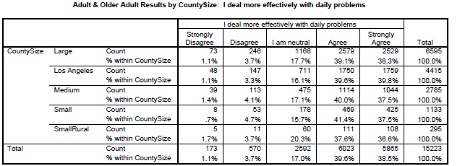

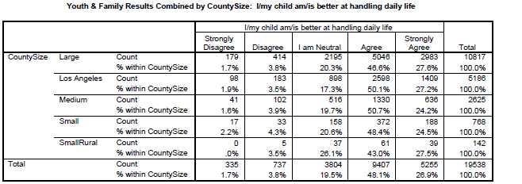

County Mental Health Plan Size: DHCS categories defined by county population.
o Small‐Rural MHPs = Alpine, Amador, Calaveras, Colusa, Del Norte, Glenn, Inyo, Lassen, Mariposa, Modoc, Mono, Plumas, Siskiyou, Trinity
o Small MHPs = El Dorado, Humboldt, Imperial, Kings, Lake, Madera, Mendocino, Napa, Nevada, San Benito, Shasta, Sutter/Yuba, Tehama, Tuolumne
o Medium MHPs = Butte, Marin, Merced, Monterey, Placer/Sierra, San Joaquin, San Luis Obispo, San Mateo, Santa Barbara, Santa Cruz, Solano, Sonoma, Stanislaus, Tulare, Yolo
o Large MHPs = Alameda, Contra Costa, Fresno, Kern, Orange, Riverside, Sacramento, San Bernardino, San Diego, San Francisco, Santa Clara, Ventura
o Los Angeles’ statistics are excluded from size comparisons, but are included in statewide data.
Total Values (in Tables above) = include all statewide data received by CiMH for those survey items.
REMINDER:

Thank you for your participation in completing your Data Notebook report.
Please feel free to provide feedback or recommendations you may have to improve this project for the following year. We welcome your input.

Please submit your Data Notebook report by email to:
DataNotebook@CMHPC.CA.GOV

Or, you may submit a printed copy by postal mail to:
- Data Notebook Project
- California Mental Health Planning Council
- 1501 Capitol Avenue, MS 2706
- P.O. Box 997413
- Sacramento, CA 95899-7413

For information, you may contact either email address above, or telephone:
(916) 449-5249, or
(916) 323-4501

Serious Mental Disorder, term used for adults 18 and older.
Severe Emotional Disorder, term used for children 17 and under.

