SUTTER & YUBA COUNTIES: DATA NOTEBOOK 2014 FOR CALIFORNIA

MENTAL HEALTH BOARDS AND COMMISSIONS

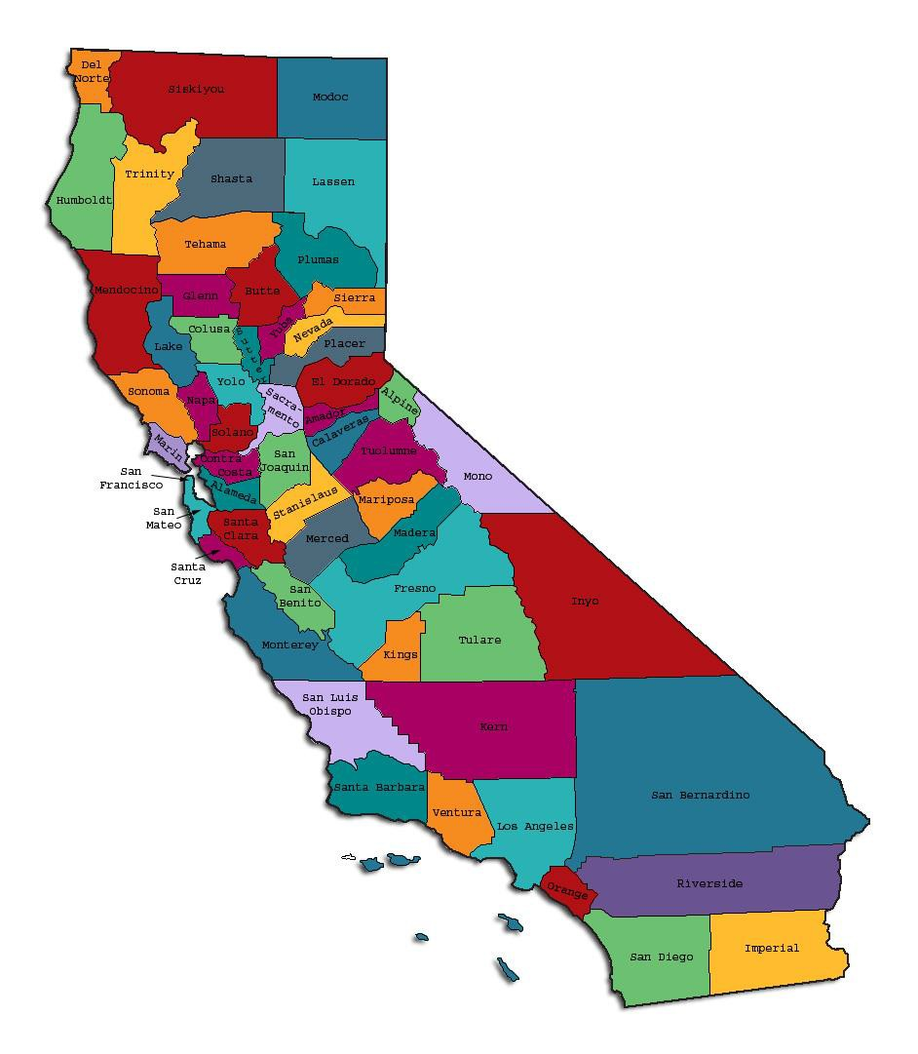
Prepared by California Mental Health Planning Council, in collaboration with: California Association of Mental Health Boards/Commissions, and APS Healthcare/EQRO

This Page Intentionally Left Blank.

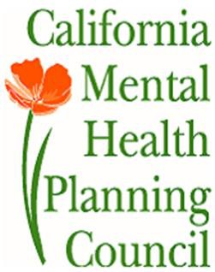Date: April 20, 2014

To: Chairpersons and/or Directors

Local Mental Health Boards and Commissions From: California Mental Health Planning Council Subject: Instructions for Data Notebook 2014

We ask that this report be prepared by the MH Board or Commission members. You are the most important resources for identifying program strengths and needs in your community.

On the first page, please fill in the requested information for your county websites:

- Department of Behavioral Health/ Mental Health
- Public reports about your county’s MH services.

Please send a copy of the filled-in first page to the Planning Council along with your final report which contains your answers to the questions in the Data Notebook. Please submit your report within 60 days by email to:

DataNotebook@cmhpc.ca.gov.

Or, you may mail a printed copy of your report to:

- Data Notebook Project
- California Mental Health Planning Council
- 1501 Capitol Avenue, MS 2706
• P.O. Box 997413 Sacramento, CA 95899-7413

Please examine the enclosed information, which will help you discuss the questions in the Data Notebook. We provide examples of recent mental health data for your county. In some figures, the term “MHP” is used to refer to your county’s Mental Health Plan.

Some data comes from APS Healthcare/EQRO, which gave permission to use their figures and tables, prepared for review of each county’s Medi-Cal Specialty Mental Health services. Data in this packet came from the following review cycle:

X Fiscal Year 2013 -- 2014: http://caeqro.com/webx/.ee85675/

X Fiscal Year 2012 -- 2013: http://caeqro.com/webx/.ee851c3/

For some questions, you will need to consult your local county Quality Improvement Coordinator, and/or Mental Health Director. If you are not able to address all of the questions, just answer the ones you can.

Thank you for your participation in the Data Notebook Project.

This Page Intentionally Left Blank

SUTTER & YUBA COUNTIES: DATA NOTEBOOK 2014 FOR CALIFORNIA

MENTAL HEALTH BOARDS AND COMMISSIONS

County Names: Sutter & Yuba Population (2013): Sutter 96,991
Yuba 73,272

Website for County Department of Mental Health (MH) or Behavioral Health:

http://www.co.sutter.ca.us

Website for Local County MH Data and Reports: http://www.co.sutter.ca.us/doc/government/depts/hs/mh/hs_mental_health
Website for local MH Board/Commission Meeting Announcements and Reports: http://www.co.sutter.ca.us
Specialty MH Data from review Year 2013-2014: http://caeqro.com/webx/.ee85675

Total number of persons receiving Medi-Cal in your county (2012): 56,583 Average number Medi-Cal eligible persons per month: 45,991
Percent of Medi-Cal eligible persons who were: Children, ages 0-17: 45.8 %
Adults, ages 18-59: 41.6 % Adults, Ages 60 and Over: 12.6 %
Total persons with SMI1 or SED2 who received Specialty MH services (2012): 3,214
Percent of Specialty MH service recipients who were: Children 0-17: 31.4 %
Adults 18-59: 57.9 %

Adults 60 and Over: 10.7 %

1 Serious Mental Disorder, term used for adults 18 and older.
2 Severe Emotional Disorder, term used for children 17 and under.

This Page Intentionally Left Blank

INTRODUCTION: Purpose, Goals, and Data Resources
This Data Notebook has been developed for the use by the local mental health (MH) boards and commissions by a yearlong workgroup comprised of members from:
- California Mental Health Planning Council (CMHPC)
- California Association of Local Mental Health Boards and Commissions (CALMHB/C)
- APS Healthcare/ EQRO (External Quality Review Organization) Our plan is for the Data Notebook to meet these goals:
- assist local boards to meet their mandates to review the local county mental health systems, identify unmet needs, and recommend improvements.
- provide a professional format for submitting reports to their local Board of Supervisors, and/or their county Director of Mental Health Services.
- function as an educational tool for local boards, whose members have varying levels of skills, frequent turnover, and need ‘refresher’ training about using data.
- help the CMHPC fulfill its mandates to review and report on the public mental health system in California, which also helps provide evidence for advocacy.
Data reporting drives policy, and policy drives funding for programs. But the data must be both recent and available to the public, or else it is not useful. So, the CMHPC will provide examples of local data from current public reports. We focus on two broad areas: (1) evaluation of program performance, and (2) indicators of client outcomes.
We recognize that each county has a unique population, resources, strengths, and needs. Thus, there is no single perfect data source to answer all the important questions one might ask about mental health services. However, the following data resources will help board members answer questions in this Data Notebook:
- experience and opinions of the local mental health board members
- recent reports about county MH programs from APS Healthcare/EQRO
- data you request from your county QI Coordinator and/or Mental Health Director (because CMHPC does not have that data, and it’s not in other public reports)
- client outcomes data provided by California Institute of Mental Health (CiMH) in their analysis of the most recent Consumer Perception Survey.
Some of our data comes from APS Healthcare/EQRO, which kindly gave permission to use their figures and tables, prepared for review of each county’s Medi-Cal Specialty Mental Health services. Those reviews are at: www.CAEQRO.com. You may find the full-length EQRO reports helpful because they summarize key programs and quality improvement efforts for each county. They also describe strengths, opportunities for improvement, and changes in mental health programs since the last year.

Understanding changes in local programs can help consumers because of the massive re-organization of mental health services statewide. Some changes have been confusing to clients. The old state Department of Mental Health was eliminated in 2012 and many functions were moved to the Department of Health Care Services. Other changes due to federal health care reform and the Affordable Care Act affect how mental health services are provided, funded, and linked to primary health care or substance use treatment. Also, local counties have adjusted to major challenges.
Remember, this report is about your community, and what you and your stakeholders choose to discuss. Examining the data can indeed “Tell a Human Story.” But quantitative data (numbers) provides only part of the picture, for example:

- measures of whether the quality of program services improve over time
- whether more people from different groups are receiving services
- how many clients got physical healthcare or needed substance use treatment.

The other part of the story gives human context to the numbers. Such qualitative data (narrative, descriptions, or stories) tells more of the story, because we can:
- describe special programs targeted for outreach to specific groups
- examine how the programs are actually implementing their goals
- list concrete steps that are taken to improve services, and
- tell what is being done to increase client engagement with continued treatment.

We hope this project contributes to ongoing quality improvement (QI) in mental health services. We seek constant improvement in our approach to quality because:
- needs change over time,
- all human endeavors are by nature imperfect,
- creativity gives rise to new ideas, and
- we can share examples of successful programs to help other communities.

One question is whether local boards are permitted to provide additional information, besides that requested in this Notebook. We always welcome supplemental reports about successful projects, or which the county administration uses to inform the public. Any additional reports may be attached in an “Appendix,” with the website address (if available). However, we emphasize such extra reports are not required.

Thank you for participating in this project. We hope this Data Notebook serves as a springboard for your discussion about all areas of the mental health system, not just those topics highlighted by our questions.

TREATING THE WHOLE PERSON:
Integrating Behavioral and Physical Health Care
Studies have shown that individuals with serious mental illness die, on average, 25 years earlier than the general population. This information makes improving the physical health of clients of great importance and should be a goal of county mental health departments along with providing effective and appropriate mental health services. Coordination of care for mental health, substance abuse and physical health is one way of accomplishing the goal.
The California Mental Health Planning Council does not have any data to provide to show how your county’s programs connect clients of mental health services with necessary physical health care. We ask that the local mental health board request information from your county mental health department for any data on numbers (or percent) of total mental health clients who are referred to, or connected with, physical health providers to assess, treat and monitor physical health issues.
If your county has data on numbers or percentages of clients who are also receiving physical health care, please include it in your Data Notebook you submit to the Council.

Check here if your county does not have such data or information.

- 36% of SYMHS’ Mental Health Outpatient clients have acknowledged that they have a Primary Care Physician on their patient demographic form.
- Please describe any efforts in your county to improve the physical health of clients.
In all our Adult Outpatient MHSA CSS Programs, we consider physical health to be integral to overall wellness. To promote overall wellness, we have built in a variety of activities, events, groups, and interventions that address not only mental health, but also physical health.
- The CSOC/TAY programs all emphasize recovery and wellness including physical health. The nature of these programs coordinates behavioral health and physical health. Many of the groups in these programs focus on healthy physical activities, healthy nutrition, and managing stress. Additionally, there are scholarships available to assist families with enrolling kids in positive, healthy, physical activities.

- How does your county address wellness programs to engage and motivate clients to take charge of improving their physical health?
Examples:

  - Exercise
  - Nutrition
  - Healthy cooking
  - Stress management
  - Quitting smoking
  - Managing chronic disease
  - Maintaining social connectedness

The following list, while not all inclusive, represents some of our efforts to address the needs of the whole person:

Adult Services
- Annual Wellness & Recovery Rally, usually held in April or May The Rally includes a variety of information booths, contests & raffles, fashion show, along with fun physical activities such as Zumba,
volleyball, a “Levy Walk”, and other active games. Each year we hold a contest for some type of healthy food which anyone can enter, and everyone gets to enjoy the contest entries! We also invite consumers and staff from adjacent counties to join us each year for the Rally.
- A Great Day to Quit! SYMHS, in partnership with County of Sutter Public Health, recently sponsored a smoking cessation program with a “quit date” of May 9, 2014. The program was available to both consumers and staff, and included group educational meetings, free smoking cessation aides, and individualized support for participants.
- Fiber Fest! A 3 hour educational and participatory workshop provided by nursing and case management staff for consumers, providing information and training regarding the importance of digestive health and balanced diet. Offered every 2 years.
- Taking Care: Provided a workshop for consumers offered in conjunction with County Health Department and Mental Health Nursing staff focused on hygiene, self-care, and minor wound care.
- Monitoring weight and vitals: Nursing staff in outpatient medication clinics monitor consumer weight and vitals, and also provide consultation on safe sex practices on a 1:1 basis per request.

- Annual Holiday Celebration: Held in early December, consumers, staff, and community members are actively involved in planning, preparation, and implementation of this large-scale multi-cultural event.
- Holiday events such as the annual Halloween Costume Party, 4th of
July Picnic, Run Drugs Out of Town 5K Run/Walk, and Thanksgiving Feast provide a variety of opportunities for consumers to be active, participate, and socialize.
- There are on-going groups offered in Wellness & Recovery/Adult Outpatient that are targeted toward overall wellness.
- Culinary Academy: Teaches budget, shopping, food selection and preparation skills; focused on the preparation of inexpensive, nutritious, and healthy menus.
- Step It Up! A group activity geared toward pairing the value of physical exercise with mental wellness. Includes stress reduction skills, nutrition and health education, smoking cessation support, basic yoga and aerobics instruction.
- Home Economics: In addition to managing a year-round organic garden and the produce it provides, this group activity focuses on a variety of skills to create and foster a healthy, active lifestyle.
- Voices of HOPE Music Group: Consumers and staff gather together to play guitar, sing, and socialize around well-known popular music.
- Pathways to Recovery Group: Utilizing curriculum from Pathways to Recovery: A Strengths Recovery Self-Help Workbook, consumers work with staff to accomplish goals and increase wellness.

CSOC/TAY/Youth
- Exercise (We have access to a gym and encourage youth to use this resource, our parent mentors have not only taken caregivers to exercise classes, but have engaged with them as well)
- Nutrition (Nutrition is covered individually as well as in groups where healthy snacks are offered).
- Healthy cooking (The TAY program teaches clients how to find and prepare healthy recipes.)
- Stress management (Incorporated into group and individual services)

- Quitting smoking (Incorporated into group and individual services)
- Managing chronic disease
- Maintaining social connectedness (Encouraged through group outings, fun friends group, and other groups designed to assist with positive social skills).
- Take weight and blood pressure routinely in med appointments. Obtain labs prior to medicating.
- Exercise and the importance of health eating are routine part of conversations with clients/parents in the course of providing therapy and medication management.

Psychiatric Health Facility
Heath education topics including, exercise, nutrition, stress management, the importance eating healthy, managing mental illness, etc., are discussed as part of on-going individual and group process.

Prevention and Early Intervention (PEI)

Prevention and Early Intervention (PEI) in Sutter-Yuba Mental Health Services involves reducing risk and stressors; building protective factors and skills; and increasing support. The goal of PEI is to promote positive cognitive, social, and emotional development, as well as encourage a state of well-being that allows the individual or group to function well.
The Recreational Scholarship Program accomplishes this goal by reaching a large target population identified by the PEI plan for Sutter and Yuba Counties; children, youth and transitional age youth (TAY) ages 16- 24 who meet the following criteria:
  - Trauma exposure: exposure to traumatic events or prolonged traumatic conditions.
  - Stressed families: placed out of home or are in families where there is substance abuse, violence, depression or other mental illness, or lack of caregiving adults (serious health conditions or incarcerations).
  - At risk of school failure
  - At or experiencing, juvenile justice involvement
  - Experiencing onset of serious psychiatric illness with

psychosis (TAY only): identified as presenting signs of mental illness first break.
  - Underserved populations: ethnically/racially diverse communities, LGBTI, etc.
PEI Programs:
  - Able Riders Program, a therapeutic horseback riding program serving children with physical, mental or emotional disabilities. This program is proven to help improve neuro-motor function, increase patience and attention, and increase confidence and self-esteem

  - The Student Garden at CORE @ The Camptonville Academy Charter School where students receive adaptive curriculum that best fits their strengths and learning style. In June 2013 CORE received Recreational Scholarship funds to help create a student garden at their Resource Center serving students dealing with emotional and distressing situations in their homes.

Based on research done by CORE the student garden has contributed to the overall health of students in many ways. Students are better able to:
    - Connect and build relationships.
    - See the value of caring for nature.
    - Improve attitudes about food, agriculture, and exercise
    - Assume responsibility
    - Become open to new experiences
    - Improve grades
    - Develop a practical life-long skill

- Common Recreation Scholarships
  - Individual: dance, football, karate, cheerleading, camp, etc.
  - Group: gym memberships, variety of sports opportunities within an organization, etc.
  - Equipment: sporting equipment, supplies, etc.

Substance Abuse Steering Coalition

The development of the strategic plan for our community had been ongoing for some time. The Strategic Prevention Framework (SPF) workgroup consisting of members from Sutter-Yuba Mental Health Services, Sutter- Yuba Friday Night Live, Sutter County and Yuba County Health Departments, Sutter County Superintendent of Schools, Yuba County Office of Education and other community partners began officially meeting in May of 2012, and started the process by working on analyzing the data, then creating the problem and mission statements.

During the initial strategic planning workgroup meetings as well as the Substance Abuse Advisory Board (SAAB) meetings, the members participated in a process to develop and refine the mission statement and goals of the strategic prevention plan. With our update, it was agreed that the following mission statement for Sutter and Yuba Bi-County Mental Health Services will remain in effect:

“Sutter County and Yuba County value and support the well-being and health of our communities. It is our commitment to educate and prevent substance abuse in our communities

The vision for Sutter and Yuba counties would be to have a healthy community for everyone. As such, our communities value collaboration, leadership, community action, and education. In addition, some of the prevention principles that our workgroup based our interventions upon were:
- Community prevention programs reaching populations in multiple settings—for example, schools, clubs, faith-based organizations, and the media—are most effective when they present consistent, community-wide messages in each setting.
- Community prevention programs that combine two or more effective programs, such as family-based and school-based programs, can be more effective than a single program alone.
The workgroup brainstormed ideas for and defined what they could realistically and reasonably accomplish. Culturally relevant services were

taken into account as they looked at the population they serve, as well as those services for which they could report change over time. The following details the problem statements again, along with corresponding goals and objectives:

- Youth who use substances at a young age are more at risk for serious substance misuse problems as adults.
Goal: Prevent the use of substances in our youth. Objectives:
  - Reduce youth access to tobacco products and support the efforts of Sutter and Yuba Counties’ Tobacco Control Program, including, but not limited to Tobacco Retail Licensing (TRL).
  - Increase and provide youth development opportunities and alternatives to community youth, including SASC and FNL youth.
  - Maintain and or create an environmental media campaign to address the most commonly abused substances in our community, including, but not limited to methamphetamines, prescription drugs, alcohol, and marijuana.
  - Research the logistics of the Athlete Committed program, with the intent to implement this program in at least one high school.

- Lack of information and modeling by some adults exacerbate substance use problems for our youth.
Goal: To create an attitude shift in the way adults view youth substance use/abuse.

Objectives:
  - Educate policy makers and key leaders regarding the emerging and local trends with regard to substances of abuse.
  - Social Host research, community awareness and possible ordinance.

  - Attend and participate in local community events to disseminate information and educate the public regarding the dangers of substance use.
  - Educate parents and families using the model curricula, Strengthening Families and Second Step in our communities.

NEW CLIENTS: One Measure of Access
One way to evaluate the quality of mental health services outreach is to measure how many clients receive services who have never been part of the service system before (“brand new” clients). Another measure is how many clients return for services after a period of time with no services (“new” clients).
The California Mental Health Planning Council is exploring how each county mental health department defines “new” clients, and how a client is labelled when they return
for additional services. This information is important in determining whether your county has a “revolving door,” that is, clients who are in and out of mental health services repeatedly. This data is one indicator of the success of your county’s programs in closing cases appropriately and providing adequate discharge planning to clients.
This data is not currently reported by the counties to the state. The Council does not have data to provide to you. This information should be requested from your county mental health department.

Check here if your county does not have this information.

- How does your county define 'new' client for those individuals who have previously received services, but who have not received services for a while? (e.g., 6 months, 12 months, 2 years?)
SYMHS’ defines ‘new’ clients as those individuals who have previously received services, but who have not received services for 12 months.

- Please provide any data your county has on the number of 'new' clients last year. And if you have it, how many of those new clients were brand new clients? You may need to ask your county mental health department for
this data.

# of Unduplicated client count for Mental Health Outpatient Services for F/Y 13/14:

 | SYMHS  Unduplicated Clients | Percent of Unduplicated Clients
Child (<18) | 769 | 14.0%
Adult (18-59) | 4,007 | 72.8%
Older Adult (60+) | 727 | 13.2%
Total: | 5,503 | 100%
Data Source: SYMHS’ Anasazi Report

# new SYMHS Clients in F/Y 13/14: 1899 ‘new ’ clients

Of these, how many (or %) are ‘brand new ’ clients: 1,220 ‘brand new ’ clients, (64% of ‘new’ clients were ‘brand new’ clients for SYMHS in F/Y 13/14).

# new children/youth (0-17 yrs.) 349

of these, how many (or %) are ‘brand new’ clients: 276 ‘brand new ’ children/youth clients

# new adults (18-59 yrs.) 1,410

of these, how many (or %) are ‘brand new’ clients 847 ‘brand new ’ adult clients

# new older adults (60+ yrs.) 140

of these, how many (or %) are ‘brand new’ clients: 97 ‘brand new ’ older adult clients

REDUCING RE-HOSPITALIZATION: Access to Follow-up Care
Sometimes, an individual experiences acute symptoms of mental illness or substance abuse which can result in a brief stay in an acute care hospital. Receiving follow-up services after discharge from a short-term (3-14 day) hospitalization can be critical to preventing a return to the hospital.
The chart below shows the percentage of people discharged in your county who received at least one service within 7 days of discharge. Also shown is the percentage of those same people who were readmitted to the hospital. The chart also shows the same information for receiving services and being readmitted to the hospital within 30 days. Red indicates the numbers for your county and the blue indicates the percentage for the state of California.

Sutter –Yuba Counties MHP:

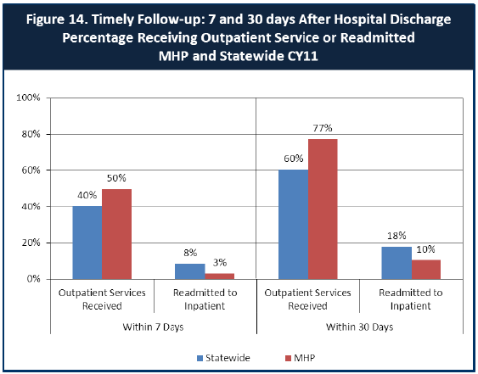

- Looking at the chart, is your county doing better or worse than the state? Discuss why (e.g., your county has programming available that specifically ensures a warm handoff for follow-up services).
SYMHS is doing better than the State with timely follow-up after hospitalization in all the categories shown in the chart.
  - 50% of SYMHS’ clients received services within 7 days after hospital discharge as compared to 40% for the statewide average.
  - Only 3% of SYMHS’ clients were readmitted within 7 days as compared to 8% for the statewide average.
  - 77% of SYMHS’ clients received services with 30 days after hospital discharge as compared to 60% for the statewide average.
  - Only 10% of SYMHS’ clients were readmitted within 30 days as compared to 18% for the statewide average.

- SYMHS Adult Services offers “bridge” case management services to persons identified as needing additional stabilization support following discharge from psychiatric inpatient. Intensive case management is provided for up to 90 days to assist & support consumers to address issues and/or dynamic risk factors which may have contributed to hospitalization. The range of services and supports includes SOAR (SSI/SSDI Outreach, Access and Recover Services), PATH (Projects for Assistance in Transition from Homelessness program), individualized SUDS (Substance Use Disorder Services) treatment, assistance obtaining medical care, and linkage to appropriate community resources. This is a relatively new service, and we are monitoring results to determine if these efforts will be successful in reducing re- hospitalization rates.

In addition, for the past five years inpatient and outpatient staff working with adults meet weekly and as needed to develop collaborative and supportive discharge plans. Outpatient providers make arrangements to connect with consumers while they are hospitalized to develop and/or support an ongoing therapeutic alliance. This approach creates a “warm handoff” from inpatient to outpatient services.

- SYMHS’ Integrated Hospital Reduction Team (IHRT pronounced I- Heart) was implemented in F/Y 02/03 to provide follow up and case management supports for youth hospitalized or at risk of hospitalization. This program has been successful providing a level of intervention

necessary to stabilize youth, address behaviors, and symptoms that jeopardize the youth’s lower level of care.

- Do you have any suggestions on how your county can improve follow-up and reduce re-hospitalizations?
(Please see question 6 above.)
- What are the three most significant barriers to service access? Examples:

  - Transportation
  - Child care
  - Language barriers or lack of interpreters
  - Specific cultural issues

Currently, the three most significant barriers to access are:
- Lack of psychiatrists for Youth and Adult Services
- Mental Health stigma, especially in the underserved Latino communities
- Lack of acute psychiatric beds for clients
ACCESS BY UNSERVED AND UNDER-SERVED COMMUNITIES
One goal of the Mental Health Services Act (MHSA) is to reach unserved and underserved communities, especially communities of color. The MHSA promotes outreach to engage these communities in services. If individuals and families in these communities are not accessing services, then we may need to explore new ways of reaching them. Or, we may need to change our programs to meet their mental health needs in ways that better complement their culture.
From data the counties report to the state, we can see how many individuals living in your county are eligible for Medi-Cal, and of those individuals, how many received mental health services. Are you serving the Medi-Cal clients who need your services?
Sutter –Yuba Counties MHP:

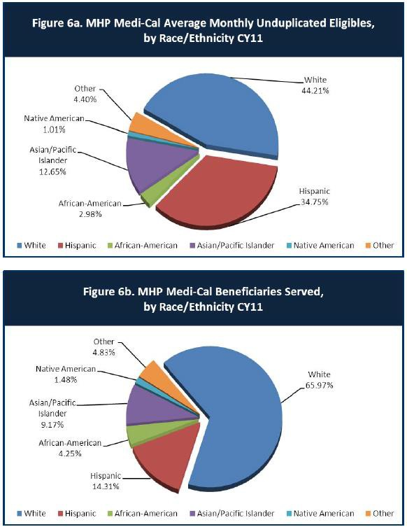

- Is there a big difference between the race/ethnicity breakdown on the two charts? Do you feel that the groups that need services in your county are receiving services?
SYMHS’ had high penetration rates for White, Native American, African American and the “Other’ category of Medi-Cal Beneficiaries in calendar year (CY) 2011.
SYMHS’ had low penetration rates for Hispanic and Asian/Pacific Islander Medi-Cal Beneficiaries CY 2011.

  - Hispanic Medi-Cal Beneficiaries have the lowest penetration rate and based on the data provided above, were underserved in CY 11 by 59%.
  - Asian/Pacific Islanders have the 2nd lowest penetrate rate and based on the data provided above, were underserved in CY 11 by 28%.
- What outreach efforts are being made to reach minority groups in your community?

- The Hmong Outreach Center - To better serve the needs of the Hmong, Sutter-Yuba Mental Health created the Hmong Outreach Center to provide outreach services and culturally and linguistically competent mental health services to the local Hmong population.

In developing the center, the county had five main goals:
  - Eliminate the stigma around mental health through a facility and name change.
  - Employ bilingual and bicultural staff.
  - Place the facility in a location in close proximity to the majority of the population.
  - Give flexible hours to bridge different concepts of time and way of being.
  - Offer culturally responsive services. Ask the Hmong what they want, such as cultural activities.
- Traditional Healers Project – The Traditional Healers Project is a PEI effort at SYMHS Hmong Outreach Center. Through this project, bilingual/bicultural Hmong staff members discuss mental health related topics with Hmong spiritual healers in culturally relevant ways and work closely with them to recognize symptoms of mental health conditions. The project provides conversations in terms understood and accepted in the Hmong community to foster healthy attitudes regarding mental health wellness.

The Traditional Healers Project went national as a promising practice model at the Alternatives 2013 Conference held in Austin, Texas, December 4-7, 2013. The workshop was part was part of the conference’s diversity track and covered The Traditional Healers Project

as an innovative and culturally responsive approach to services and stigma reduction for the Hmong community. Participants learned how the project and SYMHS’ Hmong Outreach Services addresses mental health conditions by understanding culturally specific experiences of stigma and examining exemplary programs through the lens of the “Promising Practices Program”, as well as methods of technical assistance and lessons learned.

The following list, while not all inclusive, represents some of our other efforts to reach minority clients:

- SYMHS is currently in discussions about creating a Latino Outreach Center to address the low penetration rates for this population.
- To further assist the Latino population to access services, we have extended our successful Open Access Clinic services to include a dedicated weekly clinic for Latino/Spanish-speaking clients.
- To assist with increasing access for Latino clients, bicultural/bilingual Spanish speaking Intervention Counselor and a Therapist has been hired for the Latino Outreach Program.
- To assist with increasing access for Hmong speaking clients, bicultural/bilingual Hmong speaking Intervention Counselor has been hired for the Hmong Outreach Program.
- SYMHS promotes outreach to underserved communities through both the Ethnic Outreach and Prevention and Early Intervention programs.
- Do you have suggestions for improving outreach to and/or programs for underserved groups?
- Continue to create welcoming environments for all cultures and continue to promote outreach events informing under-served populations about culturally and linguistically appropriate mental health and substance use disorder services available at Sutter-Yuba Mental Health Services.

CLIENT ENGAGEMENT IN SERVICES
One MHSA goal is to connect individuals to services they need to be successful. Clients who stop services too soon may not achieve much improvement, nor is it likely to last. So it is important to measure not only who comes in for treatment, but also how long they stay in services. Here we are considering individuals with high service needs,
not someone who just needs a ‘tune-up.’ Although not every individual needs the same amount of services, research shows that when someone with severe mental illness continues to receive services over time, their chances of recovery increase.
Engagement in services, also called ‘retention rate’, is important to review. If individuals come in, receive only one or two services and never come back, it may mean the services were not appropriate, or that the individual did not feel welcome, or some other reason that should be explored. Again, we recognize that some individuals only need minimal services, but here we are looking at those with severe mental illness.
Ultimately, the goal is to ensure they are getting needed services and are on the road to recovery. But we would not know that unless we look at how many services individuals received over time.
The chart below shows the number of Medi-Cal beneficiaries in your county who received 1, or 2, or 3, or 4, or 5, or more than15 mental health services during the year. For individuals experiencing severe mental illness, the more engaged they are in services, the greater the chance for lasting improvements in mental health.

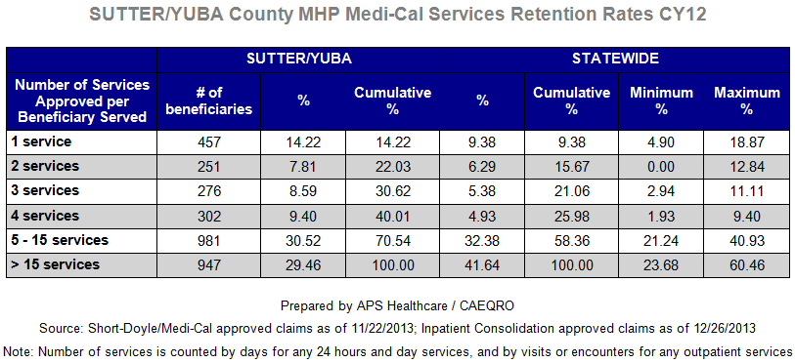

- Do you think your county is doing a good job at keeping clients engaged in services? If yes, how? If not, why?

Yes, we believe we are doing a good job keeping clients engaged in services. In adult services, the initial focus is on assisting and supporting clients to address high priority needs up front by providing high intensity services tailored to the individual. Clients who successfully address high priority needs such as obtaining housing, applying for and/or obtaining benefits, linking with and obtaining necessary health care, and/or receiving 1:1 services, and/or group assistance, addressing Substance Use Disorder Services (SUDS), tend to be both participatory and engaged.

Once someone has successfully addressed their most urgent high priority needs, we offer a menu of services addressing a variety of treatment and rehabilitative needs informed by consumer feedback.

In youth services we are doing a good job of engaging our clients. We have a low no show rate of less than 15% and are striving to reduce that. Our access services strive to match the children with the correct level of care and take into consideration such factors as need for services in the community, geographic disparity, language and ethnicity, to ensure that children get the services from a provider who can meet their unique
needs. We are flexible and make alternative arrangements when a family’s need cannot be accommodated in our usual schedule.

- For those clients receiving less than 5 services, what is your county doing to follow-up and re-engage those individuals for further mental health services?
- Clients who have had their needs met do not necessarily need or want to continue services.

- To answer this question effectively we need additional information about these clients. Is it possible they only needed 5 or fewer services? Did they move out of area? Were they connected to other resources that better met their needs?

- Over the past 7 years, personalized letters have been mailed to a high percentage of adult clients not seen for services for six months or more, encouraging them to contact us if they wanted to resume services and providing them with detailed contact and access information. As a result of these mailings, some clients returned to services, some clients indicated they did not need services.

- Looking at the previous chart of who is being served by race/ethnicity in your county, do you have any thoughts or ideas to share regarding your county’s engagement of underserved communities?
- Since the Hmong Outreach Center has been very successful in engaging the Hmong clients, SYMHS is looking at developing a Latino Outreach Center.

.

CLIENT OUTCOMES: Consumer Perception Survey (August 2013)
Ultimately, the reason we provide mental health services is to help individuals manage their mental illness and to lead productive lives. We have selected two questions from the Consumer Perception Survey which capture this intention. One question is geared toward adults of any age, and the other is for children and youth under 18.
Below are the data for responses by clients in your county to these two questions.

For general comparison, statewide reference data for similar-sized counties are shown in the tables on page 19.
The total numbers of surveys completed for Adults or Children/Youth in your county are shown separately in the tables below, under the heading “Total.”

Q1. Adults. As a direct result of the services I received, I deal more effectively with daily problems.

 | Strongly Disagree | Disagree | Neutral | Agree | Strongly Agree | Total
Number of Responses | 2 | 11 | 23 | 76 | 76 | 188
Percent of Responses | 1.1 % | 5.9 % | 12.2 % | 40.4 % | 40.4 % | 100.0 %

Q2. Children/Youth. As a result of services my child and/or family received, my child is better at handling daily life.

 | Strongly Disagree | Disagree | Neutral | Agree | Strongly Agree | Total
Number of Responses | 1 | 2 | 13 | 36 | 14 | 66
Percent of Responses | 1.5 % | 3.0 % | 19.7 % | 54.5 % | 21.2 % | 100.0 %

- Are the data consistent with your perception of the effectiveness of mental health services in your county?
- 81% of Sutter-Yuba Mental Health Services (SYMHS) Adult clients strongly agreed or agreed that as a direct result of the services I received, I deal more effectively with daily problems.
  - Sutter-Yuba’s client satisfaction score for this question was higher than the Small County and Statewide averages of 79% and 78% respectively.
- 76% of SYMHS’ of Children/Youth respondents Strongly Agreed or Agreed that as a result of services my child and/or family received, my child is better at handling daily life.
  - Sutter-Yuba’s client satisfaction score for this question was higher than the Small County and Statewide averages of 73% and 75% respectively.
This data seems to be consistent with perception of the effectiveness of mental health services in our county.
- Do you have any recommendations for improving effectiveness of services?

SYMHS’ satisfaction data was positive. There are always going to be some folks that aren’t happy and those situations can generally be handled by asking the client what they need/needed or how services could be improved. If the annual Performance Outcome and Quality Improvement Survey (POQI) Survey wasn’t already so long, perhaps a question could be added to the survey for people who disagree, strongly disagree or are neutral that asks, “What do you feel would have been helpful in assisting you managing your daily problems?”
- Many counties experience very low numbers of surveys completed. Do you have suggestions to increase the response rate?
- In regards to the Performance Outcome and Quality Improvement Survey (POQI) we give pens to clients as an incentive for them to complete the survey.
- Many consumers complain about the length of the POQI Survey.
- We achieved a very high response rate (49% = 603 returned of 1220 distributed) for returned client satisfaction surveys in conjunction with

our Open Access Clinic implementation over a two year period. Surveys were provided to each consumer upon signing in for services, and collected voluntarily at the conclusion of triage and assessment.
Surveys were anonymous and voluntary to encourage and elicit honest feedback and/or comments.

Consumers were informed that it was our intention to make Open Access Clinic a welcoming and therapeutic experience, and that we would appreciate their input and feedback about how to meet these goals. By attaching surveys to walk-in access services, making the surveys voluntary and anonymous, and letting people know that their feedback would be both welcomed and acted upon, seemed to be key to the high return rate.

- Lastly, but perhaps most important overall, with respect to delivery of services, do you have suggestions regarding any of the following:
- Specific unmet needs or gaps in services

SYMHS has an unmet need for the following:
  - More acute medical/psychiatric hospital beds for adults
  - More acute psychiatric hospital beds for children and adolescents
  - Regional continuum of crisis services such as crisis residential beds.

- Improvements to, or better coordination of, existing services

With the implementation of the Affordable Care Act (ACA), there is a need for greater system coordination with physical health care entities.

- New programs that need to be implemented to serve individuals in your county

<END>

REFERENCE DATA: for Consumer Perception Survey items (August 2013)

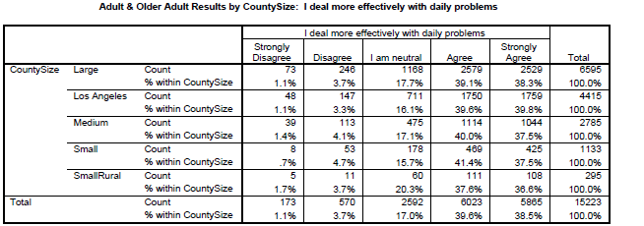

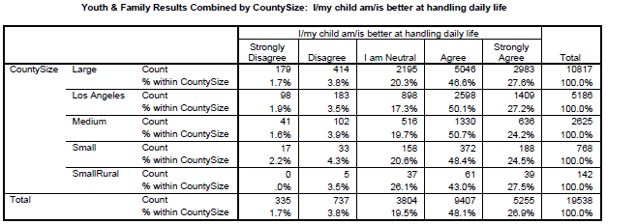

County Mental Health Plan Size: DHCS categories defined by county population.
- Small‐Rural MHPs = Alpine, Amador, Calaveras, Colusa, Del Norte, Glenn, Inyo, Lassen, Mariposa,
Modoc, Mono, Plumas, Siskiyou, Trinity

- Small MHPs = El Dorado, Humboldt, Imperial, Kings, Lake, Madera, Mendocino, Napa, Nevada, San Benito, Shasta, Sutter/Yuba, Tehama, Tuolumne

- Medium MHPs = Butte, Marin, Merced, Monterey, Placer/Sierra, San Joaquin, San Luis Obispo, San Mateo, Santa Barbara, Santa Cruz, Solano, Sonoma, Stanislaus, Tulare, Yolo

- Large MHPs = Alameda, Contra Costa, Fresno, Kern, Orange, Riverside, Sacramento, San Bernardino, San Diego, San Francisco, Santa Clara, Ventura
- Los Angeles’ statistics are excluded from size comparisons, but are included in statewide data. Total Values (in Tables above) = include all statewide data received by CiMH for those survey items.

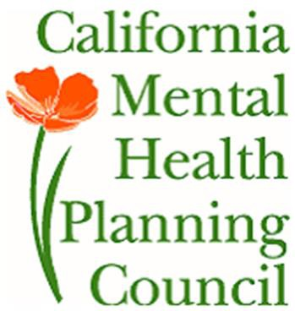REMINDER:

Thank you for your participation in completing your Data Notebook report.

Please feel free to provide feedback or recommendations you may have to improve this project for the following year. We welcome your input.

Please submit your Data Notebook report by email to: DataNotebook@CMHPC.CA.GOV

Or, you may submit a printed copy by postal mail to:

  - Data Notebook Project
  - California Mental Health Planning Council
  - 1501 Capitol Avenue, MS 2706
• P.O. Box 997413
  - Sacramento, CA 95899-7413

For information, you may contact either email address above, or telephone: (916) 449-5249, or
(916) 323-4501

