SAN LUIS OBISPO COUNTY: DATA NOTEBOOK 2014
FOR CALIFORNIA
MENTAL HEALTH BOARDS AND COMMISSIONS

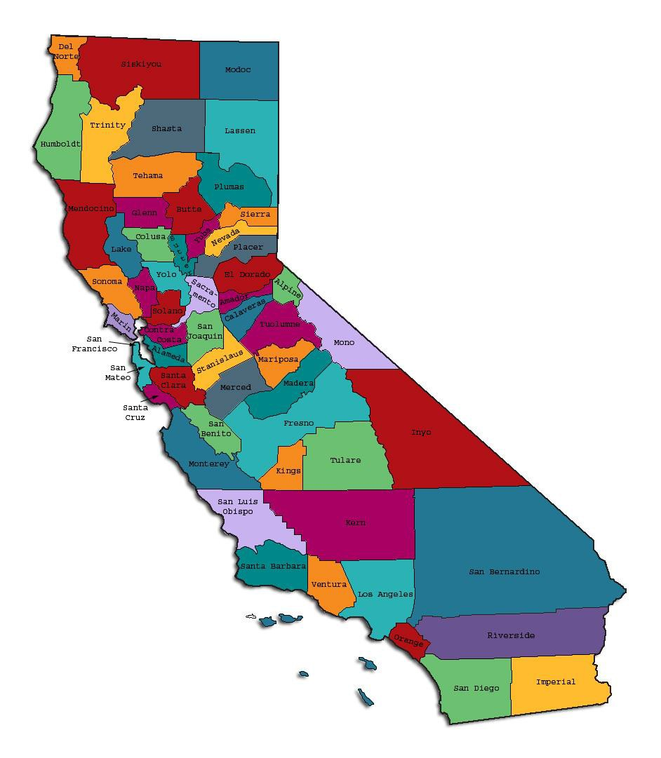
Prepared by California Mental Health Planning Council, in collaboration with: California Association of Mental Health Boards/Commissions, and APS Healthcare/EQRO

This Page Intentionally Left Blank.

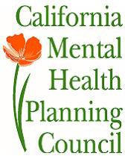Date: April 20, 2014

To: Chairpersons and/or Directors

Local Mental Health Boards and Commissions From: California Mental Health Planning Council Subject: Instructions for Data Notebook 2014

We ask that this report be prepared by the MH Board or Commission members. You are the most important resources for identifying program strengths and needs in your community.

On the first page, please fill in the requested information for your county websites:

- Department of Behavioral Health/ Mental Health

- Public reports about your county’s MH services.

Please send a copy of the filled-in first page to the Planning Council along with your final report which contains your answers to the questions in the Data Notebook. Please submit your report within 60 days by email to:

DataNotebook@cmhpc.ca.gov.

Or, you may mail a printed copy of your report to:

- Data Notebook Project

- California Mental Health Planning Council

- 1501 Capitol Avenue, MS 2706

• P.O. Box 997413 Sacramento, CA 95899-7413

Please examine the enclosed information, which will help you discuss the questions in the Data Notebook. We provide examples of recent mental health data for your county. In some figures, the term “MHP” is used to refer to your county’s Mental Health Plan.

Some data comes from APS Healthcare/EQRO, which gave permission to use their figures and tables, prepared for review of each county’s Medi-Cal Specialty Mental Health services. Data in this packet came from the following review cycle:

X Fiscal Year 2013 -- 2014: http://caeqro.com/webx/.ee85675/

Fiscal Year 2012 -- 2013: http://caeqro.com/webx/.ee851c3/

For some questions, you will need to consult your local county Quality Improvement Coordinator, and/or Mental Health Director. If you are not able to address all of the questions, just answer the ones you can.

Thank you for your participation in the Data Notebook Project.

This Page Intentionally Left Blank

San Luis Obispo County: Data Notebook 2014, for California
Mental Health Boards and Commissions

County Name: San Luis Obispo Population (2013): 271,794 Website for County Department of Mental Health (MH) or Behavioral Health:
www.slocounty.ca.gov/mentalhealth services Website for Local County MH Data and Reports: None
Website for local MH Board/Commission Meeting Announcements and Reports: www.slocounty.ca.gov/mental healthservices/Behavioral_Health_Board
Specialty MH Data from review Year 2013-2014: http://caeqro.com/webx/.ee85675

Total number of persons receiving Medi-Cal in your county (2012): 45,322 Average number Medi-Cal eligible persons per month: 35,562
Percent of Medi-Cal eligible persons who were: Children, ages 0-17: 45.9 %
Adults, ages 18-59: 41.4 % Adults, Ages 60 and Over: 12.7 %
Total persons with SMI1 or SED2 who received Specialty MH services (2012): 2,754
Percent of Specialty MH service recipients who were: Children 0-17: 43.7 %
Adults 18-59: 50.1 %

Adults 60 and Over: 6.2 %

1 Serious Mental Disorder, term used for adults 18 and older.
2 Severe Emotional Disorder, term used for children 17 and under.

This Page Intentionally Left Blank

INTRODUCTION: Purpose, Goals, and Data Resources
This Data Notebook has been developed for the use by the local mental health (MH) boards and commissions by a yearlong workgroup comprised of members from:
- California Mental Health Planning Council (CMHPC)

- California Association of Local Mental Health Boards and Commissions (CALMHB/C)
- APS Healthcare/ EQRO (External Quality Review Organization) Our plan is for the Data Notebook to meet these goals:
- assist local boards to meet their mandates to review the local county mental health systems, identify unmet needs, and recommend improvements.
- provide a professional format for submitting reports to their local Board of Supervisors, and/or their county Director of Mental Health Services.
- function as an educational tool for local boards, whose members have varying levels of skills, frequent turnover, and need ‘refresher’ training about using data.
- help the CMHPC fulfill its mandates to review and report on the public mental health system in California, which also helps provide evidence for advocacy.
Data reporting drives policy, and policy drives funding for programs. But the data must be both recent and available to the public, or else it is not useful. So, the CMHPC will provide examples of local data from current public reports. We focus on two broad areas: (1) evaluation of program performance, and (2) indicators of client outcomes.
We recognize that each county has a unique population, resources, strengths, and needs. Thus, there is no single perfect data source to answer all the important questions one might ask about mental health services. However, the following data resources will help board members answer questions in this Data Notebook:
- experience and opinions of the local mental health board members

- recent reports about county MH programs from APS Healthcare/EQRO

- data you request from your county QI Coordinator and/or Mental Health Director (because CMHPC does not have that data, and it’s not in other public reports)

- client outcomes data provided by California Institute of Mental Health (CiMH) in their analysis of the most recent Consumer Perception Survey.

Some of our data comes from APS Healthcare/EQRO, which kindly gave permission to use their figures and tables, prepared for review of each county’s Medi-Cal Specialty Mental Health services. Those reviews are at: www.CAEQRO.com. You may find the full-length EQRO reports helpful because they summarize key programs and quality improvement efforts for each county. They also describe strengths, opportunities for improvement, and changes in mental health programs since the last year.
Understanding changes in local programs can help consumers because of the massive re- organization of mental health services statewide. Some changes have been confusing to clients. The old state Department of Mental Health was eliminated in 2012 and many functions were moved to the Department of Health Care Services. Other changes due to federal health care reform and the Affordable Care Act affect how mental health services are provided, funded, and linked to primary health care or substance use treatment. Also, local counties have adjusted to major challenges.
Remember, this report is about your community, and what you and your stakeholders choose to discuss. Examining the data can indeed “Tell a Human Story.” But quantitative data (numbers) provides only part of the picture, for example:

- measures of whether the quality of program services improve over time

- whether more people from different groups are receiving services

- how many clients got physical healthcare or needed substance use treatment.

The other part of the story gives human context to the numbers. Such qualitative data (narrative, descriptions, or stories) tells more of the story, because we can:
- describe special programs targeted for outreach to specific groups

- examine how the programs are actually implementing their goals

- list concrete steps that are taken to improve services, and

- tell what is being done to increase client engagement with continued treatment.

We hope this project contributes to ongoing quality improvement (QI) in mental health services. We seek constant improvement in our approach to quality because:
- needs change over time,

- all human endeavors are by nature imperfect,

- creativity gives rise to new ideas, and

- we can share examples of successful programs to help other communities.

One question is whether local boards are permitted to provide additional information, besides that requested in this Notebook. We always welcome supplemental reports about successful projects, or which the county administration uses to inform the public. Any additional reports may be attached in an “Appendix,” with the website address (if available). However, we emphasize such extra reports are not required.

Thank you for participating in this project. We hope this Data Notebook serves as a springboard for your discussion about all areas of the mental health system, not just those topics highlighted by our questions.

TREATING THE WHOLE PERSON:
Integrating Behavioral and Physical Health Care
Studies have shown that individuals with serious mental illness die, on average, 25 years earlier than the general population. This information makes improving the physical health of clients of great importance and should be a goal of county mental health departments along with providing effective and appropriate mental health services. Coordination of care for mental health, substance abuse and physical health is one way of accomplishing the goal.
The California Mental Health Planning Council does not have any data to provide to show how your county’s programs connect clients of mental health services with necessary physical health care. We ask that the local mental health board request information from your county mental health department for any data on numbers (or percent) of total mental health clients who are referred to, or connected with, physical health providers to assess, treat and monitor physical health issues.
If your county has data on numbers or percentages of clients who are also receiving physical health care, please include it in your Data Notebook you submit to the Council.

x Check here if your county does not have such data or information.

- Please describe any efforts in your county to improve the physical health of clients.

All Medi-Cal clients in our County Operated Health System are assigned to a primary care physician by the Medi-cal Managed care company, CenCal. 73% of County Mental Health clients are Medi-Cal beneficiaries. The county has been awarded grant funds which will be used to aggressively enroll Medi-Cal eligibles with no insurance.
The sharing of information with other health professionals is hampered by confidentiality rules but the Behavioral Health Department routinely requests the client’s consent for the sharing of information. Data is gathered in all cases about the 12 core health indicators detailed in the Affordable Care Act. The Department is planning to embed mental health therapists at the Community Health Center and in emergency rooms. The Community Health Center is a Federally Qualified Health Clinic heavily used by Medi-Cal beneficiaries and indigent county residents.

- How does your county address wellness programs to engage and motivate clients to take charge of improving their physical health?
Examples:

  - Exercise
  - Nutrition
  - Healthy cooking
  - Stress management
  - Quitting smoking
  - Managing chronic disease
  - Maintaining social connectedness

The County BHD contracts with Transitions –Mental Health Agency to operate Wellness Centers. The County’s Health Agency is making conscious efforts to strengthen the partnership between its Public Health and Behavioral Health Departments. The Health Agency’s smoking cessation program is open to all BHD clients.

NEW CLIENTS: One Measure of Access
One way to evaluate the quality of mental health services outreach is to measure how many clients receive services who have never been part of the service system before (“brand new” clients). Another measure is how many clients return for services after a period of time with no services (“new” clients).
The California Mental Health Planning Council is exploring how each county mental health department defines “new” clients, and how a client is labelled when they return for additional services. This information is important in determining whether your county has a “revolving door,” that is, clients who are in and out of mental health services repeatedly.
This data is one indicator of the success of your county’s programs in closing cases appropriately and providing adequate discharge planning to clients.
This data is not currently reported by the counties to the state. The Council does not have data to provide to you. This information should be requested from your county mental health department.

x
Check here if your county does not have this information.

3. How does your county define 'new' client for those individuals who have previously received services, but who have not received services for a while? (e.g., 6 months, 12 months, 2 years?) As a general rule, an individual who has not received services for a period of 3 months is moved to “closed case” status. There is no data base differentiating a distinction between a new case and a reopened case.
4. Please provide any data your county has on the number of 'new' clients last year. And if you have it, how many of those new clients were brand new clients? You may need to ask your county mental health department for this data.
# new children/youth (0-17 yrs): 634

of these, how many (or %) are ‘brand new’ clients: Unknown

# new adults (18-59 yrs): 612

of these, how many (or %) are ‘brand new’ clients: Unknown

# new older adults (60+ yrs): 69

of these, how many (or %) are ‘brand new’ clients: Unknown

There were 1633 intake appointments scheduled for people who were not in active case status. Of those, 1314 kept their appointment.

REDUCING RE-HOSPITALIZATION: Access to Follow-up Care
Sometimes, an individual experiences acute symptoms of mental illness or substance abuse which can result in a brief stay in an acute care hospital. Receiving follow-up services after discharge from a short-term (3-14 day) hospitalization can be critical to preventing a return to the hospital.
The chart below shows the percentage of people discharged in your county who received at least one service within 7 days of discharge. Also shown is the percentage of those same people who were readmitted to the hospital. The chart also shows the same information for receiving services and being readmitted to the hospital within 30 days. Red indicates the numbers for your county (MHP = county Mental Health Plan), and the blue indicates the percentage for the state of California. (CY = Calendar Year, e.g. 2011 or 2012).

San Luis Obispo County:

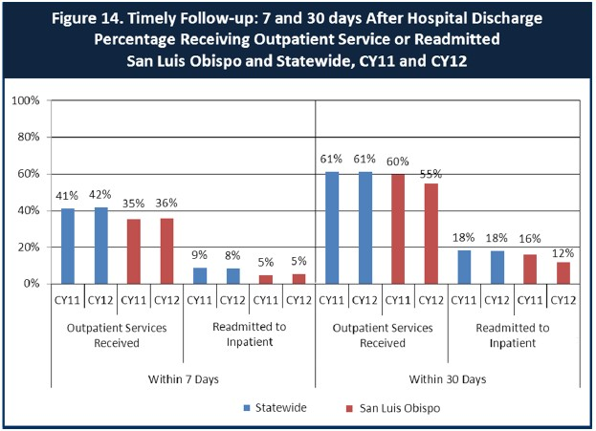

- Looking at the chart, is your county doing better or worse than the state? Discuss why (e.g., your county has programming available that specifically ensures a warm handoff for follow-up services).

Our numbers do not significantly vary from the statewide averages. As the state and county begin to recover from the recession, our county is taking steps to deliver outpatient services more quickly and reduce the frequency of readmissions. There is a warm handoff for follow up appointments from the PHF to the outpatient clinic to ensure continuation of medications, for new clients, and more robust coordination with outpatient staff for currently open clients.
There has been a long time staff vacancy in a discharge coordinator position charged with arranging and monitoring post discharge care. That position can now be filled.
We hope that long standing vacancies in psychiatrist positions may now be filled due to salary range increases. Setting appointments with a psychiatrist before a full assessment is completed will shorten the time between PHF discharge the first visit to the outpatient doctor.

- Do you have any suggestions on how your county can improve follow-up and reduce re-hospitalizations?

Recruitment and retention of qualified psychiatrists has been an issue in this county for some time. The county salary structure has not been competitive with the state hospital and the prison located in SLO County. Furthermore, the cost of housing is prohibitive for new psychiatrists with heavy student loan burdens. We applaud the recent increase by our Board of Supervisors to increase psychiatrist salary levels.
Also, we have achieved physician federal physician shortage status which will enable us to offer student loan forgiveness and visa extension opportunities to psychiatrists. We will soon enter our first contract for telepsychiatry services.

There is also better coordination with the Homeless FSP for post phf follow ups, as well as scheduled appointments with outpatient services prior to discharge.

- What are the three most significant barriers to service access? Examples:

  - Transportation
  - Child care
  - Language barriers or lack of interpreters
  - Specific cultural issues
  - Too few child or adult therapists
  - Lack of psychiatrists or tele-psychiatry services
  - Delays in service
  - Restrictive time window to schedule an appointment

In recent years, lack of bi-lingual therapists and interpreters, adult therapists and psychiatrists, has led to delays in service.

ACCESS BY UNSERVED AND UNDER-SERVED COMMUNITIES
One goal of the Mental Health Services Act (MHSA) is to reach unserved and underserved communities, especially communities of color. The MHSA promotes outreach to engage these communities in services. If individuals and families in these communities are not accessing services, then we may need to explore new ways of reaching them. Or, we may need to change our programs to meet their mental health needs in ways that better complement their culture.
From data the counties report to the state, we can see how many individuals living in your county are eligible for Medi-Cal, and of those individuals, how many received mental health services. Are you serving the Medi-Cal clients who need your services?

San Luis Obispo County Data:

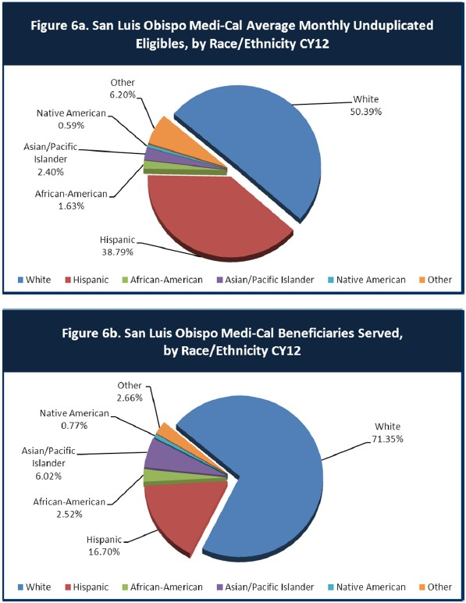

- Is there a big difference between the race/ethnicity breakdown on the two charts? Do you feel that the group(s) that need services in your county are receiving services?

There is a big difference in the breakdown on the 2 charts strongly suggesting a need to improve outreach and treatment for the county’s Hispanic population.
However, consumer satisfaction surveys completed by Spanish speakers served by the BHD reveal a very high level of satisfaction with the services received.

- What outreach efforts are being made to reach minority groups in your community?

For several years the county’s Latino Outreach Program has been limited by insufficient numbers of Spanish speaking staff, including clinicians. The improved economy permits the Department to recruit for bi-lingual staff and to train community members to serve as interpreters.
The County does an exemplary job of providing behavioral health services to foster youth and to veterans.

- Do you have suggestions for improving outreach to and/or programs for underserved groups?

Take advantage of Spanish language telepsychiatry services.

CLIENT ENGAGEMENT IN SERVICES
One MHSA goal is to connect individuals to services they need to be successful. Clients who stop services too soon may not achieve much improvement, nor is it likely to last. So it is important to measure not only who comes in for treatment, but also how long they stay in services. Here we are considering individuals with high service needs, not someone who just needs a ‘tune-up.’ Although not every individual needs the same amount of services, research shows that when someone with severe mental illness continues to receive services over time, their chances of recovery increase.
Engagement in services, also called ‘retention rate’, is important to review. If individuals come in, receive only one or two services and never come back, it may mean the services were not appropriate, or that the individual did not feel welcome, or some other reason that should be explored. Again, we recognize that some individuals only need minimal services, but here we are looking at those with severe mental illness. Ultimately, the goal is to ensure they are getting needed services and are on the road to recovery. But we would not know that unless we look at how many services individuals received over time.
The chart below shows the number of Medi-Cal beneficiaries in your county who received 1, or 2, or 3, or 4, or 5, or more than15 mental health services during the year. For individuals experiencing severe mental illness, the more engaged they are in services, the greater the chance for lasting improvements in mental health.

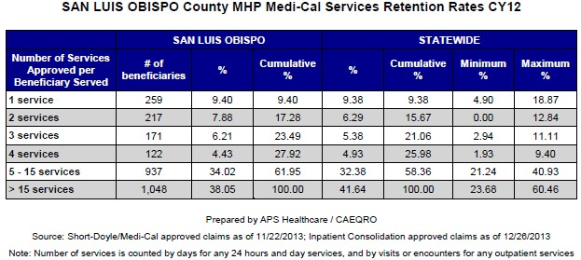

- Do you think your county is doing a good job at keeping clients engaged in services? If yes, how? If not, why?

There does not appear to be a substantive difference between the statewide statistics and those for our county. The data does not answer the question, “Are clients receiving what they need?” The next section on consumer satisfaction tries to answer that.

- For those clients receiving less than 5 services, what is your county doing to follow-up and re-engage those individuals for further mental health services?

- Looking at the previous chart of who is being served by race/ethnicity in your county, do you have any thoughts or ideas to share regarding your county’s engagement of underserved communities?

We need more bi-lingual staff and network provider resources.

CLIENT OUTCOMES: Consumer Perception Survey (August 2013)
Ultimately, the reason we provide mental health services is to help individuals manage their mental illness and to lead productive lives. We have selected two questions from the Consumer Perception Survey which capture this intention. One question is geared toward adults of any age, and the other is for children and youth under 18.
Below are the data for responses by clients in your county to these two questions.

For general comparison, statewide reference data for various sized counties are shown in the tables on page 19.
The total numbers of surveys completed for Adults or Children/Youth in your county are shown separately in the tables below, under the heading “Total.”

Q1. Adults. As a direct result of the services I received, I deal more effectively with daily problems.

 | Strongly Disagree | Disagree | Neutral | Agree | Strongly Agree | Total
Number of Responses | 3 | 4 | 19 | 57 | 60 | 143
Percent of Responses | 2.1 % | 2.8 % | 13.3 % | 39.9 % | 42.0 % | 100.0 %

Q2. Children/Youth. As a result of services my child and/or family received, my child is better at handling daily life.

 | Strongly Disagree | Disagree | Neutral | Agree | Strongly Agree | Total
Number of Responses | 2 | 0 | 10 | 36 | 27 | 75
Percent of Responses | 2.7 % | 0 % | 13.3 % | 48.0 % | 36.0 % | 100.0 %

- Are the data consistent with your perception of the effectiveness of mental health services in your county?

Yes.

- Do you have any recommendations for improving effectiveness of services?

--Develop a crisis stabilization resource.

--Continue efforts to integrate mental health and drug and alcohol services.

--Increase prevention services in the schools.

--Expand behavioral health services at the jail.

- Many counties experience very low numbers of surveys completed. Do you have suggestions to increase the response rate?

The survey format needs to be redesigned. Consumer organizations should be invited to participate in creating a user-friendly document. The practice of collecting consumer satisfaction data during only one week of the calendar year deserves reconsideration.

- Lastly, but perhaps most important overall, with respect to delivery of services, do you have suggestions regarding any of the following:

Specific unmet needs or gaps in services
- Improvements to, or better coordination of, existing services
- New programs that need to be implemented to serve individuals in your county.

See above.

<END>

REFERENCE DATA: for general comparison with your county MHP results

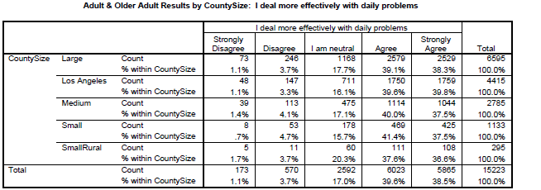

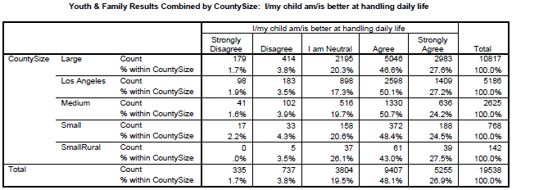

County Mental Health Plan Size: Categories are based upon DHCS definitions by county population.
- Small‐Rural MHPs = Alpine, Amador, Calaveras, Colusa, Del Norte, Glenn, Inyo, Lassen, Mariposa,
Modoc, Mono, Plumas, Siskiyou, Trinity

- Small MHPs = El Dorado, Humboldt, Imperial, Kings, Lake, Madera, Mendocino, Napa, Nevada, San Benito, Shasta, Sutter/Yuba, Tehama, Tuolumne

- Medium MHPs = Butte, Marin, Merced, Monterey, Placer/Sierra, San Joaquin, San Luis Obispo, San Mateo, Santa Barbara, Santa Cruz, Solano, Sonoma, Stanislaus, Tulare, Yolo

- Large MHPs = Alameda, Contra Costa, Fresno, Kern, Orange, Riverside, Sacramento, San Bernardino,
San Diego, San Francisco, Santa Clara, Ventura
- Los Angeles’ statistics are excluded from size comparisons, but are included in statewide data. Total Values (in Tables above) = include all statewide data received by CiMH for these survey items.

REMINDER:

Thank you for your participation in completing your Data Notebook report.

Please feel free to provide feedback or recommendations you may have to improve this project for the following year. We welcome your input.

Please submit your Data Notebook report by email to: DataNotebook@CMHPC.CA.GOV

Or, you may submit a printed copy by postal mail to:

  - Data Notebook Project

  - California Mental Health Planning Council

  - 1501 Capitol Avenue, MS 2706

• P.O. Box 997413

  - Sacramento, CA 95899-7413

For information, you may contact either email address above, or telephone: (916) 449-5249, or
(916) 323-4501

