San Diego County: Data Notebook 2018
for California
Behavioral Health Boards and Commissions
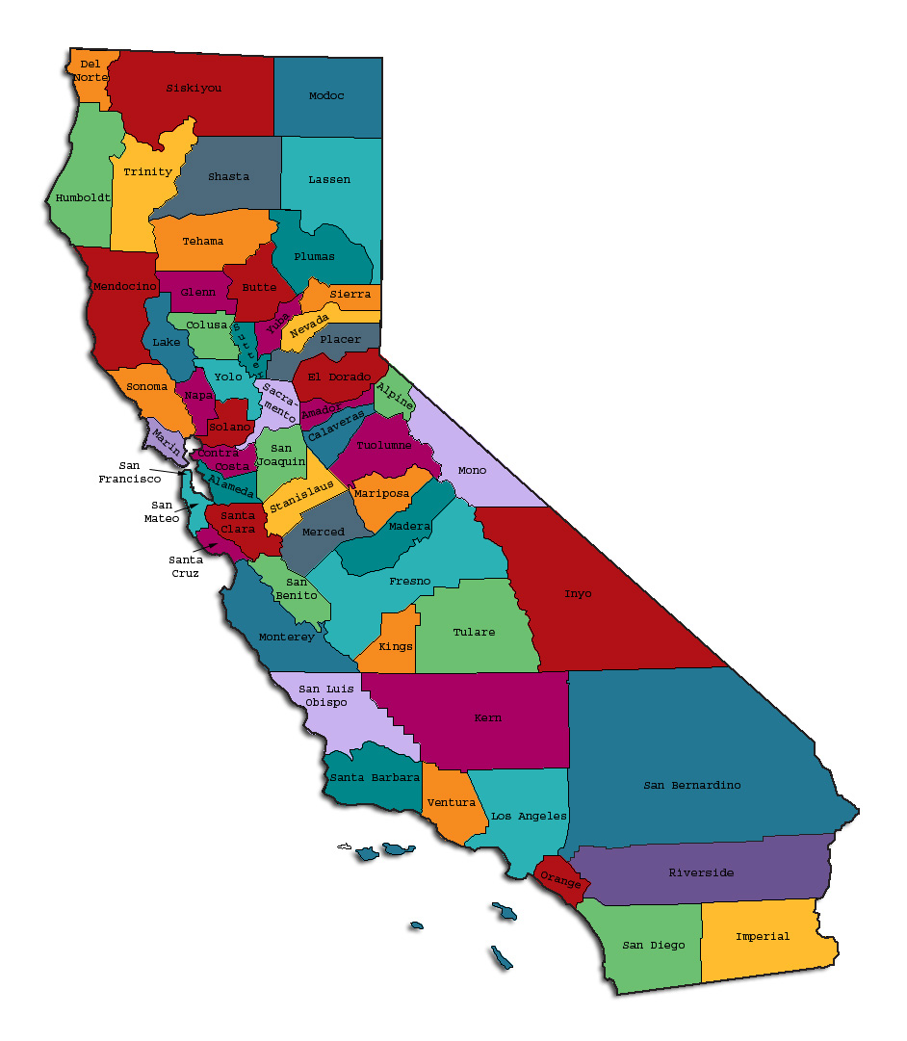
Prepared by California Behavioral Health Planning Council, in collaboration with: California Association of Local Behavioral Health Boards/Commissions
Introduction: Purpose and Goals

What is the “Data Notebook?”

The Data Notebook is a structured format for reviewing information and reporting on specific mental health services in each county. The goal of our 2018 Data Notebook is to survey types of services and needs in the behavioral health systems of care for children, adults, and older adults. This topic follows our yearly practice of focusing on different parts of the behavioral health system. However, this year we are taking a survey approach to collect data as the foundation for an overall needs review.

Local behavioral health boards/commissions are required annually to review performance data for mental health services in their county and to report their findings to the CBHPC. To provide structure for the report and to make the reporting easier, each year we create a Data Notebook for local behavioral health boards to complete and submit to the CBHPC. Afterward, the responses are compiled and analyzed by our staff to create a yearly report for policy makers, stakeholders and the general public.
The Data Notebook structure and questions are designed to meet important goals:
- To assist local boards to meet their legal mandates to review performance data for their county mental health services and report on performance every year,
- To serve as an educational resource on behavioral health data for local boards,
- To obtain opinion and thoughts of local mental health boards on specific topics,
- To identify unmet needs and make recommendations.

We encourage members of all local behavioral health boards to participate in reviewing and developing the responses for the Data Notebook. This is an opportunity for the local boards and their county behavioral health departments to work together to identify critical issues that are most important to your county. Your work will help inform county and state leadership plans for behavioral health programs.
We thank everyone for your interest and continued participation.
We are taking a somewhat different approach for the 2018 Data Notebook (DN). The 2018 DN does not include county-specific data but rather is a brief general survey about mental health services and needs in the counties to guide our advocacy in the coming year. It is anticipated that we will resume our practice of presenting county-specific data in the 2019 Data Notebook.

Your County: Evaluation of Services, Barriers to Access, and Unmet Needs
Below we ask a series of questions about the above services in your county regardless of fund source. We ask whether there are barriers to service access, unmet needs, or lack of continued or sustainable funding for a particular service or program.

- Please indicate (X) any service areas for which your county has identified that persons are substantially underserved or experience substantial unmet BH needs.
For each age Group: |  |  | Child | TAY (age 16-25) | Adult | Older Adult
(a) Pre-crisis and crisis services. |  |  |  | x | x | x
(b) Assessment
(c) Medication education & management
(d) Case management
(e) Twenty-four-hour treatment services |  |  |  | x | x | x
(f) Rehabilitation and support services
(g) Vocational services |  |  |  | x | x | x
(h) Residential services

- What are the major barriers to BH service access for persons who are in need of these services? Indicate any reasons; mark as many as apply.
For each age Group: |  |  |  |  | Child | TAY (age 16-25) | Adult | Older Adult
A: Lack of Program Funding |  |  |  |  |  | x
B: Lack specialized prof. expertise |  |  |  |  |  | x |  | x
C: Lack BH workforce/providers |  |  |  |  | x | x | x | x
D: Clients dispersed outlying areas |  |  |  |  | x | x | x | x
E: Transportation problems (bus, etc.) |  |  |  |  | x | x | x | x
F: Lack available appointment times
G: Fear government involvement
H: Linguistic needs (translation, etc.)
J: Culturally relevant needs |  |  |  |  |  |  | x | x
K: Other barrier, specify:____stigma_______ |  |  |  |  |  | x

- Please indicate (X) any areas for which your county has implemented new programs within the last 3 years.
For each age Group: |  |  | xChild | TAY (age 16-25) | Adult | Older Adult
(a) Pre-crisis and crisis services. |  |  | X | X | X | X
(b) Assessment |  |  | X | X | X | X
(c) Medication education & management |  |  | X | X | X | X
(d) Case management |  |  | X | X | X | X
(e) Twenty-four-hour treatment services |  |  | X | X | X | X
(f) Rehabilitation and support services |  |  | X | X | X | X
(g) Vocational services |  |  |  | X | X | X
(h) Residential services |  |  | x | x | X | x

- Indicate (X) whether any of the following services are funded with temporary (one-time, time-limited) funding for which you are seeking a sustainable fund source to continue services?
For each age Group: |  |  | Child | TAY (age 16-25) | Adult | Older Adult
(a) Pre-crisis and crisis services. |  |  | x | x
(b) Assessment |  |  | x | x
(c) Medication education & management |  |  | x | x
(d) Case management
(e) Twenty-four-hour treatment services
(f) Rehabilitation and support services |  |  |  | x | x | x
(g) Vocational services |  |  |  | x | x | x
(h) Residential services

- If you could have one new program or facility or resource within the next three years, what would be your highest priority need?
Please limit your response to 25 words or less.
One priority would be a fully-integrated data system to track client cases, health data, and coordinate between providers in order to improve care and inform decision-making. (25 words)

Mental Health Services Act (MHSA) Components
Background and Definitions of the MHSA (below) are excerpted from a description contained in the Executive Summary of a 2018 Report by NAMI California.
Proposition 63, the Mental Health Services Act, was passed by voters in 2004. At the time, California was struggling to meet the mental health needs of its residents. A 2003 report by the California Mental Health Planning Council estimated that as many as 1.7 million Californians were not receiving the mental health services they needed. As many as 80% of children with mental health needs were undiagnosed or unserved. The consequences of untreated mental illness were seen through health systems, school systems, and the criminal justice system. Therefore, the Act was designed to reduce homelessness, incarceration, and preventable hospitalizations, and to increase access to behavioral health services.

The Act imposes a 1% tax on personal income over $1 million and places revenues into the Mental Health Services Fund. Counties receive annual distributions from the Fund, and are responsible for providing community-based mental health services. Program expenditures align with the five core components of the Act:

Community Services and Support (CSS) is the largest component of the MHSA. The CSS component is focused on community collaboration, cultural competence, client and family driven services and systems, and wellness focus. This programming applies concepts of recovery and resilience, integrated service experiences for clients and families, as well as serving the unserved and underserved. Housing is also a large part of the CSS component. [Full Service Partnerships are another example of CSS-funded programs].

Prevention and Early Intervention (PEI) is intended to help counties implement services that promote wellness, foster health, and prevent the suffering that can result from untreated mental illness. The PEI component requires collaboration with consumers and family members in the development of PEI projects and programs.

Innovation (INN) projects aim to increase access to underserved groups, increase the quality of services, and promote interagency collaboration and increase access to services. Counties select one or more goals and use those goals as the primary priority or priorities for their proposed Innovation plan.

Capital Facilities and Technological Needs (CFTN) works toward the creation of facilities that are used for the delivery of MHSA services to mental health consumers and their families or for administrative offices. Funds may also be used to support an increase in peer-support and consumer-run facilities, development of community-based settings, and the development of a technological infrastructure for the mental health system to facilitate the highest quality and most cost-effective services and supports for clients and their families.

Workforce Education and Training (WET) is intended to develop a diverse workforce. Clients and families/caregivers are given training to help others by providing skills to promote wellness and other positive mental health outcomes. They work collaboratively to deliver client- and family-driven services, provide outreach and services that are linguistically and culturally competent and relevant, and include the viewpoints and expertise of clients and their families/caregivers.

The CSS, PEI and INN components are funded through ongoing revenue into the MHSA Fund. Per provisions of the MHSA, the Workforce Education and Training, Capital Facilities and Technological Needs components were initially funded up front in the early years and are not currently actively funded through MHSA revenues. Although counties can transfer some CSS funds for these purposes each year, essentially, the availability of that upfront funding for Workforce Education and Training, Capital Facilities and Technological Needs ended on June 30, 2018.

- Is there still a need for any of these three components in your county?
Yes_X No___.

If yes, please rank the following in priority order of need, #1 being highest.

__1__ Workforce Education and Training
__2__ Capital Facilities
__3__ Technological Needs

Optional: In 25 words or less, please specify what those needs are.

WET funding continues to be a need to address workforce challenges locally. Capital facilities can be especially valuable when leveraging other funding for building projects.
(25 words)

- Do you have a particularly successful program funded by CSS, Innovation, or PEI funds that you would like to share with us? Yes_X__ No___.

If yes, please describe briefly (maximum one paragraph, 150 words or less).

The County shifted CSS funds into Capital Facilities to finalize a building project in FY2017-2018: a multi-purpose facility in North San Diego County. This is especially noteworthy because the funds were leveraged with other local resources to open a center which will house behavioral health treatment and recovery services, as well as public health functions and a military and veteran component. Three distinct mental health programs will operate out of this new building, and there will also be a large conference room available for community use. Once fully operationalized, the facility will be a health hub where north county families can access multiple services and programs under one roof. This is an excellent use of funds because it allows the County to maximize return on expenditure instead of wasting money on overhead by operating multiple similar County services nearby. (140 words)

W.I.C. 5604.2, regarding mandated reporting roles of MH Boards and Commissions in California.
2018 MHSA County Programs: Services That Change Lives. A report created by NAMI California 2018, pages iii-iv. Downloaded from: https://static1.squarespace.com/static/5ab2d59489c1724bd8a2ca78/t/5b7de7d370a6adca27a8a959/1534978017856/NAMI+CA+2018+MHSA+Rept_072318_03_FINAL.pdf

