Overall, I am satisfied with the services my child received. (N=9)
78%
22%
0%
67%
11%
22%
57%
29%
14%
75%
13%
13%
75%
13%
13%
89%
11%
0%
63%
38%
0%
100%
0%
0%

I helped to choose my child's services. (N=9)

I helped to choose my child's treatment goals. (N=7)

The people helping my child stuck with us no matter what. (N=8)

I felt my child had someone to talk to when he/she was troubled. (N=8)

I participated in my child's treatment. (N=9)

The services my child and/or family received were right for us. (N=8)

The location of services was convenient for us. (N=9)

0% 20% 40% 60% 80% 100%

Services were available at times that were convenient for us. (N=9)
89%
11%
0%
75%
25%
0%
63%
38%
0%
89%
11%
0%
86%
14%
0%
100%
0%
0%
67%
33%
0%

My family got the help we wanted for my child. (N=8)

My family got as much help as we needed for my child. (N=8)

Staff treated me with respect. (N=9)

Staff respected my family's religious/spiritual beliefs. (N=7)

Staff spoke with me in a way that I understood. (N=9)

Staff were sensitive to my cultural/ethnic background. (N=6)

0% 20% 40% 60% 80% 100%

As a result of the services my child and/or family received:
Agree Undecided Disagree

My child is better at handling daily life. (N=9)
11%
11%
78%
0%
11%
89%
56%
11%
33%
0%
33%
67%
56%
11%
33%
0%
89%
11%
25%
38%
38%
75%
0%
25%
0%
13%
88%
63%
13%
25%
13%
13%
75%

My child gets along better with family members. (N=9)

My child gets along better with friends and other people. (N=9)

My child is doing better in school and/or work. (N=9)

My child is better able to cope when things go wrong. (N=9)

I am satisfied with our family life right now. (N=9)

My child is better able to do things he or she wants to do. (N=8)

I know people who will listen and understand me when I need to talk. (N=8)
I have people that I am comfortable talking with about my child's problem(s). (N=8)
In a crisis, I would have the support I need from family or friends. (N=8)

I have people with whom I can do enjoyable things. (N=8)

0% 20% 40% 60% 80% 100%

Is your child currently living with you? (N=8)

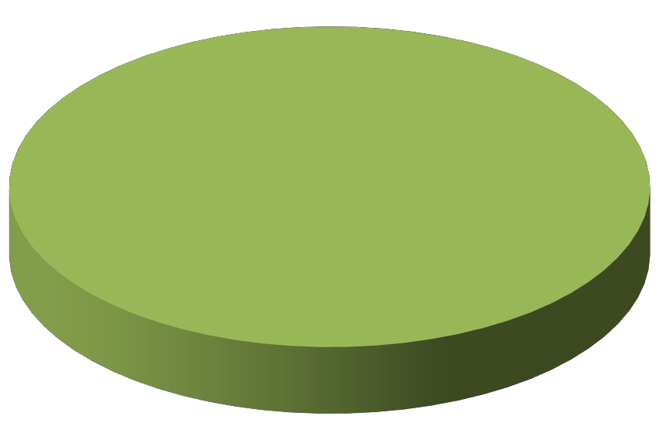Yes 8
100%

Has your child lived in any of the following places in the last 6 months? (N=4 Respondents)
(Respondents may choose multiple answers)

100%
80%
60%
40%
20%
0%

# Respondents
% Respondents
With one or both parents
3
75%
With another family member
1
25%
Total Respondents
4
100%

In the last year, did your child see a medical doctor (or nurse) for a health check-up or
because he/she was sick? (N=8)

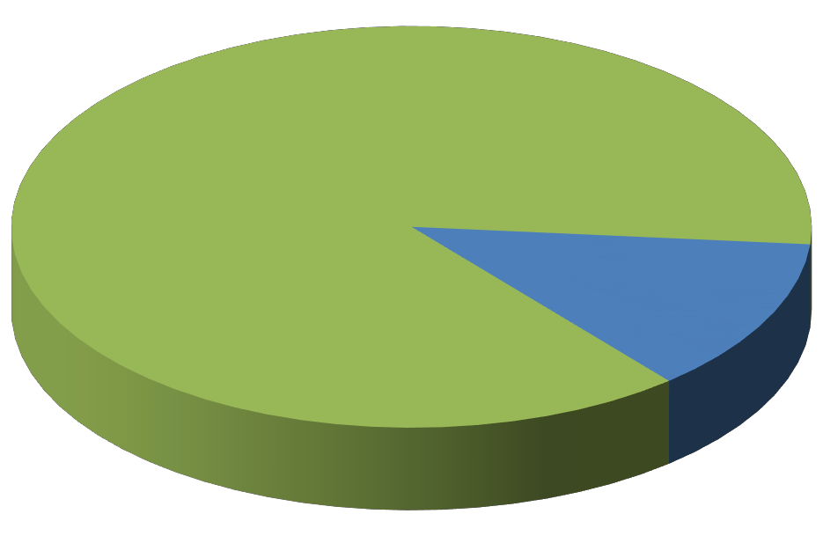Yes, in a clinic or office 7
87%

Do not remember 1
13%

Is your child on medication for emotional/behavioral problems? (N=8)

Is yes, did the doctor or nurse tell you and/or your child what side effects to watch for? (N=2)

Yes 2
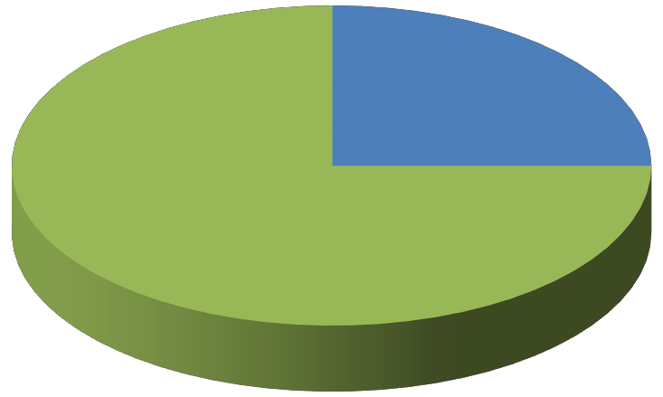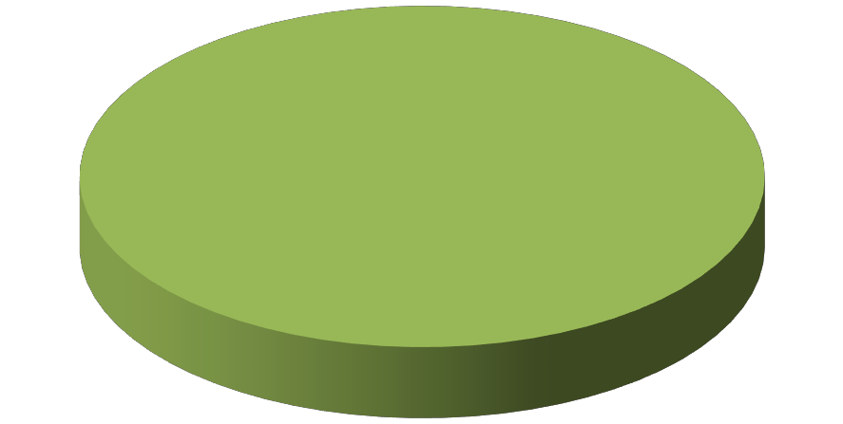25%
Yes
2
100%

No 6
75%

Approximately, how long has your child received services here? (N=8)

More than 1 year 3
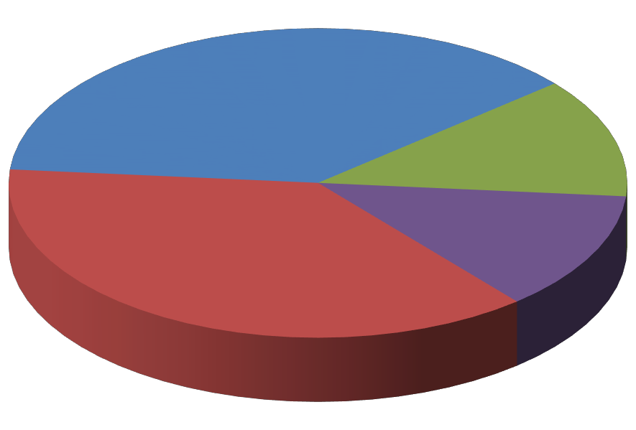38%

1 - 2 months
1
12%

6 months to 1 year
3
38%
3 - 5 months
1
12%

Was your child arrested since beginning to receive mental health services? (N=5)
Was your child arrested during the 12 months prior to that? (N=5)

No 5
100%
No
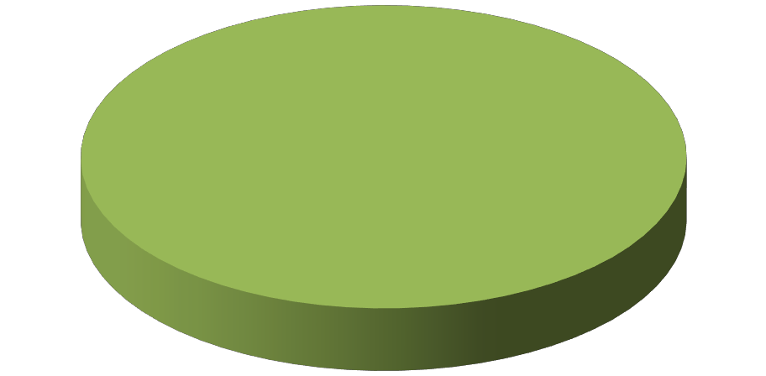5
100%

Since your child began to receive mental health services, have their encounters with the
police (reduced, same, increased, or N/A): (N=3)

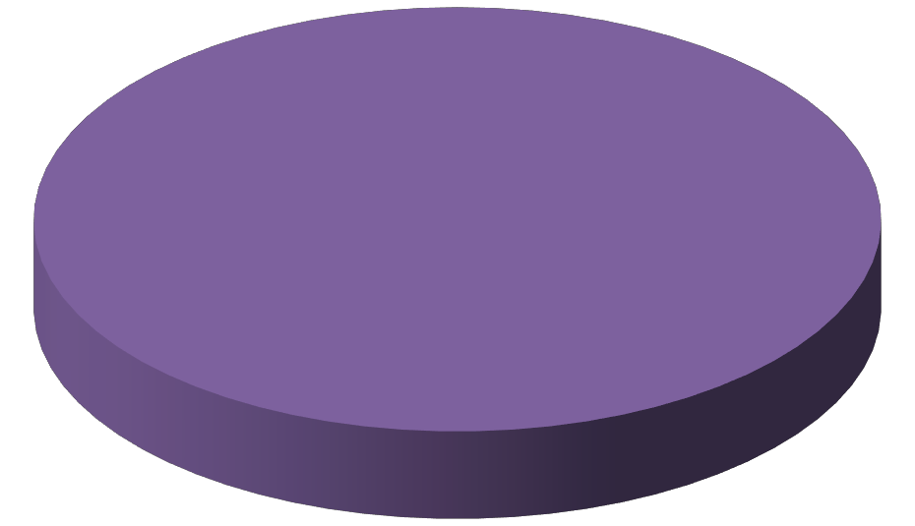
N/A 3
100%

Was your child expelled or suspended since beginning services? (N=5)

Yes 1
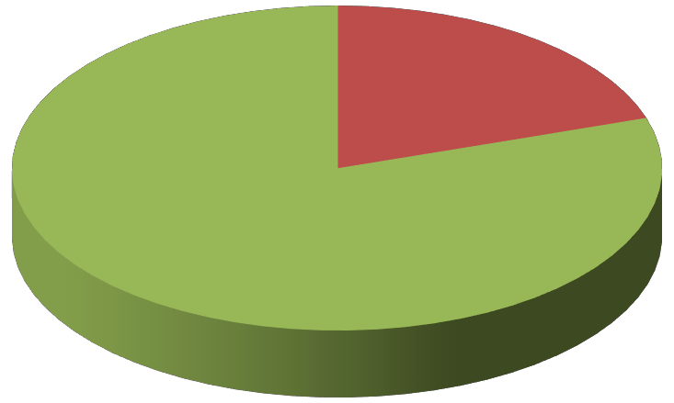20%
Was your child expelled or suspended during the 12 months prior to that? (N=5)

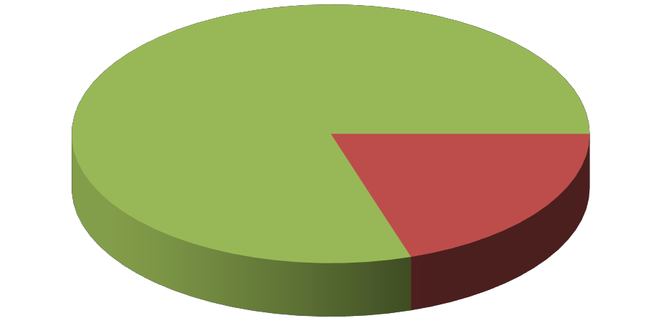No 4
No
4
80%
Yes
1
20%
80%

The one (1) respondent who was expelled or suspended since beginning services, was also expelled or suspended during the 12 months prior to that.

Since starting to receive services, the number of days my child was in school is
(greater, same, less, or N/A): (N=5)

About the same 1
20%
N/A: Child did not have a problem with attendance before starting services
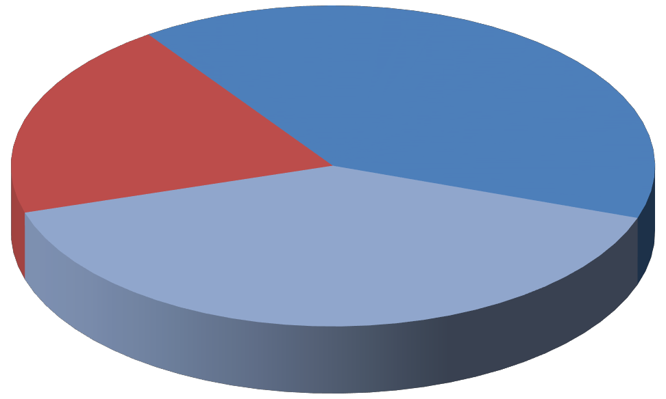2
40%

N/A: Child is home schooled
2
40%

Was your child arrested during the last 12 months? (N=3)
Was your child arrested during the 12 months prior to that? (N=3)

No 3
100%

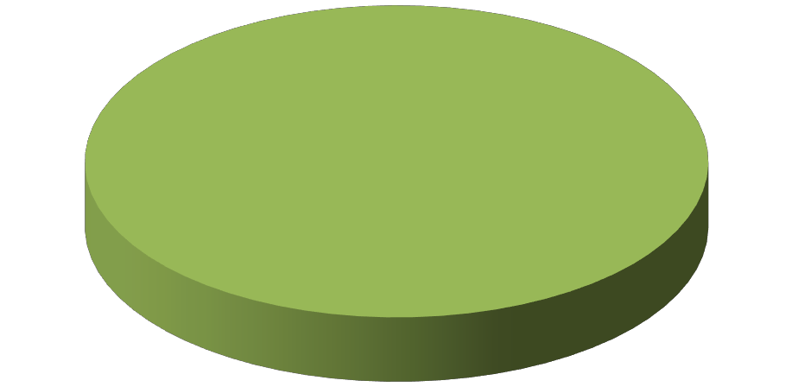No 3
100%

Over the last year, have your child's encounters with the police
(reduced, same, increased, or N/A): (N=3)

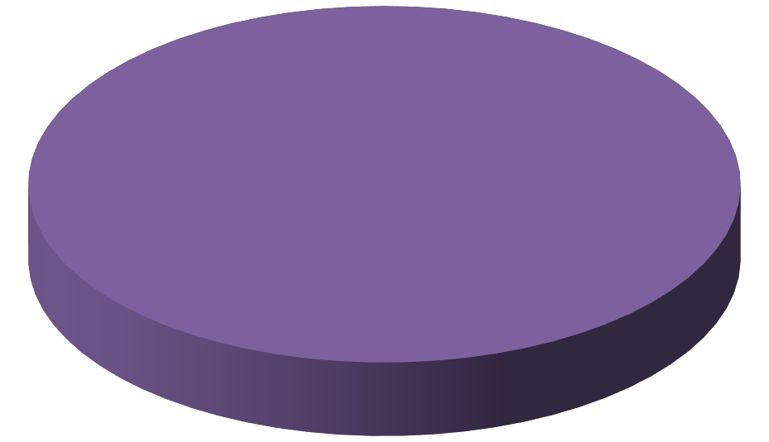N/A
3
100%

Was your child expelled or suspended during the last 12 months? (N=3)
Was your child expelled or suspended during the 12 months prior to that? (N=2)

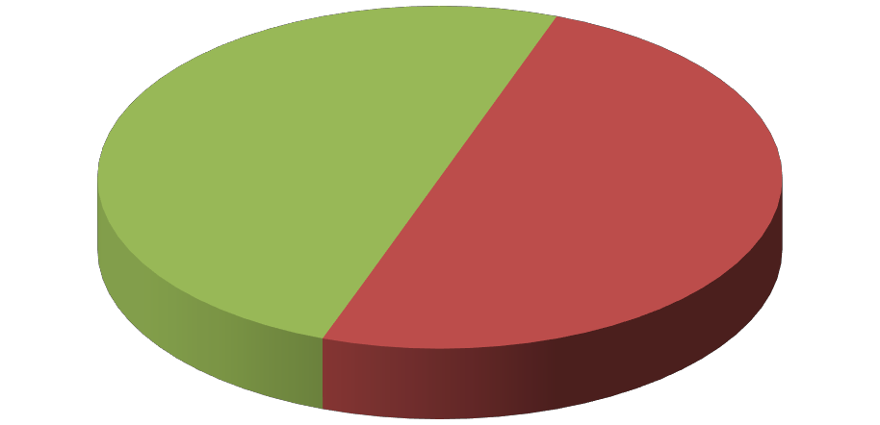No
No
1
50%
Yes
1
50%
3
100%

Over the last year, the number of days my child was in school is

(greater, same, less, or N/A): (N=3)

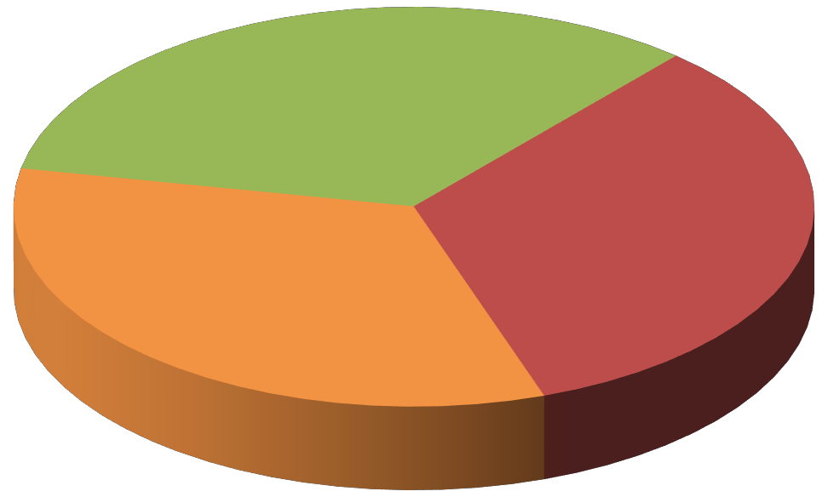Greater 1
34%

About the same 1
33%

N/A: Child did not have a problem with attendance before starting services
1
33%

Gender (N=9) Age (N=7)

Male 8
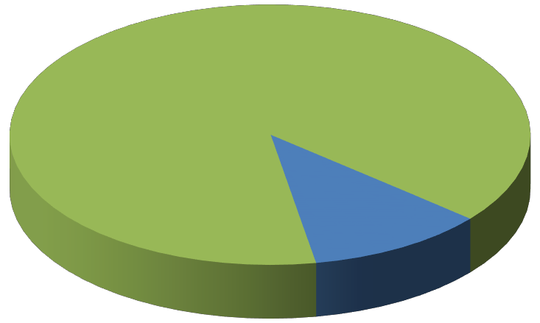89%
6 - 15 years
5
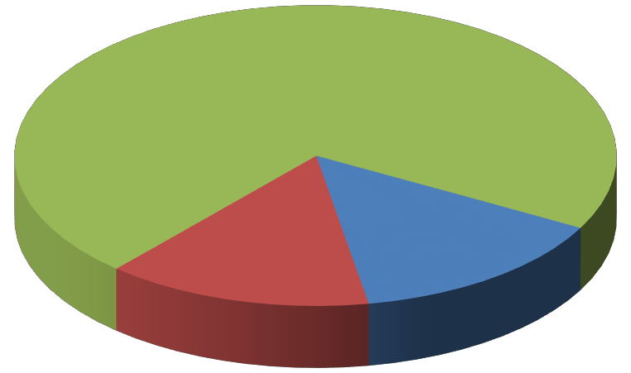72%

Female 1
11%

0 - 5 years
1
14%
16 - 25 years
1
14%

Mexican / Hispanic / Latino
(N=7) Race (N=8)

No
3
43%
Hispanic 4
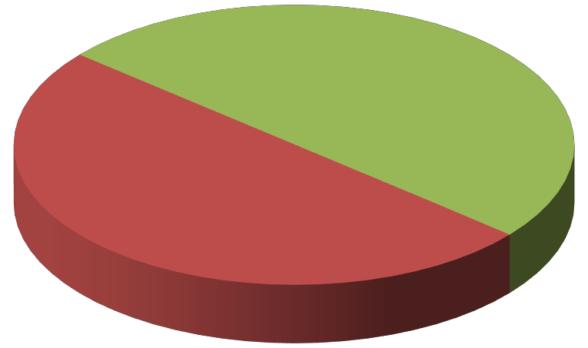50%

Yes 4
57%

White/ Caucasian 4
50%

Does your child have Medi-Cal (Medicaid) insurance? (N=8)

Yes 8
100%

Were the services your child received provided in the language he/she preferred? (N=8)
Was written information available to you in the language you prefer? (N=8)

Yes
8
100%
Yes 8
100%

Please identify who helped you complete any part of this survey. (N=8 Respondents)
(Respondents may choose multiple answers)

I did not need any help
My child's clinician/case manager helped me
Total Respondents
# Respondents
7
1
8
% Respondents
88%
13%
100%
100%
80%
60%
40%
20%
0%

