Sacramento County: Data Notebook 2019
for California
Behavioral Health Boards and Commissions
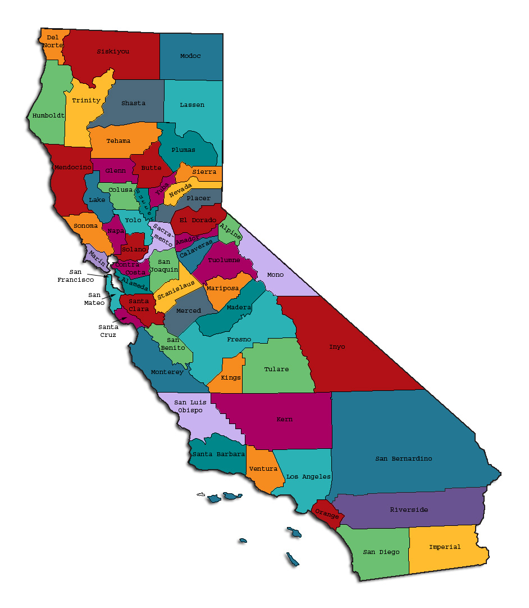
Prepared by California Behavioral Health Planning Council, in collaboration with: California Association of Local Behavioral Health Boards/Commissions
The California Behavioral Health Planning Council (Council) is under federal and state mandate to advocate on behalf of adults with severe mental illness and children with severe emotional disturbance and their families. The Council is also statutorily required to advise the Legislature on behavioral health issues, policies and priorities in California. The Council advocates for an accountable system of seamless, responsive services that are strength-based, consumer and family member driven, recovery oriented, culturally and linguistically responsive and cost effective. Council recommendations promote cross-system collaboration to address the issues of access and effective treatment for the recovery, resilience, and wellness of Californians living with severe mental illness.

Acknowledgements: Most of the trauma-informed care information and data presented in the following pages was drawn from several online sources for the purpose of public education. These sources included: www.cdc.gov, www.samhsa.gov, www.kidsdata.org, Center for Youth Wellness, and research studies of Vincent Felitti, M.D., Robert Anda, M.D. and associates (1998).
Table of Contents
County Data Page…………………………………………………………………………….. 5
Introduction: Purpose and Goals of the 2019 Data Notebook…………………………... 6
Standard Yearly Data and Questions for Counties and Local Advisory Boards……….. 7

- Rationale for these Monitoring these Data and Questions………..……………… 7
- Adult Residential Care Facilities …………………………………… ……………… 7
- Homelessness: Your County’s Programs and Services……………………………9
- Child Welfare Services: Foster Children in Certain Types of Congregate Care…11

Background and Context: Trauma-Informed Care across the Life Span………………..13
- What is Trauma and How Common is It?............................................................13
- Multiple, Complex, or Cascading Traumatic Events……………………………….14
- ACEs: Early Studies Linked Health Effects to Childhood Trauma……………….15
- Recent California Data Confirm Link of early Trauma to Health Outcomes...…. 17
- Focus on Trauma in Children and Adolescents…………………………………… 19
- Prevalence of ACEs in California’s Children………………………………………. 20
- What is Resilience?..............................................................................................21
- Trauma-Informed Care: The Basics………………………………………………….22
- Trauma-informed Programs Developed for Children and Families .……………. 23
- Conclusion………..…………………………………………………………………….24
Trauma: Focus Topic Discussion Questions for Boards/ Commissions……………….. 25

Informational Appendices: I, II, III………………….………………………………………...27

Questionnaire: How Did Your Board complete this Data Notebook? ...........................31

Reminder: Where to submit your Data Notebook before October 15, 2019…..………32

This page intentionally left blank.
Sacramento County
Population (2018): 1,534,893
Total Medi-Cal Eligible Beneficiaries (FY 2016-17): 621,119
Total Specialty Mental Health Service (SMHS) Recipients: (FY 2016-17): 22,520
Children and Youth, SMHS
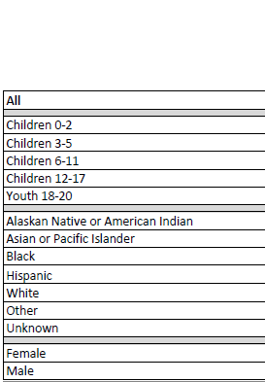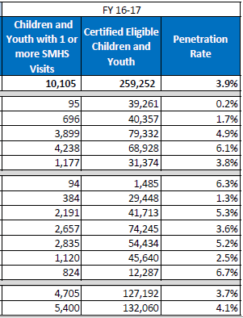
Adults and Older Adults, SMHS
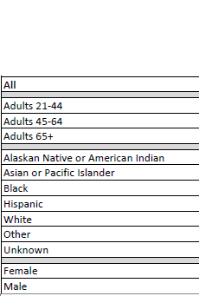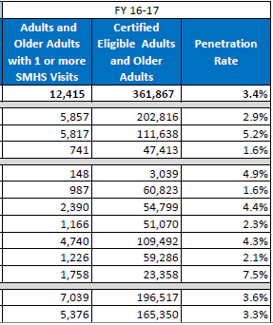
Introduction: Purpose and Goals: What is the Data Notebook?
The Data Notebook is a structured format to review information and report on each county’s behavioral health services. Recent practice has focused on different parts of the public behavioral health system each year, because the overall system is very large and complex. This system includes both mental health and substance use treatment services designed for specific age groups of adults or children and youth.

Local behavioral health boards/commissions are required to review performance outcomes data for services in their county and to report their findings to the California Behavioral Health Planning Council (CBHPC). To provide structure for the report and to make the reporting easier, each year we create a Data Notebook for local behavioral health boards to complete and submit to the CBHPC. Both statewide and county-specific data are provided for review. The discussion questions seek input from the local boards and their departments. These responses are analyzed by Council staff to create a yearly report to inform policy makers, stakeholders and the public.
The Data Notebook structure and questions are designed to meet important goals:
- To help local boards meet their legal mandates to review performance data for their county mental health services and report on performance every year,
- To serve as an educational resource on behavioral health data for local boards,
- To obtain opinion and thoughts of local board members on specific topics,
- To identify unmet needs and make recommendations.

The 2019 Data Notebook focus topic is an examination of behavioral health services and needs from a perspective of “Trauma-informed principles of care across the lifespan.” Understanding the role of childhood trauma reveals the urgent need for trauma-informed practices in all parts of the public behavioral health system.

This year the focus topic will comprise only part of the Data Notebook. We also have developed a section with standard data and related questions which will be addressed each year to help us detect any trends. Monitoring these trends will assist in identification of unmet needs or gaps in services, which may occur due to changes in the population, resources available, or public policy (i.e., eligibility criteria).

The Planning Council encourages all members of local behavioral health boards/commissions to participate in developing responses for the Data Notebook. This is an opportunity for the local boards and their county behavioral health departments to work together to identify the most important issues in their community. This work informs county and state leadership about local behavioral health programs, needs, and services. This information is used in the Council’s advocacy to the legislature and for input to the state mental health block grant application to SAMHSA.

Note that there are two sets of Discussion Questions. The first group are the standard yearly data questions. The second group, the Focus Topic Questions, are at the end of the Data Notebook, following the presentation on Trauma-informed Care.

Standard Yearly Data and Questions for Counties and Local Advisory Boards

In recent years, major improvements in data availability now permit local boards and other stakeholders to consult extensive Medi-Cal data online that is provided by the Department of Health Care Services (DHCS). These data include populations that receive Specialty Mental Health Services and substance use treatment. Related data are analyzed for yearly evaluations of county programs that are reported at www.CalEQRO.com. Additionally, Mental Health Services Act (MHSA) data can be found in the ‘MHSA Transparency Tool’ presented on the MHSOAC website.

However, members of the Planning Council would like to examine some county-level data that are not readily available online and for which there is no other accessible public source. The items of interest include data that are collected by the counties because they need to know how much they are spending in these service categories and for how many clients. Collecting this information will fill one gap in what is known about services that might be needed or provided in the course of a fiscal year (FY). And may help identify unmet needs in services.

Standard Annual Questions for the Data Notebook
Please answer these questions using information for fiscal year (FY) 2017-2018 or the most recent fiscal year for which you have data. Not all counties have readily available data for some of the questions. If so, please enter N/A for ‘data not available.’
Please note that a second group of Discussion Questions follows the Focus Topic, at the end of this Data Notebook.

Adult Residential Care Facilities
There is little publicly available data on the website of the Community Care Licensing at the CA Department of Social Services. This lack of information makes it difficult to determine how many of the licensed Adult Residential Care Facilities operate with services that would meet the needs of adults with chronic and/or serious mental illness (SMI), (and are willing to accept clients with SMI), compared to other adults such as those with physical disabilities, or who are developmentally disabled. There is a bill (AB 1766) before the legislature that would authorize and require the collection of data from licensed operators of adult residential facilities regarding how many residents have SMI, or whether these facilities have the services these clients would need to support their recovery or transition to other housing. The Planning Council supports this bill.

The Planning Council would like to understand what type of data are currently available at the county level regarding ARFs and Institutions for Mental Diseases (IMDs) available to serve individuals with SMI, and how many of these individuals (for whom the county has financial responsibility) are served in facilities such as ARFs or IMDs.

There are at least 250 licensed Adult Residential Care Facilities (ARF) in Sacramento County, according to the list on the CA Department of Social Services website.

- For how many individuals did your county pay some or all of the costs to reside in a licensed Adult Residential Care Facility (ARF), during the last FY? ___4____

- What is the total number of ARF bed-days paid for these individuals, during the last FY? ___489___

- Unmet needs: how many individuals served by your county need this type of housing but currently are not living in an ARF? _ To Be Determined __

- Does your county have any ‘Institutions for Mental Disease’ (IMD)?
___No. _X_Yes. If yes, how many IMDs? ___5___

- For how many individual clients did your county pay the costs for an IMD stay (either in or out of your county), during the last FY?
In-county:__2492__ Out-of-county: __147__

- What is the total number of IMD bed-days paid for these individuals by your county during the same time period? __17,634__

Homelessness: Your County’s Programs and Services
The Planning Council has a long history of advocacy for individuals with SMI who are homeless, or who are at risk of becoming homeless, or need assistance to transition to stable housing after a hospitalization or crisis residential stay. Within the last few years, the problem of homelessness has increased significantly, not only for those with SMI, but for large numbers of adults and children lacking resources for stable housing (for many different reasons). This increase has occurred in spite of greater resources allocated by public agencies to the problems of homelessness and affordable housing.
Studies indicate that approximately 1 in 3 individuals who are homeless also have serious mental illness and/or a substance use disorder. The Council does not endorse the idea that homelessness is caused by mental illness nor that the public behavioral health system is responsible to fix homelessness, financially or otherwise, but we know that recovery happens when an individual has a safe, stable place to live so we are interested in what types of things counties are doing. And because this issue is so complex and will not be resolved in the near future, the Council is planning to continue to track and report on the myriad of programs and supports the counties offer to assist individuals who are homeless and have serious mental illness and/or a substance use disorder and who would benefit from such programs.
Current news articles highlighted a recent surge in homelessness numbers in some counties and cities, based on analysis of data from “Point-in-Time” (PIT) counts taken in January of each year, including 2019, 2018, and 2017. From those numbers, local officials found the percent increases from 2017 to 2018, and from 2018 to 2019, to be quite startling, as outlined in New York Times articles in April and June, 2019.
The table on the next page shows the January, 2018 ‘Point in Time Count’ for the number of homeless in your county (or federally designated Continuum of Care, ‘CoC’) from the website at www.hud.gov. (For more information, see URL link in the footnote).

Table: Summary of Number of Homeless Persons in each Household Type, ‘CoC’ Region CA-503 (Includes Sacramento County)
SUMMARY of PERSONS in each TYPE of HOUSEHOLD | SHELTERED: in Emergency Shelter | SHELTERED:  In Transitional Housing | UNSHELTERED | TOTAL
Persons in Households without any Children | 785 | 282 | 2,035 | 3,102
Persons in Households with at least one adult >18 and at least one child<18 | 337 | 163 | 17 | 517
Persons in Households with only Children <18 | 2 | 0 | 0 | 2
Total Homeless Persons | 1,124 | 445 | 2,052 | 3,621

- During the most recent FY (2017-2018), what new programs were implemented, or existing programs were expanded, in your county to serve persons who are both homeless and have severe mental illness?
- _X_ Emergency shelter
- TLCS, Inc., New Directions
- ___ Temporary housing
- ___ Transitional housing
- _X_ Housing/Motel vouchers
- Consumer Self-Help Center, Wellness & Recovery Centers
- El Hogar Community Services, Inc., Guest House
- El Hogar Community Services, Inc., Regional Support Team
- Human Resource Consultants, Inc., Transitional Community Opportunities Recovery Engagement
- Sacramento Outreach Adult Recovery Program
- Telecare Corporation, Inc.
- TLCS, Inc., Human Resource Consultants
- TLCS, Inc., New Directions
- Turning Point Community Programs, Integrated Service Agency
- Turning Point Community Programs, Northgate Point
- Turning Point Community Programs, Pathways
- Visions Unlimited, Inc.
- _X_ Supportive housing
- Human Resource Consultants, Inc., Transitional Community Opportunities Recovery Engagement
- Sacramento Outreach Adult Recovery Program
- Telecare Corporation, Inc.
- TLCS, Inc., New Directions
- Turning Point Community Programs, Integrated Service Agency
- Turning Point Community Programs, Pathways
- ___ Safe parking lots
- _X_ Rapid re-housing
- Consumer Self-Help Center, Wellness & Recovery Centers
- El Hogar Community Services, Inc., Guest House
- El Hogar Community Services, Inc., Regional Support Team
- Human Resource Consultants, Inc., Transitional Community Opportunities Recovery Engagement
- Sacramento Outreach Adult Recovery Program
- Telecare Corporation, Inc.
- TLCS, Inc., Human Resource Consultants
- TLCS, Inc., New Directions
- Turning Point Community Programs, Integrated Service Agency
- Turning Point Community Programs, Northgate Point
- Turning Point Community Programs, Pathways
- Visions Unlimited, Inc.
- _X_ Adult residential care patch/subsidy
- Human Resource Consultants, Inc., Transitional Community Opportunities Recovery Engagement
- Sacramento Outreach Adult Recovery Program
- Telecare Corporation, Inc.
- TLCS, Inc., New Directions
- Turning Point Community Programs, Integrated Service Agency
- Turning Point Community Programs, Pathways
- ___ Other, please specify: ________________

- Optional: If your county (or CoC) has data for 2019, please enter that total number here: Point-in-time Count = 5,570 persons. If you compare that number to the total for 2018, you may determine the percent increase in homeless persons over one year: 19% (from the last point in time count, which was in 2017). This number may provide some indication of how much worse the problem is getting, and how quickly that change is taking place.
Child Welfare Services: Foster Children in Certain Types of Congregate Care
About 60,000 children, under the age of 18, in California are in foster care. They were removed from their homes because county child welfare departments, in conjunction with juvenile dependency courts, determined that these children could not live safely with their caregiver(s). Most children are placed with a family who receives foster children; however, a small number of the children necessitate a higher level of care and are placed in a Group Home.
California has had a long standing goal of moving away from the use of long term group homes, also known as congregate care, and are increasing youth placement in family settings. Assembly Bill 403, California’s Child Welfare Continuum of Care Reform, provided timelines and requirements to reform the foster care system including the reduction in reliance on congregate care as a long-term placement setting, AB 403 narrowly redefines the purpose of group care. Group homes are to be transitioned into a new facility type, Short-Term Residential Treatment Program (STRTP), which will provide short-term, specialized, and intensive treatment and will be used only for children whose needs cannot be safely met initially in a family setting.
A STRTP is a residential facility that provides an integrated program of specialized and intensive care and supervision, services and supports, treatment, and short-term 24-hour care and supervision to children. STRTPs are required to provide trauma-informed and culturally relevant core services, which include: specialty mental health services (SMHS); transition services; education, physical, behavioral, and extracurricular supports; transition to adulthood services; permanency support services; and Indian child services.
All of California’s counties are working toward closing long-term group homes and are establishing licensed STRTPs. This transition will take time and it is important for your board to talk with your county director about what is happening in your county for any children in foster care who are not yet able to be placed in a family setting or who are in a family setting and experience a crisis which requires short-term intensive treatment.
The following chart displays the count of children age 0-17 years in your county who were in a group home compared to a count of the children age 0-17 years who were in an STRTP at some time during that quarter. Note that it does not display point-in-time counts of children in a group home or STRTP on a particular day in the quarter. This measure looks at all children who were in a group home placement at some time during the quarter and all children who were in an STRTP placement at some time during the quarter as two separate populations. If a child was placed in one type of congregate care home but then was moved to a different type of facility during the quarter, then that child was counted once in each population group. These children are part of an extremely vulnerable population and the Council will be tracking them over the next several years.
Please examine the data below. If there were no children in a given category during that quarter, then a zero was entered. Blanks in the table mean that data were suppressed due to small numbers (<11 cases). Thus, some small population counties may have only, or mostly, blanks, indicating that “some” children were in those groups but not enough to safely depict.
Your county: Sacramento County
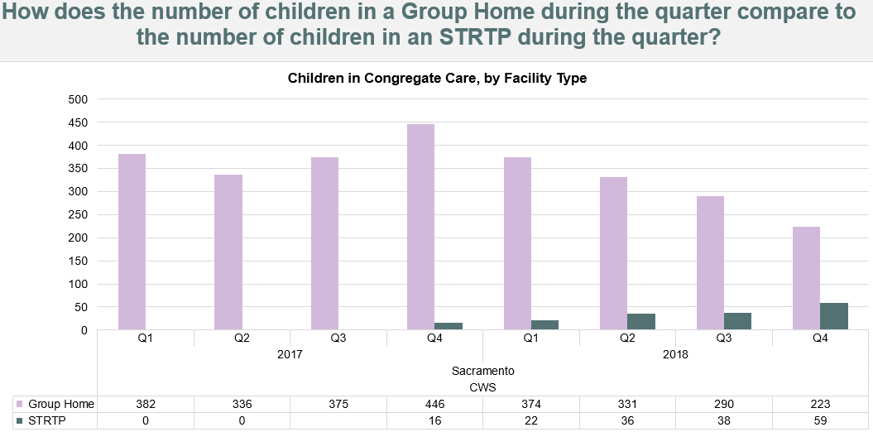

- Do you think your county is doing enough to serve the children/youth in group care? Yes__X___ No_____

- Specialty mental health resources are available to youth in group care.

- Any Medi-Cal eligible youth in group care can access specialty mental health services through the outpatient system if the group care setting does not provide services onsite.
If not, what is your recommendation? Please list or describe briefly (in 30 words or less). N/A
Many counties do not yet have STRTPs and are having to place children/youth in another county. Recent legislation (AB 1299) directs that the Medi-Cal eligibility of the child be transferred to the receiving county. This means, the county receiving the child now becomes financially responsible for his/her Medi-Cal costs.
- Has your county received any children from another county?
Yes ___X__ No_____. If yes, how many? __During calendar year 2018, Sacramento County received an average of 529 youth from another county per month, with a total of 6351 for the entire year.__

- Has your county placed any children into another county?
Yes ___X__ No ____. If yes, how many? __ During calendar year 2018, Sacramento County placed an average of 428 youth into another county per month, with a total of 5138 for the entire year.__

Background and Context: Trauma-informed Care across the Life Span
One goal of our 2019 Data Notebook is to examine behavioral health services and needs from the perspective of “Trauma-informed principles of care across the lifespan.” Our choice of this focus topic recognizes that childhood adversity and trauma contribute profoundly to an individual’s lifelong mental and physical health outcomes, and in turn, to the well-being of our families and communities.
What is Trauma and How Common is It?
- Experiences that cause ‘intense physical and psychological stress reactions.’
- Events that are physically and emotionally harmful or threatening and that cause lasting damage to a person’s physical, social, emotional, or spiritual well-being.’
- Many individuals report a single traumatic event, but ‘others--especially those seeking mental health or substance abuse services--have been exposed to multiple or chronic traumatic events.’
Why focus on trauma? Trauma is more prevalent in our society than many realize. In the U.S. general population, one survey (NSARC, 2012) found that 72% of adults reported witnessing a trauma, 31% experienced trauma due to injury, and one-sixth (17%) had experienced serious psychological trauma. Potential sources of trauma include natural disasters, accidents, interpersonal violence (domestic violence, rape, mass casualty events), and severe childhood maltreatment. (See Appendix I.) Some may experience post-traumatic stress disorder in the course of their work in military service, or as first-responders, providers of emergency healthcare or trauma therapy.
Regardless of cause, screening for psychological trauma is an essential first step to treatment, and can be performed with standard methods targeted specifically for adults, or for children and youth (See Appendix II for methods). Screening is now deemed so important that the state of California has designated specific funding for trauma screenings of all children and adults with full-scope Med-Cal (FY 2019-20).
Multiple, Complex, or Cascading Traumatic Events
- California is prone to multiple large-scale catastrophes, including fires, floods, landslides, droughts, and earthquakes.
- The primary trauma can lead to secondary losses of home, school, work, and neighborhood relationships, in a cascading sequence of loss and displacement.
- CA residents may experience consecutive and/or simultaneous natural disasters, in a pattern without time for healing from one event before another occurs.
- The mobility of our population can result in a lack of supportive relationships or resources. This lack compounds the vulnerability to trauma and delays recovery.

- Finally, when faced with new disasters, adults who experienced early life ‘adverse childhood experiences’ (ACEs) may find it much more challenging to recover and be resilient in the face of new trauma.

The concept of multiple or complex trauma is particularly important in the discussion of childhood trauma, because children may experience repeated traumatic events, multiple types of trauma, or chronic circumstances of profound neglect or deep poverty. Substantial research indicates that severe trauma, early in life, has the potential to create a level of stress that is toxic to the developing brains of young children.
The implementation of basic trauma-informed practices can help organizations provide more sensitive, respectful, and effective health care and to avoid triggers of emotional distress. Therefore, this report will include some trauma-informed practices. Briefly, trauma-informed care involves a model of care intended to promote healing and reduce risk for re-traumatization. Avoiding re-traumatization largely depends on how individuals and organizations interact with the traumatized person from initial point of contact and throughout diagnosis, screening, and the provision of care.
Next, having acknowledged the larger issues of human trauma, this Data Notebook will focus primarily on the effects of childhood trauma because of the greatly increased risks for mental illness, substance use disorders, and other social and health/medical outcomes. Knowledge about the origins and consequences of childhood trauma may yield information about how to reduce its incidence, causes, and consequences.
ACEs: Early Studies Linked Health Effects to Childhood Trauma
Several types of childhood trauma, hardship, and adversity are studied by researchers. Many of these studies build on the foundation laid by Dr. Vincent Felitti of Kaiser Permanente in San Diego and Dr. Robert Anda of the Center for Disease Control and Prevention (1998). They collected data from over 17,000 adult patients of Kaiser Permanente in the San Diego area.
These researchers found that a specific subset of traumatic childhood experiences were highly correlated with later life physical and mental health problems. They defined these traumatic experiences as “adverse childhood experiences (ACEs).” This research was the largest epidemiological study of its kind ever done to examine the health and social effects of ACEs over the lifespan. They further developed a way to categorize and determine scores for ACEs that showed a relationship to later outcomes.
There are three major categories of defined ACEs: abuse, neglect, and household dysfunction. Within these three categories are ten types of ACEs, as follows.
- Abuse: includes physical, emotional and sexual abuse
- Neglect: includes physical and emotional neglect
- Household Dysfunction: includes having a family member with: serious mental illness, substance abuse disorder, or who is incarcerated, or experiencing domestic violence, or divorce.
These adverse events were used for the basis of the “ACEs Score.” The ACE Score for each individual is determined by answering 10 questions regarding events experienced in their life prior to the age of 18 years.
In this original ‘Adverse Childhood Experiences Study’ (1998), the majority of participants were white (74.8%), middle class, had health insurance, and had achieved a college-level education (75.2%) or more. Almost two-thirds (63.9%) had experienced at least one adverse childhood experience. One in eight people (12.5%) had four or more ACEs. Clearly, for the middle class population in this study, the percentages of people who had experienced at least one or more ACE may seem surprisingly high. But these experiences were remarkably common.
The ACE Study also found that ACEs are highly interrelated – where there is one ACE, there are likely others. So, it didn’t make sense to study one category of adversity at a time. It made more sense to study the accumulation of ACEs– so the scientists made a simple score. Each type of ACE adds to the total ACE Score – from experiencing zero ACEs to experiencing all ten ACEs. ACE scores in the study ranged from 0 to 10. So even if a person experienced several different experiences of physical abuse, say spanking or kicking or blows to the head, this is counted as one ACE, that of physical abuse. The separate examples or events physical abuse do not yield any kind of cumulative score, and this was an arbitrary choice made by the researchers to find some kind of way to analyze what could otherwise be a complex data set.
Remarkably, the data showed a strong dose-response relationship between ACEs and poor health and life outcomes. As the number of ACEs increased, the risk of negative health outcomes also increased. Later studies discovered that the life expectancy of a person with six or more ACES is 20 years shorter than for someone with zero ACEs.
These results led to a new way of thinking about the connection between childhood and adult health. They found that ACE scores directly correlated with the population health. The data showed that, compared to those with zero ACEs, individuals with ACE scores of 4 or more were likely to have exhibited these high-risk behaviors:
- more than twice as likely to be smokers,
- 7 times more likely to alcoholic,
- 10 times more likely to have injected street drugs, and
- 12 times more likely to have attempted suicide.
In addition, ACEs increased the risk for serious health conditions. The data showed that, compared to those with zero ACEs, individuals with 4 or more ACEs were:
- 2.4 times as likely to have a stroke,
- 2.2 times as likely to have ischemic heart disease,
- 1.9 times as likely to have cancer, and
- 1.6 times as likely to have diabetes.
Those were very serious outcomes documented in that largely white, middle-class San Diego area population studied by Drs. Felitti and Anda. Those findings raised important questions about the effect of early life experiences on lifelong health.
But what are the results when those early studies are compared to more recent data about the economically diverse populations of the state of California as a whole? Key differences were that significant numbers of our residents lived in poverty, lacked health insurance, had poor access to healthcare, and worse outcomes.
Recent California Data Confirm Link of early Trauma to Health Outcomes
Recent statewide data (2008-2013) show that the prevalence of ACEs is relatively consistent across race and ethnic groups in the state. However, high numbers of ACEs do correlate with a person’s poverty, lack of education and/or unemployment. When compared to someone with no ACEs, data show that a person with 4 or more ACEs is:
- 21% more likely to be below 250 percent of the Federal Poverty Level (FPL),
- 27% more likely to have less than a college degree,
- 39% more likely to be unemployed,
- 50% more likely to lack health insurance (and more likely to delay seeking care).
Using this recent statewide data, what percentage of California adults recalled one or more ACEs from their childhood, regardless of household type? The data below show that 45% had 1-3 ACEs, and almost 16% (or one-sixth) had 4 or more ACEs.
TABLE: Adult Retrospective Data (2008-2013), from www.kidsdata.org
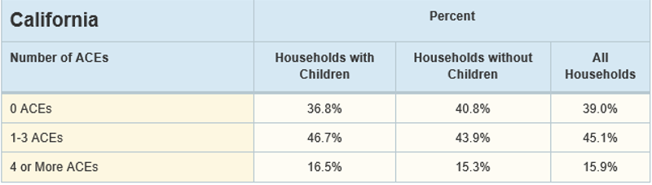
What is the prevalence of ACEs for adults in your county?

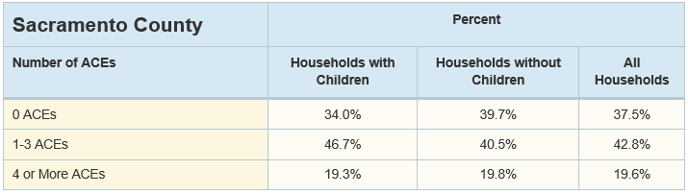

Adult retrospective data are shown above. “Retrospective surveys,” are those in which adults were asked about their life experiences prior to age 18, for example. Take note of the average percent taken from adults in all households (regardless of whether the adult resides in a household with, or without, any children). (LNE means data are suppressed due to a ‘low number event.’)

In some counties, over 75% of residents have at least one ACE. Even in counties with the lowest prevalence of ACEs, 50% had one or more adverse experiences in childhood. If the statewide numbers are very different from your county data, you may wish to explore potential contributing factors. Contributory factors could include poverty, unemployment, lack of education, high rates of child maltreatment or substance abuse, among other possible reasons. However, causes might not be readily identifiable.

Furthermore, the ranking of which ACEs were most common varies among adults in different counties. However, based on statewide data for adults, the most common ACE is emotional abuse. The most common ACEs among California adults are reported as follows (Behavioral Risk Factor Surveillance Survey data, 2008-2013):
- Emotional or verbal abuse: 34.9%
- Parental separation or divorce: 26.7%
- Substance abuse by household member: 26.1%
- Physical abuse: 19.9%
- Witness to domestic violence: 17.5%
- Household member with mental illness: 15.0%
- Sexual abuse: 11.4%
- Physical or emotional neglect: 9.3%
- Incarcerated household member: 6.6%.

ACEs affect every community in California, urban and rural, “regardless of geography, race, income, or education.” A marked percentage of adults has experienced four or more ACEs, a score that confirms a strong correlation with serious health conditions. Some health outcomes include increased lifetime risks for asthma, arthritis, and any cardiovascular disease. Specifically, adults in California with 4 or more ACEs are:
- 2.4 times as like to have chronic obstructive pulmonary disease (COPD),
- 1.9 times as likely to have asthma
- 1.7 times as likely to have kidney disease, and
- 1.6 times as likely to have a stroke.

Most importantly, behavioral health challenges in adulthood have a long association with ACEs. In California, when compared to a person with no ACEs, the data show that a person who has experienced four or more ACEs is:
- 5.1 times as likely to have depression,
- 4.7 times as likely to seek help from a mental health professional,
- 4.2 times as likely to be diagnosed with Alzheimer’s disease or dementia,
- 3.2 times as likely to engage in binge drinking,
- 2.5 – 3.0 times as likely to have mental, physical, or emotional conditions that cause difficulty in concentrating, remembering, or making decisions.
Taken together, the findings of these studies strengthen our understanding that ACEs are common, and that ACES have a strong cumulative impact on the risk of common physical and mental health problems. The results of these adult retrospective studies, where adults were asked about their experiences prior to age 18, help us to recognize the consequences of childhood trauma, and highlight the urgency of providing early screening and treatment for trauma, at every stage of a person’s life.
There is a large variety of treatments commonly utilized for adults who have experienced trauma, and there are more therapeutic approaches being developed all the time. Depending on whether a history of trauma occurs with other clinically important issues, different types of therapy may be adapted or combined to meet the individual’s current needs.

Focus on Trauma in Children and Adolescents
The ACEs Neurodevelopmental Model proposed that ACEs disrupt early brain development, which in turn leads to social, emotional, and cognitive adaptations that can then lead to the risk factors for major causes of disease, disability, social problems, and early death. Since the time of the original ACE Study, breakthrough research in developmental neuroscience showed that the hypothesis of the ACE Study is biologically sound, i.e., that the developing brain is affected by toxic stress. These studies are important because what is predictable is preventable. Preventing ACEs and their intergenerational transmission is the greatest opportunity for improving the health and well-being of our population.
Abundant data demonstrates that trauma in children and youth are linked to a variety of adverse outcomes in behavioral health, physical health and negative life outcomes. Key factors include the larger community environment and the effects of parental hardship, poverty, violence and a general lack of resources. Those resources and needed supports may not be present in a child’s family life. Many researchers and clinicians have found that adverse community environments are fertile ground for adverse childhood experiences (ACEs). (See illustration below).
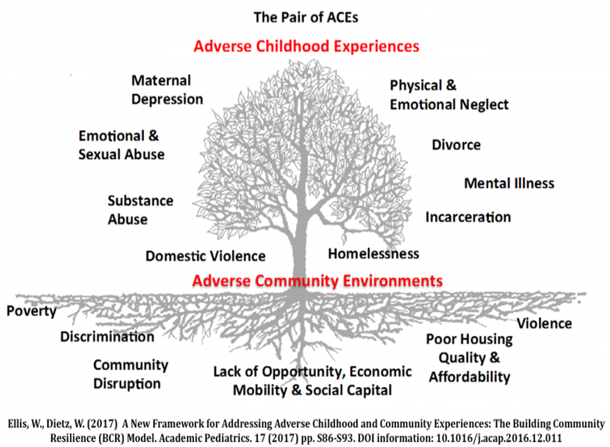

Prevalence of ACEs in California’s Children
Compared to the retrospective adult data described earlier, we want to examine what the data show for how common are ACEs in today’s children? This type of data is collected from questions asked of a parent about their children’s experience of hardships that correspond to ‘ACEs’. These 2016 data show that an estimated 16.4% of California children had experienced two or more adverse experiences.
Your county:
Sacramento County: 16.5% of children have experienced two or more adverse experiences.

Most county data are similar to those indicating that approximately one-sixth of California children (or 16.4%) have experienced two or more hardships (or ACEs). These findings further support the need to implement trauma-informed care in every school or agency or healthcare provider that touches the lives of children.
In particular, foster youth experience many stressors, many emotional losses, and are challenged to constantly make new adaptations to sudden changes in placements, often with corresponding changes in their assigned school. Foster youth are a vulnerable group that receive specific attention in county departments of child welfare and behavioral health. There are now legal requirements for early and prompt screenings and referral to address identified mental health needs. Foster youth are a key demographic in need of trauma-informed care as they interact with multiple agencies.
What is Resilience?
“Resilience is an adaptive response to hardship, and can mitigate the effects of adverse childhood experience. It is a process of adapting well in the face of adversity, trauma, threats, or other significant sources of stress.”
“Resilience involves a combination of internal and external factors. Internally, it involves behaviors, thoughts, and actions that anyone can learn and develop. Resilience is strengthened by having safe, stable, nurturing relationships and environments within and outside the family.”
Resilience is most simply described as a quality linked to recovery and the ability to heal and adapt. Research data can be obtained from mothers who were asked about their child’s behaviors when confronting a challenge or stressful experience: “Is your child usually able to stay calm and in control when faced with a challenge?” And the answer is either yes or no.
The estimated percentage of children in California (2016) who are ‘resilient’ (using that definition) is 52.4%. Examples of county data range from 50.8% to 53.2%. Data for the largest 40 counties can be found at KidsData.org.

Your data for Sacramento County: show that 52.3% of children are ‘resilient;’ that is, they stay calm and in control when faced with a challenge (as reported by parent).

Trauma-Informed Care: The Basics
Trauma-informed care describes a variety of approaches that acknowledge the impact of trauma. Programs and organizations that use a trauma-informed approach may not necessarily treat the consequences of trauma directly, but instead train their staff to interact effectively with participants who have been affected. Approaches include supporting participants’ natural coping skills and the use of appropriate behavior management techniques. The desired outcomes are to help young people develop resilience and the ability to deal with difficulties. These methods are increasingly used in systems and settings that involve young people and their families.
Schools are a frontline for meeting children and youth with trauma, in that chronic or acute home stressors may lead to problems in attention, behavior, or actions. There are excellent programs that change a school’s focus from discipline to a trauma-informed approach, with one goal being to help children find their own inner calm or strength. The results of implementing such programs have dramatically reduced the number student suspensions in those schools.
An example of one very important trauma-informed approach that interfaces between the school and first-responders is the FOCUS model, where ‘FOCUS’ stands for ‘Focusing on Children Under Stress.’ Most communities refer to the program as ‘Handle With Care.’ This is a program brought into being to respond when a child is witness or a victim of traumatic events in a child’s home or neighborhood. First responders notify the school that the child is under stress and needs a ‘focus on the child and handle them with care’ approach.
Trauma-informed Programs Developed for Children and Families
One of the most important things to address in discussions of trauma and childhood adversity is to ask: what are some of the positive, prevention-oriented, or problem-solving ways that we can address these issues? Different categories for trauma-related interventions for children have been designed for every stage of growth and development, as shown in the following figure.
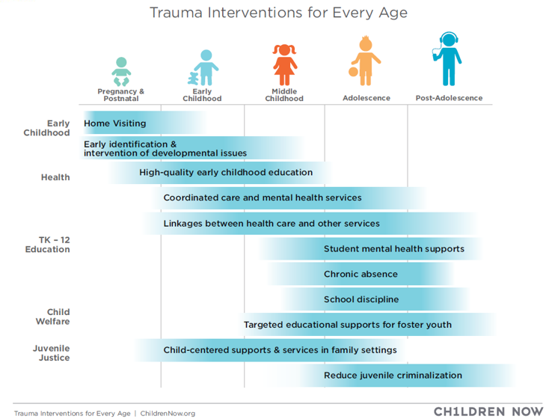

The next table lists specific programs developed for children and families. These examples are evidence-based practices rooted in the principles of trauma-informed care. These programs are common in California and it is important to publicize those that are found in your community. Often, parents may not be aware of the resources available to help them learn about parenting skills and strategies.
Evidence-Based Practices for Children and Families: Some Examples
40 Developmental Assets: are a set of skills, experiences, relationships and behaviors that enable young people to develop into thriving adults. The Search Institute developed many training materials focused on these ‘40 Developmental Assets.’

Strengthening Families has a framework that is based on engaging families, programs and communities in building five protective factors:
- Parental resilience.
- Social connections.
- Knowledge of parenting and child development.
- Concrete support in times of need.
- Social and emotional competence of children.

Help Me Grow is a new program that will give parents the opportunity to complete a developmental assessment of their child and provide support and resources for their child if any problems are identified.

Triple P is a multi-level program for children and teenagers that provides parents with training on assertive discipline and child development.

First 5 California and the First 5 county organizations provide leadership and funding for necessary programs specific to children pre-natal to 5 years of age and their families. Since 1998, First 5 CA has worked to improve the lives of children and families with the vision that California’s children will receive the best possible start in life and thrive.

In conclusion, trauma-informed care promotes resilience and health for families, communities, and public health. Resilience, in a broader sense, originates from buffers in communities and families to protect individuals from the accumulation of toxic stress due to ACEs and other types of trauma. The long-term goal is to instill trauma-informed principles of care in all systems, i.e., healthcare, social services, schools, child welfare/juvenile justice and criminal justice. Cross-system collaboration is important because many persons with serious mental illness and/or substance use disorders are served by multiple systems. For many, the experience of early trauma plays a causative, contributory, or aggravating role in their present difficulties.

Trauma-informed care: Discussion questions for local boards/commissions.
- Has your behavioral health board/commission received information or training on trauma-informed practices and/or the need for such?
____ Yes __X__No

However, the following information was presented. At the March 2018 Public Hearing, conducted by the Mental Health Board regarding the Mental Health Services Act Fiscal Years 2017-20 Three-Year Plan, community members commented regarding an observed gap in services to address trauma experienced in the African American community. In response, a community planning process was convened to gather feedback from the African American community and provide recommendations for a new prevention program to address mental health and wellness needs of African American community members who have experienced or have been exposed to trauma.
At the October 2018 Mental Health Board meeting, a policy brief presentation was given by the My Brother’s Keeper Sacramento Youth Fellowship. This presentation provided local statistic of traumatic events affecting teen African American males and real life examples of traumatic events experienced by teens as well as examples of support that helped them overcome trauma they experienced.

If yes, what type of information/training was it? Please state or list briefly:

- Is your county currently implementing trauma-informed practices for youth? __X__ Yes ____ No For adults: __X__ Yes ____ No
If yes, what evidence-based practices for trauma-informed care are being used in your county? Please state or list briefly: Sacramento County uses trauma-informed practices for both children and adults. Assessments screen for types of trauma and providers utilize trauma-informed practices along with trauma-specific interventions according to the type of trauma and related symptoms. These include the following: Trauma-Focused Cognitive Behavioral Therapy (CBT), Seeking Safety, Parent-Child Interaction Therapy, Alternatives for Families CBT, and Dialectical Behavior Therapy.

- Are you aware of service areas in your county that are not using trauma-informed practices that should be doing so? _____Yes __X__ No
If yes, please identify those service areas briefly below.
___ Schools
___ First responders
___ Child Welfare Services
___ Juvenile Detention Facilities
___ Jail (Adults)
___ Other criminal justice system services, please specify: __________________.
___ Un-served or underserved cultural groups, please specify: _______________.
___ Other, Please specify: ________________.

- If you recommend the expansion of trauma-informed practices in your county for youth and/or adults, what are your top three priorities for services (or programs) for each age group?
Priorities for Children/Youth services, please state or list briefly:
1.___________ Services to ages 0-5__________________
2.___________ Prevention & Early Intervention services for all youth_________
3.___________ Crisis continuum services for all youth__________________
Priorities for Adult services, please state or list briefly:
1.____________Prevention & Early Intervention services_________________
2.____________Crisis continuum services_________________
3.____________Trauma-Informed Training_________________
Priorities for Older Adult services, please state or list briefly:
1.____________Prevention, Suicide Prevention, and Outreach services______
2.____________Crisis continuum services_________________
3.____________Trauma-Informed Training_________________

Appendix I. Types of Trauma. (per SAMHSA).

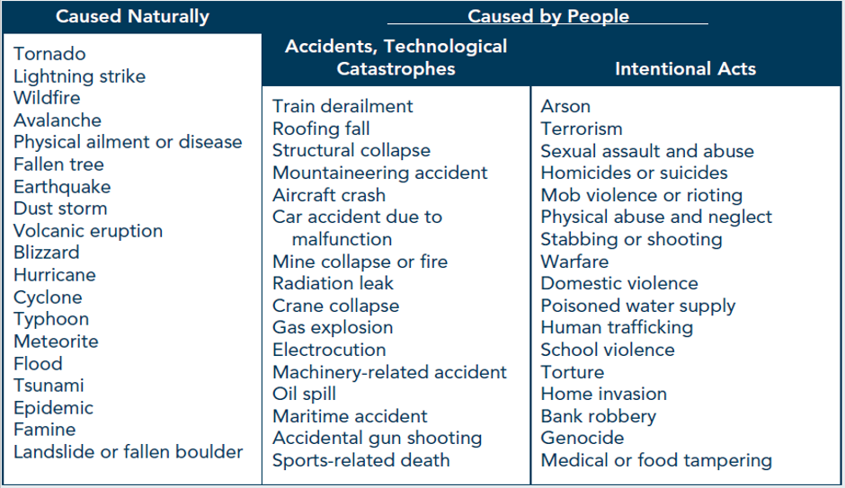

Appendix II.
Examples of Trauma Screening tools designed for specific age/ developmental groups:
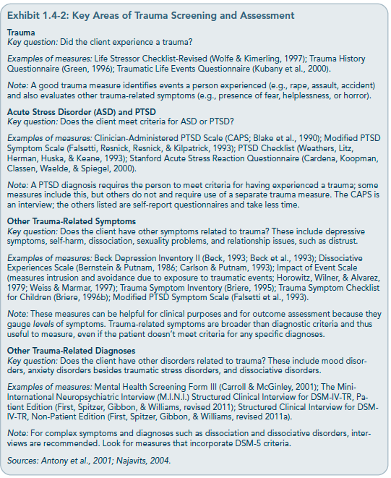

QUESTIONAIRE: How Did Your Board Complete the Data Notebook?

Completion of your Data Notebook helps fulfill the board’s requirements for reporting to the California Behavioral Health Planning Council. Questions below ask about operations of mental health boards, behavioral health boards or commissions, etc. Signature lines indicate review and approval to submit your Data Notebook.
- What process was used to complete this Data Notebook? Please check all that apply.
___ MH Board reviewed W.I.C. 5604.2 regarding the reporting roles of mental health boards and commissions.
__X_ MH Board completed majority of the Data Notebook
___ County staff and/or Director completed majority of the Data Notebook
__X_ Data Notebook placed on Agenda and discussed at Board meeting
___ MH Board work group or temporary ad hoc committee worked on it
__X_ MH Board partnered with county staff or director
__X_ MH Board submitted a copy of the Data Notebook to the County Board of Supervisors or other designated body as part of their reporting function.
___Other; please describe: _______________________________________.

- Does your Board have designated staff to support your activities?
Yes__X_ No___
If yes, please provide their job classification __Human Services Program Planner_________________
- What is the best method for contacting this staff member or board liaison?
Name and County: _Jason Richards, Sacramento County__
Email__richardsja@saccounty.net____________________
Phone #___916-875-6482__________________________
Signature: ______________________________
Other (optional): ____________________________________
- What is the best way to contact your Board presiding officer (Chair, etc.)?
Name and County: ___Ann Arneill, Sacramento County______________
Email: __ann@arneill.com__________________________________
Phone #___916-529-5602______________________________
Signature: ______________________________
REMINDER: Please submit this Data Notebook by October 15, 2019.

Thank you for your participation in completing your Data Notebook report.
Please feel free to provide feedback or recommendations you may have to improve this project for next year. As always, we welcome your input.

Please submit your Data Notebook report by email to:
DataNotebook@CMHPC.ca.gov .

For information, you may contact the email address above, or telephone:
(916) 327-6560

Or, you may contact us by postal mail to:
Data Notebook
California Behavioral Health Planning Council
1501 Capitol Avenue, MS 2706
P.O. Box 997413
Sacramento, CA 95899-7413

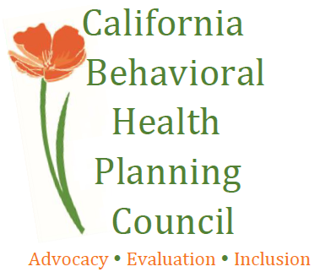

W.I.C. 5604.2, regarding mandated reporting roles of MH Boards and Commissions in California.
SAMHSA: Substance Abuse and Mental Health Services Administration, an agency of the Department of Health and Human Services in the U.S. federal government. For more information and reports, see www.SAMHSA.gov.
Institution for Mental Diseases (IMD) List https://www.dhcs.ca.gov/services/MH/Pages/MedCCC-IMD_List.aspx.
Link at CDSS: https://secure.dss.ca.gov/CareFacilitySearch/Search/AdultResidentialAndDaycare
www.NYTimes.com, April 10, 2019. California Today: How Large is the Bay Area’s Homeless Population?
www.NYTimes.com, June 5, 2019. California Today: Homeless Populations Are Surging. Here’s Why.
Your county data may be grouped with other counties, depending on the assigned group for federal “Continuum of Care” (CoC) designation. Example: data for the CoC CA-516, which includes Redding/Shasta, Siskiyou, Sierra, Lassen, Plumas, Del Norte, and Modoc Counties. The annual HUD “Point-in-Time” counts of homeless persons for all California counties are at: https://www.hudexchange.info/programs/coc/coc-homeless-populations-and-subpopulations-reports/?filter_Year=2018&filter_Scope=CoC&filter_State=CA&filter_CoC=&program+Coc&group=PopSub.
Data definition: Persons in Households with only Children <18 includes unaccompanied child or youth, parenting youth<18 who have one or more children, or may include sibling groups<18 years of age.
SAMHSA, Treatment Improvement Protocol (TIP) 57.
NSARC: National Epidemiological Survey on Alcohol and Related Conditions, 2012.
SAMHSA, TIP 57, page 47.
The definitive early study of Felitti, Anda, et al.,: Vincent J. Felitti, et al., Relationship of childhood abuse and household dysfunction to many of the leading causes of death in adults: The Adverse Childhood Experiences (ACE) study. American Journal of Preventative Medicine, 245 (1998).
These statewide data findings (following pages) were derived from four years of statewide data from 27,745 adults that was collected by the annual California Behavioral Risk Factor Surveillance Survey data [BRFSS, 2008-2013]. These data were reported by the Center for Youth Wellness, using analyses by the Public Health Institute.
Your county data may be found at: https://www.kidsdata.org/ .
These data are from BRFSS and CDC statewide data collection in California during the years 2008-2013. The numbers are similar, but not identical, to the findings from the early studies (1998) of Drs. Felitti and Anda on San Diego area patients of Kaiser Permanente, which were cited earlier in this report.
https://www.kidsdata.org
National Survey of Children’s Health, 2016, Data Source: Population Reference Bureau, analysis of data from the National Survey of Children's Health and the American Community Survey (Mar. 2018).
Definitions and descriptions from background research material provided at www.KidsData.org.
Definition: Estimated percentage of children ages 6-17 who are calm and in control when facing a challenge (e.g., in 2016, an estimated 52.4% of California children ages 6-17 were resilient). Data Source: Population Reference Bureau, data from the National Survey of Children's Health and the American Community Survey (Mar. 2018).
You may examine the data tables at the following source. https://www.kidsdata.org/topic/1928/resilience-nsch/table#fmt=2450&loc=2,127,331,171,345,357,324,369,362,360,337,364,356,217,328,354,320,339,334,365,343,367,344,366,368,265,349,361,4,273,59,370,326,341,338,350,342,359,363,340,335&tf=88.
http://www.focuscalifornia.org
www.samhsa.gov, Substance Abuse and Mental Health Services Administration, Treatment Improvement Protocol (TIP) 57.
www.samhsa.gov, SAMHSA: Treatment Improvement Protocol (TIP) 57.

