Napa County: Data Notebook 2014
for California
Mental Health Boards and Commissions
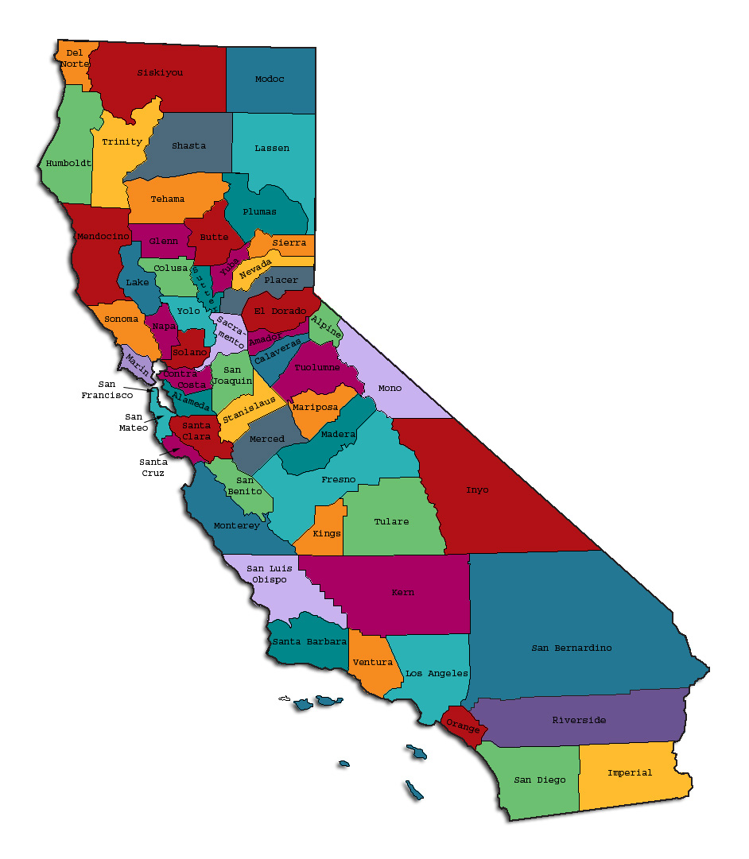
Prepared by California Mental Health Planning Council, in collaboration with: California Association of Mental Health Boards/Commissions, and APS Healthcare/EQRO

Napa County: Data Notebook 2014
for California
Mental Health Boards and Commissions

County Name: Napa Population (2013): 139,100
Website for County Department of Mental Health (MH) or Behavioral Health:
http://www.countyofnapa.org/MentalHealth
Website for Local County MH Data and Reports:
Live Healthy Napa County: http://www.countyofnapa.org/LHNC/
Website for local MH Board/Commission Meeting Announcements and Reports:
http://www.countyofnapa.org/MentalHealth
Specialty MH Data from review Year 2013-2014: http://caeqro.com/webx/.ee85675
Total number of persons receiving Medi-Cal in your county (2012): 22,900
Average number Medi-Cal eligible persons per month: 18,534
Percent of Medi-Cal eligible persons who were:
Children, ages 0-17: 45.4 %
Adults, ages 18-59: 39.2 %
Adults, Ages 60 and Over: 15.4 %
Total persons with SMI or SED who received Specialty MH services (2012): 1,314
Percent of Specialty MH service recipients who were:
Children 0-17: 47.3 %
Adults 18-59: 45.4 %
Adults 60 and Over: 7.3 %

TREATING THE WHOLE PERSON:
Integrating Behavioral and Physical Health Care
1) Please describe any efforts in your county to improve the physical health of clients.
In February, 2014, in coordination with community members, the county put forward a strategy: “The Napa County Community Health Improvement Plan” as a follow-up to the comprehensive “Live Healthy Napa County” project and report. This is available at: http://www.countyofnapa.org/lhnc/ .

2) How does your county address wellness programs to engage and motivate clients to take charge of improving their physical health?
Below are some examples of wellness programs in Napa County.
Local non-profit, Clinic Olé, provides a full-service clinic for adult clients at the county campus and children at a different location. Of the county clients, they have identified 30 high risk individuals and work with them, beginning with very small goals toward diet and exercise. One client has lost 75 pounds over the last several months.

A Nutrition/Exercise Coordinator goes once a month to a day program run by peers, “People Empowering People” to teach exercise and nutrition. Outreach also includes visits to the County homeless shelter.

Clinic Olé will soon begin working with clients toward quitting smoking (identifying smokers, performing lung capacity tests, providing smoking cessation services and information.)

Local non-profit, “COPE” coordinates a multi-agency prevention collaborative, which includes assessment, outreach and mental health services to at-risk families under the “Strengthening Families At-Risk Project”. This project focuses on building on the existing collaborative of Prevention and Early Intervention (PEI) funded projects. A network of family resource centers and local service providers addresses the therapeutic, parenting and life skills of parents and caregivers.

NEW CLIENTS: One Measure of Access
3. How does your county define 'new' client for those individuals who have previously received services, but who have not received services for a while? (e.g., 6 months, 12 months, 2 years?)
Per the Mental Health Division’s Discharging From and Returning To Mental Health Services policy, a client who has previously received services, but has not received services for a while is considered “new” if they return to services within “180 days (6 months) of the last date of service from the last open program. At that time, the person must be re-enrolled and all registration documents should be reviewed and updated if there are any changes. Unless there are significant clinical changes in functioning or a change in diagnosis, the Assessment form does not need to be updated, however a new treatment session and subunit assignment must be recorded and the existing Wellness and Recovery Plan (WRP) must be reviewed and revised, if necessary.”
4. Please provide any data your county has on the number of 'new' clients last year. And if you have it, how many of those new clients were brand new clients? You may need to ask your county mental health department for this data.
# new children/youth (0-17 yrs) 317
of these, how many (or %) are ‘brand new’ clients 273 (86%)
# new adults (18-59 yrs) 221
of these, how many (or %) are ‘brand new’ clients 152 (69%)

# new older adults (60+ yrs) 24
of these, how many (or %) are ‘brand new’ clients 20 (83%)

REDUCING RE-HOSPITALIZATION: Access to Follow-up Care
The chart below shows the percentage of people discharged in your county who received at least one service within 7 days of discharge. Also shown is the percentage of those same people who were readmitted to the hospital. The chart also shows the same information for receiving services and being readmitted to the hospital within 30 days. Red indicates the numbers for your county and the blue indicates the percentage for the state of California.
Napa County:
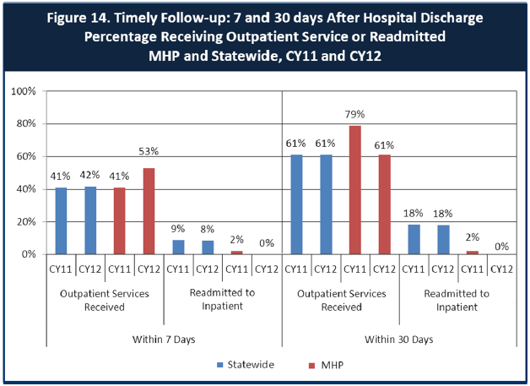
6. Looking at the chart, is your county doing better or worse than the state? Discuss why (e.g., your county has programming available that specifically ensures a warm handoff for follow-up services).
According to this chart, Napa County is performing better than the state.
Within the last few years, there has been an increased concerted effort by Napa County Mental Health and other programs within Health and Human Services to become more integrative initiated by “warm handoffs” to referral programs or within and increased follow up by staff. We provide intensive case management along with psychotherapy. These services include regular contact with the client, family involvement (if the client allows this), close involvement with other providers, help with medication adherence, help with transportation to mental health appointment, warm hand offs, and in general good support while building strength and independence. One of our strengths as a county is that we get people involved in outpatient services. Examples include the following:

- A new multidisciplinary care access unit called “The Hub” provides screening, assessment of needs, navigation and referral to the appropriate services for individuals with multiple needs, providing an integrated approach to care. This includes warm-hand-offs to county or community-based services.

- On October 15, 2014, “Community Connection Network” was established. It is a collaborative between nonprofits: Progress Foundation and Family Service of Napa Valley, providing site-based crisis triage services, mental health support and linkages to stabilize individuals who would otherwise escalate to needing higher levels of care such as the Crisis Clinic, emergency room services or inpatient hospitalization. Crisis Triage operates Monday-Friday, 8am-8pm and Saturday, 11am-7pm. They carry a case for about a month, giving steady counseling and referrals with warm hand-offs. This is funded for four years by a grant made possible by SB82.

- NCMH has made a significant effort to engage clients from initial hospitalization through the first week of post hospitalization by streamlining accessing services such as psychiatry and continued interaction with the client by the hospital liaison who is able to continue to assess and refer the client to needed services for continued support and stabilization.
Mental Health Services Act Full Service Providers, named “Treatment Teams” involve intensive case management for people after crisis and very few re-hospitalizations happen when this is utilized. After any acute hospitalization, or 5150 or to jail and back, intensive work with clients connect them with services. Before discharge, all case managers and a hospital liaison meet and talk about the hospitalized clients. Aftercare and follow up concentrate on engaging clients in further treatment.

- A Wellness Recovery Group taught by peers helps people work on their crisis plan. 13 currently attend rotating meetings at their homes and at PEP (People Empowering People), a day program run by peers. Participants are encouraged to develop a “toolbox” containing items that will help them through a crisis (e.g. phone numbers, a candle, etc.)

- Progress Place is a step down from acute care. Stays can be up to 30 days. It not only helps people keep out of crisis but also is a diversion from going to or going back to the hospital. This is a step down residence available after the typical acute residential average of 6.7 days.
- The McAlister Institute Residential Program is also a step down program, especially for adults struggling with substance abuse and other drug-related problems, including co-occurring mental health issues. Over the course of a 30-, 60-, or 90-day stay, clients receive assessment, individual and group counseling, vocational training, health education, and life skills workshops. 5 - 10 day detox also available.
7. Do you have any suggestions on how your county can improve follow-up and reduce re-hospitalizations?
Suggestions from Napa County Mental Health staff and board members include the following:
  - Improved Communication between doctors: It’s important that the doctor (psychiatrist) in the acute setting communicate with the doctor (psychiatrist) in the field. Moreover, it’s important that they (the doctors involved, acute and field) communicate with the primary care doctor. There needs to be better doctor to doctor communication from hospital to outpatient. Many times medications are changed in the hospital, and this should be discussed and clarified directly, so that the community M.D. comes to an agreement about appropriate care with the hospital M.D. Psychoactive drugs generally should not be changed abruptly.

  - More levels of care: It would be helpful to have access to more levels of care, for example, an enhanced board and care within Napa County as a number of clients are not able to maintain within the community independently for extended periods of time and supports are available but limited. A broader array of care services would enable increased mobility within the system and allow clients to remain in Napa.

  - Progress Place for older adults – It would be helpful to have in-between placements like a Progress Place, but for older adults. It would be important for this placement to allow people who struggle with incontinence yet take care of all their ADLs. Further, it needs to be a place that can handle walkers and wheelchairs. It would also help if the stay could span longer than 30 days if need be.

  - Programs for older adults - A partial hospitalization program or an additional day treatment program in the county that offers structure for people who don’t have dementia but struggle with the complex issues that older adults have when they suffer from the toll of long-term mental illness, health-related issues, cognitive decline and limited to no supports.

  - Rehabilitation Program teaching life & work skills - A rehabilitation program that builds strengths and skills while creating personal empowerment, i.e. teaching people how to engage beyond basic care such as volunteerism, computer, cell phone skills, etc.
  - More intensive case management services that could include trainees who are supervised by a licensed professional. (This appears to be currently addressed by staff – see answer to question #6.)

  - Track individuals newly discharged from the hospital to see if they follow through with appointments (medication compliance, etc.) It is important that people being discharged be met within a day of discharge by a County social worker to be sure they have enough medication, clear instructions on taking the medication, and a medical appointment in a reasonable time. The social worker should make a reminder phone call about the appointment and if necessary, arrange transportation for the appointment. (This appears to be currently addressed by staff – see answer to question #6.)

8. What are the three most significant barriers to service access?
- Lack of sufficient resources for unserved/underserved groups (to provide licensed, bilingual, culturally competent staff, offering community-based services during flexible hours (mornings/evenings/weekends) in natural settings.

- Lack of psychiatrists and tele-psychiatry services (note: tele-psychiatry is beginning to be implemented)

- Transportation

ACCESS BY UNSERVED AND UNDER-SERVED COMMUNITIES
From data the counties report to the state, we can see how many individuals living in your county are eligible for Medi-Cal, and of those individuals, how many received mental health services. Are you serving the Medi-Cal clients who need your services? Napa County Data:
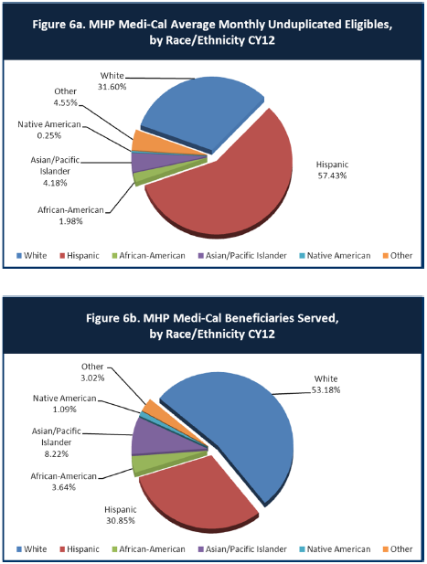
9. Is there a big difference between the race/ethnicity breakdown on the two charts? Do you feel that the group(s) that need services in your county are receiving services?
Yes. The largest group that continues to be underserved is the Latino community. The other identified groups on the chart appear to be receiving services in greater percentage than their percentage of the population. (Note: There may be people who identify themselves both as “Latino” and as “White”. This may be an issue with the statistics presented on the charts.)

10. What outreach efforts are being made to reach minority groups in your community?
- Napa County Health & Human Services System Navigators – helps connect people to mental health services, transportation, resources, and referral services to individuals and families throughout Napa County with a focus on the needs of the Latino community. They provide support and guidance in connecting with mainstream resources such as mental health care, physical health care, Medi-Cal, Food Stamps, housing services and more. Hours are Monday through Friday, with evening appointments available. On-site Napa County offices at 1500 3rd Street in Napa and 5 offsite locations: Calistoga Family Resource Center, St. Helena Family Resource Center, HOPE Resource Center, Napa Junction School, American Canyon Family Resource Center.

- The Division also partners with a number of community-based organizations to conduct outreach to the community through contracted services.
  - The Division’s Mental Health Services Act (MHSA) Prevention and Early Intervention (PEI) programs are targeted to such populations as Older Adults, LGBTQ, Latinos, Native Americans, etc.

  - Napa County Mental Health Division’s Innovations Project, implemented by On The Move, is reaching out to consumers, providers, and unserved/underserved groups to identify strategies to reduce barriers to access and to improve the quality of services.

  - ParentsCAN, a local nonprofit provides support and services families

- Latina Women’s Conference
- Binational Health Week Conference
- Hispanic Network
- Puertas Abiertas

11. Do you have suggestions for improving outreach to and/or programs for underserved groups? (some items may need to be omitted if they are not current)
The Division is making efforts to reach out to the community when they are available, during non-traditional times and in natural settings. (Note: The Division will soon increase its capacity to offer culturally competent services in the morning, evening, and weekend on campus and throughout the community.) Suggestions include:

      - Culturally Competent Hiring

      - Increase licensed bilingual staff

      - Increased partnership with non-profits and churches (from the “Healthy Aging Initiative Senior Survey – Mental Health Focus”: Of seniors who would seek help for feelings and worries, 48% of Latino seniors would go to a minister and 33% would seek help from a peer counselor.)

      - Increased hours (outside weekdays 8-5) for when clients are available

      - Targeted outreach and services to cultural/ethnic groups at cultural celebrations, group meetings and other natural settings and gathering places, i.e. Suscol Inter-Tribal Pow-Wow, Aloha Festival, Cinco de Mayo Celebrations, following Spanish masses, at Mexican Supermarkets, wineries, and vineyards, Gay Pride Week events, Napa Valley Adult Education, Senior Center, Rianda House, Nursing Homes, Board and Care Homes, McPherson Neighborhood Center, etc.

      - Develop comprehensive transportation services to help address transportation barriers.

      - There are other issues that affect connecting with the underserved, including the fear of stigma, spiritual beliefs, fear of being deported.

CLIENT ENGAGEMENT IN SERVICES
The chart below shows the number of Medi-Cal beneficiaries in your county who received 1, or 2, or 3, or 4, or 5, or more than15 mental health services during the year. For individuals experiencing severe mental illness, the more engaged they are in services, the greater the chance for lasting improvements in mental health.
Note: This data does not identify retention rates by seriousness of mental illness. Staff have commented that they are reviewing, on a case by case basis, to determine when during treatment that the intervention can be “stepped-down”. This would open resources for other potential clients and services.

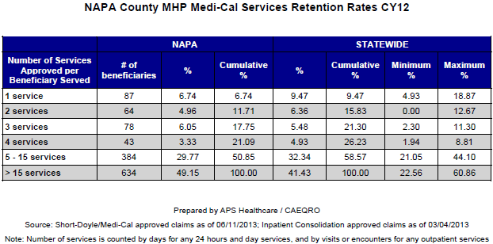
12. Do you think your county is doing a good job at keeping clients engaged in services? If yes, how? If not, why?
Yes, a relatively high percentage is engaged. Contributing factors:
- System of calling and reminding people about appointments.

- The lag between the initial assessment and treatment is filled by a Mental Health worker, who helps with conversations about coping and information about referrals while clients wait 2-4 weeks to begin group and individual services.

- A new multidisciplinary care access unit called “The Hub” provides screening, assessment of needs, navigation and referral to the appropriate services for individuals with multiple needs, providing an integrated approach to care. This includes warm-hand-offs to county or community-based services. The Undocumented in need of mental health services can go to The Hub, and for those who make too much money for county services, but not enough to pay for a therapist, The Hub offers brief therapy and referral to local non-profits, with “warm hand-offs” and transportation if necessary (or helps people understand the bus schedule.)

- A new tele-psychiatry system is a hopeful program just beginning to be established

- With two days a week, 32 slots for long distance therapy to be made available.

13. For those clients receiving less than 5 services, what is your county doing to follow-up and re-engage those individuals for further mental health services?
- System of calling and reminding people about appointments.

- Provide transportation if necessary (and/or consult on bus system)
- The lag between the initial assessment and treatment is filled by a Mental Health worker, who helps with conversations about coping and information about referrals while they wait 2-4 weeks to begin group and individual services.

- Clients coming out of acute facilities are given priority for psychiatric appointments to ensure they have needed medication.

- We have a hospital liaison – a position that hones in on anyone coming out of acute inpatient facility to help connect them with services and medical care.

- Clients coming out of jail are connected with mental health services before being released. (There are three Mental Health Counselors stationed at the jail, so the connection is seamless.)

14. Looking at the previous chart of who is being served by race/ethnicity in your county, do you have any thoughts or ideas to share regarding your county’s engagement of underserved communities?
In the last couple of years, NCMH has made a concerted effort to increase and extend outreach to multiple unserved and underserved populations. Primarily, this has been to the Hispanic population, with increased outreaches by bicultural and bilingual staff to increase education and service access attending such forums as the Latina Women’s Conference and other community events.

There has also been increased placement of staff in key areas of the county such as Calistoga and American Canyon to increase accessibility to services. However, it is clear that we have not reached as many as we would like and efforts will continue to address each unique population and figure out ways in which needs can be better addressed.

CLIENT OUTCOMES: Consumer Perception Survey (August 2013)
For general comparison, statewide reference data for various sized counties are shown in the tables on page 19.
The total numbers of surveys completed for Adults or Children/Youth in your county are shown separately in the tables below, under the heading “Total.”
Q1. Adults. As a direct result of the services I received, I deal more effectively with daily problems.
 | Strongly Disagree | Disagree | Neutral | Agree | Strongly Agree | Total
Number of Responses | 0 | 3 | 7 | 25 | 24 | 59
Percent of Responses | 0 % | 5.1 % | 11.9 % | 42.4 % | 40.7 % | 100.0 %

Q2. Children/Youth. As a result of services my child and/or family received, my child is better at handling daily life.

 | Strongly Disagree | Disagree | Neutral | Agree | Strongly Agree | Total
Number of Responses | 0 | 2 | 4 | 13 | 11 | 30
Percent of Responses | 0 % | 6.7 % | 13.3 % | 43.3 % | 36.7 % | 100.0 %

15. Are the data consistent with your perception of the effectiveness of mental health services in your county? Too small a sample to draw any conclusion. The members of the mental health board expressed varied perceptions of the effectiveness of mental health services.
Currently there are no objective measures of effectiveness of mental health services. Self-reporting by clients, while important, does not provide the feedback to providers as to what is working and what is not working. It is critical that the Mental Health Planning Council and Mental Health Services Oversight and Accountability Commission take on a comprehensive project to establish measureable performance outcome standards of mental health services. In the meantime, the mental health departments need to establish a means of tracking clients with regular assessments to determine individual progress over time. The Planning Council and MHSOAC need to provide consultation services to those counties that want to implement a local client assessment system.
16. Do you have any recommendations for improving effectiveness of services?
(In addition to responses to questions #7 and #11.) The broad geographic spread of Napa County and the vast increase in Medi-Cal payees because of the new Affordable Care Act, coupled with increased numbers of clients due to outreach efforts present challenges in terms of timeliness and geographical access.
Timeliness: The Napa County Mental Health Department has made many efforts to try new procedures and shows an openness to try even more. Over several years, they have revamped and retried about 14 different approaches to address the timeliness question. These include:
- Increased times per week that assessments can be done

- Four times per week walk-in assessments are available

- Shortening the form and process of initial assessment to a little over 2 hours (goal is to get it under 2 hours)

- A terminology and documentation change to “restarting the clock” if there is a no show in 26 days

- Reminder calls for next appointments and

- Offers and action to pick up a client for his/her appointment.
Geographical Access
- Transportation remains part of the problem and two small clinics each open 3 hours a week, one in the South homeless shelter and one at the Hope Center try to address this problem .

- The Division’s partnership with Clinic Ole also addresses geography with its many clinics around the county.

- “Up Valley Family Centers”, a nonprofit located in St. Helena and Calistoga, had success with a 10 week group for families. This was not specifically for mental health but it did familiarize families with services and the opportunities to come use the mental health services in the city of Napa.
17. Many counties experience very low numbers of surveys completed. Do you have suggestions to increase the response rate? Suggestions and concerns about this question from board members and staff include the following.
- Make the location of services more welcoming and inviting. Should have a TV or video screen in the waiting area, decaf coffee and decaf tea, magazines and NAMI reading material in the waiting area. Make it a place where people might want to “hang out,” and then have a social worker or trained person out in the area, interacting with those who come in.

- Emphasize the anonymity of the survey.

- If there were a trained and friendly person out in a friendly waiting area, that person could encourage and help people with questionnaires.

- Simplify the survey format - individuals who self-select to complete surveys are unique. Some people find it annoying and time-consuming. The shorter the survey, the more likely it will be filled out. It needs to be user-friendly.

- Offer a lottery scratcher as an incentive for completing the survey.

- Case workers/therapists could work with clients to complete surveys at each visit to establish a history and on-going record.

- There is concern that the surveys themselves may be a barrier to getting services (adding one more level of complexity and time.)

18. Lastly, but perhaps most important overall, with respect to delivery of services, do you have suggestions regarding any of the following:
Suggestions from board members and staff (for items a, b and c) include the following:
- Specific unmet needs or gaps in services
- With increased outreach (and corresponding increased demand), there is a need for another assessor position on staff.
- Increased outreach and services to the Latino population
- Further integration of Substance/Alcohol treatment into Mental Health treatmentIncreased senior outreach.
- Mobile Crisis unit.
- Youth substance/alcohol awareness and treatment program. (Wolfe Center?)
- More housing resources for individuals with mental illness.
- Increase case management services as a follow up tool.
- Services geared towards Veterans.
- Suicide prevention campaigns.
- Increase transportation systems for elderly and disabled.
- Improvements to, or better coordination of, existing services

- Improvements to, or better coordination of, existing services.
(please see response to question #7.)

- New programs that need to be implemented to serve individuals in your county Need to be compared against current status and source

- Increased access to geographically remote areas (Berryessa, Pope Valley, etc.) through increased outreach in partnership with local non-profits & churches.

- Tele-psychiatry: A new tele-psychiatry system is a hopeful program just beginning to be established with two days a week, 32 slots for Long distance therapy to be made available.
- Need more programs and help with exercise and nutrition, particularly to help with weight loss since drugs for serious mental illness often cause severe weight gain. Perhaps the County could hire a personal trainer to set up a general exercise program, and also work on specific exercise/nutrition programs for individuals.

- More help with job training and mentoring as happens with the developmentally disabled population. Most people with severe mental illness have a great deal of anxiety as well as poor self-esteem and concerns about failure. In our culture, where self-worth is often linked to income, paid work is a key to self-esteem for adults. It is also important for people to have a routine for which they are responsible to others. Jobs also offer “normal” social interaction. The Mental Health department should work more closely with the California Department of Rehabilitation and its contractors to help with job coaching and placement.

REFERENCE DATA: for general comparison with your county MHP results

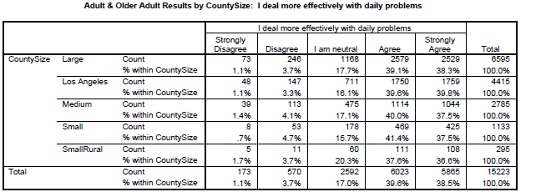

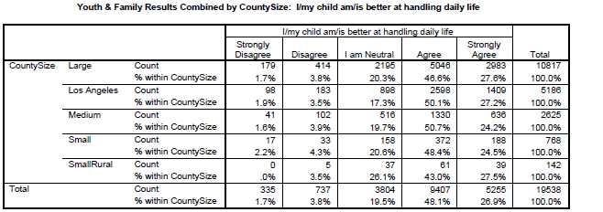
County Mental Health Plan Size: Categories are based upon DHCS definitions by county population.
o Small‐Rural MHPs = Alpine, Amador, Calaveras, Colusa, Del Norte, Glenn, Inyo, Lassen, Mariposa, Modoc, Mono, Plumas, Siskiyou, Trinity
o Small MHPs = El Dorado, Humboldt, Imperial, Kings, Lake, Madera, Mendocino, Napa, Nevada, San Benito, Shasta, Sutter/Yuba, Tehama, Tuolumne
o Medium MHPs = Butte, Marin, Merced, Monterey, Placer/Sierra, San Joaquin, San Luis Obispo, San Mateo, Santa Barbara, Santa Cruz, Solano, Sonoma, Stanislaus, Tulare, Yolo
o Large MHPs = Alameda, Contra Costa, Fresno, Kern, Orange, Riverside, Sacramento, San Bernardino, San Diego, San Francisco, Santa Clara, Ventura
o Los Angeles’ statistics are excluded from size comparisons, but are included in statewide data.
Total Values (in Tables above) = include all statewide data received by CiMH for these survey items.
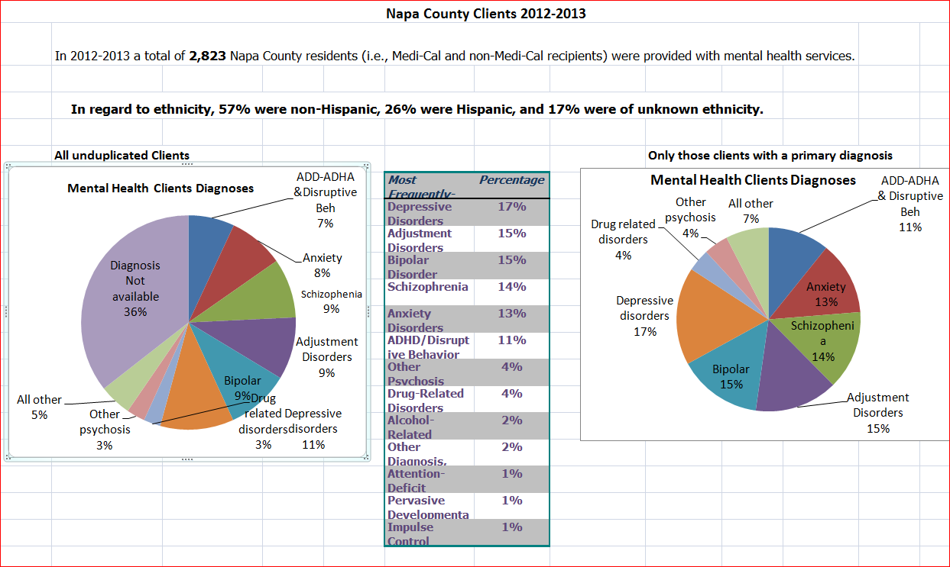

Napa County Mental Health Division Budget 2012-2013
Program | Total  Expenditures/ Revenue | County  Dollar | Realignment | MHSA  Revenue | Medi-Cal | Realigned  EPSDT | Fed/State Grants | MAA/UR | Realigned Mngd Care | Inter-  County | Other  Revenue
MHSA Children's FSP | 836,575 |  |  | 483,626 | 146,377 | 131,739 |  | 74,833
MHSA TAY FSP | 453,337 |  |  | 298,044 | 81,733 | 73,560
MHSA Mobile Outreach | 279,479 |  |  | 276,653 |  |  |  | 2,826
MHSA Project Access | 475,442 |  |  | 448,144 |  |  | 6,739 | 20,559
MHSA ADULT FSP | 587,439 |  |  | 433,426 | 75,790 |  | 36,337 | 41,886
Adult Team Treatment Program | 300,000 |  |  | 300,000
MHSA Admin | 147,855 |  |  | 136,169 |  |  |  | 11,686
MHSA WET | 211,585 |  |  | 211,585
MHSA PEI | 1,296,820 |  |  | 1,296,820
MHSA Innovations | 114,850 |  |  | 114,850
MHSA Tech Needs | 27,000 |  |  | 27,000
MHSA Sub Total | 4,730,382 | - | - | 4,026,317 | 303,900 | 205,299 | 43,076 | 151,790 | - | - | -
Adult Crisis | 840,861 | 416,754 | 221,488 |  | 113,372 |  | 32,751 | 25,495 |  |  | 31,001
Adult Central Intake | 120,772 | 22,278 | 43,952 |  | 43,952 |  |  | 10,590
Adult Med Clinic | 1,003,476 | 227,005 | 380,400 |  | 298,523 |  | 29,328 | 31,142 |  |  | 37,079
Adult Case Mgmt | 5,712,302 | 344,712 | 3,328,143 |  | 1,138,797 |  | 202,131 | 35,459 | 568,760 |  | 94,300
In-house Outpt Therapy | 230,240 | 29,979 | 97,417 |  | 97,417 |  |  | 5,427
Jail | 340,861 | 113,848 |  |  |  |  |  |  |  | 227,013
CONREP | 202,100 | 38,827 |  |  |  |  | 163,273
Children's Med Clinic | 557,497 | 222,071 | 72,104 |  | 147,538 | 114,784 |  |  |  |  | 1,000
Children's Case Mgt | 4,809,975 | 318,197 | 437,135 |  | 1,846,578 | 1,832,425 |  | 266,186 |  | 104,954 | 4,500
Juvenile Hall | 175,072 | 14,285 |  |  |  |  |  |  |  | 160,787
MHD Administration | 2,615,251 | 1,263,055 | 119,993 | 366,746 |  |  | 546,426 | 316,153 |  |  | 2,879
Non-MHSA Sub Total | 16,608,408 | 3,011,011 | 4,700,631 | 366,746 | 3,686,177 | 1,947,209 | 973,909 | 690,452 | 568,760 | 492,754 | 170,759
GRAND TOTAL  Summary by Group | 21,338,790 | 3,011,011 | 4,700,631 | 4,393,063 | 3,990,077 | 2,152,508 | 1,016,985 | 842,241 | 568,760 | 492,754 | 170,759
 | Total  Expenditures/ Revenue | County  Dollar | Realignment | MHSA  Revenue | Medi-Cal | Realigned  EPSDT | Fed/State Grants | MAA/UR | Realigned Mngd Care | Inter-  County | Other  Revenue
Non-Age Specific MHSA Prog. | 2,405,176 | - | - | 2,375,052 | - | - | 6,739 | 23,385 | - | - | -
Adult Services | 9,338,051 | 1,193,403 | 4,071,399 | 733,426 | 1,767,851 | - | 463,820 | 149,999 | 568,760 | 227,013 | 162,380
Childrens Services | 6,379,119 | 554,553 | 509,239 | 483,626 | 2,140,493 | 2,078,949 | - | 341,018 | - | 265,741 | 5,500
Transitional Age Youth | 453,337 | - | - | 298,044 | 81,733 | 73,560 | - | - | - | - | -
General Administration | 2,763,107 | 1,263,055 | 119,993 | 502,915 | - | - | 546,426 | 327,839 | - | - | 2,879

Napa Mental Health Budget 2012-13 Revenue Definitions
Realignment: State sales tax and vehicle license fees realigned to Mental Health to provide services under the Mental Health Plan agreement with the State. There is no reporting done for this program; we are under contract with the State to provide the community with services outlined in the Plan.
Realigned EPSDT: Historically the Early Periodic Screening, Diagnosis and Treatment (EPSDT) program funding was used to pay for 50% of the mental health services for children not coved by the 50% under Federal Medi-Cal (FFP). The program was realigned so the money will come as a monthly allocation rather than incorporated with the typical FFP payments received by the State. There is no separate reporting for EPSDT, information regarding this funding is incorporated in the Mental Health Cost Report.
Fed/State Grants: These are the federal and state funding sources. Most of them are ongoing State contracts. They include: Mental Health Block Grant (MHBG) (formerly known as SAMHSA), Federal Projects for Assistance for Transition from Homelessness (PATH), Conditional Release Program (CONREP), Housing and Urban Development (HUD), and Meaningful Use of Electronic Health Record Funds (funds will diminish in future periods).
MAA/UR: Medi-Cal Administrative Activities (MAA) and Utilization Review (UR) are both programs that are geared to enhance, market and improve the quality of Medi-Cal services. They are claimed quarterly to the State and reported upon annually. The money is a mixture of State General Fund and Federal Funds passed through the State.
Realigned Mngd Care: Refers clients to contracting community mental health providers for acute inpatient treatment and/or outpatient counseling services under the mental health managed care program operated by HHSA for Medi-Cal beneficiaries in Napa County. As with EPSDT this funding source will now be collected through realignment. It previously was an allocation.
Inter-county: Funds received from other County Departments. In this case from Corrections, Probation, Child Welfare for mental health services provided to the Jail, Juvenile Hall for a children’s program funded by SB163. Mental Health invoices these Departments for the salary and benefits for agreed upon employees.
Other Revenue: These are the revenue sources that were too small to mention separately. These include: CMSP, Client Fees, Private Insurance, Medicare, Donations, Miscellaneous and Medical Record Copy Charges.

Napa County Mental Health Board Data Notebook 2013-2014

Staff Focus Groups

Focus Group Categories

Healthcare

Access Barriers

Engagement and Retention

Timely Follow-up Post Hospitalization

Participating Staff: Organized by Doug Hawker, Mental Health Manager

Sarah Hayes – Supervising Mental Health Counselor – Access and the HUB Programs

Amanda Jones – Supervising Mental Health Worker – Adult Full Service Partnership

Adriana Navarro – Supervising Mental Health Counselor – Children’s Full Service Partnership

Robin Merrill Payne – Supervising Mental Health Counselor – Jail and CONREP Programs

Tina Zoppel – Behavioral Health Manager, Clinic Ole HHSA on site medical services

Amanda Jones – Supervising Mental Health Worker

Harry Collamore – Quality Coordinator

Felix Bedolla – MHSA Project Manager

Mental Health Board, Information and Data Work Group Members

Theresa Comstock

Beryl Nielsen

John Pearson

Serious Mental Disorder, term used for adults 18 and older.
Severe Emotional Disorder, term used for children 17 and under.

