MERCED COUNTY: DATA NOTEBOOK 2014

FOR CALIFORNIA
MENTAL HEALTH BOARDS AND COMMISSIONS

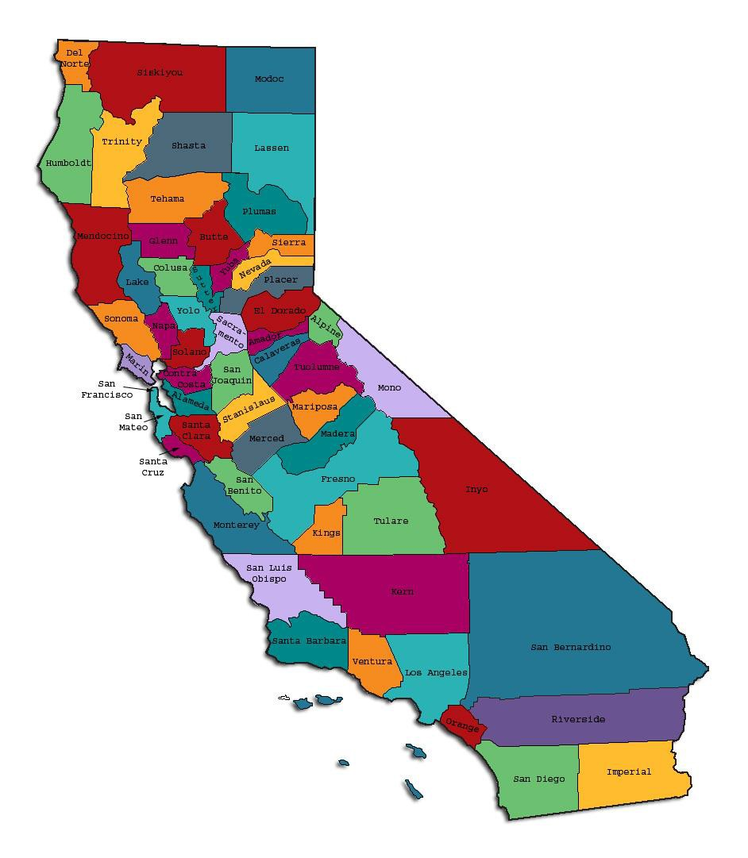
Prepared by California Mental Health Planning Council, in collaboration with: California Association of Mental Health Boards/Commissions, and APS Healthcare/EQRO

This Page Intentionally Left Blank.

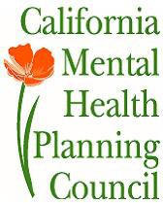Date: April 20, 2014

To: Chairpersons and/or Directors

Local Mental Health Boards and Commissions From: California Mental Health Planning Council Subject: Instructions for Data Notebook 2014

We ask that this report be prepared by the MH Board or Commission members. You are the most important resources for identifying program strengths and needs in your community.

On the first page, please fill in the requested information for your county websites:

- Department of Behavioral Health/ Mental Health
- Public reports about your county’s MH services.

Please send a copy of the filled-in first page to the Planning Council along with your final report which contains your answers to the questions in the Data Notebook. Please submit your report within 60 days by email to:

DataNotebook@cmhpc.ca.gov.

Or, you may mail a printed copy of your report to:

- Data Notebook Project
- California Mental Health Planning Council
- 1501 Capitol Avenue, MS 2706
• P.O. Box 997413 Sacramento, CA 95899-7413

Please examine the enclosed information, which will help you discuss the questions in the Data Notebook. We provide examples of recent mental health data for your county. In some figures, the term “MHP” is used to refer to your county’s Mental Health Plan.

Some data comes from APS Healthcare/EQRO, which gave permission to use their figures and tables, prepared for review of each county’s Medi-Cal Specialty Mental Health services. Data in this packet came from the following review cycle:

X Fiscal Year 2013 -- 2014: http://caeqro.com/webx/.ee85675/

X Fiscal Year 2012 -- 2013: http://caeqro.com/webx/.ee851c3/

For some questions, you will need to consult your local county Quality Improvement Coordinator, and/or Mental Health Director. If you are not able to address all of the questions, just answer the ones you can.

Thank you for your participation in the Data Notebook Project.

This Page Intentionally Left Blank

MERCED COUNTY: DATA NOTEBOOK 2014

FOR CALIFORNIA
MENTAL HEALTH BOARDS AND COMMISSIONS
County Name: Merced Population (2013): 263,026 Website for County Department of Mental Health (MH) or Behavioral Health:
http://www.co.merced.ca.us/index.aspx?nid=78 Website for Local County MH Data and Reports:
http://www.co.merced.ca.us/pdfs/mentalhealth/mhsa/mhsa_proposed_program_update
_2013_2014_draft_30_day_posting.pdf

Website for local MH Board/Commission Meeting Announcements and Reports:

Mental Health Advisory Board Information: http://www.co.merced.ca.us/index.aspx?NID=1863

Specialty MH Data from review Year 2013-2014: http://caeqro.com/webx/.ee85ab0/

Total number of persons receiving Medi-Cal in your county (2012): 108,282 Average number Medi-Cal eligible persons per month: 88,461 Percent of Medi-Cal eligible persons who were:
Children, ages 0-17: 50.0 %

Adults, ages 18-59: 40.4 % Adults, Ages 60 and Over: 9.6 %
Total persons with SMI1 or SED2 who received Specialty MH services (2012): 3,083
Percent of Specialty MH service recipients who were: Children 0-17: 29.1 %
Adults 18-59: 64.0 %

Adults 60 and Over: 6.9 %

1 Serious Mental Disorder, term used for adults 18 and older.
2 Severe Emotional Disorder, term used for children 17 and under.

This Page Intentionally Left Blank

INTRODUCTION: Purpose, Goals, and Data Resources
This Data Notebook has been developed for the use by the local mental health (MH) boards and commissions by a yearlong workgroup comprised of members from:
- California Mental Health Planning Council (CMHPC)
- California Association of Local Mental Health Boards and Commissions (CALMHB/C)
- APS Healthcare/ EQRO (External Quality Review Organization) Our plan is for the Data Notebook to meet these goals:
- assist local boards to meet their mandates to review the local county mental health systems, identify unmet needs, and recommend improvements.
- provide a professional format for submitting reports to their local Board of Supervisors, and/or their county Director of Mental Health Services.
- function as an educational tool for local boards, whose members have varying levels of skills, frequent turnover, and need ‘refresher’ training about using data.
- help the CMHPC fulfill its mandates to review and report on the public mental health system in California, which also helps provide evidence for advocacy.
Data reporting drives policy, and policy drives funding for programs. But the data must be both recent and available to the public, or else it is not useful. So, the CMHPC will provide examples of local data from current public reports. We focus on two broad areas: (1) evaluation of program performance, and (2) indicators of client outcomes.
We recognize that each county has a unique population, resources, strengths, and needs. Thus, there is no single perfect data source to answer all the important questions one might ask about mental health services. However, the following data resources will help board members answer questions in this Data Notebook:
- experience and opinions of the local mental health board members
- recent reports about county MH programs from APS Healthcare/EQRO
- data you request from your county QI Coordinator and/or Mental Health Director (because CMHPC does not have that data, and it’s not in other public reports)
- client outcomes data provided by California Institute of Mental Health (CiMH) in their analysis of the most recent Consumer Perception Survey.
Some of our data comes from APS Healthcare/EQRO, which kindly gave permission to use their figures and tables, prepared for review of each county’s Medi-Cal Specialty Mental Health services. Those reviews are at: www.CAEQRO.com. You may find the full-length EQRO reports helpful because they summarize key programs and quality

improvement efforts for each county. They also describe strengths, opportunities for improvement, and changes in mental health programs since the last year.
Understanding changes in local programs can help consumers because of the massive re-organization of mental health services statewide. Some changes have been confusing to clients. The old state Department of Mental Health was eliminated in 2012 and many functions were moved to the Department of Health Care Services. Other changes due to federal health care reform and the Affordable Care Act affect how mental health services are provided, funded, and linked to primary health care or substance use treatment. Also, local counties have adjusted to major challenges.
Remember, this report is about your community, and what you and your stakeholders choose to discuss. Examining the data can indeed “Tell a Human Story.” But quantitative data (numbers) provides only part of the picture, for example:

- measures of whether the quality of program services improve over time
- whether more people from different groups are receiving services
- how many clients got physical healthcare or needed substance use treatment.

The other part of the story gives human context to the numbers. Such qualitative data (narrative, descriptions, or stories) tells more of the story, because we can:
- describe special programs targeted for outreach to specific groups
- examine how the programs are actually implementing their goals
- list concrete steps that are taken to improve services, and
- tell what is being done to increase client engagement with continued treatment.

We hope this project contributes to ongoing quality improvement (QI) in mental health services. We seek constant improvement in our approach to quality because:
- needs change over time,
- all human endeavors are by nature imperfect,
- creativity gives rise to new ideas, and
- we can share examples of successful programs to help other communities.

One question is whether local boards are permitted to provide additional information, besides that requested in this Notebook. We always welcome supplemental reports about successful projects, or which the county administration uses to inform the public. Any additional reports may be attached in an “Appendix,” with the website address (if available). However, we emphasize such extra reports are not required.

Thank you for participating in this project. We hope this Data Notebook serves as a springboard for your discussion about all areas of the mental health system, not just those topics highlighted by our questions.

TREATING THE WHOLE PERSON:
Integrating Behavioral and Physical Health Care
Studies have shown that individuals with serious mental illness die, on average, 25 years earlier than the general population. This information makes improving the physical health of clients of great importance and should be a goal of county mental health departments along with providing effective and appropriate mental health services. Coordination of care for mental health, substance abuse and physical health is one way of accomplishing the goal.
The California Mental Health Planning Council does not have any data to provide to show how your county’s programs connect clients of mental health services with necessary physical health care. We ask that the local mental health board request information from your county mental health department for any data on numbers (or percent) of total mental health clients who are referred to, or connected with, physical health providers to assess, treat and monitor physical health issues.
If your county has data on numbers or percentages of clients who are also receiving physical health care, please include it in your Data Notebook you submit to the Council.

_x
Check here if your county does not have such data or information.

Please describe any efforts in your county to improve the physical health of clients.
Clients are regularly referred to a physician during the assessment process when deemed necessary. Protocol also requires that a letter be sent to a client’s physician to alert the physician that the client is receiving behavioral health care. As part of our annual packet, a letter is sent to the PCP outlining the client’s medications and the diagnosis. The PCP is updated at least annually to the clients’ medications. If the client does not have a PCP, a referral is made to a community health facility such as Golden Valley or to a Family Practice. Also as part of the annual packet and the initial packet, the client is asked sign a consent form to allow communication and sharing of information with the PCP.
Blood tests and other laboratory testing is regularly ordered and collected. If there are any abnormalities, the client referred to the PCP.
The MHP progress notes have a check off box that contains: “ f/u with PCP re:
.”

At the Psychiatric Health Facility, a Physician’s Assistant (PA) is on staff to work closely with the patients. The PA performs the physical exams.

How does your county address wellness programs to engage and motivate clients to take charge of improving their physical health?
Through the 3 Wellness Centers, the following classes or groups are offered:
- Exercise
- Nutrition
- Healthy cooking and meal preparation
- Stress management
- Smoking Cessation
- Managing chronic disease
- Maintaining social connectedness

Regular clinicians also involve clients in outings to promote activity, exposure, exploration of new experiences. Groups of clients have gone to the coast and Yosemite for enrichment activity.

NEW CLIENTS: One Measure of Access
One way to evaluate the quality of mental health services outreach is to measure how many clients receive services who have never been part of the service system before (“brand new” clients). Another measure is how many clients return for services after a period of time with no services (“new” clients).
The California Mental Health Planning Council is exploring how each county mental health department defines “new” clients, and how a client is labelled when they return
for additional services. This information is important in determining whether your county has a “revolving door,” that is, clients who are in and out of mental health services repeatedly. This data is one indicator of the success of your county’s programs in closing cases appropriately and providing adequate discharge planning to clients.
This data is not currently reported by the counties to the state. The Council does not have data to provide to you. This information should be requested from your county mental health department.

Check here if your county does not have this information.

How does your county define 'new' client for those individuals who have previously received services, but who have not received services for a while? (e.g., 6 months, 12 months, 2 years?)

Our definition of a “new” client is anyone who is being assessed to determine if they meet medical necessity and are within the target population. We have not classified “new” clients in terms of duration of services.
Our county does not define our clients as “new” clients for those individuals that have received previous services. They are considered clients restarting services and these clients are not tracked. Only “new” clients that go through our Access POE process are tracked.

Please provide any data your county has on the number of 'new' clients last year. And if you have it, how many of those new clients were brand new clients? You may need to ask your county mental health department for this data.
# new children/youth (0-17 yrs): 686 (FY 2013-2014) of these, how many (or %) are ‘brand new’ clients: All.

# new adults (18-59 yrs): 529 (FY 2013-2014 & includes both Adult & Older Adults) of these, how many (or %) are ‘brand new’ clients: All.

# new older adults (60+ yrs): Not tracked.(included in Adult population)

of these, how many (or %) are ‘brand new’ clients: Not tracked (included in Adult population)

REDUCING RE-HOSPITALIZATION: Access to Follow-up Care
Sometimes, an individual experiences acute symptoms of mental illness or substance abuse which can result in a brief stay in an acute care hospital. Receiving follow-up services after discharge from a short-term (3-14 day) hospitalization can be critical to preventing a return to the hospital.
The chart below shows the percentage of people discharged in your county who received at least one service within 7 days of discharge. Also shown is the percentage of those same people who were readmitted to the hospital. The chart also shows the same information for receiving services and being readmitted to the hospital within 30 days. Red indicates services or events within 30 days post-discharge, and the blue indicates services or events within 7 days after hospital discharge. (CY = calendar year, 2011 or 2012; MHP = county mental health plan).

Merced County:

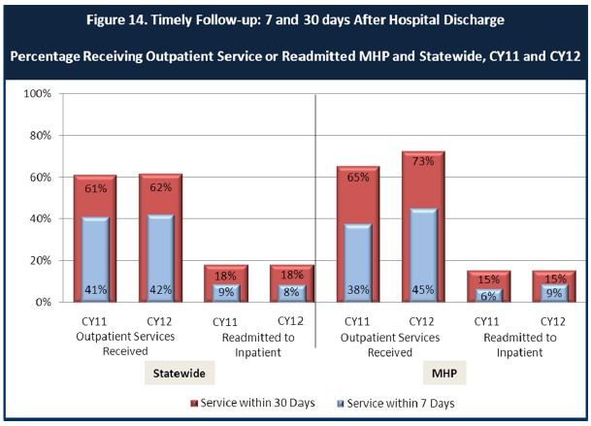

- Looking at the chart, is your county doing better or worse than the state? Discuss why (e.g., your county has programming available that specifically ensures a warm handoff for follow-up services).
For Merced County, there is an increase in receiving services whether it is within 7 or 30 days. However, there is a lower readmission date when compared with state averages with the exception of one percentage point for services received within seven days in calendar year 2012.
Appointments are made by the Marie Green Psychiatric Health Facility social workers upon discharge of patients. Telephone calls are also made the day before scheduled appointments.

Do you have any suggestions on how your county can improve follow-up and reduce re-hospitalizations?
This is item is currently being reviewed for a Process Improvement Project and further data is being gathered.
One strategy that has been implemented is to send a text reminder to a client’s cell phone at the request of the clients now that many of them have cells phones.

What are the three most significant barriers to service access?

- Transportation is an issue for many clients and the local city bus system can be challenging.
- Availability of clinicians and psychiatrists results in restricted time availability. We have positions open and are actively recruiting however the the pool of clinicians seems to be limited in this area.
- Cultural barriers such as language and the limited availability of interpreters.

ACCESS BY UNSERVED AND UNDER-SERVED COMMUNITIES

One goal of the Mental Health Services Act (MHSA) is to reach unserved and underserved communities, especially communities of color. The MHSA promotes outreach to engage these communities in services. If individuals and families in these communities are not accessing services, then we may need to explore new ways of reaching them. Or, we may need to change our programs to meet their mental health needs in ways that better complement their culture.
From data the counties report to the state, we can see how many individuals living in your county are eligible for Medi-Cal, and of those individuals, how many received mental health services. Are you serving the Medi-Cal clients who need your services?

Merced County:

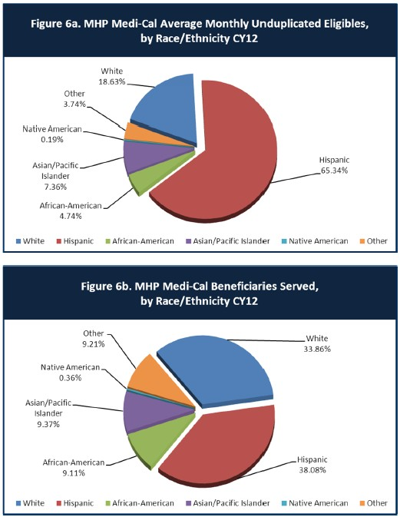

- Is there a big difference between the race/ethnicity breakdown on the two charts? Do you feel that the group(s) that need services in your county are receiving services?
Most evident is that the Hispanic population appears underserved by the MHP; however, there are two collaborative agencies who serve the Hispanic population that may explain the discrepancy. One of the providers target populations in the rural area with satellite clinics located in those areas. The other provider is located in Merced County’s third largest city whose population is largely Hispanic. Theoretically, the Hispanic population may be receiving services; however, from other collaborative providers.
The MHP reaches a larger section of the Medi-Cal beneficiaries through contractors and community outreach workers who provide engagement, prevention education, and connecting individuals/families to needed services.

What outreach efforts are being made to reach minority groups in your community?
Through the MHSA program, several outreach efforts are made throughout the year through presentations, classes, trainings and community events. The MHSA Innovation Project was developed to improve access to services for diverse populations.
We also have a very successful Community Mentor program which was designed specifically to reach out to the Hispanic community.

Do you have suggestions for improving outreach to and/or programs for underserved groups?
Continue communication with our competing vendors and obtain statistics on how many clients are seen by them according to race and ethnicity. We are collaborating with more community partners such as Public Health and the National Alliance for the Mentally Ill (NAMI) to increase outreach to diverse populations.
Increase the number of trained, culturally appropriate workforce that is specific to the minority community needs.
This item is currently the focus of a Process Improvement Project.

CLIENT ENGAGEMENT IN SERVICES
One MHSA goal is to connect individuals to services they need to be successful. Clients who stop services too soon may not achieve much improvement, nor is it likely to last. So it is important to measure not only who comes in for treatment, but also how long they stay in services. Here we are considering individuals with high service needs,
not someone who just needs a ‘tune-up.’ Although not every individual needs the same amount of services, research shows that when someone with severe mental illness continues to receive services over time, their chances of recovery increase.
Engagement in services, also called ‘retention rate’, is important to review. If individuals come in, receive only one or two services and never come back, it may mean the services were not appropriate, or that the individual did not feel welcome, or some other reason that should be explored. Again, we recognize that some individuals only need minimal services, but here we are looking at those with severe mental illness.
Ultimately, the goal is to ensure they are getting needed services and are on the road to recovery. But we would not know that unless we look at how many services individuals received over time.
The chart below shows the number of Medi-Cal beneficiaries in your county who received 1, or 2, or 3, or 4, or 5, or more than15 mental health services during the year. For individuals experiencing severe mental illness, the more engaged they are in services, the greater the chance for lasting improvements in mental health.

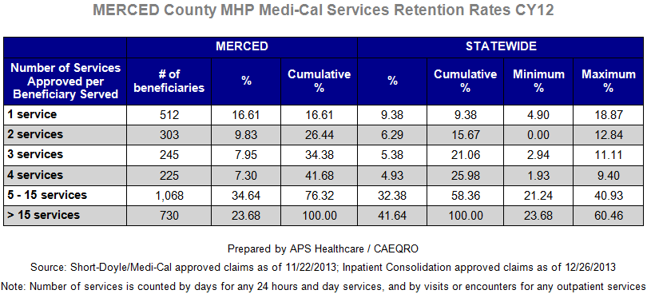

Do you think your county is doing a good job at keeping clients engaged in services? If yes, how? If not, why?
According to the statistics, it appears that Merced County does a very good job and retaining clients compared to the state average.
Engagement with the client appears to be in question. Merced County has had a regular practice of assessing clients as “walk-ins” which could account for the higher clients
who are provided one service. Clients could also be referred following the initial assessment to the community for services. Transportation issues as stated before could be another explanation. The newly developed discharge form will help track this data.

For those clients receiving less than 5 services, what is your county doing to follow-up and re-engage those individuals for further mental health services?
In an effort to follow-up with clients, providers and office personnel make phone calls to clients after missed appointments. Client satisfaction surveys are made available in the lobbies and regularly throughout the year for clients to complete. Information from the surveys is reported to the QIC and assessed for further action to improve access and service delivery as needed.
Merced County was awarded a Triage Grant that could be used to do provide follow up with clients who might be at risk of relapse or deterioration of their symptoms and assist them in following up with services. There is currently a recruitment effort for additional workforce with the grant funding.

Looking at the previous chart of who is being served by race/ethnicity in your county, do you have any thoughts or ideas to share regarding your county’s engagement of underserved communities?
There are competing vendors and their penetrations rates will be examined. This issue is currently being planned as a PIP. If the data collected from the contractors and other vendors continues to demonstrate a low penetration rate, we will have to do a better job of reaching out to the Hispanic population. This would involve hiring culturally sensitive staff that is able to connect with the clients, and clients are able to easily identify with them. Additionally, there are many factors impacting this penetration rate including, cultural issues, mental health stigma, fear of the system, and that often times the Hispanic culture is very close knit unit that remains private, which can make it difficult to engage. The development of Promotoras in the communities is also an option and brings stakeholders together to assist in identifying the needs of this population

CLIENT OUTCOMES: Consumer Perception Survey (August 2013)
Ultimately, the reason we provide mental health services is to help individuals manage their mental illness and to lead productive lives. We have selected two questions from the Consumer Perception Survey which capture this intention. One question is geared toward adults of any age, and the other is for children and youth under 18.
Below are the data for responses by clients in your county to these two questions. Note: zero responses were received by CiMH from your county for these items.
Therefore, we are providing you with the summary data for medium-sized counties3 as
Merced fits into that category. For general comparison, statewide reference data for various sized counties are shown in the tables on page 19.
The total numbers of surveys completed for Adults or Children/Youth in each category are shown separately in the tables below, under the heading “Total.”

Q1. Adults. As a direct result of the services I received, I deal more effectively with daily problems.

 | Strongly Disagree | Disagree | Neutral | Agree | Strongly Agree | Total
Number of Responses | 39 | 113 | 475 | 1114 | 1044 | 2785
Percent of Responses | 1.4 % | 4.1 % | 17.1 % | 40.0 % | 37.5 % | 100.0 %

Q2. Children/Youth. As a result of services my child and/or family received, my child is better at handling daily life.

 | Strongly Disagree | Disagree | Neutral | Agree | Strongly Agree | Total
Number of Responses | 41 | 102 | 516 | 1330 | 636 | 2625
Percent of Responses | 1.6 % | 3.9 % | 19.7 % | 50.7 % | 24.2 % | 100.0 %

3 Medium-sized counties: Butte, Marin, Merced, Monterey, Placer/Sierra, San Joaquin, San Luis Obispo, San Mateo, Santa Barbara, Santa Cruz, Solano, Sonoma, Stanislaus, Tulare, Yolo.

Are the data consistent with your perception of the effectiveness of mental health services in your county?
The data demonstrates that both the adult and child population show high satisfaction. Approximately 75% agree or strongly agree that their life is better as a result of MCDMH services provided to them. The data supports the anecdotal comments staff hears and report.

Do you have any recommendations for improving effectiveness of services?

MCDMH should examination of the neutral responses given. Perhaps focus groups should be used to find out these responses.

Many counties experience very low numbers of surveys completed. Do you have suggestions to increase the response rate?
The tool used for client responses are very important in terms of structure, length and time. Great care in the development of a survey tool is crucial for responses by the client.
Peer mentors have had success in administering the survey by providing them to each client and helping to answer questions related to the question content if the client is not clear what the question is asking.

Lastly, but perhaps most important overall, with respect to delivery of services, do you have suggestions regarding any of the following:
  - Specific unmet needs or gaps in services
Katie A mandate to provide services to foster care youth requires a build-up in trained staff.
The need for effective Evidence Based Practices.

Improvements to, or better coordination of, existing services
Continued improvement of collaboration and integration with primary health and other community partners who provide services in the continuum of care.

New programs that need to be implemented to serve individuals in your county
Katie A population: Providing the initial assessments and ongoing services to the Class and Subclass children and youth.
Developing the Central Intake Unit and implementing services through the Triage Grant.

<END>

REFERENCE DATA: for general comparison with your county MHP results

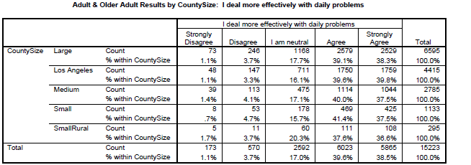

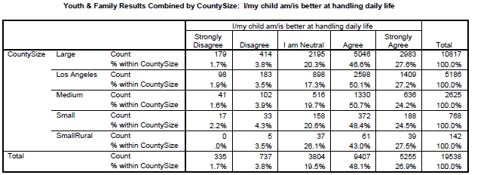

County Mental Health Plan Size: Categories are based upon DHCS definitions by county population.
- Small‐Rural MHPs = Alpine, Amador, Calaveras, Colusa, Del Norte, Glenn, Inyo, Lassen, Mariposa,
Modoc, Mono, Plumas, Siskiyou, Trinity

- Small MHPs = El Dorado, Humboldt, Imperial, Kings, Lake, Madera, Mendocino, Napa, Nevada, San Benito, Shasta, Sutter/Yuba, Tehama, Tuolumne

- Medium MHPs = Butte, Marin, Merced, Monterey, Placer/Sierra, San Joaquin, San Luis Obispo, San Mateo, Santa Barbara, Santa Cruz, Solano, Sonoma, Stanislaus, Tulare, Yolo

- Large MHPs = Alameda, Contra Costa, Fresno, Kern, Orange, Riverside, Sacramento, San Bernardino, San Diego, San Francisco, Santa Clara, Ventura

- Los Angeles’ statistics are excluded from size comparisons, but are included in statewide data.

Total Values (in Tables above) = include all statewide data received by CiMH for these survey items.

REMINDER:

Thank you for your participation in completing your Data Notebook report.

Please feel free to provide feedback or recommendations you may have to improve this project for the following year. We welcome your input.

Please submit your Data Notebook report by email to: DataNotebook@CMHPC.CA.GOV

Or, you may submit a printed copy by postal mail to:

  - Data Notebook Project
  - California Mental Health Planning Council
  - 1501 Capitol Avenue, MS 2706
• P.O. Box 997413
  - Sacramento, CA 95899-7413

For information, you may contact either email address above, or telephone: (916) 449-5249, or
(916) 323-4501

