Lassen County: Data Notebook 2014
for California
Mental Health Boards and Commissions
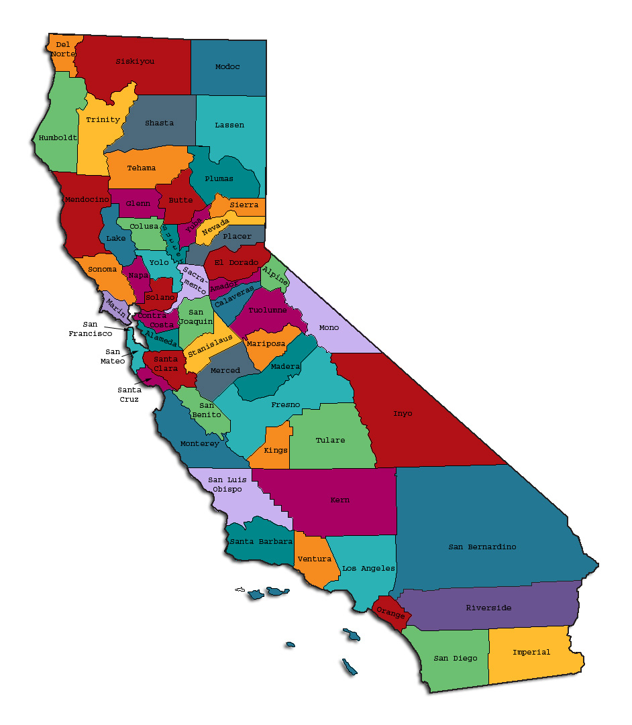
Prepared by California Mental Health Planning Council, in collaboration with: California Association of Mental Health Boards/Commissions, and APS Healthcare/EQRO
This Page Intentionally Left Blank.
Date: April 20, 2014
To: Chairpersons and/or Directors
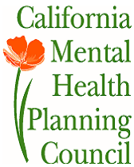
Local Mental Health Boards and Commissions
From: California Mental Health Planning Council
Subject: Instructions for Data Notebook 2014

We ask that this report be prepared by the MH Board or Commission members. You are the most important resources for identifying program strengths and needs in your community.
On the first page, please fill in the requested information for your county websites:
- Department of Behavioral Health/ Mental Health
- Public reports about your county’s MH services.
Please send a copy of the filled-in first page to the Planning Council along with your final report which contains your answers to the questions in the Data Notebook. Please submit your report within 60 days by email to:
DataNotebook@cmhpc.ca.gov.
Or, you may mail a printed copy of your report to:
- Data Notebook Project
- California Mental Health Planning Council
- 1501 Capitol Avenue, MS 2706
- P.O. Box 997413 Sacramento, CA 95899-7413
Please examine the enclosed information, which will help you discuss the questions in the Data Notebook. We provide examples of recent mental health data for your county. In some figures, the term “MHP” is used to refer to your county’s Mental Health Plan.
Some data comes from APS Healthcare/EQRO, which gave permission to use their figures and tables, prepared for review of each county’s Medi-Cal Specialty Mental Health services.Data in this packet came from the following review cycle:
_____ Fiscal Year 2013 -- 2014: http://caeqro.com/webx/.ee85675/
__X__ Fiscal Year 2012 -- 2013: http://caeqro.com/webx/.ee851c3/
For some questions, you will need to consult your local county Quality Improvement Coordinator, and/or Mental Health Director. If you are not able to address all of the questions, just answer the ones you can.
Thank you for your participation in the Data Notebook Project.
This Page Intentionally Left Blank

Lassen County: Data Notebook 2014
for California
Mental Health Boards and Commissions

County Name: Lassen Population (2013): 32,726
Website for County Department of Mental Health (MH) orBehavioral Health:
________________________________________________________________
Website for Local County MH Data and Reports:
________________________________________________________________
Website for local MH Board/Commission Meeting Announcements and Reports:
________________________________________________________________
Specialty MH Data from review Year 2013-2014: http://caeqro.com/webx/.ee85ab0/
Total number of persons receiving Medi-Cal in your county(2012): 6,801
Average number Medi-Cal eligible persons per month: 5,160
Percent of Medi-Cal eligible persons who were:
Children, ages 0-17: 42.1 %
Adults, ages 18-59: 45.3%
Adults, Ages 60 and Over: 12.6%
Total persons with SMI or SED who received Specialty MH services (2012):
Percent of Specialty MH service recipients who were: 584
Children 0-17:30.8%
Adults 18-59: 64.7%
Adults 60 and Over: 4.5%
This Page Intentionally Left Blank
INTRODUCTION: Purpose, Goals, and Data Resources
This Data Notebook has been developed for the use by the local mental health (MH) boards and commissions by a yearlong workgroup comprised of members from:
- California Mental Health Planning Council (CMHPC)
- California Association of Local Mental Health Boards and Commissions (CALMHB/C)
- APS Healthcare/ EQRO (External Quality Review Organization)
Our plan is for the Data Notebook to meet these goals:
- assist local boards to meet their mandates to review the local county mental health systems, identify unmet needs, and recommend improvements.
- provide a professional format for submitting reports to their local Board of Supervisors, and/or their county Director of Mental Health Services.
- function as an educational tool for local boards, whose members have varying levels of skills, frequent turnover, and need ‘refresher’ training about using data.
- help the CMHPC fulfill its mandates to review and report on the public mental health system in California, which also helps provide evidence for advocacy.
Data reporting drives policy, and policy drives funding for programs. But the data must be both recent and available to the public, or else it isnot useful. So, the CMHPC will provide examples of local data from current public reports. We focus on two broad areas: (1) evaluation of program performance, and (2) indicators of client outcomes.
We recognize that each county has a unique population, resources, strengths, and needs. Thus, there is no single perfect data source to answer all the important questions one might ask about mental health services. However, the following data resources will help board members answer questions in this Data Notebook:
- experience and opinions of the local mental health board members
- recent reports about county MH programs from APS Healthcare/EQRO
- data you request from your county QI Coordinator and/or Mental Health Director (because CMHPC does not have that data, and it’s not in other public reports)
- client outcomes data provided by California Institute of Mental Health (CiMH) in their analysis of the most recent Consumer Perception Survey.
Some of our data comes from APS Healthcare/EQRO, which kindly gave permission to use their figures and tables, prepared forreview of each county’s Medi-Cal Specialty Mental Health services. Those reviews are at: www.CAEQRO.com. You may find the full-length EQRO reports helpful because they summarizekey programs and quality improvement efforts for each county. They also describe strengths, opportunities for improvement, and changes in mental health programs since the last year.
Understanding changes in local programs can help consumers because of the massive re-organization of mental health services statewide. Some changes have been confusing to clients. The old state Department of Mental Health was eliminated in 2012 and many functions were moved to the Department of Health Care Services. Other changes due to federal health care reform and the Affordable Care Act affect how mental health services are provided, funded, and linked to primary health care or substance use treatment. Also, local counties have adjusted to major challenges.
Remember, this report is about your community, and what you and your stakeholders choose to discuss. Examining the data can indeed “Tell a Human Story.” But quantitative data (numbers) provides only part of the picture, for example:
- measures of whether the quality of program services improve over time
- whether more people from different groups are receiving services
- how many clients got physical healthcare or needed substance use treatment.
The other part of the story gives human context to the numbers. Such qualitative data (narrative, descriptions, or stories) tells more of the story, because we can:
- describe special programs targeted for outreach to specific groups
- examine how the programs are actually implementing their goals
- list concrete steps that are taken to improve services, and
- tell what is being done to increase client engagement with continued treatment.
We hope this project contributes to ongoing quality improvement (QI) in mental health services. We seek constant improvement in our approach to quality because:
- needs change over time,
- all human endeavors are by nature imperfect,
- creativity gives rise to new ideas, and
- we can share examples of successful programs to help other communities.
One question is whether local boards are permitted to provide additional information, besides that requested in this Notebook. We always welcomesupplemental reports about successful projects,or which the county administration uses to inform the public. Any additional reports may be attached in an “Appendix,” with the website address (if available). However, we emphasize such extra reports arenot required.
Thank you for participating in this project. We hope this Data Notebook serves as a springboard for your discussion about all areas of the mental health system, not just those topics highlighted by our questions.
TREATING THE WHOLE PERSON:
Integrating Behavioral and Physical Health Care
Studies have shown that individuals with serious mental illness die, on average, 25 years earlier than the general population. This information makes improving the physical health of clients of great importance and should be a goal of county mental health departments along with providing effective and appropriate mental health services. Coordination of care for mental health, substance abuse and physical health is one way of accomplishing the goal.
The California Mental Health Planning Council does not have any data to provide to show how your county’s programs connect clients of mental health services with necessary physical health care. We ask that the local mental health board request information from your county mental health department for any data on numbers (or percent) of total mental health clients who are referred to, or connected with, physical health providers to assess, treat and monitor physical health issues.
If your county has data on numbers or percentages of clients who are also receiving physical health care, please include it in your Data Notebook you submit to the Council.
_X__ Check here if your county does not have such data or information.

- Please describe any efforts in your county to improve the physical health of clients.
Lassen County began introducing integration using SAMHSA- HRSA integration weninars and recommendations. We contracted with consultants Dr. Ken Minkoff and Dr. Chris Cline and learned to assess our capabilities for integration treating the whole person. Our first step was integrating substance use services with mental health services explored strategies for co-locating or working with primary healthcare providers. We currently have an ongoing dialog with our community clinics building professional relationships. A beginning step that has been successful is we found common ground in Primary Prevention Strategies like Screening Brief Intervention Referral to Treatment SBIRT. We offer PCP trainings, and have improved a treatment referral process. Case management includes updating and sharing health care visits as indicated on services plans. We developed a program improvement strategy for client access by assuring a nurse visit, orientation and medical records review for each new client. Regular staff trainings are held for understanding the impacts of the Affordable Care Act, Meaningful Use with Electronic Health Records as it relates to improving client care with bi-directional PCP and Pharmacy communication.

2) How does your county address wellness programs to engage and motivate clients to take charge of improving their physical health?
- Lassen County provides weekly group sessions utilizing evidence based curriculum on Whole Health Action, Management (WHAM) . This is a 12 week program that includes these elements to empower the clients to take charge of their wellness, .including:
- Physical exercise
- Nutrition
- Healthy cooking
- Stress management
- Tobacco Education & Cessation
- Symptoms recognition, and managment
- Social events and support groups

NEW CLIENTS: One Measure of Access
One way to evaluate the quality of mental health services outreach is to measure how many clients receive services who have never been part of the service system before (“brand new” clients). Another measure is how many clients return for services after a period of time with no services (“new” clients).
The California Mental Health Planning Council is exploring how each county mental health department defines “new” clients, and how a client is labelled when they return for additional services. This information is important in determining whether your county has a “revolving door,”that is, clients who are in and out of mental health services repeatedly. This data is one indicator of the success of your county’s programs in closing cases appropriately and providing adequate discharge planning to clients.
This data is not currently reported by the counties to the state. The Council does not have data to provide to you. This information should be requested from your county mental health department.
____ Check here if your county does not have this information.
3. How does your county define 'new' client for those individuals who have previously received services, but who have not received services for a while? (e.g., 6 months, 12 months, 2 years?)
Clients who have not received services in 12 months are re-opened with a new service plan and consents updated. LCBH wants clients to be reassessed with a continuous review of progress. Clients who have medical necessity are evaluated for level of care and re-engaged based on those identified needs. These could be called “new clients’ in that process as we improve our chronic care model, the clients are identified as continuous in recovery and an successful outcome measurement with their stated treatment goals is to assist them to move forward and not hinder them with a label or diagnosis. A new client has not received services or “has been newly identified in our tracking system.
4. Please provide any data your county has on the number of 'new' clients last year. And if you have it, how many of those new clients were brand new clients? You may need to ask your county mental health department for this data.
*NOT AVAILABLE AT THIS TIME
# new children/youth (0-17 yrs) _____
of these, how many (or %) are ‘brand new’ clients _____

# new adults (18-59 yrs) _____
of these, how many (or %) are ‘brand new’ clients _____

# new older adults (60+ yrs)_____
of these, how many (or %) are ‘brand new’ clients _____
*This information has not been accessed in our new electronic system, and reports are not accurate at this time.

REDUCING RE-HOSPITALIZATION: Access to Follow-up Care
Sometimes, an individual experiences acute symptoms of mental illness or substance abuse which can result in a brief stay in an acute care hospital. Receiving follow-up services after discharge from a short-term (3-14 day) hospitalization can be critical to preventing a return to the hospital.
The chart below shows the percentage of people discharged in your county who received at least one service within 7 days of discharge. Also shown is the percentage of those same people who were readmitted to the hospital. The chart also shows the same information for receiving services and being readmitted to the hospital within 30 days. Red indicates the numbers for your county and the blue indicates the percentage for the state of California.

LassenCounty:
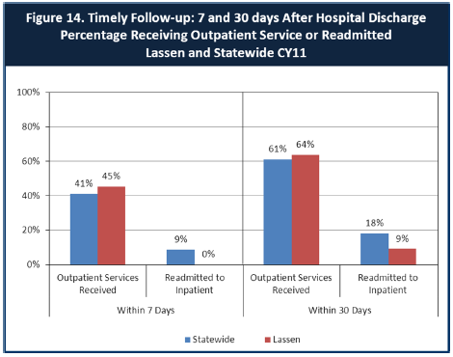

6. Looking at the chart, is your county doing better or worse than the state? Discuss why (e.g., your county has programming available that specifically ensures a warm handoff for follow-up services).
Looking at the chart, our county is doing about average. We have implemented a warm hand off from crisis to stabilization. The success of the LCBH “Rebound” program is dependent on an open and continuous communication channel with the admitting hospitals, discharge planners, and ER personnel. Discharge planning begins early centered on targeted case management for engaging the client with welcoming support. Our clients have transportation arranged and appointments scheduled for their follow up. Some clients still fall through the cracks and our quality review team uses these instances to improve the system of follow up procedures. 7. Do you have any suggestions on how your county can improve follow-up and reduce re-hospitalizations?
Our 24/7 crisis and On Call Providers work with us to provide daily documentation for immediate follow up on any calls after hours.
Lassen County Behavioral Health works closely with Lassen Aurora Network, a local non profit organization serving the community by providing a safe environment for drop ins and mental health awareness and education. They connect utilizing peer volunteers with lived experience. They work closely with Behavioral Health, serve on the BH Advisory Board and help extend our outreach capabilities to those clients who do not access well.
We are currently diligently working on developing a recovery oriented system of care. This includes offering a new day program that is located on the clinic site. This proposed New Horizons Recovery Center (NHRC) will be staffed with LCBH Case Workers and Volunteers. It will open daily for drop in serves and enhance opportunities for clients to have immediate access to case managers, learn from recovering peers to help identify their symptoms and with support,learn skills for communicating their needs at an earlier stage.
8. What are the three most significant barriers to service access? Examples:
- Transportation
- Child care
- Language barriers or lack of interpreters
- Specific cultural issues
- Too few child or adult therapists
- Lack of psychiatrists or tele-psychiatry services
- Delays in service
- Restrictive time window to schedule an appointment

Primarily we serve clients in a large geographic rural area. Unemployment and homelessness is a growing challenge in serving Veterans and transitioning young adults, Poverty is a culture that impacts our clients. Some clients have needs for alternatives in the models of treatment based on their ethnic or cultural backgrounds. For example migrant workers, whose primary languages are other than English. Native American clients who have limited mental health services on the Reservation yet have co-occurring diagnosis of substance use and physical chronic illness. Also, many “no shows” are clients who have been recently released from our Detention Facilities and prisons with a long history of incarceration and trauma. They are referred from Probation or Parole and do not seem to follow through with appointments. This creates a delay in scheduling others.. There is a challenge of outreach and engagement and training for staff on seamless delivery systems among substance use, primary care, and mental health providers.ACCESS BY UNSERVED AND UNDER-SERVED COMMUNITIES
One goal of the Mental Health Services Act (MHSA) is to reach unserved and underserved communities, especially communities of color. The MHSA promotes outreach to engage these communities in services. If individuals and families in these communities are not accessing services, then we may need to explore new ways of reaching them. Or, we may need to change our programs to meet their mental health needs in ways that better complement their culture.
From data the counties report to the state, we can see how many individuals living in your county are eligible for Medi-Cal, and of those individuals, how many received mental health services. Are you serving the Medi-Cal clients who need your services?
LassenCounty:
The data has indicated we are doing well with these individuals.
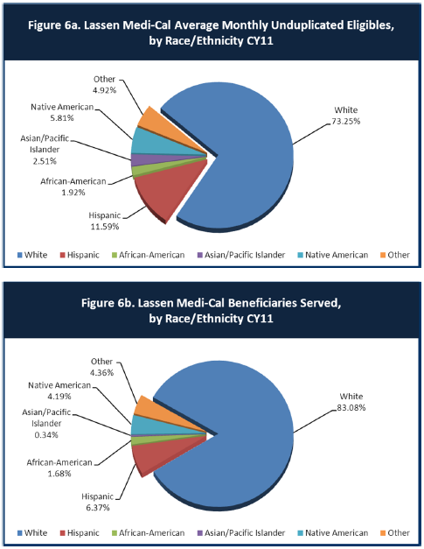
9. Is there a big difference between the race/ethnicity breakdown on the two charts? Do you feel that the group(s) that need services in your county are receiving services?
We have been concentrating on improving our outreach through regular meetings with leadership and front line staff from our county social services and public health departments. Our staff is also cross trained and updated with supprot for identifying potential clients who qualify for these benefits and we have case managers prepared to assist them with language needs.

10. What outreach efforts are being made to reach minority groups in your community?

11. Do you have suggestions for improving outreach to and/or programs for underserved groups?

CLIENT ENGAGEMENT IN SERVICES
One MHSA goal is to connect individuals to services they need to be successful. Clients who stop services too soon may not achieve much improvement, nor is it likely to last. So it is important to measure not only who comes in for treatment, but also how long they stay in services. Here we are considering individuals with high service needs, not someone who just needs a ‘tune-up.’ Although not every individual needs the same amount of services, research shows that when someone with severe mental illness continues to receive services over time, their chances of recovery increase.
Engagement in services, also called ‘retention rate’, is important to review. If individuals come in, receive only one or twoservices and never come back, it may mean the services were not appropriate, or that the individual did not feel welcome, or some other reason that should be explored. Again, we recognize that some individuals only need minimal services, but here we are looking at those with severe mental illness. Ultimately, the goal is to ensure they are getting needed services and are on the road to recovery. But we would not know that unless we look at how many services individuals received over time.
The chart below shows the number of Medi-Cal beneficiaries in your county who received 1, or 2, or 3, or 4, or 5, or more than15 mental health services during the year. For individuals experiencing severe mental illness, the more engaged they are in services, the greater the chance for lasting improvements in mental health.

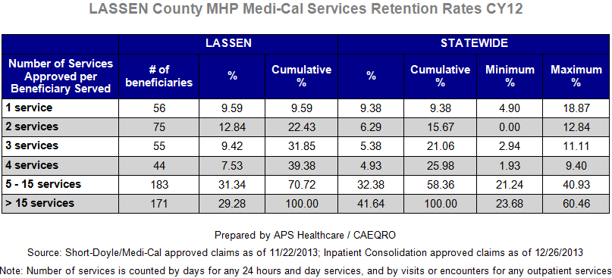

12. Do you think your county is doing a good job at keeping clients engaged in services? If yes, how? If not, why?
I think we are doing fairly well, but our demographics has changed over the past few years with more identified minorities needing services in the outlying areas of the county. Our professional and financial commitment to keeping services at the “one stop” Resource Centers located in these areas seems to be helping us to reach more of the underserved populations
13. For those clients receiving less than 5 services, what is your county doing to follow-up and re-engage those individuals for further mental health services?
The Quality Improvement committee is tasked with identifying the issues associated with a lack of follow up or when a client seems to disengage. Current focus on improving client care through welcoming and immediate access seems to be one answer to strengthening our presence in the community. Working with evidence based Prevention and Early Intervention materials, and training our staff to work within interdisciplinary teams, and establishing community partnerships provides new perspectives on client and community engagement.
14. Looking at the previous chart of who is being served by race/ethnicity in your county, do you have any thoughts or ideas to share regarding your county’s engagement of underserved communities?
Recently we chose to target a public school population (parents and students as well as faculty) where we identified underserved populations with needs for, language and cultural differences and isolation due to rural location. We are presenting evidence based early intervention through life skills training for students and parents in Spanish by a trained facilitator, case manager and prevention specialist. We are engaging this learning community while helping them to be comfortable accessing more services that are available for their families. Empowering these identified small populations with skills, will assist us reaching out the larger community of underserved populations and developing relationships in their safe environments like schools seems to make sense

CLIENT OUTCOMES: Consumer Perception Survey(August 2013)
Ultimately, the reason we provide mental health services is to help individuals manage their mental illness and to lead productive lives. We have selected two questions from the Consumer Perception Survey which capture this intention. One question is geared toward adults of any age, and the other is for children and youth under 18.
Below are the data for responses by clients in your county to these two questions.
For general comparison, statewide reference information and data for various sized counties are shown in the tables on page 19.
The total numbers of surveys completed for Adults or Children/Youth in your county are shown separately in the tables below, under the heading “Total.”

Q1. Adults. As a direct result of the services I received, I deal more effectively with daily problems.
 | Strongly Disagree | Disagree | Neutral | Agree | Strongly Agree | Total
Number of Responses | 3 | 0 | 14 | 9 | 7 | 33
Percent of Responses | 9.1 % | 0 % | 42.4 % | 27.3 % | 21.2 % | 100.0 %

Q2. Children/Youth. As a result of services my child and/or family received, my child is better at handling daily life.

 | Strongly Disagree | Disagree | Neutral | Agree | Strongly Agree | Total
Number of Responses | 0 | 0 | 4 | 4 | 2 | 10
Percent of Responses | 0 % | 0 % | 40.0 % | 40.0 % | 20.0 % | 100.0 %

15. Are the data consistent with your perception of the effectiveness of mental health services in your county?
Somewhat consistent however improvement is needed in overall number of responses.
16. Do you have any recommendations for improving effectiveness of services?
More consumer involvement in all areas of program design. More opportunities for input and provide routine satisfaction surveys, at the end of sessions or appointment experiences to measure our improvement.
17. Many counties experience very low numbers of surveys completed. Do you have suggestions to increase the response rate?
Generate energy and excitement for participation before a survey period. We should report the findings and possible changes that result from their participation in the surveys like newsletter articles. We should also create a display for improvement plans that were developed as a result of their input. Clients need to feel what they say made a difference or the complacency grows

18. Lastly, but perhaps most important overall, with respect to delivery of services, do you have suggestions regarding any of the following:

- Specific unmet needs or gaps in services

- Improvements to, or better coordination of, existing services

- New programs that need to be implemented to serve individuals in your county

- We are experiencing challenges in this period of accepting and learning to utilize the new data collection capabilities of our Electronic Health Records. Frustration is running high as staff attempts to learn and use these new systems. There are some gaps that are not easily identified because the system and software design is a moving target, with new regulations and criteria being added. Newer data reports are often not complete or sometimes lack accurate or applicable information. The system will improve as more agencies in California are involved in the software development of cohesive, integrated and responsive Electronic Health Records. A need for precious staff time for training on systems, and the necessary communication skills to helping clients understand the clinical usefulness of technology that will keep them in charge of their health including shared systems with their primary care providers.
- Workforce development is a need. Rural communities like Lassen County often experience access issues due to a lack of qualified professional staff, including RNs, clinical psychologists, and board certified psychiatrists. We have had a difficult time attracting qualified professionals to our area due to employment opportunities for spouses or family members. As a result we have recently decided to dedicate time and money towards measuring the effectiveness and the technical challenges of providing tele-psychiatry. In order for this type of service to be successful we must have our staff fully engaged with our clients at every visit or phone call. Interactions with caring volunteers, staff and peers will be essential for the new “tele medicine” era. Insurance and parity issues for serving our clients Training is needed for accountability and helping them to understand changes in modalities are needed for complex co-occurring diagnosis and treatment effectiveness as well as meeting the managed care payment systems.
- Over the past 2 years we faced the challenges of integrating our substance use disorders services and our mental health services. However merging the state and federal requirements in code for Medi-Cal and Drug Medi-Cal, Title 9 and Title 22, restrictions on confidentiality etc. have been challenging for our staff to co-create coordinated person centered care plans.
.
- We have a growing population of criminal justice referrals, crisis calls, and clients who become incarcerated as a result of their mental illness. We need to continue to work on the community relationships with our law enforcement and judicial partners and work with the local primary care clinics and hospital ER to open pathways or crosswalks for the seriously mentally ill clients we are all serving. Medication assisted therapy, and cognitive restructuring programs are needed and appear to be on the horizon.

- And as others have identified, Lassen County likewise has a growing need for early intervention, and primary prevention to make a difference in the future’s families by working with young children, parents, and transitioning youth who have been affected by the environmental stressors and trauma of their lives. We will continue to identify effective strategies by attending meetings, belonging to professional associations, and creating a desire to learn new methods and among our staff and especially among our clients.

<END>

REFERENCE DATA: for general comparison with your county MHP results

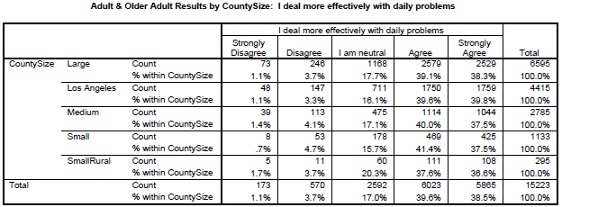

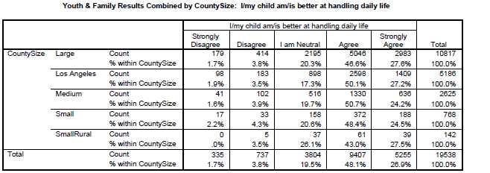

County Mental Health Plan Size: Categories are based upon DHCS definitions by county population.
o Small‐Rural MHPs = Alpine, Amador, Calaveras, Colusa, Del Norte, Glenn, Inyo, Lassen, Mariposa, Modoc, Mono, Plumas, Siskiyou, Trinity
o Small MHPs = El Dorado, Humboldt, Imperial, Kings, Lake, Madera, Mendocino, Napa, Nevada, SanBenito, Shasta, Sutter/Yuba, Tehama, Tuolumne
o Medium MHPs = Butte, Marin, Merced, Monterey, Placer/Sierra, San Joaquin, San Luis Obispo, San Mateo, Santa Barbara, Santa Cruz, Solano, Sonoma, Stanislaus, Tulare, Yolo
o Large MHPs = Alameda, Contra Costa, Fresno, Kern, Orange, Riverside, Sacramento, San Bernardino, San Diego, San Francisco, Santa Clara, Ventura
o Los Angeles’ statistics are excluded from size comparisons, but are included in statewide data.
Total Values (in Tables above) = include all statewide data received by CiMH for these survey items.

REMINDER:

Thank you for your participation in completing your Data Notebook report.
Please feel free to provide feedback or recommendations you may have to improve this project for the following year. We welcome your input.

Please submit your Data Notebook report by email to:
DataNotebook@CMHPC.CA.GOV

Or, you may submit a printed copy by postal mail to:
- Data Notebook Project
- California Mental Health Planning Council
- 1501 Capitol Avenue, MS 2706
- P.O. Box 997413
- Sacramento, CA 95899-7413

For information, you may contact either email address above, or telephone:
(916) 449-5249, or
(916) 323-4501

Serious Mental Disorder, term used for adults 18 and older.
Severe Emotional Disorder, term used for children 17 and under.

