KERN COUNTY: DATA NOTEBOOK 2014

FOR CALIFORNIA
MENTAL HEALTH BOARDS AND COMMISSIONS

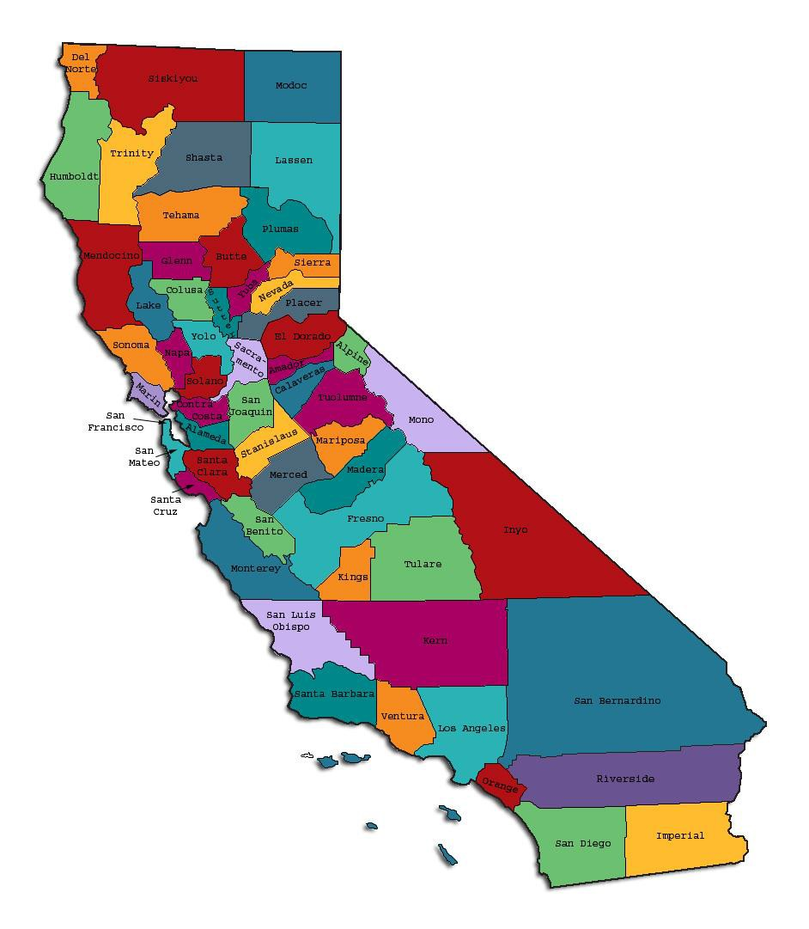
Prepared by California Mental Health Planning Council, in collaboration with: California Association of Mental Health Boards/Commissions, and APS Healthcare/EQRO

This Page Intentionally Left Blank.

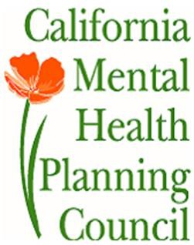Date: April 20, 2014

To: Chairpersons and/or Directors

Local Mental Health Boards and Commissions From: California Mental Health Planning Council Subject: Instructions for Data Notebook 2014

We ask that this report be prepared by the MH Board or Commission members. You are the most important resources for identifying program strengths and needs in your community.

On the first page, please fill in the requested information for your county websites:

- Department of Behavioral Health/ Mental Health
- Public reports about your county’s MH services.

Please send a copy of the filled-in first page to the Planning Council along with your final report which contains your answers to the questions in the Data Notebook. Please submit your report within 60 days by email to:

DataNotebook@cmhpc.ca.gov.

Or, you may mail a printed copy of your report to:

- Data Notebook Project
- California Mental Health Planning Council
- 1501 Capitol Avenue, MS 2706
• P.O. Box 997413 Sacramento, CA 95899-7413

Please examine the enclosed information, which will help you discuss the questions in the Data Notebook. We provide examples of recent mental health data for your county. In some figures, the term “MHP” is used to refer to your county’s Mental Health Plan.

Some data comes from APS Healthcare/EQRO, which gave permission to use their figures and tables, prepared for review of each county’s Medi-Cal Specialty Mental Health services. Data in this packet came from the following review cycle:

X Fiscal Year 2013 -- 2014: http://caeqro.com/webx/.ee85675/

Fiscal Year 2012 -- 2013: http://caeqro.com/webx/.ee851c3/

For some questions, you will need to consult your local county Quality Improvement Coordinator, and/or Mental Health Director. If you are not able to address all of the questions, just answer the ones you can.

Thank you for your participation in the Data Notebook Project.

This Page Intentionally Left Blank

KERN COUNTY: DATA NOTEBOOK 2014

FOR CALIFORNIA
MENTAL HEALTH BOARDS AND COMMISSIONS

County Name: Kern Population (2013): 866,977 Website for County Department of Mental Health (MH) or Behavioral Health:
http://www.co.kern.ca.us/artman2/kcmh/publish/

Website for Local County MH Data and Reports:

Website for local MH Board/Commission Meeting Announcements and Reports:

_http://www.co.kern.ca.us/kcmh/bhb/

Specialty MH Data from review Year 2013-2014: http://caeqro.com/webx/.ee85675

Total number of persons receiving Medi-Cal in your county (2012): 307,682 Average number Medi-Cal eligible persons per month: 249,957
Percent of Medi-Cal eligible persons who were: Children, ages 0-17: 51.9 %
Adults, ages 18-59: 39.3 % Adults, Ages 60 and Over: 8.8 %
Total persons with SMI1 or SED2 who received Specialty MH services (2012): 12,796
Percent of Specialty MH service recipients who were: Children 0-17: 53.0 %
Adults 18-59: 43.0 %

Adults 60 and Over: 4.0 %

1 Serious Mental Disorder, term used for adults 18 and older.
2 Severe Emotional Disorder, term used for children 17 and under.

This Page Intentionally Left Blank

INTRODUCTION: Purpose, Goals, and Data Resources
This Data Notebook has been developed for the use by the local mental health (MH) boards and commissions by a yearlong workgroup comprised of members from:
- California Mental Health Planning Council (CMHPC)
- California Association of Local Mental Health Boards and Commissions (CALMHB/C)
- APS Healthcare/ EQRO (External Quality Review Organization) Our plan is for the Data Notebook to meet these goals:
- assist local boards to meet their mandates to review the local county mental health systems, identify unmet needs, and recommend improvements.
- provide a professional format for submitting reports to their local Board of Supervisors, and/or their county Director of Mental Health Services.
- function as an educational tool for local boards, whose members have varying levels of skills, frequent turnover, and need ‘refresher’ training about using data.
- help the CMHPC fulfill its mandates to review and report on the public mental health system in California, which also helps provide evidence for advocacy.
Data reporting drives policy, and policy drives funding for programs. But the data must be both recent and available to the public, or else it is not useful. So, the CMHPC will provide examples of local data from current public reports. We focus on two broad areas: (1) evaluation of program performance, and (2) indicators of client outcomes.
We recognize that each county has a unique population, resources, strengths, and needs. Thus, there is no single perfect data source to answer all the important questions one might ask about mental health services. However, the following data resources will help board members answer questions in this Data Notebook:
- experience and opinions of the local mental health board members
- recent reports about county MH programs from APS Healthcare/EQRO
- data you request from your county QI Coordinator and/or Mental Health Director (because CMHPC does not have that data, and it’s not in other public reports)
- client outcomes data provided by California Institute of Mental Health (CiMH) in their analysis of the most recent Consumer Perception Survey.
Some of our data comes from APS Healthcare/EQRO, which kindly gave permission to use their figures and tables, prepared for review of each county’s Medi-Cal Specialty Mental Health services. Those reviews are at: www.CAEQRO.com. You may find the full-length EQRO reports helpful because they summarize key programs and quality improvement efforts for each county. They also describe strengths, opportunities for improvement, and changes in mental health programs since the last year.

Understanding changes in local programs can help consumers because of the massive re-organization of mental health services statewide. Some changes have been confusing to clients. The old state Department of Mental Health was eliminated in 2012 and many functions were moved to the Department of Health Care Services. Other changes due to federal health care reform and the Affordable Care Act affect how mental health services are provided, funded, and linked to primary health care or substance use treatment. Also, local counties have adjusted to major challenges.
Remember, this report is about your community, and what you and your stakeholders choose to discuss. Examining the data can indeed “Tell a Human Story.” But quantitative data (numbers) provides only part of the picture, for example:

- measures of whether the quality of program services improve over time
- whether more people from different groups are receiving services
- how many clients got physical healthcare or needed substance use treatment.

The other part of the story gives human context to the numbers. Such qualitative data (narrative, descriptions, or stories) tells more of the story, because we can:
- describe special programs targeted for outreach to specific groups
- examine how the programs are actually implementing their goals
- list concrete steps that are taken to improve services, and
- tell what is being done to increase client engagement with continued treatment.

We hope this project contributes to ongoing quality improvement (QI) in mental health services. We seek constant improvement in our approach to quality because:
- needs change over time,
- all human endeavors are by nature imperfect,
- creativity gives rise to new ideas, and
- we can share examples of successful programs to help other communities.

One question is whether local boards are permitted to provide additional information, besides that requested in this Notebook. We always welcome supplemental reports about successful projects, or which the county administration uses to inform the public. Any additional reports may be attached in an “Appendix,” with the website address (if available). However, we emphasize such extra reports are not required.

Thank you for participating in this project. We hope this Data Notebook serves as a springboard for your discussion about all areas of the mental health system, not just those topics highlighted by our questions.

TREATING THE WHOLE PERSON:
Integrating Behavioral and Physical Health Care
Studies have shown that individuals with serious mental illness die, on average, 25 years earlier than the general population. This information makes improving the physical health of clients of great importance and should be a goal of county mental health departments along with providing effective and appropriate mental health services. Coordination of care for mental health, substance abuse and physical health is one way of accomplishing the goal.
The California Mental Health Planning Council does not have any data to provide to show how your county’s programs connect clients of mental health services with necessary physical health care. We ask that the local mental health board request information from your county mental health department for any data on numbers (or percent) of total mental health clients who are referred to, or connected with, physical health providers to assess, treat and monitor physical health issues.
If your county has data on numbers or percentages of clients who are also receiving physical health care, please include it in your Data Notebook you submit to the Council.

Check here if your county does not have such data or information.

Please describe any efforts in your county to improve the physical health of clients.
(Information provided by the Mental Health Plan - MHP)

If an individual receiving mental health services does not have a primary care physician, Kern County Mental Health (KCMH), adult and children’s services treatment teams attempt to link clients with a physician whenever possible. It is also a KCMH policy for the mental health department to coordinate mental health services with the client’s primary care physician. The adult Recovery and Wellness Center teams monitor the medical conditions, treatment and medications prescribed by a client’s primary care physician and attempt to coordinate mental health treatment with physical health care providers.
Specific examples of these efforts are found at the Stockdale Recovery and Wellness Center and the Northeast Brief Therapy Clinic. These clinics provide one on one nursing assessments and assistance to connect and communicate effectively with primary care. For the FY 2013-2014 90 nursing assessments were completed. Both teams have a goal of 100% of their clients having an assigned primary care physician. These teams also regularly communicate with a client’s health care provider during

treatment and work closely with primary care when a client is being transitioned from receiving specialty mental health services.
Also, the Self-Empowerment Team (“peer” clinical services) works one on one with clients to increase their skill with medical self-advocacy and being prepared and knowledgeable about their medications and their mental health and physical health diagnosis. These clinicians also help clients to make lists prior to medical appointments and also link and accompany clients to medical appointments as requested.
Issues related to physical health care, combined with substance use and mental illness are common to most every client seen at KCMH. The Department has a long history of treating the whole individual, providing both treatment for substance use/abuse and mental health needs as well as coordinating with physical health care.

The adult treatment teams of the Kern Linkage Division utilize the following practices

- Collaboration with local health care providers (e.g.,FQHCs) to streamline appointments for clients with a PCP. Within this collaborative effort, individuals are also applied for Medi-Cal under the Affordable Healthcare Act.
- Within the jail setting, collaboration with Kern Medical Center and Flood ministries allows clients in-custody to apply for Medi-Cal. Appointments with local FQHC’S are scheduled so that upon release, the client has immediate access to a PCP. Physical health treatment is also provided within the jail.
- Clients seeking services also receive a nursing assessment and releases of information are obtained by staff to contact the client’s health care provider and pharmacy. Every effort is made to ensure that clients see their healthcare provider, including providing transportation on rare occasions..

How does your county address wellness programs to engage and motivate clients to take charge of improving their physical health?
(Information provided by MHP)

The Consumer Family Learning Center (CFLC) offers peer support groups that focus on wellness and self- efficacy. Hearts and Minds is a NAMI-developed education class with a focus on eliminating and reducing the special risk factors persons with mental health challenges experience including: heart disease, smoking cessation, diabetes, hypertension, and medication side effects such as obesity. Dance Therapy offers exercise and high energy fun. Illness Management and Recovery is a SAMSHA developed program focusing on developing and using recovery and wellness strategies that include medical check-ups, medication consultation with primary care and psychiatry.

Additional examples of self-help activities at the CFLC to help clients take charge of improving their physical health include:
- Exercise- Dance and yoga classes
- Nutrition/Healthy Cooking - The Consumer Family Learning Center offers monthly healthy and low cost cooking classes in which clients are active participants.
- Stress management - The conflict management/resolution class, Overcoming Anxiety class, Yoga, along with using Laughter Yoga, drumming and the development of leisure activities are offered at least once a week. The Self- Empowerment Team provides two Wellness Recovery Action Planning groups for the broader working/student population with mental health challenges. The Mood Disorder Support Group is offered in the evenings to allow working people to attend.
- Quitting Smoking and other Unhealthy Habits - Hearts and Minds and Illness Management and Recovery Classes discuss quitting bad health habits like smoking.
- Maintaining social connectedness- The CFLC actively engages consumers in volunteerism both at the clinic and in community settings. The CFLC also encourages individual to engage and advocate on behalf of people with mental illness by serving on mental health system committees. The CFLC regularly posts community events/activities that are low/no cost and take clients into community settings such as the California Living Museum.
- The Recovery Supports Administration provides a Recovery Conference every year, inviting clients and family members, board and care residents, sober living residents, and people from the larger “disability” community to share their recovery stories and learn more skills.

Adult treatment teams encourage clients to engage in a variety of groups and community activities to take greater control of their physical health.

One example, within the Kern linkage division, involves encouraging clients to attend a variety of groups that assist in meeting their needs. One such group targets social skills. Within this group, a curriculum addresses the importance of exercise, nutrition, healthy cooking, stress management and increasing social connectedness. Grief and loss groups are provided to teach the skills necessary to manage chronic disease and other forms of loss. Kern linkage, also provides activities allowing clients to share their creative projects and/or skills with others consumers.

NEW CLIENTS: One Measure of Access
One way to evaluate the quality of mental health services outreach is to measure how many clients receive services who have never been part of the service system before (“brand new” clients). Another measure is how many clients return for services after a period of time with no services (“new” clients).
The California Mental Health Planning Council is exploring how each county mental health department defines “new” clients, and how a client is labeled when they return for additional services. This information is important in determining whether your county has a “revolving door,” that is, clients who are in and out of mental health services repeatedly. This data is one indicator of the success of your county’s programs in closing cases appropriately and providing adequate discharge planning to clients.
This data is not currently reported by the counties to the state. The Council does not have data to provide to you. This information should be requested from your county mental health department.

Check here if your county does not have this information.

How does your county define 'new' client for those individuals who have previously received services, but who have not received services for a while? (e.g., 6 months, 12 months, 2 years?)
(Information provided by MHP)

Kern County Mental Health defines a “new” client, for those individuals who have previously received services, if they haven’t received services for at least one year.

Please provide any data your county has on the number of 'new' clients last year. And if you have it, how many of those new clients were brand new clients? You may need to ask your county mental health department for
this data.

(Information provided by MHP)
# new children/youth (0-17 yrs): 4,953
of these, how many (or %) are ‘brand new’ clients: | 3,815 (77%)
# new adults (18-59 yrs): 9,810
of these, how many (or %) are ‘brand new’ clients: | 5,726 (58%)
# new older adults (60+ yrs): 548
of these, how many (or %) are ‘brand new’ clients: | 364 (66%)

REDUCING RE-HOSPITALIZATION: Access to Follow-up Care
Sometimes, an individual experiences acute symptoms of mental illness or substance abuse which can result in a brief stay in an acute care hospital. Receiving follow-up services after discharge from a short-term (3-14 day) hospitalization can be critical to preventing a return to the hospital.
The chart below shows the percentage of people discharged in your county who received at least one service within 7 days of discharge. Also shown is the percentage of those same people who were readmitted to the hospital. The chart also shows the same information for receiving services and being readmitted to the hospital within 30 days. Red indicates the numbers for services or events within 30 days, and the blue indicates services or events within 7 days of patient discharge. (CY = Calendar Year, e.g., 2011 or 2012, as indicated below).

Kern County:

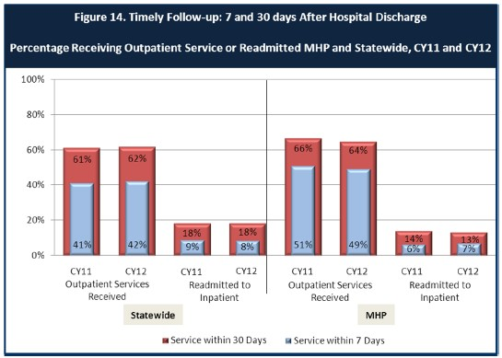

- Looking at the chart, is your county doing better or worse than the state? Discuss why (e.g., your county has programming available that specifically ensures a warm handoff for follow-up services).
(Information provided by MHP)

KCMH exceeds the state’s performance in post-hospitalization follow-up through a number of efforts. We have a policy prescribing outpatient clinical service contact within 7 days of discharge. We also have policy and agreements/MOUs with our acute inpatient facilities requiring us to be very involved in the discharge planning process from the moment of admission. This enables us to be involved in the discharge, often taking the client from the facility to their home or our office. KCMH also operates a weekly, multiagency meeting (Length of Stay) with our partners to ensure discharge planning is taking place and being effective.

Additional KCMH clinical activities that help our department to have a lower recidivism rate compared to the State average include:

- For many years, KCMH has had an outpatient program (Crisis Case Management Outreach-CCMO) working to transition individuals to mental health services following hospitalizations
- Since 2012 KCMH’s Crisis Services Division has implemented a Care Management Project to support KCMH’s effort to reduce recidivism. This enhanced program includes:
  - Weekly meetings to monitor length of hospitalization and develop post hospital plans
  - Assuring that Interdisciplinary Team Plans (IDTs) are developed within 3 days of hospitalization and weekly thereafter
  - Developing “Integrated Enhanced Service Plans” (IESP) for individuals who have returned to the hospital
  - Efforts to assure coordination between the hospital and outpatient programs and assure a “warm handoff” between these programs
- KCMH is also monitoring and addressing recidivism to the crisis and inpatient units and engaging individuals who are utilizing crisis services frequently, making efforts to connect them to assessments so they can access outpatient mental health services.
- Friese Hope House also serves to reduce recidivism, providing individuals with a stable, supportive environment at a lower level of care immediately following hospitalization. This service often reduces re-hospitalizations for individuals at risk.
- If a hospitalized individual is not connected to mental health services and this need is identified while the individual is inpatient, then the Assessment Center also maintains connections with hospital social workers who may contact Assessment Center to schedule an urgent assessment appointment upon discharge.
- Additionally, the department is re-starting follow up phone calls to individuals being discharged from inpatient units in order to ensure individuals are knowledgeable about how to access mental health services following inpatient discharge and can be connected to services if needed.

Do you have any suggestions on how your county can improve follow-up and reduce re-hospitalizations?
(Information provided by MHP)

Because some clients require transition to Long-Term-Care facilities from the acute facilities, the follow-up rate will always be less than 100%. When poor follow-up and/or re-hospitalization occurs, lack of adequate housing and related supports often proves to be a factor. KCMH is working to ensure a comprehensive continuum of housing resources exists for this population. In addition, efforts like our Adult Residential Facility Task Force bring our professional staff and housing providers together to address problems and support and extend competencies to work effectively with our complex population.

What are the three most significant barriers to service access?

(Information provided by MHP)

- The criteria for acceptance to receive mental health services has been a barrier for individuals with milder mental health problems in the recent past, although people with severe psychiatric symptoms were able to access services. However, the California Department of Health Care Services (DHCS) has recently revised the eligibility criteria for receiving mental health services and Medi-Cal beneficiaries with less severe conditions may now receive mental health services. Individuals with mild to moderate mental health problems may receive mental health services from their Managed Care Plans (MCPs) and those with “significant” mental health problems may receive services from Kern County’s Mental Health Plan (i.e., Kern County Mental Health)..
- Another significant barrier is the number of appointments individual seeking services must attend before they actually begin treatment. On average, clients seeking services must go through a screening, assessment, and orientation appointment before they begin with group services, medication services or therapy services. With other barriers present (difficulty with transportation, difficulty with motivation and engagement), the number of appointments an individual must initially attend can be a significant barrier.
- Substance use and the lack of integration at initial assessment between substance abuse and mental health. Many individuals coming into the system of care have co-occurring disorders. While substance abuse services are integrated once an individual is engaged in an outpatient team, the coordination of services between mental health and substance abuse could be more collaborative and integrative to assist individuals in accessing both services simultaneously rather than having to attend two separate intake, orientations and programs.

Another significant barrier important to mention involves transportation to and from services. Many of the individuals seeking services do not have reliable transportation and /or do not the funds to obtain transportation.

ACCESS BY UNSERVED AND UNDER-SERVED COMMUNITIES
One goal of the Mental Health Services Act (MHSA) is to reach unserved and underserved communities, especially communities of color. The MHSA promotes outreach into these communities to engage these communities in services. If individuals and families in these communities are not accessing services, then we may need to explore new ways of reaching them. Or, we may need to change our programs to meet their mental health needs in ways that better complement their culture.
From data the counties report to the state, we can see how many individuals living in your county are eligible for Medi-Cal, and of those individuals, how many received mental health services. Are you serving the Medi-Cal clients who need your services?

Kern County Data:

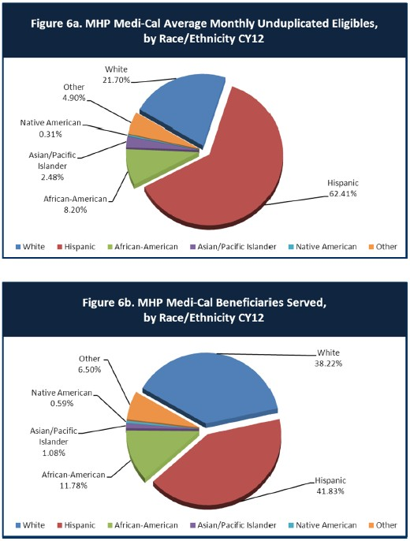

- Is there a big difference between the race/ethnicity breakdown on the two charts? Do you feel that the group(s) that need services in your county are receiving services?
(Information provided by MHP)

The two charts compare: 1) the % of Medi-Cal eligibles for each race/ethnicity group in Kern County to 2) the % of each race/ethnicity group that actually received mental health services.

In comparison, the following race/ethnicity groups are receiving a higher percentage of services than would be predicted by their percentage of the Medi-Cal population

Race/Ethnic Group | % Medi-Cal Eligible | % Receiving MH Services
White | 21.70 | 38.22
Native American | .31 | .59
African-American | 8.20 | 11.78

In comparison, the following race/ethnicity groups are receiving a lower percentage of services than would be predicted by their percentage of the Medi-Cal population.

Race/Ethnic Group | % Medi-Cal Eligible | % Receiving MH Services
Hispanic | 62.41 | 41.83
Asian/Pacific Islander | 2.48 | 1.08

Based on this data alone, KCMH may be adequately providing mental services to communities who are White, Native-American and African American. However, additional outreach efforts may be needed with a focus on the Hispanic and Asian/Pacific Islander groups.

It’s important to note that additional data comparing Kern County with other large mental health departments within California indicates that our department is underserving the African-American population compared to the percentages seen across the state.

What outreach efforts are being made to reach minority groups in your community?
(Information provided by MHP)

KCMH has a variety of ongoing efforts to reach unserved and underserved minority groups in our community.

The department’s Cultural Competence Resource Committee (CCRC) reviews the need for outreach and engagement efforts based on this data and promotes a variety of efforts to reach the unserved and underserved.

The CCRC provides frequent outreach and education efforts targeted to the Hispanic population including: trainings, attendance at community events and provision of educational presentations, sometimes in the Spanish language.

Our Outreach & Education Coordinator has joined as a member of the Promotoras group in Kern County, a group of volunteer community health workers and other community leaders associated with local agencies to provide services to the Latino communities in Kern County. The Promotoras Network carries out this work through a model based on community strength.
KCMH recently provided a community presentation regarding Mental Health to a group of more than 250 Spanish-speaking Promotoras. This presentation titled Los 3 Trastornos Más Comunes en los Latinos y Lo Que Impide La Intervención (The Top 3 Mental Health Issues Among Latinos and Barriers to Intervention)
As a direct result of this collaborative, Promotoras have joined KCMH’s cadre of volunteers. Our Consumer Family Learning Center (CFLC) now offers a “Bailo Terapia” (Dance Therapy) class facilitated by Promotora volunteers. Promotoras have also received QPR (Question, Persuade, and Refer) suicide prevention training and are now taking this information to other Promotoras and the monolingual Spanish-population in Kern County.

KCMH continues to address access barriers within the Latino community through stakeholder meetings, cultural competence trainings and Spanish community presentations that focus on the family including domestic violence and the possible connection to mental health issues within the Hispanic community.

KCMH’s outreach efforts have also included collaborating with the faith community in our efforts to reach the unserved and underserved. For instance, for the past three years, we have collaborated with the Spanish speaking Faith Based Catholic Community, providing them with a monthly workshop on mental health topics of their choice.

The CCRC has also conducted a series of outreach efforts targeted toward reaching the African American population including public presentations, collaboration with community agencies providing services to this population and providing classes with the homeless population.

These efforts with the African American populations have also included outreach efforts with the faith community including contacts with ministers and providing referral information for accessing mental health services.

KCMH works in collaboration with Flood Ministries in helping to identify individuals who are homeless and in need of mental health services. The department provides assessments for individuals identified by Flood Ministries.
KCMH also works collaboratively with the Kern County Sheriff’s office, Detentions Bureau to identify inmates who are veterans in order to provide trauma informed group therapy. Inmates who have experienced various forms of trauma are also provided with the opportunity to receive trauma informed therapy.

KCMH also provides a MHSA program focused on outreach services for the elderly population

Do you have suggestions for improving outreach to and/or programs for underserved groups?
(Information provided by MHP)

KCMH has identified populations that it deems hard to reach or underserved. They are as follows:
- Compared to other large county mental health departments, KCMH has a relatively lower penetration rate in providing mental health services to African-Americans.
- Individuals released from incarceration into homelessness. Utilize discharge planning for individuals being released from custody. Kern County is currently funding five (5) extra help positions to provide discharge planning for inmates prior to release.
- Individuals who suffer from chronic and persistent mental illness and/or substance use and are homeless. Many of these individuals have not heard about the Affordable Care Act (ACA) and would not access the services now available to them. A multi-agency approach to outreach for these individuals is the goal.
- Populations, such as foster care youth that are aging out of the system, isolated seniors living alone and students continuously suspended and/or expelled from school are currently being underserved. While Kern County Mental Health provides services to meet the needs of individuals within these populations, and the need for service continues to grow beyond what KCMH can currently provide.

To further improve outreach efforts for underserved groups, KCMH indicated in its most recent MHSA three year plan that there will be an increased focus on “outreach & engagement”. This describes enhanced efforts to connect directly with potential mental health clients within the community and assist these individuals in linking to mental health services.

For instance, several CCRC projects have focused on the goal of increasing the penetration rate of African American consumers by working with referral agencies and

providing education classes directly to African American homeless individuals. Because the African American penetration rate has not yet significantly improved, the next three year plan includes developing more direct “engagement” efforts that will include more direct contacts with African American individuals within the community and assisting them to enroll in mental health services.
Kern County Mental Health will continue to include the faith-based community as part of outreach efforts in reaching the un-served and underserved populations.
CLIENT ENGAGEMENT IN SERVICES

One MHSA goal is to connect individuals to services they need to be successful. Clients who stop services too soon may not achieve much improvement, nor is it likely to last. So it is important to measure not only who comes in for treatment, but also how long they stay in services. Here we are considering individuals with high service needs,
not someone who just needs a ‘tune-up.’ Although not every individual needs the same amount of services, research shows that when someone with severe mental illness continues to receive services over time, their chances of recovery increase.
Engagement in services, also called ‘retention rate’, is important to review. If individuals come in, receive only one or two services and never come back, it may mean the services were not appropriate, or that the individual did not feel welcome, or some other reason that should be explored. Again, we recognize that some individuals only need minimal services, but here we are looking at those with severe mental illness.
Ultimately, the goal is to ensure they are getting needed services and are on the road to recovery. But we would not know that unless we look at how many services individuals received over time.
The chart below shows the number of Medi-Cal beneficiaries in your county who received 1, or 2, or 3, or 4, or 5, or more than15 mental health services during the year. For individuals experiencing severe mental illness, the more engaged they are in services, the greater the chance for lasting improvements in mental health.

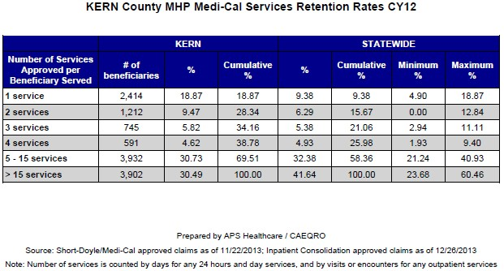

Do you think your county is doing a good job at keeping clients engaged in services? If yes, how? If not, why?
(Information provided by MHP)

The data above show that, compared to statewide averages, Kern County Mental Health has a higher percentage of individuals receiving three services or less and a lower percentage of individuals receiving a higher number of services (e.g., greater than 15 services).

Our county can continue to improve in this area. Many individuals drop out of or do not engage in ongoing services after initial contacts for a number of reasons—ambivalence, lack of motivation, lack of resources, and the level of commitment and time it takes to begin and engage in services. Individuals are often looking for specific needs to be met and become discouraged when mental health is unable to be a one-stop shop for many of their needs (quick access to medications, needs for housing, social service resources, etc.).

Another factor in the high percentage of clients who only have a brief number of services has been the relatively large number of individuals who receive crisis services but do not follow-up with beginning mental health services.

For those clients receiving less than 5 services, what is your county doing to follow-up and re-engage those individuals for further mental health services?
(Information provided by MHP)

As part of the implementation of the Affordable Care Act (ACA) KCMH has recently initiated new treatment programs to provide mental health services to a wider portion of the community who request mental health services. In addition to providing mental health services to individuals with very serious mental illness, services will now be available to community members who have significant mental health problems that can be treated in a relatively briefer period of time. The implementation of these programs is likely to increase the number of clients who receive more than 5 services and will more broadly provide accessibility to mental health services.

Looking at the previous chart of who is being served by race/ethnicity in your county, do you have any thoughts or ideas to share regarding your county’s engagement of underserved communities?
(Information provided by MHP)

In reviewing the chart of underserved populations, KCMH appears to be generally providing mental health services to different race/ethnicity in a similar proportion to their percentage within our local population. However, we appear to be providing a lower percentage of mental health services to African-American individuals when we are compared to other counties within California. The department is now planning some additional outreach and engagement projects to better engage this population.

CLIENT OUTCOMES: Consumer Perception Survey (August 2013)
Ultimately, the reason we provide mental health services is to help individuals manage their mental illness and lead productive lives. We have selected two questions from the Consumer Perception Survey which capture this intention. One question is geared toward adults of any age, and the other is for children and youth under 18.
Below are the data for responses by clients in your county to these two questions.

For general comparison, statewide reference data for various sized counties are shown in the tables on page 19.
The total numbers of surveys completed for Adults or Children/Youth in your county are shown separately in the tables below, under the heading “Total.”

Q1. Adults. As a direct result of the services I received, I deal more effectively with daily problems.

 | Strongly Disagree | Disagree | Neutral | Agree | Strongly Agree | Total
Number of Responses | 4 | 18 | 76 | 137 | 110 | 345
Percent of Responses | 1.2 % | 5.2 % | 22.0 % | 39.7 % | 31.9 % | 100.0 %

Q2. Children/Youth. As a result of services my child and/or family received, my child is better at handling daily life.

 | Strongly Disagree | Disagree | Neutral | Agree | Strongly Agree | Total
Number of Responses | 8 | 20 | 80 | 148 | 67 | 323
Percent of Responses | 2.5 % | 6.2 % | 24.8 % | 45.8 % | 20.7 % | 100.0 %

Are the data consistent with your perception of the effectiveness of mental health services in your county?
(Information provided by MHP)

Kern County data is comparable to the state data, finding 93.6% of adult consumers and 91.3% of minors receiving services either strongly agree, agree or are neutral when asked if their mental health services help them to handle their daily life better.

Do you have any recommendations for improving effectiveness of services?

(Information provided by MHP)

KCMH has continuously collected outcome data regarding the effectiveness of services. To further improve this system, the department is now developing and automating a more organized system of clinical outcomes based on a federal model (SAMHSA) for assessing the effectiveness of services. Based on this data, the department will be better able to determine areas for improving the effectiveness of clinical programs.

Additional ideas for improving service effectiveness include:

- Create more direct access to the services individuals are seeking (medication, therapy, groups, social services).
- Create more diverse outpatient teams that operate geographically rather than based on level of care.
- Make specialized services mobile (travel to different teams to offer specific services on specific days).

Many counties experience very low numbers of surveys completed. Do you have suggestions to increase the response rate?
(Information provided by MHP)

Kern County Mental Health has tried a variety of methods to improve the response rates and has made some improvements with our local “Recovery Survey”. This includes a shorter, more user friendly survey and is much easier for consumers to complete. Also this survey is not mailed but is handed to consumers when they arrive for services. This approach has produced a much higher rate of response.

Lastly, but perhaps most important overall, with respect to delivery of services, do you have suggestions regarding any of the following:
(Information provided the MHP)

- Specific unmet needs or gaps in services

The department needs to continue, and expand, its efforts to obtain input from relevant stakeholder groups with an emphasis on those who receive services.

More specific ideas include:

  - Voluntary crisis unit
  - Collaboration of services between mental health and social services— linkage/sign up to Medi-Cal, substance abuse services and housing services

- Improvements to, or better coordination of, existing services.

Develop a menu of services, and who offers them, in order to link clients with the appropriate service need instead of duplication of services and working in silos.

- New programs that need to be implemented to serve individuals in your county.

The department should improve the coordination and utilization of the existing services as a primary focus.

The department should continue the implementation of the ACA brief treatment programs to meet the needs of a wider proportion of the Medi-Cal population

The department should enhance its use of evidence based practices in a wide variety of areas. This use should include maintaining the fidelity of these practices to assure services are effective. For instance, in the implementation of the new ACA treatment programs, KCMH should assure that the evidence based practice, Solution Focused Therapy, is used with fidelity to the principles of that practice.

KCMH should further improve the integration of mental health and substance abuse services to provide better services for those with co-occurring disorders.

KCMH should improve access to mental health services (i.e., reducing the time between a client’s first request for services and the beginning of treatment) by streamlining the process for entry.

<END>

REFERENCE DATA: for general comparison with your county MHP results

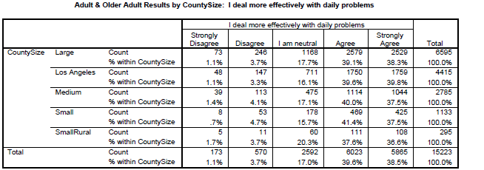

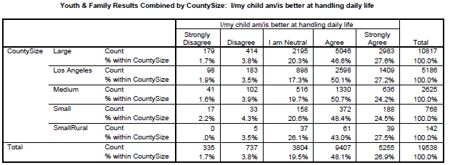

County Mental Health Plan Size: Categories are based upon DHCS definitions by county population.
- Small‐Rural MHPs = Alpine, Amador, Calaveras, Colusa, Del Norte, Glenn, Inyo, Lassen, Mariposa,
Modoc, Mono, Plumas, Siskiyou, Trinity

- Small MHPs = El Dorado, Humboldt, Imperial, Kings, Lake, Madera, Mendocino, Napa, Nevada, San Benito, Shasta, Sutter/Yuba, Tehama, Tuolumne

- Medium MHPs = Butte, Marin, Merced, Monterey, Placer/Sierra, San Joaquin, San Luis Obispo, San Mateo, Santa Barbara, Santa Cruz, Solano, Sonoma, Stanislaus, Tulare, Yolo

- Large MHPs = Alameda, Contra Costa, Fresno, Kern, Orange, Riverside, Sacramento, San Bernardino, San Diego, San Francisco, Santa Clara, Ventura
- Los Angeles’ statistics are excluded from size comparisons, but are included in statewide data. Total Values (in Tables above) = include all statewide data received by CiMH for these survey items.

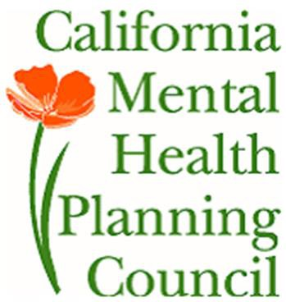REMINDER:

Thank you for your participation in completing your Data Notebook report.

Please feel free to provide feedback or recommendations you may have to improve this project for the following year. We welcome your input.

Please submit your Data Notebook report by email to: DataNotebook@CMHPC.CA.GOV

Or, you may submit a printed copy by postal mail to:

  - Data Notebook Project
  - California Mental Health Planning Council
  - 1501 Capitol Avenue, MS 2706
• P.O. Box 997413
  - Sacramento, CA 95899-7413

For information, you may contact either email address above, or telephone: (916) 449-5249, or
(916) 323-4501

