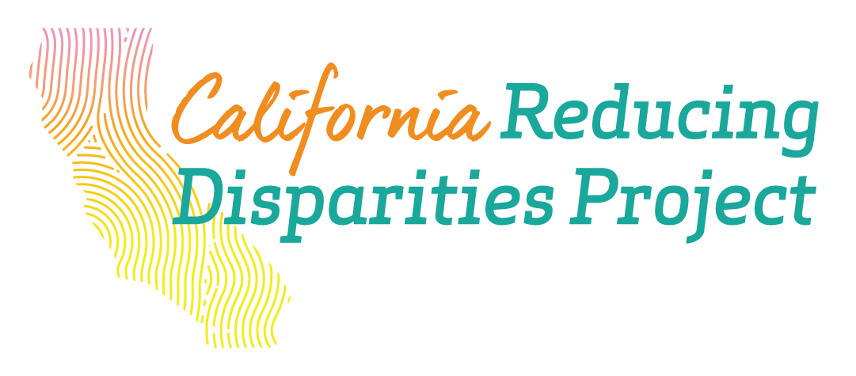
Implementation Pilot Project (IPP) Native American Hub

Community-Defined Evidence Practice (CDEP)
Community defined evidence practices include programs and interventions that are accepted and used by a group or culture, but is oftentimes not accepted, funded, or used in the mainstream mental health system. Within the California Reducing Disparities Projects, these are culturally and linguistically appropriate, as well as trauma-informed programs. They aim to improve mental health of African American/ Black identified; Latino/x; Asian and Pacific Islander; Native American; and LGBTQ+ communities. These practices have been overlooked, erased, and underfunded by Western modalities of mental health treatment, leading to harm and stigma in these populations.

Friendship House—San Francisco City and County
Friendship House Healing Center for Men and Women, Friendship House Women’s Lodge

For the purposes of evaluating ceremonial aspects of the Friendship House American Indian Traditional Treatment and Recovery Healing Model (Friendship House Model) within the three years of CRDP implementation (2018-2021), this study will examine the effectiveness of traditional healing methods of the residential substance abuse treatment program for American Indians adults. The traditional healing methods for the Friendship House Community Defined Evidence Practice (FH CDEP) examination include Wiping of the Tears, Sweat Lodge, and Traditional Healer Ceremonies. Wiping of the Tears symbolizes the letting go of grief and shame, and moving forward to sustain recovery and welcome healing. The Sweat Lodge Ceremony is a spiritual healing ritual that medicine people use to heal many illnesses. One enters the Sweat Lodge to cleanse and purify. Through participation in these Traditional Healer sessions, clients learn healing songs and rituals and participate in prayer services. They also receive opportunities for individual counseling and doctoring sessions with Traditional Healers. The local evaluation will measure changes in cultural connectedness, knowledge, practices, and client outcomes.

Contact: Nelson Jim| (415) 865-0964 | nelsonj@friendshiphousesf.org | WEBSITE

Indian Health Center— Santa Clara Valley
Strengthening Youth and Families Project

The Strengthening Youth and Families Project is a prevention/early intervention program that aims to prevent and/or reduce signs of early onset mental illness for American Indian people in Santa Clara County by 1) increasing knowledge of mental health factors of historical trauma, suicide prevention, and stigma and discrimination reduction 2) increasing knowledge in access and linkage to treatment and wrap-around services 3) increasing knowledge of cultural appropriateness of services provided and 4) increasing knowledge of signs of early onset of mental illness.

The CDEP is designed to address mental health disparities by increasing connection to community and increasing knowledge and sustainment of cultural traditions/practices and ceremonies to address the loss of culture. This will promote mental health wellbeing and increases protective factors for the American Indian community in Santa Clara County.

The CDEP will implement four existing activities of our weekly Youth Programming, Cultural Arts Class, Drum and Dance Class, and an Annual Wellness Gathering with a youth run mini-Powwow. It will also provide knowledge on mental health factors of historical trauma, suicide prevention, and stigma and discrimination reduction. It is important to understand Native American culture IS the intervention - getting people reconnected to culture and traditions will help heal the imbalance.

Contact: Michael Duran | 408-445-3400 | mduran@ihcscv.org | WEBSITE

Indian Health Council—San Diego County
REZolution

The REZolution uses self-expression as a coping skill. It addresses multiple mental health needs including cultural/social stigma associated with mental health services, timely access to services, and the multilayered negative outcomes resulting from unresolved grief and loss and historic trauma including suicide, prolonged suffering, removal of children from their homes, and school failure.

REZolution is implemented through community events when community members have the opportunity to express themselves through artistry, poetry, music, theatre, dance, videography, photography, cooking and any other of forms of self-expression which may be chosen by tribal community members. It is a time when community gathers to encourage members to share their pain, personal experiences, feelings of grief and loss, challenges in coping with trauma, as well as their achievement and personal development.

Contact: Sasha Spite | 760-749-1410 ext. 5280 | sspite@indianhealth.com | WEBSITE

Native American Health Center—Alameda County
Gathering of Native Americans (GONA)

Examining outcomes of the Gathering of Native Americans is a ‘manualized’ CDEP with a 4-day curriculum that provides a structured culturally specific format for AIANs (American Indians and Alaska Natives) which addresses historical trauma, substance abuse and other risk factors for: self-destructive behavior, and emotional/social/mental health. The ‘community’ is the perceived ‘patient’ or entity that needs healing versus the individual, consistent with indigenous worldviews. Individual healing and reduction of mental health risk factors are a direct result of this process. Individuals heal as a part of a collective community healing process.

Community healing from historical and intergenerational trauma is a central theme of the GONA curriculum. This perspective allows GONA to be tailored to support mental health in multiple subpopulations such as ‘2-Spirit’ (e.g., LGBTQ), elders, men, women and youth. This facilitates an understanding of healing of self, family, and community. The curriculum focuses on underlying issues that lead to individuals, families, and communities becoming at risk for addictions and self-destructive behaviors. The curriculum recognizes that health (e.g., physical & mental) for Native Americans is embedded in Native American culture, spirituality and values. This is significant and very important to recognize, particularly for non-Native Americans. Essentially, this means that for Native Americans, culture is a determinant of health and that the loss of culture is a risk factor; whereas, re-connecting is protective on multiple levels. GONA participants actively work to identify approaches to healing the community, a process that then results in self-reflection, increased understanding of the root causes of health disparities in Native communities, and increased individual healing and resiliency. Youth participants also form permanent relationships with mentors and members of their communities.

GONA is more comprehensive than interventions and treatments typically delivered by ‘western or mainstream’ medicine in North America because of the holistic approach. Thus, when compared to ‘mainstream medicine’, GONA has the capacity for increased long-term effects and to positively affect more determinants of health (e.g., risk factors and protective factors).

Contact: Karina Banuelos| 510-434-5455| karinab@nativehealth.org | WEBSITE

Indian Health Project—Sonoma County
Aunties and Uncles Program

“Aunties and Uncles” is a 5 year pilot project whose aim is to reduce suicide and depressive symptoms, increase mental health awareness and use of SCIHP (Sonoma County Indian Health Project) mental health resources, and also to increase cultural connectedness among youth 12 – 25 years old. By tradition, aunties and uncles are community members that have the responsibility and privilege to mentor and nurture our community’s youth. Our key focus is to evidence that the Aunties and Uncles model is an effective intervention to increase mental wellness and prevent suicide using the “culture is prevention” approach. A second focus is to build capacity in our community through involvement as Aunties and Uncles. An Eagle Council (Community Based Advisory Board) is being created, and they will help shape our evaluation.

Components of the Aunties and Uncles program are divided into two areas: 1. School-based activities with a three-pronged approach, including Native art, Suicide PEI (QPR, SafeTalk), and Native Wellness Institute’s “Native Youth Leadership Curriculum.” 2. Outreach and relationship building with the four surrounding tribes, Kashia, Cloverdale, Dry Creek, and Manchester Pt. Arena. Tribal relations are in inception stages, and outreach methods are being developed and tested. It is too early to determine if the three-pronged approach will resonate with our surrounding tribes, although we hope to craft a single curriculum using those three components as a base.

Contact: Kurt Schweigman | 707-521-4523 | kurt.schweigman@scihp.org | WEBSITE

Two Feathers Native American Family Services—Northern California, Humboldt and Del Norte Counties
A.C.O.R.N Youth Wellness Program

The Stick Game is a regional inter-Tribal ancestral cultural event that brings community together, engages American Indian boys (ages 6-18) and is held across Tribal communities in the region. Stick Game tournaments are often held as part of larger community events, and many community members will attend, support and provide positive reinforcement to stick game players throughout the tournament. The Stick Game is a centuries old traditional ancestral practice that is a cross between lacrosse and wrestling and has a much deeper cultural context, meaning and spiritual context than mainstream athletics. As such, it represents a particularly innovative culturally-based mental health prevention and early intervention approach.

The Flower Dance is a young woman’s coming of age ceremony that has been practiced in Northern California for centuries. It was outlawed by the US government for over 100 years and rejuvenated by elders 20 years ago. This community-based ceremony calls people together to participate and support a young woman during the 1-2 years of preparation and multi-day (2-10) ceremony. It focuses on an individual girl (age 12-16), but is a CDEP that impacts all who attend and participate. It also has a deep cultural context and meaning, and a significant spiritual context. It brings together AI (American Indian) community members of all ages, from children to elders, to recognize that a girl is now a young woman within the community. During the ceremony, the girl’s family and community support her through days of fasting, running and nights of singing. The ceremonial dance is an opportunity for community members to sing, dance and build relationships with each other and with the young women.

Contact: Blair Kutcher| 707-839-1933 | director@twofeathers-nafs.org | WEBSITE

United American Indian Involvement—Los Angeles
Native American Drum, Dance and Regalia (NADDAR) Program

Native American Drum, Dance and Regalia (NADDAR) Program consists of 12 weeks of interactive workshops providing instruction in drumming, dancing and regalia making that are repeated throughout the year. It is an American Indian/Alaska Native (AI/AN) culturally based program that incorporates cultural activities and cultural based education founded upon AI/AN traditional ideals of health and wellness. It provides participants with the opportunity to engage in healing activities that have been utilized for many centuries among indigenous populations to promote healing and self-expression. The workshops provide an opportunity for both adults and youth to learn about traditional AI/AN ideals of wellness, to enhance their cultural identity and self-esteem, to decrease stress levels, and to enhance their social skills through community-enhancing activities.

NADDAR Outcome Data

- Populations served: 1,000 American Indian and Alaska Native participants ages 3-80

- Hours of service: 100

- Outcome Data: All participants reporting feeling more connected to their community after attending NADDAR.

- Programmatic Solutions: NADDAR provides a community space for community members to learn, engage, and practice cultural traditions such as drumming, powwow dancing, and regalia making. Because this is an intergenerational program, families are able to share this knowledge and experience together. Strong family bonds have been shown to increase mental health wellness.

- COVID-19 Accommodation: Our team continues to adapt and improve our program each week. We facilitate NADDAR on Zoom. We provide the necessary technology to our instructors to provide the best video, audio, and interactive tools to improve our participant's experience. We have also integrated an online RSVP system where participants can RSVP, get the Zoom link, and let us know how many family members will be attending. We provide food delivery for our participating families.

- Other outcomes? Since its inception in 2005, the NADDAR program continues to provide a space for other urban Native Americans to connect with other Natives. NADDAR has provided an opportunity for community members of all ages to learn powwow dancing, drumming, and general powwow protocol. Participants are able to engage in other community events like powwows.

Contact: Cynthia Begay | 661-706-1651| cbegay@uaii.org | WEBSITE

About California Reducing Disparities Project (CRDP)
California Reducing Disparities Project (CRDP), under Prop 63 (Mental Health Services Act), funds 35 culturally responsive, innovative Implementation Pilot Projects (IPPs) across the state of California working in the five population groups: African American/ Black identified; Latino/x; Asian and Pacific Islander; Native American; and LGBTQ+. The goal of the CRDP is to simultaneously demonstrate that community derived mental health practices reduce mental health disparities across the five unserved, underserved, and inappropriately served population groups as opposed to traditionally funded mental health services based on Western clinical models.

