Humboldt County: Data Notebook 2014
for California
Mental Health Boards and Commissions
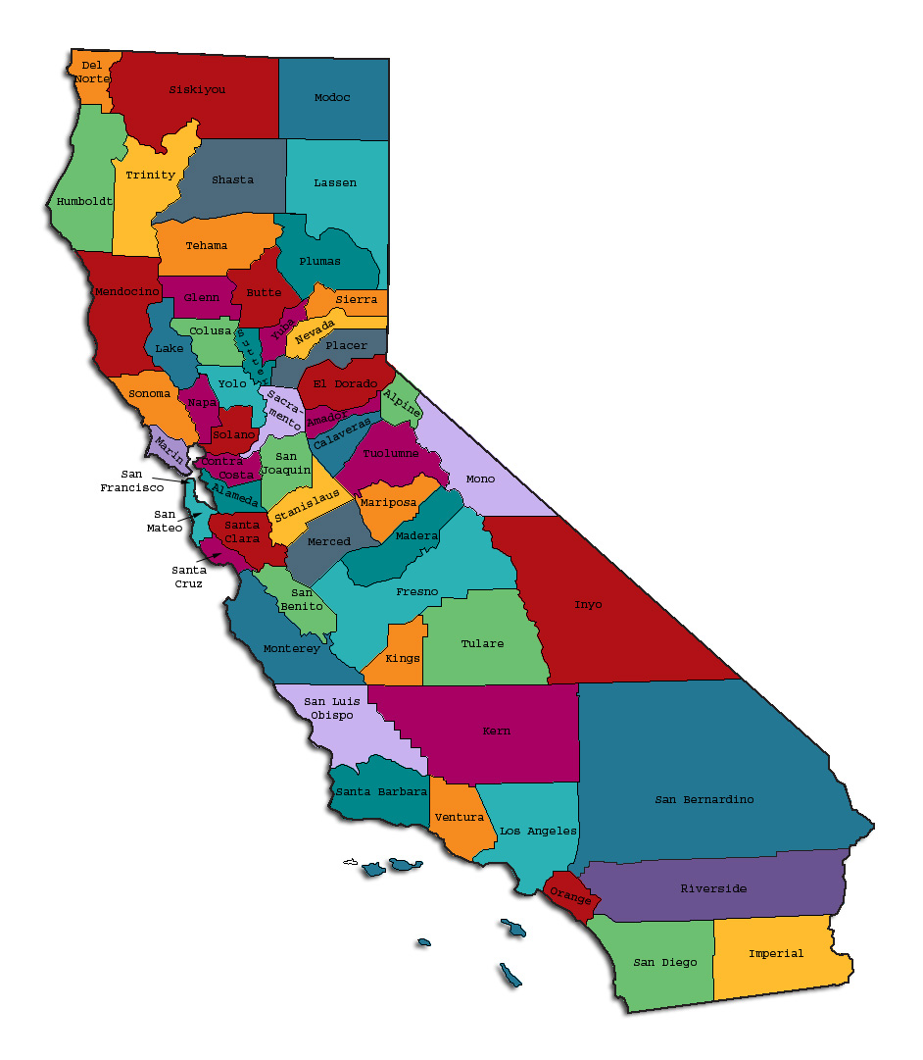
Prepared by California Mental Health Planning Council, in collaboration with: California Association of Mental Health Boards/Commissions, and APS Healthcare/EQRO
This Page Intentionally Left Blank.
Date: April 20, 2014
To: Chairpersons and/or Directors
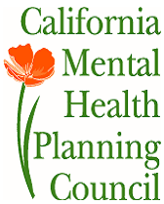
Local Mental Health Boards and Commissions
From: California Mental Health Planning Council
Subject: Instructions for Data Notebook 2014

We ask that this report be prepared by the MH Board or Commission members. You are the most important resources for identifying program strengths and needs in your community.
On the first page, please fill in the requested information for your county websites:
- Department of Behavioral Health/ Mental Health
- Public reports about your county’s MH services.
Please send a copy of the filled-in first page to the Planning Council along with your final report which contains your answers to the questions in the Data Notebook. Please submit your report within 60 days by email to:
DataNotebook@cmhpc.ca.gov.
Or, you may mail a printed copy of your report to:
- Data Notebook Project
- California Mental Health Planning Council
- 1501 Capitol Avenue, MS 2706
- P.O. Box 997413 Sacramento, CA 95899-7413
Please examine the enclosed information, which will help you discuss the questions in the Data Notebook. We provide examples of recent mental health data for your county. In some figures, the term “MHP” is used to refer to your county’s Mental Health Plan.
Some data comes from APS Healthcare/EQRO, which gave permission to use their figures and tables, prepared for review of each county’s Medi-Cal Specialty Mental Health services. Data in this packet came from the following review cycle:
__X__ Fiscal Year 2013 -- 2014: http://caeqro.com/webx/.ee85675/
_____ Fiscal Year 2012 -- 2013: http://caeqro.com/webx/.ee851c3/
For some questions, you will need to consult your local county Quality Improvement Coordinator, and/or Mental Health Director. If you are not able to address all of the questions, just answer the ones you can.
Thank you for your participation in the Data Notebook Project.
This Page Intentionally Left Blank

Humboldt County: Data Notebook 2014
for California
Mental Health Boards and Commissions

County Name: Humboldt Population (2013): 134,819
Website for County Department of Mental Health (MH) or Behavioral Health:
http://www.co.humboldt.ca.us/hhs/mhb/
Website for Local County MH Data and Reports:
http://www.co.humboldt.ca.us/hhs/administration/documents/dhhsintegratedprogressandtrendsreport2013q4.pdf/
Website for local MH Board/Commission Meeting Announcements and Reports:
http://www.co.humboldt.ca.us/hhs/mhb/behavioralhealthboard.asp/
Specialty MH Data from review Year 2013-2014: http://caeqro.com/webx/.ee85675
Total number of persons receiving Medi-Cal in your county (2012): 35,146
Average number Medi-Cal eligible persons per month: 28,385
Percent of Medi-Cal eligible persons who were:
Children, ages 0-17: 40.2 %
Adults, ages 18-59: 47.4 %
Adults, Ages 60 and Over: 12.4 %
Total persons with SMI or SED who received Specialty MH services (2012): 2,917
Percent of Specialty MH service recipients who were:
Children 0-17: 38.5 %
Adults 18-59: 54.4 %
Adults 60 and Over: 7.1 %
This Page Intentionally Left Blank
INTRODUCTION: Purpose, Goals, and Data Resources
This Data Notebook has been developed for the use by the local mental health (MH) boards and commissions by a yearlong workgroup comprised of members from:
- California Mental Health Planning Council (CMHPC)
- California Association of Local Mental Health Boards and Commissions (CALMHB/C)
- APS Healthcare/ EQRO (External Quality Review Organization)
Our plan is for the Data Notebook to meet these goals:
- assist local boards to meet their mandates to review the local county mental health systems, identify unmet needs, and recommend improvements.
- provide a professional format for submitting reports to their local Board of Supervisors, and/or their county Director of Mental Health Services.
- function as an educational tool for local boards, whose members have varying levels of skills, frequent turnover, and need ‘refresher’ training about using data.
- help the CMHPC fulfill its mandates to review and report on the public mental health system in California, which also helps provide evidence for advocacy.
Data reporting drives policy, and policy drives funding for programs. But the data must be both recent and available to the public, or else it is not useful. So, the CMHPC will provide examples of local data from current public reports. We focus on two broad areas: (1) evaluation of program performance, and (2) indicators of client outcomes.
We recognize that each county has a unique population, resources, strengths, and needs. Thus, there is no single perfect data source to answer all the important questions one might ask about mental health services. However, the following data resources will help board members answer questions in this Data Notebook:
- experience and opinions of the local mental health board members
- recent reports about county MH programs from APS Healthcare/EQRO
- data you request from your county QI Coordinator and/or Mental Health Director (because CMHPC does not have that data, and it’s not in other public reports)
- client outcomes data provided by California Institute of Mental Health (CiMH) in their analysis of the most recent Consumer Perception Survey.
Some of our data comes from APS Healthcare/EQRO, which kindly gave permission to use their figures and tables, prepared for review of each county’s Medi-Cal Specialty Mental Health services. Those reviews are at: www.CAEQRO.com. You may find the full-length EQRO reports helpful because they summarize key programs and quality improvement efforts for each county. They also describe strengths, opportunities for improvement, and changes in mental health programs since the last year.
Understanding changes in local programs can help consumers because of the massive re-organization of mental health services statewide. Some changes have been confusing to clients. The old state Department of Mental Health was eliminated in 2012 and many functions were moved to the Department of Health Care Services. Other changes due to federal health care reform and the Affordable Care Act affect how mental health services are provided, funded, and linked to primary health care or substance use treatment. Also, local counties have adjusted to major challenges.
Remember, this report is about your community, and what you and your stakeholders choose to discuss. Examining the data can indeed “Tell a Human Story.” But quantitative data (numbers) provides only part of the picture, for example:
- measures of whether the quality of program services improve over time
- whether more people from different groups are receiving services
- how many clients got physical healthcare or needed substance use treatment.
The other part of the story gives human context to the numbers. Such qualitative data (narrative, descriptions, or stories) tells more of the story, because we can:
- describe special programs targeted for outreach to specific groups
- examine how the programs are actually implementing their goals
- list concrete steps that are taken to improve services, and
- tell what is being done to increase client engagement with continued treatment.
We hope this project contributes to ongoing quality improvement (QI) in mental health services. We seek constant improvement in our approach to quality because:
- needs change over time,
- all human endeavors are by nature imperfect,
- creativity gives rise to new ideas, and
- we can share examples of successful programs to help other communities.
One question is whether local boards are permitted to provide additional information, besides that requested in this Notebook. We always welcome supplemental reports about successful projects, or which the county administration uses to inform the public. Any additional reports may be attached in an “Appendix,” with the website address (if available). However, we emphasize such extra reports are not required.
Thank you for participating in this project. We hope this Data Notebook serves as a springboard for your discussion about all areas of the mental health system, not just those topics highlighted by our questions.
TREATING THE WHOLE PERSON:
Integrating Behavioral and Physical Health Care
Studies have shown that individuals with serious mental illness die, on average, 25 years earlier than the general population. This information makes improving the physical health of clients of great importance and should be a goal of county mental health departments along with providing effective and appropriate mental health services. Coordination of care for mental health, substance abuse and physical health is one way of accomplishing the goal.
The California Mental Health Planning Council does not have any data to provide to show how your county’s programs connect clients of mental health services with necessary physical health care. We ask that the local mental health board request information from your county mental health department for any data on numbers (or percent) of total mental health clients who are referred to, or connected with, physical health providers to assess, treat and monitor physical health issues.
If your county has data on numbers or percentages of clients who are also receiving physical health care, please include it in your Data Notebook you submit to the Council.
___ Check here if your county does not have such data or information.
Yes, we collect this information, but do not have it in aggregate form.

1) Please describe any efforts in your county to improve the physical health of clients.
(a). Food nutrition programs, food assistance, education programs, public health fairs.
(b). Promotion of services in media (bus stop ads, bus ads, radio & TV spots), health fairs, TV and local radio.
(c). Immunization clinics, community fun runs.
(d). Information from Humboldt County staff: Department of Health and Human Services—Mental Health implemented the HRSA Rural Network Planning Grant to support the implementation of integrated health services in Humboldt County by forming the Humboldt County Behavioral Health Integration Network (HCBHIN). Although there are various efforts taking place in this rural community related to transformation of the health care system consistent with the Triple Aims of the Affordable Care Act, this is the only network with a stated purpose of facilitation of care for adult clients with serious mental illness (SMI) and co-morbid health conditions. The key goal is to strengthen the safety net for this vulnerable, underserved and often stigmatized population of our community.
2) How does your county address wellness programs to engage and motivate clients to take charge of improving their physical health?
Examples:
- Exercise
- Nutrition
- Healthy cooking
- Stress management
- Quitting smoking
- Managing chronic disease
- Maintaining social connectedness

Responses from Board members: Immunization clinics, health fairs, community fun runs, ads on buses and bus stops.

Responses from Behavioral Health staff:
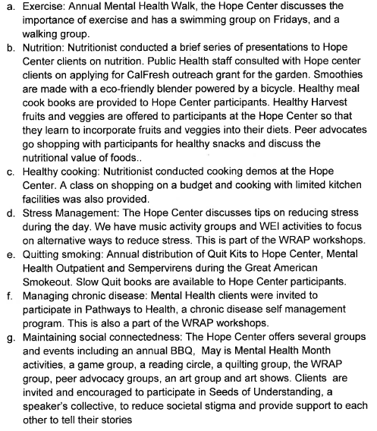

NEW CLIENTS: One Measure of Access
One way to evaluate the quality of mental health services outreach is to measure how many clients receive services who have never been part of the service system before (“brand new” clients). Another measure is how many clients return for services after a period of time with no services (“new” clients).
The California Mental Health Planning Council is exploring how each county mental health department defines “new” clients, and how a client is labelled when they return for additional services. This information is important in determining whether your county has a “revolving door,” that is, clients who are in and out of mental health services repeatedly. This data is one indicator of the success of your county’s programs in closing cases appropriately and providing adequate discharge planning to clients.
This data is not currently reported by the counties to the state. The Council does not have data to provide to you. This information should be requested from your county mental health department.
____ Check here if your county does not have this information.
Yes, we have this information. See next pages.
3. How does your county define 'new' client for those individuals who have previously received services, but who have not received services for a while? (e.g., 6 months, 12 months, 2 years?)
- New system is in place to keep track of psychiatric patients over a period of years.

- Information from County Behavioral Health staff:

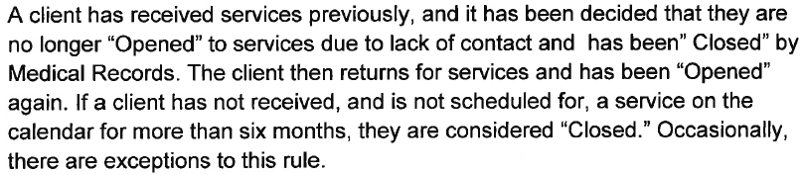

4. Please provide any data your county has on the number of 'new' clients last year. And if you have it, how many of those new clients were brand new clients? You may need to ask your county mental health department for this data.
# new children/youth (0-17 yrs): 645 New clients
of these, how many (or %) are ‘brand new’ clients: 330 Brand New Clients.

# new adults (18-59 yrs): 2,226 New Clients.
of these, how many (or %) are ‘brand new’ clients: 897 Brand New Clients.

# new older adults (60+ yrs): 168 New Clients
of these, how many (or %) are ‘brand new’ clients: 79 Brand New Clients.

Data Source: Avatar Episode Report 5/9/13—5/8/14.
Information provided by Humboldt County Behavioral Health staff.
REDUCING RE-HOSPITALIZATION: Access to Follow-up Care
Sometimes, an individual experiences acute symptoms of mental illness or substance abuse which can result in a brief stay in an acute care hospital. Receiving follow-up services after discharge from a short-term (3-14 day) hospitalization can be critical to preventing a return to the hospital.
The chart below shows the percentage of people discharged in your county who received at least one service within 7 days of discharge. Also shown is the percentage of those same people who were readmitted to the hospital. The chart also shows the same information for receiving services and being readmitted to the hospital within 30 days. Red indicates the numbers for your county and the blue indicates the percentage for the state of California.

Humboldt County:
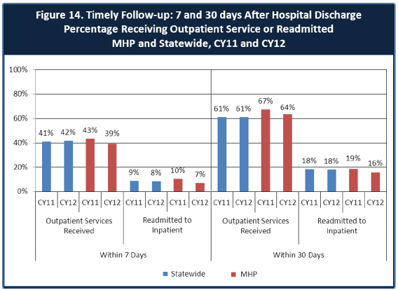

6. Looking at the chart, is your county doing better or worse than the state? Discuss why (e.g., your county has programming available that specifically ensures a warm handoff for follow-up services).

(a) Humboldt is moving from worse than, toward better than, state figures. I don’t why this is so, as there is not an effective “handoff” system in place to produce this result.
(b) About the same, perhaps slightly worse. Follow-up services may be hard to implement. Psychiatric services are largely 5150, so client may not want any services when released.
(c) After reviewing the data, I am very pleased to see how well we are doing. We are an isolated county hours away from support services. In some areas we are a few percentage points above the rest of the state; in others we are at an equivalent level. In others we fall behind. All in all, we are within 3 % points of the rest of the state.

7. Do you have any suggestions on how your county can improve follow-up and reduce re-hospitalizations?

(a) Establish a “warm hand-off” system between health care facilities and mental/AOD facilities. This should work in both directions, and it presumes that healthcare workers in both systems are asking the right questions of their patients.
(b) Expand the use of client-friendly community centers, such as The Hope Center. Increase use of case management.
(c) Improve follow-up with more support at the client’s place, home school, community center. Especially at first, go to the client, work toward having them come to an office, especially in outlying communities. Going to the client will help to normalize and de-stigmatize them and their living situations.
(d) Information received from County Behavioral Health staff:
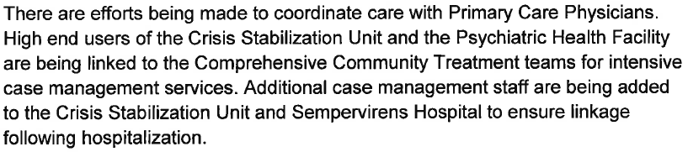

8. What are the three most significant barriers to service access? Examples:
- Transportation
- Child care
- Language barriers or lack of interpreters
- Specific cultural issues
- Too few child or adult therapists
- Lack of psychiatrists or tele-psychiatry services
- Delays in service
- Restrictive time window to schedule an appointment

The following items received votes: Transportation: 3 votes Delays in service: 2 votes Child care: 1 vote Too few child or adult therapists: 1 vote Lack of psychiatrists or tele-psychiatry service: 1 vote Restrictive time window to schedule an appointment: 1 vote
Plus this comment: We are considered a “frontier county” by the U.S. census. Our county is very spread out geographically! Transportation is a major issue.

ACCESS BY UNSERVED AND UNDER-SERVED COMMUNITIES
One goal of the Mental Health Services Act (MHSA) is to reach unserved and underserved communities, especially communities of color. The MHSA promotes outreach to engage these communities in services. If individuals and families in these communities are not accessing services, then we may need to explore new ways of reaching them. Or, we may need to change our programs to meet their mental health needs in ways that better complement their culture.
From data the counties report to the state, we can see how many individuals living in your county are eligible for Medi-Cal, and of those individuals, how many received mental health services. Are you serving the Medi-Cal clients who need your services?
Humboldt County:
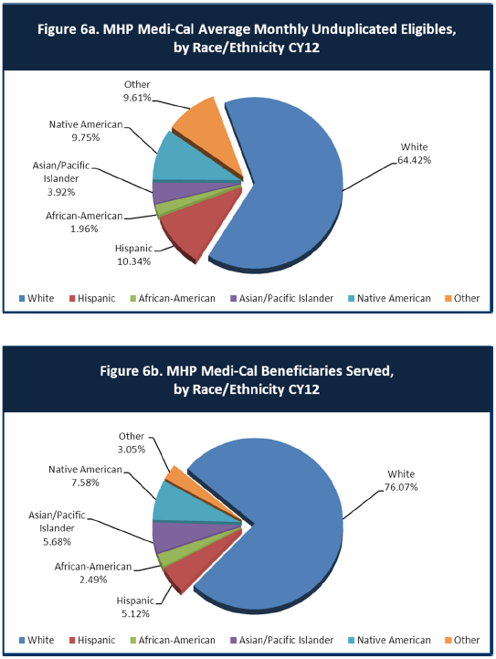
9. Is there a big difference between the race/ethnicity breakdown on the two charts? Do you feel that the group(s) that need services in your county are receiving services?

(a) From the way I read the charts I feel that we are doing a good job serving people. There is always room for improvement.
(b) Ethnic groups seem to be underserved.
(c) Native American and Hispanic groups are under-represented in receiving services. We need better communications to cut through language and cultural barriers to seeking services, and better transportation options for isolated tribal members.

10. What outreach efforts are being made to reach minority groups in your community?
(a) Outreach in the schools, Community-based service organizations, especially those working with children and families, health fairs, bus stop and bus posters in multiple languages.
(b) Latino-Net, for Hispanic population. Public Health makes efforts to communicate relevant information to those with language barriers.
(c) See comprehensive information about outreach efforts by Humboldt County and related efforts across multiple systems of care, provided in the attached Supplement, at the end of this Data Notebook.

11. Do you have suggestions for improving outreach to and/or programs for underserved groups?
(a) This is something we are discussing as a Behavioral Health Board. How do we reach the cultural and spiritual centers/ leaders to help with this?
(b) Expand use of mobile units to rural areas. Also, some additional in-city use, similar to services available to homeless, to those neighborhoods showing lack of services. County should acquire data about ethnicity based on place of residence, such as used by the school system.
(c) See the Humboldt County Cultural Competence Plan, summarized briefly below.

CLIENT ENGAGEMENT IN SERVICES
One MHSA goal is to connect individuals to services they need to be successful. Clients who stop services too soon may not achieve much improvement, nor is it likely to last. So it is important to measure not only who comes in for treatment, but also how long they stay in services. Here we are considering individuals with high service needs, not someone who just needs a ‘tune-up.’ Although not every individual needs the same amount of services, research shows that when someone with severe mental illness continues to receive services over time, their chances of recovery increase.
Engagement in services, also called ‘retention rate’, is important to review. If individuals come in, receive only one or two services and never come back, it may mean the services were not appropriate, or that the individual did not feel welcome, or some other reason that should be explored. Again, we recognize that some individuals only need minimal services, but here we are looking at those with severe mental illness. Ultimately, the goal is to ensure they are getting needed services and are on the road to recovery. But we would not know that unless we look at how many services individuals received over time.
The chart below shows the number of Medi-Cal beneficiaries in your county who received 1, or 2, or 3, or 4, or 5, or more than15 mental health services during the year. For individuals experiencing severe mental illness, the more engaged they are in services, the greater the chance for lasting improvements in mental health.

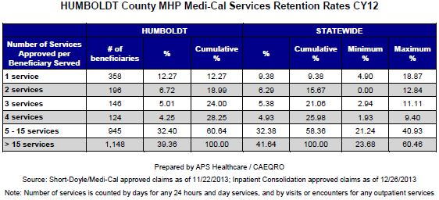

12. Do you think your county is doing a good job at keeping clients engaged in services? If yes, how? If not, why?

(a) The data show that we are. We are reaching the person, bringing it to the human level. The services being offered and providers are doing so are very committed to what they are doing.
(b) Yes, the county has a case management system that is effective for willing clients. Some ethnic groups need more attention. Lock down facilities are limited.
(c) Humboldt County tracks closely with statewide figures; we are average, which is not good enough to improve outcomes.

13. For those clients receiving less than 5 services, what is your county doing to follow-up and re-engage those individuals for further mental health services?

(a) Outreach as best as possible, coordinating services as appropriate with other community based services, schools, judicial, etc.
(b) Voluntary services at community outreach center, e.g. The Hope Center.
(c) Information received from Humboldt County Behavioral Health:
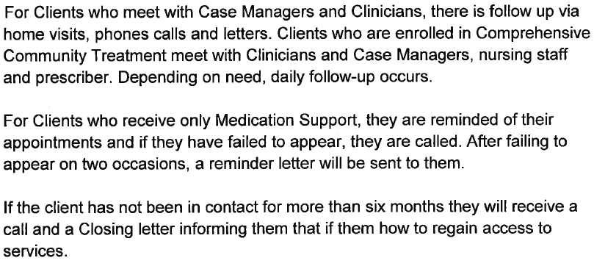

14. Looking at the previous chart of who is being served by race/ethnicity in your county, do you have any thoughts or ideas to share regarding your county’s engagement of underserved communities?

(a) We are constantly looking at, examining, dialoguing and engaging with all community members from diverse backgrounds in an attempt to get to know cultural ways, backgrounds, and uniqueness of all.
(b) County outreach might communicate with Indian Health Services, for example to find ways to health for Native American psychiatric patients. Case management might employ additional case managers who are bilingual. Public Health might employ activists or educators to reach underserved communities.
(c) It’s a safe bet that the language/cultural and transportation barriers causing low service access by Native American and Hispanic clients are reflected in modest retention rates. Improving service access should enhance retention.
CLIENT OUTCOMES: Consumer Perception Survey (August 2013)
Ultimately, the reason we provide mental health services is to help individuals manage their mental illness and to lead productive lives. We have selected two questions from the Consumer Perception Survey which capture this intention. One question is geared toward adults of any age, and the other is for children and youth under 18.
Below are the data for responses by clients in your county to these two questions.
For general comparison, statewide reference data for various sized counties are shown in the tables on page 19.
The total numbers of surveys completed for Adults or Children/Youth in your county are shown separately in the tables below, under the heading “Total.”

Q1. Adults. As a direct result of the services I received, I deal more effectively with daily problems.
 | Strongly Disagree | Disagree | Neutral | Agree | Strongly Agree | Total
Number of Responses | 1 | 4 | 9 | 32 | 33 | 79
Percent of Responses | 1.3 % | 5.1 % | 11.4 % | 40.5 % | 41.8 % | 100.0 %

Q2. Children/Youth. As a result of services my child and/or family received, my child is better at handling daily life.

 | Strongly Disagree | Disagree | Neutral | Agree | Strongly Agree | Total
Number of Responses | 1 | 2 | 15 | 47 | 21 | 86
Percent of Responses | 1.2 % | 2.3 % | 17.4 % | 54.7 % | 24.4 % | 100.0 %

15. Are the data consistent with your perception of the effectiveness of mental health services in your county?
(a) Yes (three votes).
(b) The data are encouraging, though the population survey is small (or at least few submitted a response).

16. Do you have any recommendations for improving effectiveness of services?
(a) Continued integration of services across community—schools, clubs, practitioners.
(b) Improve psychiatric services—need additional psychiatrists. Also—better coordination with medical services—could employ an internist to evaluate overall medical picture, and reveal aggravating conditions, e.g., thyroid problems.

17. Many counties experience very low numbers of surveys completed. Do you have suggestions to increase the response rate?
(a) Case management might assist clients to fill out questionnaires.
(b) “Meet & greets” with food and children’s activities.
(c) Re-asses the use, timing, and placement of the survey. Seek a greater participation rate.
(d) Suggestions received from county staff below:
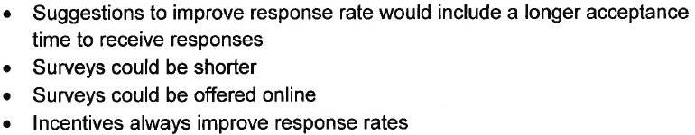

18. Lastly, but perhaps most important overall, with respect to delivery of services, do you have suggestions regarding any of the following:

- Specific unmet needs or gaps in services

--Reach out to target ethnic groups

- Improvements to, or better coordination of, existing services

-- Be sure to include alternative education settings when talking with schools. And talk directly with teachers, especially special education teachers. Don’t work under the expectation that the administration is disseminating info.

--Expand voluntary mental health community centers

- New programs that need to be implemented to serve individuals in your county

--Education programs in high schools to help students understand mental illness and reduce stigma, e.g., a required psychology class.

<END>

REFERENCE DATA: for general comparison with your county MHP results

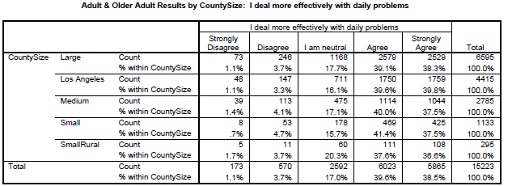

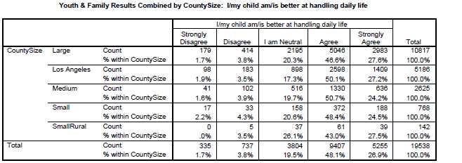

County Mental Health Plan Size: Categories are based upon DHCS definitions by county population.
o Small‐Rural MHPs = Alpine, Amador, Calaveras, Colusa, Del Norte, Glenn, Inyo, Lassen, Mariposa, Modoc, Mono, Plumas, Siskiyou, Trinity
o Small MHPs = El Dorado, Humboldt, Imperial, Kings, Lake, Madera, Mendocino, Napa, Nevada, San Benito, Shasta, Sutter/Yuba, Tehama, Tuolumne
o Medium MHPs = Butte, Marin, Merced, Monterey, Placer/Sierra, San Joaquin, San Luis Obispo, San Mateo, Santa Barbara, Santa Cruz, Solano, Sonoma, Stanislaus, Tulare, Yolo
o Large MHPs = Alameda, Contra Costa, Fresno, Kern, Orange, Riverside, Sacramento, San Bernardino, San Diego, San Francisco, Santa Clara, Ventura
o Los Angeles’ statistics are excluded from size comparisons, but are included in statewide data.
Total Values (in Tables above) = include all statewide data received by CiMH for these survey items.

APPENDIX

Supplemental Information (pages 26—34) provided by Humboldt County Behavioral Health staff to address Question 10.
What outreach efforts are being made to reach minority groups in your community?
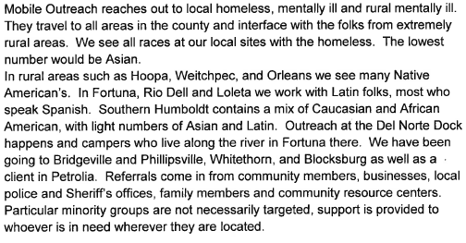
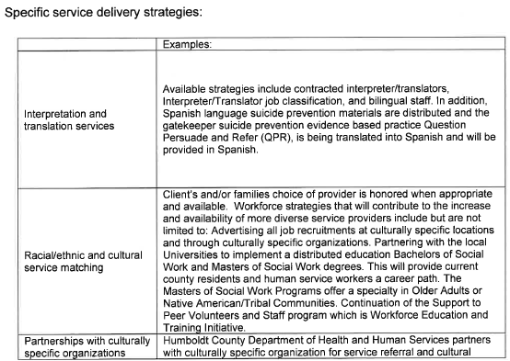

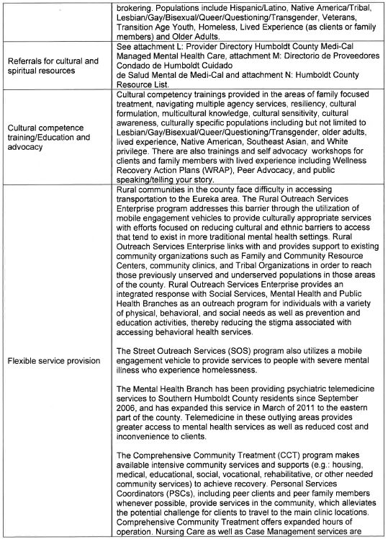

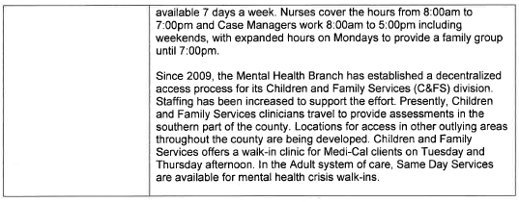
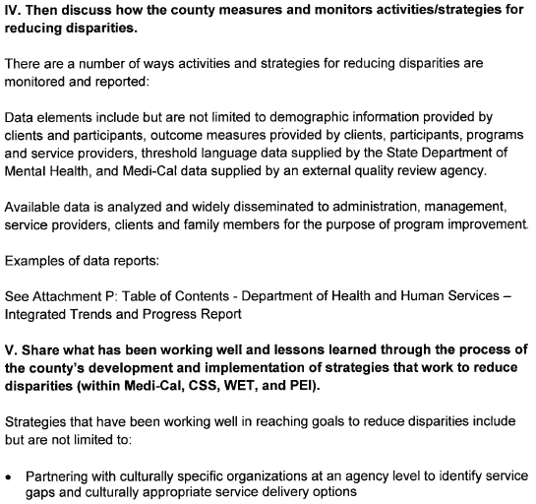

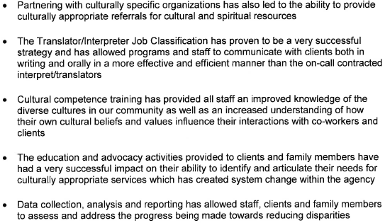

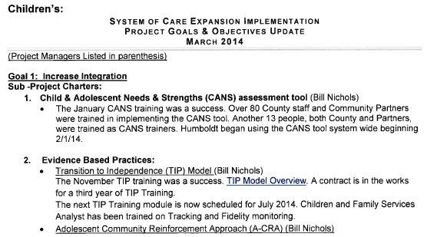

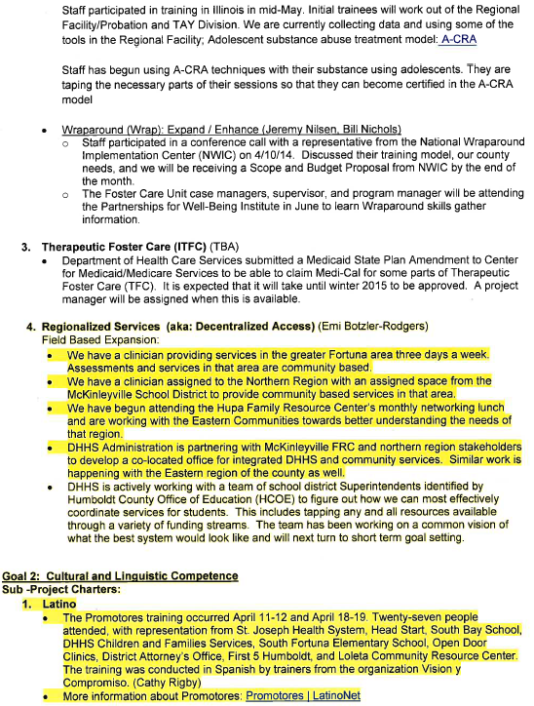
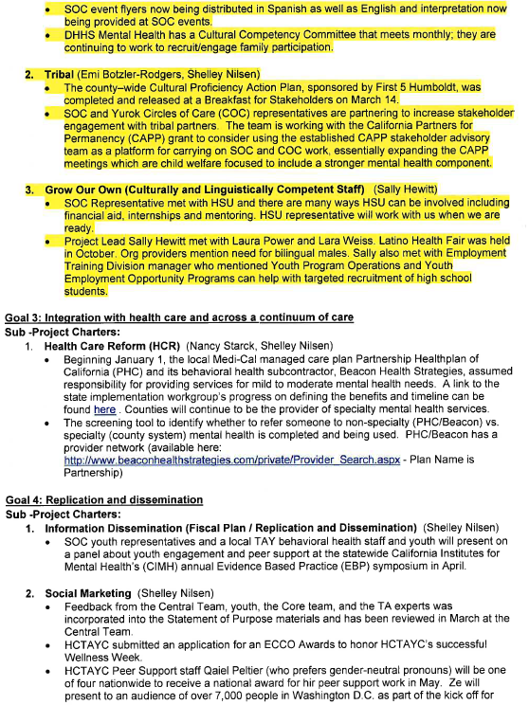
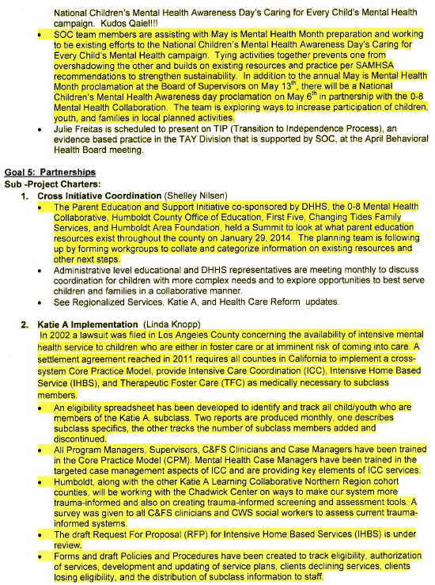
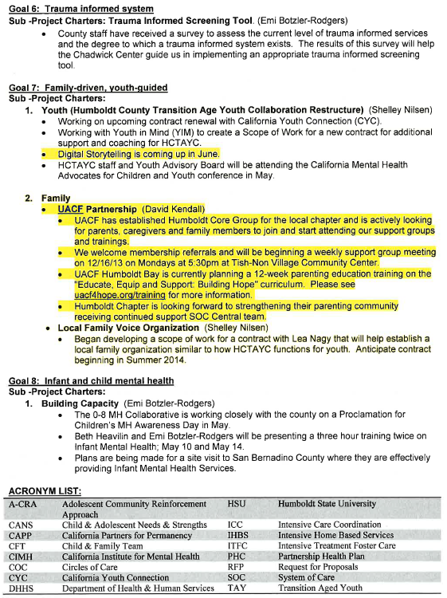
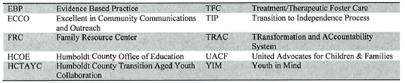

REMINDER:

Thank you for your participation in completing your Data Notebook report.
Please feel free to provide feedback or recommendations you may have to improve this project for the following year. We welcome your input.

Please submit your Data Notebook report by email to:
DataNotebook@CMHPC.CA.GOV

Or, you may submit a printed copy by postal mail to:
- Data Notebook Project
- California Mental Health Planning Council
- 1501 Capitol Avenue, MS 2706
- P.O. Box 997413
- Sacramento, CA 95899-7413

For information, you may contact either email address above, or telephone:
(916) 449-5249, or
(916) 323-4501

Serious Mental Illness, term used for adults 18 and older.
Severe Emotional Disorder, term used for children 17 and under.

