EL DORADO COUNTY: DATA NOTEBOOK 2014

FOR CALIFORNIA
MENTAL HEALTH BOARDS AND COMMISSIONS

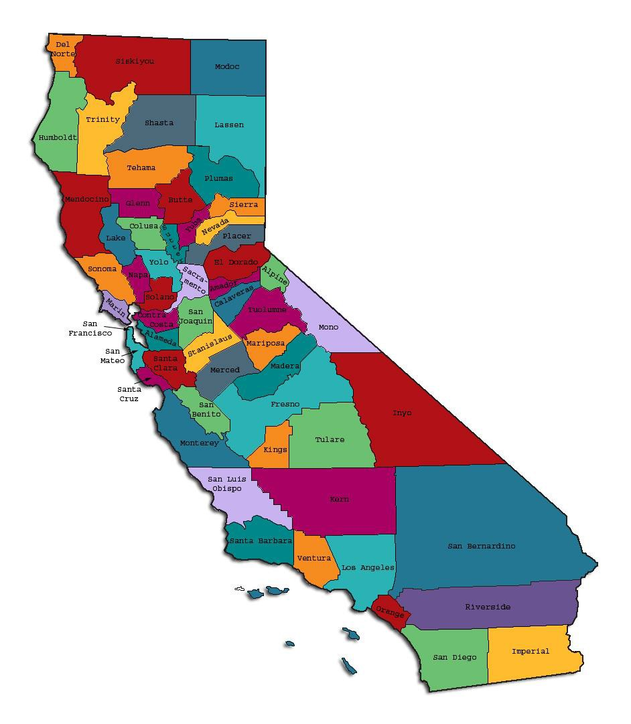
Prepared by California Mental Health Planning Council, in collaboration with: California Association of Mental Health Boards/Commissions, and APS Healthcare/EQRO

This Page Intentionally Left Blank.

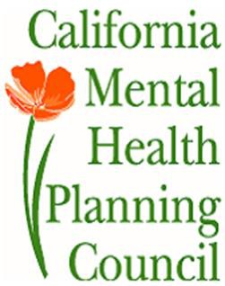Date: April 20, 2014

To: Chairpersons and/or Directors

Local Mental Health Boards and Commissions From: California Mental Health Planning Council Subject: Instructions for Data Notebook 2014

We ask that this report be prepared by the MH Board or Commission members. You are the most important resources for identifying program strengths and needs in your community.

On the first page, please fill in the requested information for your county websites:

- Department of Behavioral Health/ Mental Health
- Public reports about your county’s MH services.

Please send a copy of the filled-in first page to the Planning Council along with your final report which contains your answers to the questions in the Data Notebook. Please submit your report within 60 days by email to:

DataNotebook@cmhpc.ca.gov.

Or, you may mail a printed copy of your report to:

- Data Notebook Project
- California Mental Health Planning Council
- 1501 Capitol Avenue, MS 2706
• P.O. Box 997413 Sacramento, CA 95899-7413

Please examine the enclosed information, which will help you discuss the questions in the Data Notebook. We provide examples of recent mental health data for your county. In some figures, the term “MHP” is used to refer to your county’s Mental Health Plan.

Some data comes from APS Healthcare/EQRO, which gave permission to use their figures and tables, prepared for review of each county’s Medi-Cal Specialty Mental Health services. Data in this packet came from the following review cycle:

X Fiscal Year 2013 -- 2014: http://caeqro.com/webx/.ee85675/

Fiscal Year 2012 -- 2013: http://caeqro.com/webx/.ee851c3/

For some questions, you will need to consult your local county Quality Improvement Coordinator, and/or Mental Health Director. If you are not able to address all of the questions, just answer the ones you can.

Thank you for your participation in the Data Notebook Project.

This Page Intentionally Left Blank

EL DORADO COUNTY: DATA NOTEBOOK 2014

FOR CALIFORNIA
MENTAL HEALTH BOARDS AND COMMISSIONS

County Name: El Dorado Population (2013): 183,376 Website for County Department of Mental Health (MH) or Behavioral Health:
http://www.edcgov.us/MentalHealth/ Website for Local County MH Data and Reports:
http://www.edcgov.us/MentalHealth/MHSA.aspx

Website for local MH Board/Commission Meeting Announcements and Reports: http://www.edcgov.us/MentalHealth/#MHCommission
Specialty MH Data from review Year 2013-2014: http://caeqro.com/webx/.ee85675

Total number of persons receiving Medi-Cal in your county (2012): 26,358 Average number Medi-Cal eligible persons per month: 20,327
Percent of Medi-Cal eligible persons who were: Children, ages 0-17: 42.5 %
Adults, ages 18-59: 44.2 % Adults, Ages 60 and Over: 13.3 %
Total persons with SMI1 or SED2 who received Specialty MH services (2012): 1,437
Percent of Specialty MH service recipients who were: Children 0-17: 51.2 %
Adults 18-59: 43.8 %

Adults 60 and Over: 5.0 %

1 Serious Mental Disorder, term used for adults 18 and older.42.54
2 Severe Emotional Disorder, term used for children 17 and under.

This Page Intentionally Left Blank

INTRODUCTION: Purpose, Goals, and Data Resources
This Data Notebook has been developed for the use by the local mental health (MH) boards and commissions by a yearlong workgroup comprised of members from:
- California Mental Health Planning Council (CMHPC)
- California Association of Local Mental Health Boards and Commissions (CALMHB/C)
- APS Healthcare/ EQRO (External Quality Review Organization) Our plan is for the Data Notebook to meet these goals:
- assist local boards to meet their mandates to review the local county mental health systems, identify unmet needs, and recommend improvements.
- provide a professional format for submitting reports to their local Board of Supervisors, and/or their county Director of Mental Health Services.
- function as an educational tool for local boards, whose members have varying levels of skills, frequent turnover, and need ‘refresher’ training about using data.
- help the CMHPC fulfill its mandates to review and report on the public mental health system in California, which also helps provide evidence for advocacy.
Data reporting drives policy, and policy drives funding for programs. But the data must be both recent and available to the public, or else it is not useful. So, the CMHPC will provide examples of local data from current public reports. We focus on two broad areas: (1) evaluation of program performance, and (2) indicators of client outcomes.
We recognize that each county has a unique population, resources, strengths, and needs. Thus, there is no single perfect data source to answer all the important questions one might ask about mental health services. However, the following data resources will help board members answer questions in this Data Notebook:
- experience and opinions of the local mental health board members
- recent reports about county MH programs from APS Healthcare/EQRO
- data you request from your county QI Coordinator and/or Mental Health Director (because CMHPC does not have that data, and it’s not in other public reports)
- client outcomes data provided by California Institute of Mental Health (CiMH) in their analysis of the most recent Consumer Perception Survey.
Some of our data comes from APS Healthcare/EQRO, which kindly gave permission to use their figures and tables, prepared for review of each county’s Medi-Cal Specialty Mental Health services. Those reviews are at: www.CAEQRO.com. You may find the full-length EQRO reports helpful because they summarize key programs and quality improvement efforts for each county. They also describe strengths, opportunities for improvement, and changes in mental health programs since the last year.

Understanding changes in local programs can help consumers because of the massive re-organization of mental health services statewide. Some changes have been confusing to clients. The old state Department of Mental Health was eliminated in 2012 and many functions were moved to the Department of Health Care Services. Other changes due to federal health care reform and the Affordable Care Act affect how mental health services are provided, funded, and linked to primary health care or substance use treatment. Also, local counties have adjusted to major challenges.
Remember, this report is about your community, and what you and your stakeholders choose to discuss. Examining the data can indeed “Tell a Human Story.” But quantitative data (numbers) provides only part of the picture, for example:

- measures of whether the quality of program services improve over time
- whether more people from different groups are receiving services
- how many clients got physical healthcare or needed substance use treatment.

The other part of the story gives human context to the numbers. Such qualitative data (narrative, descriptions, or stories) tells more of the story, because we can:
- describe special programs targeted for outreach to specific groups
- examine how the programs are actually implementing their goals
- list concrete steps that are taken to improve services, and
- tell what is being done to increase client engagement with continued treatment.

We hope this project contributes to ongoing quality improvement (QI) in mental health services. We seek constant improvement in our approach to quality because:
- needs change over time,
- all human endeavors are by nature imperfect,
- creativity gives rise to new ideas, and
- we can share examples of successful programs to help other communities.

One question is whether local boards are permitted to provide additional information, besides that requested in this Notebook. We always welcome supplemental reports about successful projects, or which the county administration uses to inform the public. Any additional reports may be attached in an “Appendix,” with the website address (if available). However, we emphasize such extra reports are not required.

Thank you for participating in this project. We hope this Data Notebook serves as a springboard for your discussion about all areas of the mental health system, not just those topics highlighted by our questions.

TREATING THE WHOLE PERSON:
Integrating Behavioral and Physical Health Care
Studies have shown that individuals with serious mental illness die, on average, 25 years earlier than the general population. This information makes improving the physical health of clients of great importance and should be a goal of county mental health departments along with providing effective and appropriate mental health services. Coordination of care for mental health, substance abuse and physical health is one way of accomplishing the goal.
The California Mental Health Planning Council does not have any data to provide to show how your county’s programs connect clients of mental health services with necessary physical health care. We ask that the local mental health board request information from your county mental health department for any data on numbers (or percent) of total mental health clients who are referred to, or connected with, physical health providers to assess, treat and monitor physical health issues.
If your county has data on numbers or percentages of clients who are also receiving physical health care, please include it in your Data Notebook you submit to the Council.
_x_ Check here if your county does not have such data or information.

Please describe any efforts in your county to improve the physical health of clients.
One of the goals of the Mental Health Division is provide all consumers with assistance in obtaining Medi-Cal or other health care coverage. Case workers work with consumers to connect them to their primary health care provider for physical health and assist consumers in obtaining a medical home if they don’t yet have one. The Wellness Centers offer consumers many classes to improve their physical health including smoking cessation, Healthy Pleasures, nutrition and meal planning, and exercise.
Recently, the soda in the Wellness Centers was replaced with water and juices to provide more healthy choices for consumers.

How does your county address wellness programs to engage and motivate clients to take charge of improving their physical health?
The Wellness Centers offer recovery-oriented support and activities for adults with serious psychiatric conditions. Wellness activities include group therapy, social and recreational activities, independent living skills training, symptom management, medication education, recovering from co-occurring mental health and addiction issues, improving quality of life, reaching educational goals, obtaining employment, living a healthy lifestyle, building support networks, community reintegration and accomplishing personal goals.

NEW CLIENTS: One Measure of Access
One way to evaluate the quality of mental health services outreach is to measure how many clients receive services who have never been part of the service system before (“brand new” clients). Another measure is how many clients return for services after a period of time with no services (“new” clients).
The California Mental Health Planning Council is exploring how each county mental health department defines “new” clients, and how a client is labelled when they return for additional services. This information is important in determining whether your county has a “revolving door,” that is, clients who are in and out of mental health services repeatedly. This data is one indicator of the success of your county’s programs in closing cases appropriately and providing adequate discharge planning to clients.
This data is not currently reported by the counties to the state. The Council does not have data to provide to you. This information should be requested from your county mental health department.

x
Check here if your county does not have this information.

How does your county define 'new' client for those individuals who have previously received services, but who have not received services for a while? (e.g., 6 months, 12 months, 2 years?)
All clients, brand new and those who have previously received services are treated as a new client whenever there is a new request for service. When a request for service is received, the clinical team completes a new assessment, a new client plan is developed, and a new episode is created in the consumer’s electronic health record.

Please provide any data your county has on the number of 'new' clients last year. And if you have it, how many of those new clients were brand new clients? You may need to ask your county mental health department for
this data.

The Mental Health Division does not track new clients or brand new clients. Whenever a request for service is received, a new assessment is completed, a new client plan is developed, and a new episode is created for the client.

# new children/youth (0-17 yrs) _n/a_

of these, how many (or %) are ‘brand new’ clients _n/a_

# new adults (18-59 yrs) _n/a_

of these, how many (or %) are ‘brand new’ clients _n/a_

# new older adults (60+ yrs) _n/a_

of these, how many (or %) are ‘brand new’ clients _n/a_

REDUCING RE-HOSPITALIZATION: Access to Follow-up Care
Sometimes, an individual experiences acute symptoms of mental illness or substance abuse which can result in a brief stay in an acute care hospital. Receiving follow-up services after discharge from a short-term (3-14 day) hospitalization can be critical to preventing a return to the hospital.
The chart below shows the percentage of people discharged in your county who received at least one service within 7 days of discharge. Also shown is the percentage of those same people who were readmitted to the hospital. The chart also shows the same information for receiving services and being readmitted to the hospital within 30 days. Red indicates the numbers for your county and the blue indicates the percentage for the state of California.

El Dorado County:

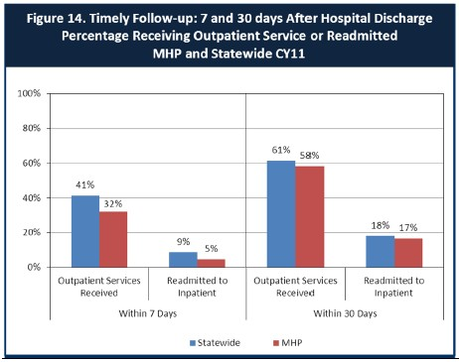

- Looking at the chart, is your county doing better or worse than the state? Discuss why (e.g., your county has programming available that specifically ensures a warm handoff for follow-up services).
El Dorado County has a lower percentage of outpatient services received than the state average within both seven days and thirty days. However, in both categories El Dorado County has a lower percentage of consumers readmitted to inpatient than the state average. The Mental Health Division has a process in place to link both new and existing consumers to follow-up outpatient services. A Psychiatric Health Facility (PHF) social worker contacts the assigned clinician if an existing consumer is preparing to discharge. For new consumers, an episode is opened when the PHF social worker calls the mental health outpatient clinic so that a clinician may be assigned, and a follow-up psychiatry appointment is made within the next four weeks. In either instance, the Division has a seven day standard within which a discharged consumer is expected to be contacted and subsequently seen by a nonmedical clinician. Anyone discharging from the PHF receives a discharge summary which details their medication, community resources, and their scheduled medication follow-up appointment. If they are in urgent need of care prior to their scheduled psychiatry follow-up appointment, they can be seen at the PHF for service.

Do you have any suggestions on how your county can improve follow-up and reduce re-hospitalizations?
The Mental Health Division works closely with the El Dorado County Sheriff’s Office Crisis Intervention Team (CIT) who has received special training on how to help consumers experiencing a mental health crisis. Follow up is provided by the CIT as well as the mental health Intensive Case Management (ICM) team to provide increased service contact to the client after they have been discharged. Full Service Partnership clients are provided support and services using a “whatever it takes” approach in an effort to minimize future crisis incidents and re-hospitalizations. Ongoing coordination with these programs and our local hospitals will continue to increase follow-up and reduce re-hospitalizations.

What are the three most significant barriers to service access? Examples:

  - Transportation
  - Lack of transitional and permanent supportive housing
  - Lack of psychiatrists

ACCESS BY UNSERVED AND UNDER-SERVED COMMUNITIES
One goal of the Mental Health Services Act (MHSA) is to reach unserved and underserved communities, especially communities of color. The MHSA promotes outreach to engage these communities in services. If individuals and families in these communities are not accessing services, then we may need to explore new ways of reaching them. Or, we may need to change our programs to meet their mental health needs in ways that better complement their culture.
From data the counties report to the state, we can see how many individuals living in your county are eligible for Medi-Cal, and of those individuals, how many received mental health services. Are you serving the Medi-Cal clients who need your services?

El Dorado County Data:

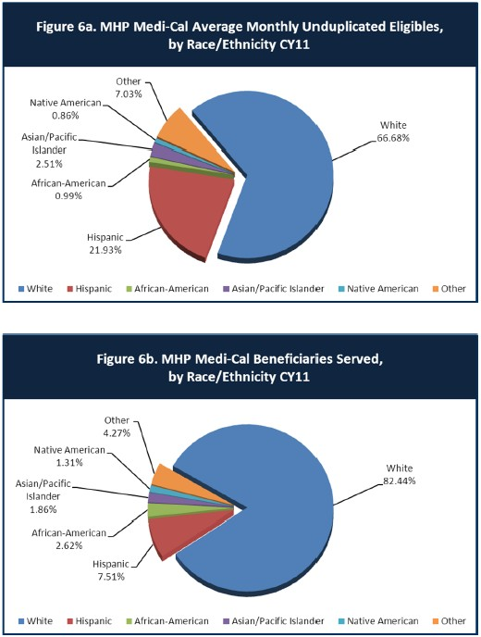

- Is there a big difference between the race/ethnicity breakdown on the two charts? Do you feel that the group(s) that need services in your county are receiving services?
The percentage of eligible Hispanic beneficiaries is higher than the percentage of Hispanic beneficiaries served. While this group has been historically underserved, the department is making strides to improve access to services for this group. The Mental Health Division has in-house bilingual/bicultural staff members who are assigned referrals from Spanish-speaking consumers. The Division also has a contract for interpreter services which can be utilized by staff as needed. Additionally, the Health and Human Services Agency has active contracts in place with providers on the west slope and South Lake Tahoe to provide mental health services to the Latino community. One challenge in serving this group is cultural stigmas related to mental illness. Please see the next section for how this issue is being addressed.

What outreach efforts are being made to reach minority groups in your community?
To reach out to the Native American community, the Health and Human Services Agency currently contracts with Foothill Indian Education Alliance to provide a program called “Wennem Wadati: A Native Path to Healing,” which applies a combination of mental health services and traditional cultural teachings unique to the local Native American community. The program was designed to provide culturally specific Native American services through use of Cultural Specialists, who are Native American community members, working in a professional capacity that access unique cultural contexts and characteristics through the use of traditional Native American healing approaches. The program uses various prevention and early intervention strategies to address all age groups in the target population with the intent to maintain mental health well-being, improve wellness, and decrease health disparities experienced by the Native American community. There is also a dedicated crisis line for the Native American population.
To reach out to the Latino community, the Health and Human Services Agency currently contracts with two providers, New Morning Youth and Family Services on the west slope and the Family Resource Center in South Lake Tahoe. The Latino Outreach program addresses isolation in the Spanish-speaking or limited English-speaking Latino adult population and peer and family problems in the youth population as community issues resulting from unmet mental health needs by contributing to system of care designed to engage Latino families and provide greater access to culturally competent mental health services.
The Latino Outreach program for the western slope of the County is a Promotora outreach and engagement program that utilizes a non-professional Latino peer to provide community-based outreach and engagement to the various geographically-

spread communities in the western slope, in addition to community-based bilingual/bicultural licensed clinical mental health services for adults. The goal of the El Dorado County Latino Engagement Program is to collaborate with existing agencies in the areas of outreach, engagement and provision of support services while adding the availability of bilingual and bicultural mental health services for the Latino community.
The South Lake Tahoe community primarily voiced a need for bilingual/bicultural mental health services rather than outreach and linkage to services. This community is geographically concentrated and has an existing family resource center located in the heart of the Latino residential community with a strong Latino participant base.
Therefore, although outreach is a component of the program in the Tahoe Basis, it is not the primary component of the program and additional funds for services are provided for the Tahoe Basin.
The Mental Health First Aid program is working to get two Spanish speaking instructors certified to be able to offer this program to the community in Spanish as well as English.

Do you have suggestions for improving outreach to and/or programs for underserved groups?
El Dorado County plans to continue providing outreach to the Native American and Latino communities through both the Wennem Wadati and the Latino Outreach programs. Additionally, the Mental Health Division has made a shift to providing more community-based mental health services, including a program to provide a community health outreach worker. El Dorado County is geographically diverse with many people living in outlying areas where public transportation is limited or non-existent. Many of our programs focus on taking our services to the communities that have historically been unserved or underserved.

CLIENT ENGAGEMENT IN SERVICES
One MHSA goal is to connect individuals to services they need to be successful. Clients who stop services too soon may not achieve much improvement, nor is it likely to last. So it is important to measure not only who comes in for treatment, but also how long they stay in services. Here we are considering individuals with high service needs,
not someone who just needs a ‘tune-up.’ Although not every individual needs the same amount of services, research shows that when someone with severe mental illness continues to receive services over time, their chances of recovery increase.
Engagement in services, also called ‘retention rate’, is important to review. If individuals come in, receive only one or two services and never come back, it may mean the services were not appropriate, or that the individual did not feel welcome, or some other reason that should be explored. Again, we recognize that some individuals only need minimal services, but here we are looking at those with severe mental illness.
Ultimately, the goal is to ensure they are getting needed services and are on the road to recovery. But we would not know that unless we look at how many services individuals received over time.
The chart below shows the number of Medi-Cal beneficiaries in your county who received 1, or 2, or 3, or 4, or 5, or more than15 mental health services during the year. For individuals experiencing severe mental illness, the more engaged they are in services, the greater the chance for lasting improvements in mental health.

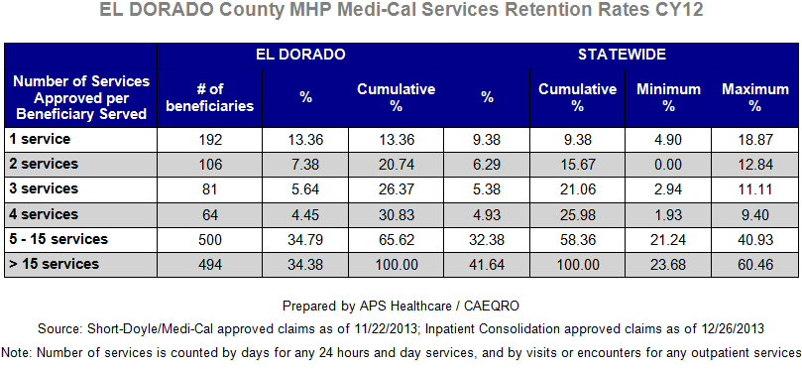

Do you think your county is doing a good job at keeping clients engaged in services? If yes, how? If not, why?
Based upon the statistics provided in the table, El Dorado County is doing a good job of keeping clients engaged in services. In most of the categories, our retention rate percentage is better than the statewide percentages and all of our percentages are well above the minimum percentage. Clients receive regular contact from their case managers and are encouraged to participate regularly in activities provided at the mental health outpatient Wellness Centers. The Division facilitates transportation to and from Wellness Center activities for clients who are living in transitional housing within the county.

For those clients receiving less than 5 services, what is your county doing to follow-up and re-engage those individuals for further mental health services?
The Mental Health Division maintains as a list of medication only clients. Most clients receiving less than 5 services fall into this category. These clients are generally stable as long as they stay on their prescribed medications, but are at risk of decompensation if they go off their medications. The clinicians attempt to make monthly contact with these clients to check in and to keep them engaged.

Looking at the previous chart of who is being served by race/ethnicity in your county, do you have any thoughts or ideas to share regarding your county’s engagement of underserved communities?
The Hispanic community has historically been an underserved group. Based on the statistics provided in the table, El Dorado County needs to continue to expand its engagement efforts with this community. Great progress is being made with outreach and engagement as a result of Latino Outreach programs. The two contract providers, New Morning Youth and Family Services on the west slope and the Family Resource Center in South Lake Tahoe are doing excellent work with this population. All of our contract providers participate in quarterly cultural competency meetings where ideas are shared with each other on what improvements can be made in providing services to unserved and underserved groups. Additionally, the Mental Health Division has several bicultural/bilingual staff who can provide culturally appropriate services.

CLIENT OUTCOMES: Consumer Perception Survey (August 2013)
Ultimately, the reason we provide mental health services is to help individuals manage their mental illness and to lead productive lives. We have selected two questions from the Consumer Perception Survey which capture this intention. One question is geared toward adults of any age, and the other is for children and youth under 18.
Below are the data for responses by clients in your county to these two questions.

For general comparison, statewide reference information and data for various sized counties are shown in the tables on page 19.
The total numbers of surveys completed for Adults or Children/Youth in your county are shown separately in the tables below, under the heading “Total.”

Q1. Adults. As a direct result of the services I received, I deal more effectively with daily problems.

 | Strongly Disagree | Disagree | Neutral | Agree | Strongly Agree | Total
Number of Responses | 0 | 1 | 4 | 15 | 12 | 32
Percent of Responses | 0 % | 3.1 % | 12.5 % | 46.9 % | 37.5 % | 100.0 %

Q2. Children/Youth. As a result of services my child and/or family received, my child is better at handling daily life.

 | Strongly Disagree | Disagree | Neutral | Agree | Strongly Agree | Total
Number of Responses | 0 | 0 | 1 | 0 | 1 | 2
Percent of Responses | 0 % | 0 % | 50.0 % | 0 % | 50.0 % | 100.0 %

Are the data consistent with your perception of the effectiveness of mental health services in your county?
The responses to Q1 are very consistent with the Divisions’ perception of the effectiveness of the mental health services in El Dorado County. It is difficult to assess the data for Q2 due to the small sample size. Mental health services for children and youth are provided through contracted vendors. The services provided are monitored closely by the Division’s Utilization Review / Quality Improvement (UR/QI) team.

Do you have any recommendations for improving effectiveness of services?

Increasing the number of staff devoted to UR/QI activities will help identify areas where service improvement is needed and develop an implementation plan. The UR/QI team continues to recruit for vacant positions.

Many counties experience very low numbers of surveys completed. Do you have suggestions to increase the response rate?
One way to potentially increase the response rate would be to offer incentives to the consumers for completing the survey. Some examples include providing snacks or lunch, gift cards, or a drawing for prizes. Additionally, surveys could be completed as part of the regular assessments rather than as a separate follow up process.

Lastly, but perhaps most important overall, with respect to delivery of services, do you have suggestions regarding any of the following:
- Specific unmet needs or gaps in services
Increased community-based services, especially in outlying areas and increased services for transitional age youth (TAY).

Improvements to, or better coordination of, existing services
The Mental Health Division has made improvements to the overall system of care by collaborating with the El Dorado County Sheriff’s Office Crisis Intervention Team (CIT). This partnership has allowed for better follow up care upon discharge and serves to reduce re-hospitalizations. An outreach team would also improve the system of care by reaching individuals before they reach a crisis incident.

New programs that need to be implemented to serve individuals in your county
El Dorado County received great feedback on programs and services needed in the county as a result of our MHSA Three-Year Plan update community planning process. Our current MHSA plan is comprehensive and more ambitious than it has ever been. New or expanded MHSA programs include services for children 0-5, foster care children, older adults, transitional age youth (TAY), suicide prevention, and community-based services.

<END>

REFERENCE DATA: for general comparison with your county MHP results

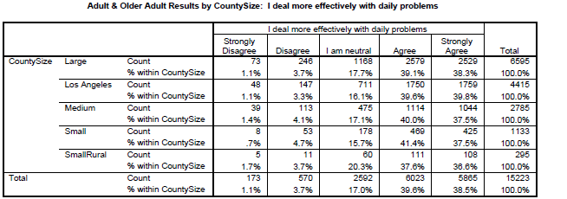

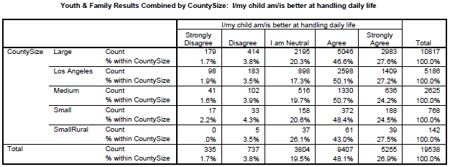

County Mental Health Plan Size: Categories are based upon DHCS definitions by county population.
- Small‐Rural MHPs = Alpine, Amador, Calaveras, Colusa, Del Norte, Glenn, Inyo, Lassen, Mariposa,
Modoc, Mono, Plumas, Siskiyou, Trinity

- Small MHPs = El Dorado, Humboldt, Imperial, Kings, Lake, Madera, Mendocino, Napa, Nevada, San Benito, Shasta, Sutter/Yuba, Tehama, Tuolumne

- 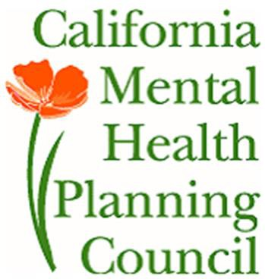Medium MHPs = Butte, Marin, Merced, Monterey, Placer/Sierra, San Joaquin, San Luis Obispo, San Mateo, Santa Barbara, Santa Cruz, Solano, Sonoma, Stanislaus, Tulare, Yolo

- Large MHPs = Alameda, Contra Costa, Fresno, Kern, Orange, Riverside, Sacramento, San Bernardino, San Diego, San Francisco, Santa Clara, Ventura

- Los Angeles’ statistics are excluded from size comparisons, but are included in statewide data. Total Values (in Tables above) = include all statewide data received by CiMH for these survey items.

REMINDER:

Thank you for your participation in completing your Data Notebook report.

Please feel free to provide feedback or recommendations you may have to improve this project for the following year. We welcome your input.

Please submit your Data Notebook report by email to: DataNotebook@CMHPC.CA.GOV

Or, you may submit a printed copy by postal mail to:

  - Data Notebook Project
  - California Mental Health Planning Council
  - 1501 Capitol Avenue, MS 2706
• P.O. Box 997413
  - Sacramento, CA 95899-7413

For information, you may contact either email
address above, or telephone:

(916) 449-5249, or

(916) 323-4501

