Executive Summary
The California Office of the State Long-Term Care Ombudsman advocates for the health, safety, welfare and rights of individuals living in long-term care facilities. The Ombudsman program is administered by Area Agencies on Aging (AAA) which is responsible for fiscal and contract administration.
The legislative intent of this program is to use volunteers and volunteer programs to effectively assist older individuals residing in long-term care facilities in the assertion of their civil and human rights. Volunteers are primarily older adults over the age of the 65 and represents 61% of the volunteer pool.
The primary role of the Ombudsman is to be an advocate for residents’ rights and to respond and elevate complaints of abuse and neglect to licensing and state agencies that regulate Long-Term Care facilities. In addition, Ombudsmen are encouraged to address and attempt to rectify broader or underlying causes of problems experienced by residents through advocacy and policy change. Their visibility in facilities adds an additional layer of quality assurance in residents’ level of care. The pandemic along with the decision to deem Ombudsman as “non-essential workers” has limited their ability to provide oversight of care and rights
Ombudsman programs are now advocating for entering facilities prior to families and other service professionals. The decision to deem Ombudsman programs as non-essential services restricted their ability to respond to reports of complaints. In lieu of entering facilities, Ombudsman programs have transitioned their services from providing direct services to residents to conducting weekly calls to facilities, holding conference calls, and Zoom meetings. The Ombudsman’s ability to respond to complaints essentially ceased because they were not permitted in facilities.

Recommendations:
- The State Office of Long Term Care Ombudsman maintains on-going communication with the California Department of Public Health regarding the importance of Ombudsman services to the community
- Require facilities to create a policy on active engagement to address isolation of residents
- The State Office to immediately examine ways to implement and give guidance on digital technology to assist the local ombudsman
- C4A and the State Office to educate and form a plan on realistic accountability measures between the administrator and the program
- Review Older Californians Act, and if necessary, amend language to modernize the program
- Restructure how volunteers are used in the program and require more paid staff

BACKGROUND:
The California Office of the State Long-Term Care Ombudsman (Office), advocates for the health, safety, welfare and rights of individuals living in long-term care facilities. To accomplish its goals, the Office designates public and non-profit organizations throughout the state to act as local Ombudsmen in hearing, investigating and resolving complaints filed by or on behalf of long-term care residents. The legislative intent of this program is to use volunteers and volunteer programs to effectively assist older individuals residing in long-term care facilities in the assertion of their civil and human rights [OAA 712(a)(1)(B) and WIC 9700, 9701(f)]. Approximately 80% of California’s State Certified Ombudsman representatives are volunteers and are a critical component to service delivery in the Long-Term Care Ombudsman Program (LTCOP) services. Volunteers are primarily individuals over age 65 and represent 61% of LTCOP volunteer pool.
The California Association of Area Agencies on Aging (C4A) is the membership body representing a statewide network of Area Agencies on Aging (AAA) charged with providing services to over 8.82 million older adults throughout California. Ombudsman is administered by the AAA which is responsible for fiscal and contract administration. Services may be provided by contractors implementing the program on behalf of the AAA or as a direct service. AAA must ensure that LTCOP allocations are expended to carry out the established activities of the local program. Although services are contracted by the AAA, strict regulations exist that limit information sharing and restrict data reporting to aggregate data only. In addition, AAA is not privy to program details which may contribute to accountability issues between AAA and the LTCOP.
Figure 1:
§ 1324.17 Responsibilities of agencies hosting local Ombudsman entities
(a) The agency in which a local Ombudsman entity is organizationally located shall be responsible for the personnel management, but not the programmatic oversight, of representatives, including employee and volunteer representatives, of the Office.
(b) The agency in which a local Ombudsman entity is organizationally located shall not have personnel policies or practices which prohibit the representatives of the Office from performing the duties, or from adhering to the access, confidentiality and disclosure requirements of section 712 of the Act, as implemented through this rule and the policies and procedures

IMPACT:
In March 2020, Governor Newsom in consult with the California Public Health officer issued an Executive Order for the preservation of public health and safety throughout the entire State of California. A special advisory was issued specifically to older adults instructing them to Shelter in Place (SIP) because they were identified as vulnerable and at high risk of death. The SIP advisory immediately impacted Ombudsman LTCOP services because a major part of their workforce (volunteers) were no longer available to provide services. The State Ombudsman, Joseph Rodriguez, reports a record high of volunteers resigning and has resulted in a decline from 605 to 115 volunteers statewide.
Ombudsman’s primary role is to advocate for residents’ rights and to respond and elevate complaints of abuse and neglect to licensing and state agencies that regulate Long-Term Care Facilities (LTCF). In addition, Ombudsmen are encouraged to address and attempt to rectify broader or underlying causes of problems experienced by LTCF residents through advocacy and policy change. Their visibility in facilities adds an additional layer of quality assurance in residents’ level of care. The pandemic along with the decision to deem Ombudsman as “non-essential workers” has limited their ability to provide oversight of care and rights….this issue is very alarming and may have contributed to:
Figure4:

the Ombudsman shall “Represent the interests of residents before governmental agencies, assure that individual residents have access to, and pursue (as the Ombudsman determines as necessary and consistent with resident interests) administrative, legal, and other remedies to protect the health, safety, welfare, and rights of residents;”
45 CFR Part 1324.13(a)(5)
- Residents’ Rights being impacted
- Social Engagement drastically decreased, increasing social isolation
- Primary focus on healthcare issues, although COVID-19 positive patients were discharged to SNFs
- Decrease in level of care standards
- Loss of Placement: voluntary and discharges
- SNF deaths are increasingly higher than the general population
- Limited visits from family members and community connection

DATA AT A GLANCE:
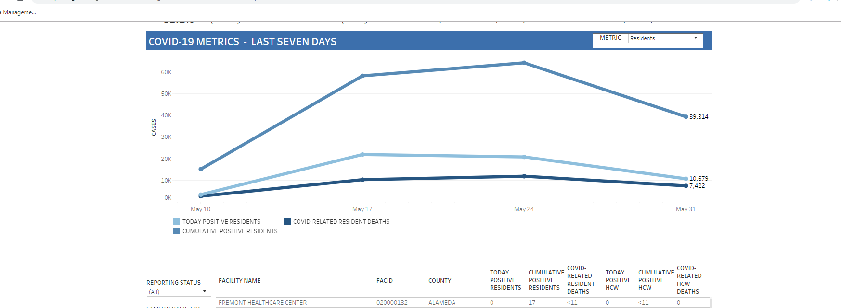
Figure 2: CDPH Dashboard 5/10 -5/31: All data in this dashboard is provided to offer a snapshot of COVID-19 in skilled nursing facilities in California and does not imply wrongdoing on the part of the facility. https://www.cdph.ca.gov/Programs/CID/DCDC/Pages/COVID-19/SNFsCOVID_19.aspx

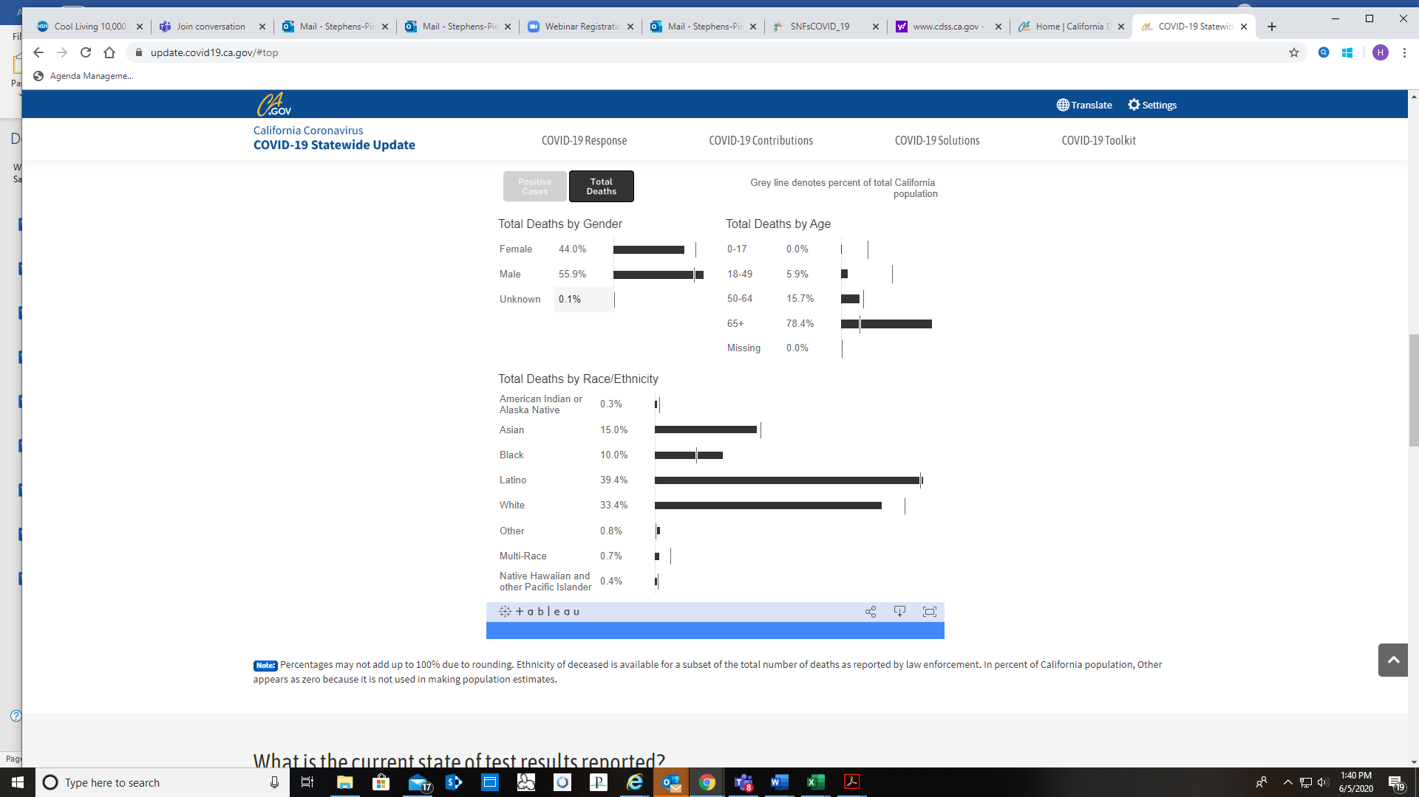
Figure 3: COIVD-19 Statewide Update: 65+ age group account for 78.4% of total deaths an account for 15.6% of the total California population https://update.covid19.ca.gov/#top

COVID RESPONSE:
The overall response of Ombudsman programs varied across the state. In a recent interview with CLTCOA (Ombudsman State Association) President, Libby Anderson, explained that programs are challenged with several issues and are seeking guidance from CDSS, CDPH, and CMMS on how to re-enter facilities. The information they are receiving is primarily public health related and is not substantial enough to give uniformed guidance on moving forward. Ombudsman programs are advocating to enter facilities before families and other service professionals can enter. Interestingly, in several counties private Care Managers are allowed in facilities because they’re considered an essential service. The decision to deem Ombudsman programs as non-essential services restricted their ability to respond to reports of complaints, resulting in a 41% decline in reports of abuse as highlighted in the table below:
ANNUAL COMPARISON | # OF COMPLAINTS 2019 | # OF ABUSE COMPLAINTS 2020
FEBRUARY 2020 |  | 603
MARCH 2020 |  | 457
APRIL 2020 |  | 340
Figure 5: Annual Comparison of abuse reports, reported by Ombudsman State Office
Although reports of abuse declined, information and assistance reports drastically increased. In lieu of entering facilities, Ombudsman Programs have transitioned their services from providing direct services to residents to conducting weekly calls to facilities, holding conference calls, and zoom calls (if available) until the SIP is lifted.

DIGITAL DIVIDE:
As mentioned in the digital divide and social isolation position papers, the pandemic highlighted the need to address gaps and inequities in digital technologies. This group agrees with the position of CDA and C4A working together to address the digital divide for older adults living in assisted living and skilled nursing facilities. At the onset of COVID-19, LTCOP Ombudsman’s ability to respond to complaints ceased because they were not allowed in facilities. California is the forefront of digital technology; however, the Ombudsman program had no mechanism to implement services using updated technology. As a result, residents in facilities did not have a clear path on communicating complaints and are relying on facility staff to address concerns that are Ombudsman related.
RECOMMENDATIONS:
- COVID response/Issues
  - Systemic Changes: communication/ advocacy - local, state, and federal
  - Creation of taskforce or strike team: think outside of the box…utilize local universities to do research on how to move forward
  - Essential Workers: immediately begin advocacy on being included in essential services
  - Weekly Meeting or Scheduled Meetings: Regular meeting with stakeholders to strategize on how to move forward….CANHR, CDSS, CDPH, LTCF Associations
  - PPE: Supply and educate staff/volunteers on proper PPE usage. The OSLTCO should provide uniform guidance to local LTCOP on PPE training
  - PSA’s on Ombudsman Services: Increase visibility—local cable networks
  - A proactive service plan: specific steps Ombudsman will take to re-implement resident centered services vs. facility-centered service
  - Digital Divide: OSLTCO immediately examine ways to implement and give guidance on digital technology in the local LTCOP programs
  - CARES Funding: Use funding to immediately address digital divide issues

- Long Term :
  - Generational: Take advantage of this historical moment to review the program structure and take steps to make needed changes:
    - Review Older Americans Act, and if necessary, amend language to modernize the program
    - Include language that meets current service delivery models: digital technology and volunteer recruitment
    - Systemic Change: looking forward, language and service delivery model to be reexamined to ensure it is relevant
  - Accountability: C4A and OSLTCO to educate and form a plan on realistic accountability measures between the administrator and the program
  - Visibility/Transparency: OSLTCO and C4A work on a plan to increase visibility of the program through PSA’s and education
  - Volunteer Pool: OSLTCO may need to restructure how volunteers are used in the program, increase paid staff
  - Build stronger relationships with State Organizations and equivalent at Federal level i.e. ACL with CMMS
  - Association/ Advocacy Partnerships: Build partnerships with associations and advocacy groups that have an existing older adult advocacy platform i.e. CANHR and Justice in Aging)

