Sonoma County: Data Notebook 2014
for California
Mental Health Boards and Commissions
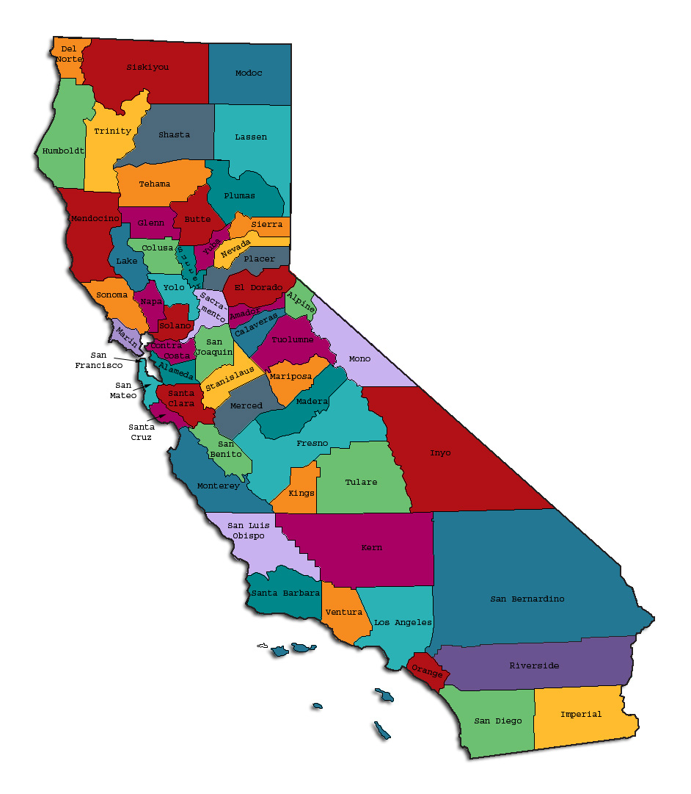
Prepared by California Mental Health Planning Council, in collaboration with: California Association of Mental Health Boards/Commissions, and APS Healthcare/EQRO
This Page Intentionally Left Blank.
Date: April 20, 2014
To: Chairpersons and/or Directors
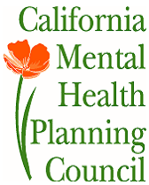
Local Mental Health Boards and Commissions
From: California Mental Health Planning Council
Subject: Instructions for Data Notebook 2014

We ask that this report be prepared by the MH Board or Commission members. You are the most important resources for identifying program strengths and needs in your community.
On the first page, please fill in the requested information for your county websites:
- Department of Behavioral Health/ Mental Health
- Public reports about your county’s MH services.
Please send a copy of the filled-in first page to the Planning Council along with your final report which contains your answers to the questions in the Data Notebook. Please submit your report within 60 days by email to:
DataNotebook@cmhpc.ca.gov.
Or, you may mail a printed copy of your report to:
- Data Notebook Project
- California Mental Health Planning Council
- 1501 Capitol Avenue, MS 2706
- P.O. Box 997413 Sacramento, CA 95899-7413
Please examine the enclosed information, which will help you discuss the questions in the Data Notebook. We provide examples of recent mental health data for your county. In some figures, the term “MHP” is used to refer to your county’s Mental Health Plan.
Some data comes from APS Healthcare/EQRO, which gave permission to use their figures and tables, prepared for review of each county’s Medi-Cal Specialty Mental Health services. Data in this packet came from the following review cycle:
__X__ Fiscal Year 2013 -- 2014: http://caeqro.com/webx/.ee85675/
_____ Fiscal Year 2012 -- 2013: http://caeqro.com/webx/.ee851c3/
For some questions, you will need to consult your local county Quality Improvement Coordinator, and/or Mental Health Director. If you are not able to address all of the questions, just answer the ones you can.
Thank you for your participation in the Data Notebook Project.
This Page Intentionally Left Blank

Sonoma County: Data Notebook 2014
for California
Mental Health Boards and Commissions

County Name: Sonoma Population (2013): 492,337
Website for County Department of Mental Health (MH) or Behavioral Health:
http://www.sonoma-county.org/health/about/behavioralhealth.asp.
Website for Local County MH Data and Reports:
http://www.sonoma-county.org/health/publications/index.asp.
Website for local MH Board/Commission Meeting Announcements and Reports:
http://www.sonoma-county.org/health/meetings/mhboard.asp.
Specialty MH Data from review Year 2013-2014: http://caeqro.com/webx/.ee85675
Total number of persons receiving Medi-Cal in your county (2012): 84,131
Average number Medi-Cal eligible persons per month: 67,510
Percent of Medi-Cal eligible persons who were:
Children, ages 0-17: 45.8 %
Adults, ages 18-59: 39.9 %
Adults, Ages 60 and Over: 14.3 %

Total persons with SMI or SED who received Specialty MH services (2012):
Percent of Specialty MH service recipients who were: 3,010
Children 0-17: 40.9 %
Adults 18-59: 48.9 %
Adults 60 and Over: 10.2 %
This Page Intentionally Left Blank
INTRODUCTION: Purpose, Goals, and Data Resources
This Data Notebook has been developed for the use by the local mental health (MH) boards and commissions by a yearlong workgroup comprised of members from:
- California Mental Health Planning Council (CMHPC)
- California Association of Local Mental Health Boards and Commissions (CALMHB/C)
- APS Healthcare/ EQRO (External Quality Review Organization)
Our plan is for the Data Notebook to meet these goals:
- assist local boards to meet their mandates to review the local county mental health systems, identify unmet needs, and recommend improvements.
- provide a professional format for submitting reports to their local Board of Supervisors, and/or their county Director of Mental Health Services.
- function as an educational tool for local boards, whose members have varying levels of skills, frequent turnover, and need ‘refresher’ training about using data.
- help the CMHPC fulfill its mandates to review and report on the public mental health system in California, which also helps provide evidence for advocacy.
Data reporting drives policy, and policy drives funding for programs. But the data must be both recent and available to the public, or else it is not useful. So, the CMHPC will provide examples of local data from current public reports. We focus on two broad areas: (1) evaluation of program performance, and (2) indicators of client outcomes.
We recognize that each county has a unique population, resources, strengths, and needs. Thus, there is no single perfect data source to answer all the important questions one might ask about mental health services. However, the following data resources will help board members answer questions in this Data Notebook:
- experience and opinions of the local mental health board members
- recent reports about county MH programs from APS Healthcare/EQRO
- data you request from your county QI Coordinator and/or Mental Health Director (because CMHPC does not have that data, and it’s not in other public reports)
- client outcomes data provided by California Institute of Mental Health (CiMH) in their analysis of the most recent Consumer Perception Survey.
Some of our data comes from APS Healthcare/EQRO, which kindly gave permission to use their figures and tables, prepared for review of each county’s Medi-Cal Specialty Mental Health services. Those reviews are at: www.CAEQRO.com. You may find the full-length EQRO reports helpful because they summarize key programs and quality improvement efforts for each county. They also describe strengths, opportunities for improvement, and changes in mental health programs since the last year.
Understanding changes in local programs can help consumers because of the massive re-organization of mental health services statewide. Some changes have been confusing to clients. The old state Department of Mental Health was eliminated in 2012 and many functions were moved to the Department of Health Care Services. Other changes due to federal health care reform and the Affordable Care Act affect how mental health services are provided, funded, and linked to primary health care or substance use treatment. Also, local counties have adjusted to major challenges.
Remember, this report is about your community, and what you and your stakeholders choose to discuss. Examining the data can indeed “Tell a Human Story.” But quantitative data (numbers) provides only part of the picture, for example:
- measures of whether the quality of program services improve over time
- whether more people from different groups are receiving services
- how many clients got physical healthcare or needed substance use treatment.
The other part of the story gives human context to the numbers. Such qualitative data (narrative, descriptions, or stories) tells more of the story, because we can:
- describe special programs targeted for outreach to specific groups
- examine how the programs are actually implementing their goals
- list concrete steps that are taken to improve services, and
- tell what is being done to increase client engagement with continued treatment.
We hope this project contributes to ongoing quality improvement (QI) in mental health services. We seek constant improvement in our approach to quality because:
- needs change over time,
- all human endeavors are by nature imperfect,
- creativity gives rise to new ideas, and
- we can share examples of successful programs to help other communities.
One question is whether local boards are permitted to provide additional information, besides that requested in this Notebook. We always welcome supplemental reports about successful projects, or which the county administration uses to inform the public. Any additional reports may be attached in an “Appendix,” with the website address (if available). However, we emphasize such extra reports are not required.
Thank you for participating in this project. We hope this Data Notebook serves as a springboard for your discussion about all areas of the mental health system, not just those topics highlighted by our questions.
TREATING THE WHOLE PERSON:
Integrating Behavioral and Physical Health Care
Studies have shown that individuals with serious mental illness die, on average, 25 years earlier than the general population. This information makes improving the physical health of clients of great importance and should be a goal of county mental health departments along with providing effective and appropriate mental health services. Coordination of care for mental health, substance abuse and physical health is one way of accomplishing the goal.
The California Mental Health Planning Council does not have any data to provide to show how your county’s programs connect clients of mental health services with necessary physical health care. We ask that the local mental health board request information from your county mental health department for any data on numbers (or percent) of total mental health clients who are referred to, or connected with, physical health providers to assess, treat and monitor physical health issues.
If your county has data on numbers or percentages of clients who are also receiving physical health care, please include it in your Data Notebook you submit to the Council.
___ Check here if your county does not have such data or information.
1) Please describe any efforts in your county to improve the physical health of clients.
Sonoma County Behavioral Health Division (SC-BHD) invests over 1 million dollars into Sonoma County’s Federally Qualified Health Centers and Indian Health Services, locally referred to as community health centers (CHC). SC-BHD both co-locates mental health staff inside and provides funds directly to CHCs to hire staff to support the integration of behavioral health and physical health.

The co-location of staff includes, psychiatrist, social workers, both licensed and unlicensed, to meet three goals:
1) Ensure specialty mental health clients receive appropriate, integrated physical health care
2) Ensure coordination of health care efforts including good communication, and treatment planning
3) Support the bi-directional referral process ensuring smooth transition of clients between SC-BHD and CHCs for clients moving through care

Beginning in 2011/12 SC-BHD has partnered with Santa Rosa Community Health Centers (SRCHC) to provide physical health care inside of SC-BHD largest specialty mental health outpatient program. Efforts focused on building a dedicated space for a nurse practitioner from SRCHC to provide medical services to those specialty mental health clients who are not connected to health care. This satellite clinic opened in March 2012 and thus far has primarily focused on health issues related to metabolic syndromes that are more likely to occur in people who take anti-psychotic medications.

SC-BHD also administers an evidence based assessment tool as part of the initial assessment and every six months thereafter to client monitor progress. The tools - CANS for children, and ANSA for adults – are used to identify functional impairments that are related to mental illness. The CANS and ANSA’s also include assessing for physical health care needs in order to ensure that addressing those concerns are including in the client’s overall treatment plan.

Recently, Sonoma County Behavioral Health, in partnership with Santa Rosa Community Health Centers received a grant from SAMHSA to improve health outcomes for people with serious mental illness. This project, Bridge Health Services, targets 300 to 600 adults per year using strategies include complex care management by nurse case managers, and peer navigation and patient navigation services to support implementation of individual care plans and access to health promotion activities. Bridge will link patients to a patient-centered medical home as their ongoing source of primary care, provide medical services in the home, patient navigation, and behavioral and mental health services. Program goals are to (1) improve patient experience by delivering care when and where it is most needed, providing 24/7 access to clinical support and activating patients and their care givers in their health care; (2) improve the health status of the target population as defined by specified care quality and health outcome indicators through adherence to guidelines and protocols for chronic disease management; and (3) lower the total cost of care by reducing avoidable hospital admissions and re-admissions.

2) How does your county address wellness programs to engage and motivate clients to take charge of improving their physical health?
Examples:
- Exercise
- Nutrition
- Healthy cooking
- Stress management
- Quitting smoking
- Managing chronic disease
- Maintaining social connectedness

As stated above SC-BHD administers an evidence based assessment tool as part of the initial assessment and every six months thereafter to client monitor progress. The tools - CANS for children, and ANSA for adults – are used to identify functional impairments that are related to mental illness. The CANS and ANSA’s also include assessing for physical health care needs in order to ensure that addressing those concerns are including in the client’s overall treatment plan.

The CANS and ANSA also identifies other issues related to overall wellness. Issues identified are placed on the treatment plan and a plan is developed with the consumer and, when appropriate, family member and/or other significant people in the consumer’s life, to address issuer including overall wellness. SC-BHD Personal Service Coordinators (PSC) work closely with consumers to identify areas of health the consumer wishes to improve as well as interventions that would target those behaviors. Plans are customized for each consumer. SC-BHD staff will also facilitate smoking cessation groups, walking groups, cooking demonstrations, etc. depending on need and interest.

Specifically, SC-BHD funds 4 consumer run wellness programs throughout Sonoma County. Consumer run programs are key to helping people receiving specialty mental health services meet their wellness goals. SC-BHD Personal Service Coordinators assist mental health consumers to link to these programs.

NEW CLIENTS: One Measure of Access
One way to evaluate the quality of mental health services outreach is to measure how many clients receive services who have never been part of the service system before (“brand new” clients). Another measure is how many clients return for services after a period of time with no services (“new” clients).
The California Mental Health Planning Council is exploring how each county mental health department defines “new” clients, and how a client is labelled when they return for additional services. This information is important in determining whether your county has a “revolving door,” that is, clients who are in and out of mental health services repeatedly. This data is one indicator of the success of your county’s programs in closing cases appropriately and providing adequate discharge planning to clients.
This data is not currently reported by the counties to the state. The Council does not have data to provide to you. This information should be requested from your county mental health department.
____ Check here if your county does not have this information.
3. How does your county define 'new' client for those individuals who have previously received services, but who have not received services for a while? (e.g., 6 months, 12 months, 2 years?)
Sonoma County Behavioral Health Division makes every effort not to interrupt care and to keep clients engaged in services. SC-BHD has an exhaustive Client Engagement Policy to assist and encourage clients to remain in treatment. Clients who do not respond to outreach and engagement efforts are ultimately closed to the Mental Health Plan. SC-BHD considered “new” clients when they are opened to SC-BHD regardless if they previously received services or not.

4. Please provide any data your county has on the number of 'new' clients last year. And if you have it, how many of those new clients were brand new clients? You may need to ask your county mental health department for this data.
Number of UniqueClients Served During FY 13-14 | 3473
Number of "New" (Returning) Clients Served | 182 | 5.24%
Number of "Brand New" Clients Served | 1722 | 49.58%
Total Number of "New" & "Brand New" Clients Served | 1904
# New Youth (0-17) | 747
# Brand New Youth (0-17) | 736 | 98.53%
# New Adults (18-59) | 1003
# Brand New Adults | 872 | 86.94%
# New Older Adults (60+) | 154
# Brand New Older Adults | 114 | 74.03%

REDUCING RE-HOSPITALIZATION: Access to Follow-up Care
Sometimes, an individual experiences acute symptoms of mental illness or substance abuse which can result in a brief stay in an acute care hospital. Receiving follow-up services after discharge from a short-term (3-14 day) hospitalization can be critical to preventing a return to the hospital.
The chart below shows the percentage of people discharged in your county who received at least one service within 7 days of discharge. Also shown is the percentage of those same people who were readmitted to the hospital. The chart also shows the same information for receiving services and being readmitted to the hospital within 30 days. Red indicates the numbers for your county and the blue indicates the percentage for the state of California.
Sonoma County:
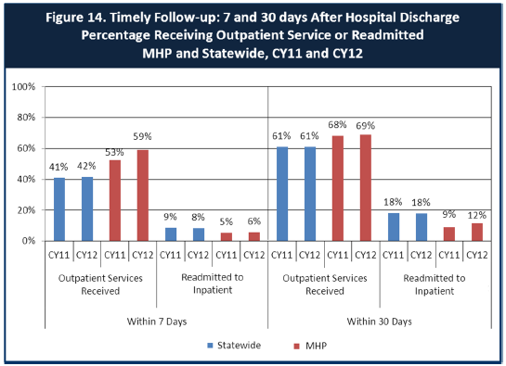
6. Looking at the chart, is your county doing better or worse than the state? Discuss why (e.g., your county has programming available that specifically ensures a warm handoff for follow-up services).
Sonoma County has lower re-hospitalization rates than the state average. In 2009 SC-BHD implemented a process for behavioral health staff to go to the home of any MediCal beneficiary or any Sonoma County residents who have no mental health coverage, who has recently experienced a psychiatric hospitalization. These home visits take place within 7 days of the beneficiary’s discharge. The purpose of the post-psychiatric hospitalization home visit is to assess the beneficiary’s current status, including mental status, living situation, assess living environment , monitor progress toward medication adherence, and identify follow up actions and appointments the beneficiary may need, and ensure linkage to current providers or assist with identification of a provider who can provide follow up care.

These home visits also provide behavioral health clinicians an opportunity to screen whether the beneficiary who has just experienced a psychiatric hospitalization, should be assessed for specialty mental health services, whether the individual is able to follow discharge instructions including garnering medications and if the individual is set up with an outpatient follow up appointment.

7. Do you have any suggestions on how your county can improve follow-up and reduce re-hospitalizations?
Continued attention to this project will continue to keep re-hospitalization down in Sonoma County.
8. What are the three most significant barriers to service access? Examples:
- Transportation
- Child care
- Language barriers or lack of interpreters
- Specific cultural issues
- Too few child or adult therapists
- Lack of psychiatrists or tele-psychiatry services
- Delays in service
- Restrictive time window to schedule an appointment

Barriers to care are vary based upon diverse population needs. However, some barriers to service include

- Language barriers for people who speak a language other than English. Sonoma County has one threshold language which is Spanish. Sonoma County is working on workforce recruitment strategies to recruit, hire, train, and retain people who speak Spanish and who are also bi-cultural.

- Shortage of psychiatrists is a national problem, particularly child psychiatrists. This is particularly an issue in Sonoma County. SC-BHD is working with a national recruiter to try and fill this gap.

- Transportation is always issue in rural counties. Improving mobility is vital in allowing access to services in areas outside of major population hubs. The responsibility for infrastructure to improve transportation rests at the federal, state, county, and city levels. To impact this issue, SC-BHD has offices located throughout Sonoma County, however transportation to those sites can create barriers for people of fixed incomes.

ACCESS BY UNSERVED AND UNDER-SERVED COMMUNITIES
One goal of the Mental Health Services Act (MHSA) is to reach unserved and underserved communities, especially communities of color. The MHSA promotes outreach into these communities to engage these communities in services. If individuals and families in these communities are not accessing services, then we may need to explore new ways of reaching them. Or, we may need to change our programs to meet their mental health needs in ways that better complement their culture.
From data the counties report to the state, we can see how many individuals living in your county are eligible for Medi-Cal, and of those individuals, how many received mental health services. Are you serving the Medi-Cal clients who need your services?
Sonoma County:
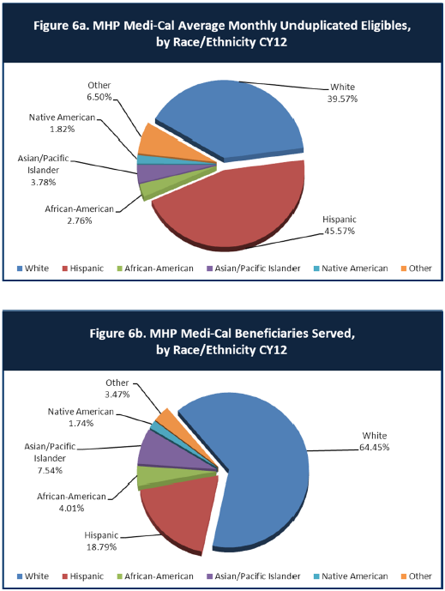

9. Is there a big difference between the race/ethnicity breakdown on the two charts? Do you feel that the group(s) that need services in your county are receiving services?
Sonoma County has high penetration rates to most race/and ethnic MediCal beneficiaries except for Latino MediCal beneficiaries. Forty-six percent of all MediCal beneficiaries in Sonoma County are under the age of 18.

This under-representation in MediCal service may be reflective, in part, of a MediCal population who are too young to exhibit diagnosable problems. Furthermore, behavioral health clinician’s are very cautious in diagnosing for concern for early labeling of small children. Other potential disparities include language/cultural barriers, and certain racial/ethnic parents avoid seeking mental health services for fear of labeling, stereotyping, and stigmatizing of their children and themselves.

It is important to note that what this data does not capture is SC-BHD efforts to provide screening in settings where Latinos seek care – community health centers. SC-BHD funds Sonoma County’s 0-5 Early Childhood Collaborative. One of the activities of the 0-5 Early Childhood Collaborative is to train and support 5 CHCs to implement the parent administered the Ages and Stages Questionnaire (ASQ) and to train primary care providers to administer the ASQ – Social Emotional and 2 CHCs administer the Pediatric Symptom Checklist. These tools screen for developmental and social-emotional issues in young children. For those children identified as having social emotional issues, referrals are made into the appropriate level of care. These referrals into specialty mental health are helped by SC-BHD staff co-located in CHCs.

10. What outreach efforts are being made to reach minority groups in your community?
As mentioned above, SC-BHD provides funds screening at Sonoma County’s community health centers. These screening include ASQ-SE and Pediatric Symptom Checklist, and at Sonoma County Indian Health Project, the PHQ-9. The majority of people seeking services from Sonoma County’s network of community health centers are people of color, specifically Latinos. Furthermore, SC-BHD co-locates mental health clinicians and psychiatrist at the CHC.

SC-BHD also funds numerous outreach activities geared to reach ethnic and cultural minority populations. These outreach activities are lead by SC-BHD Community Intervention Program contractors who provide specific activities and services that target minority ethnic and cultural populations. These activities include:

- Participation and distribution of education materials at cultural fairs and events (for example, Martin Luther King Day at Community Baptist Church, Caesar Chavez Fair, Cinco de Mayo Celebration, Latino Health Forum, Gathering of Native Americans (GONAs))
- Parenting programs targeting communities of color held at schools and churches
- Support groups for Laotian and Cambodian men and women struggling with depression
- Home visits to Latino families who request assistance for a loved one

SC-BHD also funds outreach and engagement programs through Mental Health Services Act - Prevention and Early Intervention funds to increase access by decreasing stigma associated with mental illness. These activities and contractors include:
- Support groups and activities for LGBTQQI youth through Positive Images
- Aunties and Uncles Program mentoring program offered by Sonoma County Indian Health Project
- Latino Services Providers networking activities for services providers who provide services to Latinos
- Community Baptist Church – Community Baptist Collaborative provides various mental health outreach activities that increase protective factors for young children, mentoring programs for teens, and stress reduction programs for adults

As a member of CalMHSA Sonoma County has access to numerous outreach and engagement campaigns that target communities of color through their three prevention and early intervention initiatives: Suicide Prevention, Stigma and Discrimination Reduction, and Student Mental Health. These campaigns include:
- Each Mind Matter/SanaMente
- Know the Signs campaigns targeting Latinos, Asian/Pacific Islanders, African Americans
- ReachOutHere and BuscaApoyo

11. Do you have suggestions for improving outreach to and/or programs for underserved groups?
SC-BHD would like to strengthen its outreach and engagement efforts on Asian and Pacific Islanders who live in Sonoma County. Currently, SC-BHD is exploring whether there are individuals or organizations who work closely with these communities in order to engage them in SC-BHD’s efforts.

CLIENT ENGAGEMENT IN SERVICES
One MHSA goal is to connect individuals to services they need to be successful. Clients who stop services too soon may not achieve much improvement, nor is it likely to last. So it is important to measure not only who comes in for treatment, but also how long they stay in services. Here we are considering individuals with high service needs, not someone who just needs a ‘tune-up.’ Although not every individual needs the same amount of services, research shows that when someone with severe mental illness continues to receive services over time, their chances of recovery increase.
Engagement in services, also called ‘retention rate’, is important to review. If individuals come in, receive only one or two services and never come back, it may mean the services were not appropriate, or that the individual did not feel welcome, or some other reason that should be explored. Again, we recognize that some individuals only need minimal services, but here we are looking at those with severe mental illness. Ultimately, the goal is to ensure they are getting needed services and are on the road to recovery. But we would not know that unless we look at how many services individuals received over time.
The chart below shows the number of Medi-Cal beneficiaries in your county who received 1, or 2, or 3, or 4, or 5, or more than15 mental health services during the year. For individuals experiencing severe mental illness, the more engaged they are in services, the greater the chance for lasting improvements in mental health.

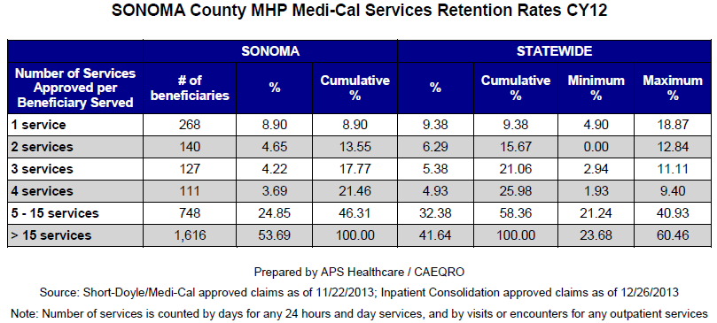

12. Do you think your county is doing a good job at keeping clients engaged in services? If yes, how? If not, why?
As outlined in the data above, SC-BHD is successful at keeping people engaged in services. SC-BHD staff works very hard to help each client develop and implement his or her client plan that will best meet the client’s needs.

13. For those clients receiving less than 5 services, what is your county doing to follow-up and re-engage those individuals for further mental health services?
SC-BHD Access Team provides a thorough assessment of MediCal beneficiaries who request services. The Access team ensures all clients who do not meet medical necessity receive a referral and in some cases, assistance in setting up an appointment with the appropriate mental health care. Furthermore, those MediCal beneficiaries who do not qualify for services are instructed to call the Access Team back should their situation change.

As mentioned above, SC-BHD has a robust client engagement policy with the goal of keeping people engaged in services. SC-BHD Client Engagement Policy force staff to be active in understanding client needs if the client is not following up with care.

14. Looking at the previous chart of who is being served by race/ethnicity in your county, do you have any thoughts or ideas to share regarding your county’s engagement of underserved communities?
As stated above, SC-BHD has focused efforts and strategies to engage various racial and ethnic groups. Many ethnic and cultural groups receive their health services from Sonoma County’s federally qualified health centers and Indian Health Centers. Sonoma County has a large Latino a population and low penetration rates for Latinos. Low Latino penetration rates are an issue statewide. Two specific strategies include:

SC-BHD’s Community Intervention Program outstations psychiatrist and social workers to provide mental health treatment in these community health centers. NAMI’s 2006 Eliminating Disparities: Multicultural Strategic Summit report recommends providing mental health services in the primary care setting as an effective strategy for eliminating barriers to care.

SC-BHD is also actively involved in recruiting, hiring, training, and retaining a workforce who match our County demographic. SC-BHD has a contract with Latino Service Providers, a local networking organization focused on Latinos in Sonoma County, to assist with recruitment of potential mental health providers.

CLIENT OUTCOMES: Consumer Perception Survey (August 2013)
Ultimately, the reason we provide mental health services is to help individuals manage their mental illness and to lead productive lives. We have selected two questions from the Consumer Perception Survey which capture this intention. One question is geared toward adults of any age, and the other is for children and youth under 18.
Below are the data for responses by clients in your county to these two questions. The total numbers of surveys completed for Adults or Children/Youth in each category are shown separately in the tables below, under the heading “Total.”
For general comparison, statewide reference data for various sized counties are shown in the tables on page 19.
The total number of CPS surveys completed in your county and sent to CiMH was zero. Therefore, we are providing you with summary data for medium-sized counties.

Q1. Adults. As a direct result of the services I received, I deal more effectively with daily problems.
 | Strongly Disagree | Disagree | Neutral | Agree | Strongly Agree | Total
Number of Responses | 39 | 113 | 475 | 1114 | 1044 | 2785
Percent of Responses | 1.4 % | 4.1 % | 17.1 % | 40.0 % | 37.5 % | 100.0 %

Q2. Children/Youth. As a result of services my child and/or family received, my child is better at handling daily life.

 | Strongly Disagree | Disagree | Neutral | Agree | Strongly Agree | Total
Number of Responses | 41 | 102 | 516 | 1330 | 636 | 2625
Percent of Responses | 1.6 % | 3.9 % | 19.7 % | 50.7 % | 24.2 % | 100.0 %

15. Are the data consistent with your perception of the effectiveness of mental health services in your county?
Sonoma County Behavioral Health administered its own Client Satisfaction Survey. This survey was developed by mental health consumers and administered by mental health consumers. Some of the findings include:

 | 5 | 4 | 3 | 2 | 1
 | Strongly Agree | Agree | I am Neutral | Disagree | Strongly Disagree | Not Applicable | Total Answers/ question
Because of the help I get, I am better able to manage my life. | 141 | 119 | 43 | 14 | 5 | 1 | 323
 | 43.65% | 36.84% | 13.31% | 4.33% | 1.55% | 0.31%
SCMH staff treat me like a human being, with dignity and respect. | 177 | 110 | 20 | 9 | 3 | 0 | 319
 | 55.49% | 34.48% | 6.27% | 2.82% | 0.94% | 0.00%
SCMH staff are helping me to be in charge of my mental health recovery. | 122 | 127 | 45 | 13 | 7 | 4 | 318
 | 38.36% | 39.94% | 14.15% | 4.09% | 2.20% | 1.26%
When I have a crisis, I receive enough support. | 123 | 118 | 45 | 16 | 9 | 5 | 316
 | 38.92% | 37.34% | 14.24% | 5.06% | 2.85% | 1.58%
SCMH staff believe I can recover and have the kind of life I want. | 109 | 118 | 56 | 12 | 6 | 8 | 309
 | 35.28% | 38.19% | 18.12% | 3.88% | 1.94% | 2.59%
I feel comfortable talking with SCMH staff about my challenges, needs, and hopes. | 128 | 126 | 38 | 14 | 7 | 3 | 316
 | 40.51% | 39.87% | 12.03% | 4.43% | 2.22% | 0.95%
SCMH staff seek to be sensitive to my cultural background and needs (race, ethnicity, religion, language, deaf culture, sexual orientation, gender identity, etc.). | 111 | 115 | 54 | 10 | 6 | 19 | 315
 | 35.24% | 36.51% | 17.14% | 3.17% | 1.90% | 6.03%

16. Do you have any recommendations for improving effectiveness of services?
Our consumer developed and implemented the surveys and subsequent Client Satisfaction Surveys. Sonoma County was able to provide mental health consumers who helped implement the survey with a stipend. Consumers went into waiting rooms of outpatient programs, into psychiatric emergency services, board and care facilities, and consumer wellness centers in order to get a full range of feedback. The consumer developed survey has been an important tool for consumers and providers to work together to think through and solve specific problems.

17. Many counties experience very low numbers of surveys completed. Do you have suggestions to increase the response rate?
The feedback SC-BHD has received about the bi-annual client satisfaction surveys is that they are VERY long, they are too frequent, and it’s not in the consumer language. The length of these surveys has an impact on whether people are willing to fill them out. Also, administering these surveys twice per year is very cumbersome and many consumers reply when asked to fill out a survey, “Didn’t I already do that?” Also, it is very difficult to get specific feedback from the survey. It is hard to know which part of the services is being evaluated because the information comes back to the county in aggregate. Lastly, the state has a hard time giving counties local feedback quickly so consumers are being asked to complete twice and are getting no feedback nor giving time for Counties to respond with consumers with feedback.

18. Lastly, but perhaps most important overall, with respect to delivery of services, do you have suggestions regarding any of the following:
- Specific unmet needs or gaps in services

The prohibition for IMDs to draw down federal Medicaid matching payments for individuals’ ages 22 to 64 with SMPI is a barrier to necessary treatment options.

- Improvements to, or better coordination of, existing services

With the advent of the Patient Protection and Affordable Care Act MediCal beneficiaries who have mild and moderate mental health needs can now receive mental health treatment. This increased benefit has taken the pressure off of County Mental Health Plans to serve people whose mental health issues do not reach the level of medical necessity. Also, it provides continued ongoing treatment to beneficiaries who can step down from specialty mental health services into a lower level of care.

- New programs that need to be implemented to serve individuals in your county

<END>

REFERENCE DATA: for general comparison with your county MHP results

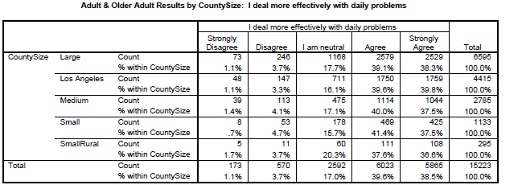

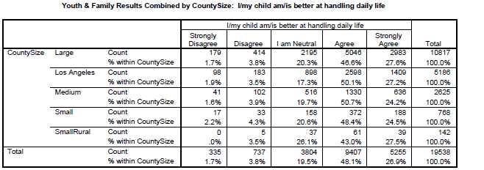

County Mental Health Plan Size: Categories are based upon DHCS definitions by county population.
o Small‐Rural MHPs = Alpine, Amador, Calaveras, Colusa, Del Norte, Glenn, Inyo, Lassen, Mariposa, Modoc, Mono, Plumas, Siskiyou, Trinity
o Small MHPs = El Dorado, Humboldt, Imperial, Kings, Lake, Madera, Mendocino, Napa, Nevada, San Benito, Shasta, Sutter/Yuba, Tehama, Tuolumne
o Medium MHPs = Butte, Marin, Merced, Monterey, Placer/Sierra, San Joaquin, San Luis Obispo, San Mateo, Santa Barbara, Santa Cruz, Solano, Sonoma, Stanislaus, Tulare, Yolo
o Large MHPs = Alameda, Contra Costa, Fresno, Kern, Orange, Riverside, Sacramento, San Bernardino, San Diego, San Francisco, Santa Clara, Ventura
o Los Angeles’ statistics are excluded from size comparisons, but are included in statewide data.
Total Values (in Tables above) = include all statewide data received by CiMH for these survey items.

REMINDER:

Thank you for your participation in completing your Data Notebook report.
Please feel free to provide feedback or recommendations you may have to improve this project for the following year. We welcome your input.

Please submit your Data Notebook report by email to:
DataNotebook@CMHPC.CA.GOV

Or, you may submit a printed copy by postal mail to:
- Data Notebook Project
- California Mental Health Planning Council
- 1501 Capitol Avenue, MS 2706
- P.O. Box 997413
- Sacramento, CA 95899-7413

For information, you may contact either email address above, or telephone:
(916) 449-5249, or
(916) 323-4501

Serious Mental Disorder, term used for adults 18 and older.
Severe Emotional Disorder, term used for children 17 and under.
Medium-sized counties: Butte, Marin, Merced, Monterey, Placer/Sierra, San Joaquin, San Luis Obispo, San Mateo, Santa Barbara, Santa Cruz, Solano, Sonoma, Stanislaus, Tulare, Yolo.

