Siskiyou County: Data Notebook 2014
for California
Mental Health Boards and Commissions
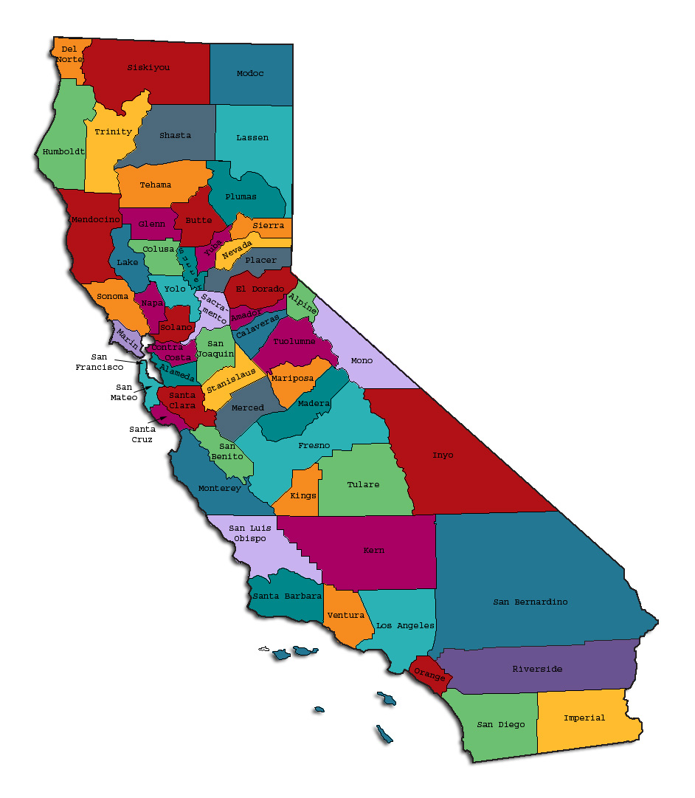
Prepared by California Mental Health Planning Council, in collaboration with: California Association of Mental Health Boards/Commissions, and APS Healthcare/EQRO
This Page Intentionally Left Blank.
Date: April 20, 2014
To: Chairpersons and/or Directors
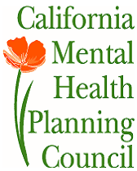
Local Mental Health Boards and Commissions
From: California Mental Health Planning Council
Subject: Instructions for Data Notebook 2014

We ask that this report be prepared by the MH Board or Commission members. You are the most important resources for identifying program strengths and needs in your community.
On the first page, please fill in the requested information for your county websites:
- Department of Behavioral Health/ Mental Health
- Public reports about your county’s MH services.
Please send a copy of the filled-in first page to the Planning Council along with your final report which contains your answers to the questions in the Data Notebook. Please submit your report within 60 days by email to:
DataNotebook@cmhpc.ca.gov.
Or, you may mail a printed copy of your report to:
- Data Notebook Project
- California Mental Health Planning Council
- 1501 Capitol Avenue, MS 2706
- P.O. Box 997413 Sacramento, CA 95899-7413
Please examine the enclosed information, which will help you discuss the questions in the Data Notebook. We provide examples of recent mental health data for your county. In some figures, the term “MHP” is used to refer to your county’s Mental Health Plan.
Some data comes from APS Healthcare/EQRO, which gave permission to use their figures and tables, prepared for review of each county’s Medi-Cal Specialty Mental Health services. Data in this packet came from the following review cycle:
__X__ Fiscal Year 2013 -- 2014: http://caeqro.com/webx/.ee85675/
_____ Fiscal Year 2012 -- 2013: http://caeqro.com/webx/.ee851c3/
For some questions, you will need to consult your local county Quality Improvement Coordinator, and/or Mental Health Director. If you are not able to address all of the questions, just answer the ones you can.
Thank you for your participation in the Data Notebook Project.
This Page Intentionally Left Blank

Siskiyou County: Data Notebook 2014
for California
Mental Health Boards and Commissions

County Name: Siskiyou Population (2013): 45,243
Website for County Department of Mental Health (MH) or Behavioral Health:
________________________________________________________________
Website for Local County MH Data and Reports:
________________________________________________________________
Website for local MH Board/Commission Meeting Announcements and Reports:
________________________________________________________________
Specialty MH Data from review Year 2013-2014: http://caeqro.com/webx/.ee85675
Total number of persons receiving Medi-Cal in your county (2012): 13,801
Average number Medi-Cal eligible persons per month: 11,120
Percent of Medi-Cal eligible persons who were:
Children, ages 0-17: 39.5 %
Adults, ages 18-59: 45.5 %
Adults, Ages 60 and Over: 15.0 %
Total persons with SMI or SED who received Specialty MH services (2012): 736
Percent of Specialty MH service recipients who were:
Children 0-17: 30.7 %
Adults 18-59: 59.6 %
Adults 60 and Over: 9.7 %
This Page Intentionally Left Blank
INTRODUCTION: Purpose, Goals, and Data Resources
This Data Notebook has been developed for the use by the local mental health (MH) boards and commissions by a yearlong workgroup comprised of members from:
- California Mental Health Planning Council (CMHPC)
- California Association of Local Mental Health Boards and Commissions (CALMHB/C)
- APS Healthcare/ EQRO (External Quality Review Organization)
Our plan is for the Data Notebook to meet these goals:
- assist local boards to meet their mandates to review the local county mental health systems, identify unmet needs, and recommend improvements.
- provide a professional format for submitting reports to their local Board of Supervisors, and/or their county Director of Mental Health Services.
- function as an educational tool for local boards, whose members have varying levels of skills, frequent turnover, and need ‘refresher’ training about using data.
- help the CMHPC fulfill its mandates to review and report on the public mental health system in California, which also helps provide evidence for advocacy.
Data reporting drives policy, and policy drives funding for programs. But the data must be both recent and available to the public, or else it is not useful. So, the CMHPC will provide examples of local data from current public reports. We focus on two broad areas: (1) evaluation of program performance, and (2) indicators of client outcomes.
We recognize that each county has a unique population, resources, strengths, and needs. Thus, there is no single perfect data source to answer all the important questions one might ask about mental health services. However, the following data resources will help board members answer questions in this Data Notebook:
- experience and opinions of the local mental health board members
- recent reports about county MH programs from APS Healthcare/EQRO
- data you request from your county QI Coordinator and/or Mental Health Director (because CMHPC does not have that data, and it’s not in other public reports)
- client outcomes data provided by California Institute of Mental Health (CiMH) in their analysis of the most recent Consumer Perception Survey.
Some of our data comes from APS Healthcare/EQRO, which kindly gave permission to use their figures and tables, prepared for review of each county’s Medi-Cal Specialty Mental Health services. Those reviews are at: www.CAEQRO.com. You may find the full-length EQRO reports helpful because they summarize key programs and quality improvement efforts for each county. They also describe strengths, opportunities for improvement, and changes in mental health programs since the last year.
Understanding changes in local programs can help consumers because of the massive re-organization of mental health services statewide. Some changes have been confusing to clients. The old state Department of Mental Health was eliminated in 2012 and many functions were moved to the Department of Health Care Services. Other changes due to federal health care reform and the Affordable Care Act affect how mental health services are provided, funded, and linked to primary health care or substance use treatment. Also, local counties have adjusted to major challenges.
Remember, this report is about your community, and what you and your stakeholders choose to discuss. Examining the data can indeed “Tell a Human Story.” But quantitative data (numbers) provides only part of the picture, for example:
- measures of whether the quality of program services improve over time
- whether more people from different groups are receiving services
- how many clients got physical healthcare or needed substance use treatment.
The other part of the story gives human context to the numbers. Such qualitative data (narrative, descriptions, or stories) tells more of the story, because we can:
- describe special programs targeted for outreach to specific groups
- examine how the programs are actually implementing their goals
- list concrete steps that are taken to improve services, and
- tell what is being done to increase client engagement with continued treatment.
We hope this project contributes to ongoing quality improvement (QI) in mental health services. We seek constant improvement in our approach to quality because:
- needs change over time,
- all human endeavors are by nature imperfect,
- creativity gives rise to new ideas, and
- we can share examples of successful programs to help other communities.
One question is whether local boards are permitted to provide additional information, besides that requested in this Notebook. We always welcome supplemental reports about successful projects, or which the county administration uses to inform the public. Any additional reports may be attached in an “Appendix,” with the website address (if available). However, we emphasize such extra reports are not required.
Thank you for participating in this project. We hope this Data Notebook serves as a springboard for your discussion about all areas of the mental health system, not just those topics highlighted by our questions.
TREATING THE WHOLE PERSON:
Integrating Behavioral and Physical Health Care
Studies have shown that individuals with serious mental illness die, on average, 25 years earlier than the general population. This information makes improving the physical health of clients of great importance and should be a goal of county mental health departments along with providing effective and appropriate mental health services. Coordination of care for mental health, substance abuse and physical health is one way of accomplishing the goal.
The California Mental Health Planning Council does not have any data to provide to show how your county’s programs connect clients of mental health services with necessary physical health care. We ask that the local mental health board request information from your county mental health department for any data on numbers (or percent) of total mental health clients who are referred to, or connected with, physical health providers to assess, treat and monitor physical health issues.
If your county has data on numbers or percentages of clients who are also receiving physical health care, please include it in your Data Notebook you submit to the Council.
X Check here if your county does not have such data or information.

1) Please describe any efforts in your county to improve the physical health of clients.
Clinicians and Case Managers work individually with clients to link them to primary care providers. The MHP also provides transportation to medical appointments, and Case Management support to assist clients in accessing care.

2) How does your county address wellness programs to engage and motivate clients to take charge of improving their physical health?
Clinicians and case managers make referrals to partner agencies and to primary care providers to support, engage and motivate them to take charge of improving their physical health. The MHP also provides funds on occasion through the FSP (Full Services Partnership program) to engage clients in activities that promote improved physical health such as Y memberships. The MHP remains limited in its ability to provide wellness programs as they have been implemented in other counties due to the lack of a Wellness Center.

Examples:
- Exercise
- Nutrition
- Healthy cooking
- Stress management
- Quitting smoking
- Managing chronic disease
- Maintaining social connectedness

NEW CLIENTS: One Measure of Access
One way to evaluate the quality of mental health services outreach is to measure how many clients receive services who have never been part of the service system before (“brand new” clients). Another measure is how many clients return for services after a period of time with no services (“new” clients).
The California Mental Health Planning Council is exploring how each county mental health department defines “new” clients, and how a client is labelled when they return for additional services. This information is important in determining whether your county has a “revolving door,” that is, clients who are in and out of mental health services repeatedly. This data is one indicator of the success of your county’s programs in closing cases appropriately and providing adequate discharge planning to clients.
This data is not currently reported by the counties to the state. The Council does not have data to provide to you. This information should be requested from your county mental health department.
X Check here if your county does not have this information.
3. How does your county define 'new' client for those individuals who have previously received services, but who have not received services for a while? (e.g., 6 months, 12 months, 2 years?)
MHP currently defines ‘new’ clients as clients who have never received mental health services at this agency. The MHP converted to an EHR in November of 2012, and the difficulties surrounding pulling data from two systems complicates this issue. The numbers below are clients seen in FY 13-14 who had not previously been open to the system since the MHP converted to Anasazi in 11/2012.

4. Please provide any data your county has on the number of 'new' clients last year. And if you have it, how many of those new clients were brand new clients? You may need to ask your county mental health department for this data.
# new children/youth (0-17 yrs) 130
of these, how many (or %) are ‘brand new’ clients _____
# new adults (18-59 yrs) 397
of these, how many (or %) are ‘brand new’ clients _____
# new older adults (60+ yrs) 60
of these, how many (or %) are ‘brand new’ clients _____
REDUCING RE-HOSPITALIZATION: Access to Follow-up Care
Sometimes, an individual experiences acute symptoms of mental illness or substance abuse which can result in a brief stay in an acute care hospital. Receiving follow-up services after discharge from a short-term (3-14 day) hospitalization can be critical to preventing a return to the hospital.
The chart below shows the percentage of people discharged in your county who received at least one service within 7 days of discharge. Also shown is the percentage of those same people who were readmitted to the hospital. The chart also shows the same information for receiving services and being readmitted to the hospital within 30 days. Red indicates the numbers for your county and the blue indicates the percentage for the state of California. (MHP = county Mental Health Plan).

Siskiyou County:
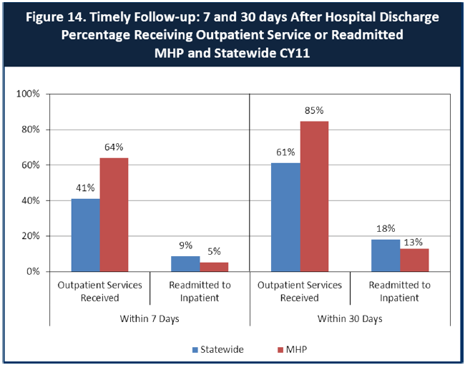

6. Looking at the chart, is your county doing better or worse than the state? Discuss why (e.g., your county has programming available that specifically ensures a warm handoff for follow-up services).
In CY11 (data reported above) Siskiyou County was doing better than the statewide average on all reported measures. More recent EQRO data suggests a decline in these measures compared with those reported in CY11.
In CY12, 54% of the MHP clients received Outpatient Services within 30-days of discharge from the hospital as compared with 85% in CY11. The statewide average for CY12 was 62%. In CY12, 29% of MHP clients received an Outpatient Service within 7-days post discharge from the hospital compared with the 64% that received an Outpatient Services within 7-days post discharge in CY11. The statewide average for 7-day post discharge follow up in CY12 was 42%. CY12 data is not available for Readmitted to Inpatient services for the MHP.
In 2012, the MHP was undergoing significant changes in leadership and in the structure of the agency, as well as changes at the program level. Multiple staff lay-offs resulted in significant cuts in services. The closure of the Day Treatment program without a viable alternative left the most vulnerable clients without sustained support and services.
There are many other things that could be said here, and I can certainly go on and describe this in greater detail, but think you all have a clear picture of this period in the Agency’s history.
7. Do you have any suggestions on how your county can improve follow-up and reduce re-hospitalizations?
The MHP has been understaffed for several years and the demand for services exceeds capacity. Salaries are not competitive with those in surrounding or like counties, and recruiting a stable, professional workforce is an ongoing challenge for the MHP. The MHP has been unsuccessful in developing a Wellness Center. In other counties this program has significantly decreased inpatient hospitalizations and has facilitated access to immediate follow-up post hospitalization as there is a facility open where clients may go on a drop-in basis to receive services.
The MHP has been working on developing Policies and Procedures to provide follow-up for clients immediately upon discharge from acute hospitalizations. This process has included the creation of a new Program Coordinator position to track, monitor and ensure continuity of care for clients who are hospitalized. Other counties have developed Peer Provider programs in which peers are hired to provide support and follow-up both pre and post hospitalization. The MHP has had significant feedback in EQRO reviews regarding both the lack of a Peer Provider program, and the lack of a Wellness Center.
8. What are the three most significant barriers to service access? Examples:
- Transportation
- Child care
- Language barriers or lack of interpreters
- Specific cultural issues
- Too few child or adult therapists
- Lack of psychiatrists or tele-psychiatry services
- Delays in service
- Restrictive time window to schedule an appointment

Geography is a significant barrier to service access. The MHP provides transportation from outlying areas. However, the distance to services is often a barrier, particularly for crisis services.

Lack of understanding/education across the system regarding health care reform (i.e. appropriate level of service, appropriate provider, issues regarding insurance coverage etc.). Lack of understanding has a significant impact on the referral process.

The MHP continues to work on improving its negative image in the community. However, this remains a barrier to service access.

Delays in access to services.

ACCESS BY UNSERVED AND UNDER-SERVED COMMUNITIES
One goal of the Mental Health Services Act (MHSA) is to reach unserved and underserved communities, especially communities of color. The MHSA promotes outreach to engage these communities in services. If individuals and families in these communities are not accessing services, then we may need to explore new ways of reaching them. Or, we may need to change our programs to meet their mental health needs in ways that better complement their culture.
From data the counties report to the state, we can see how many individuals living in your county are eligible for Medi-Cal, and of those individuals, how many received mental health services. Are you serving the Medi-Cal clients who need your services?

Siskiyou County Data:
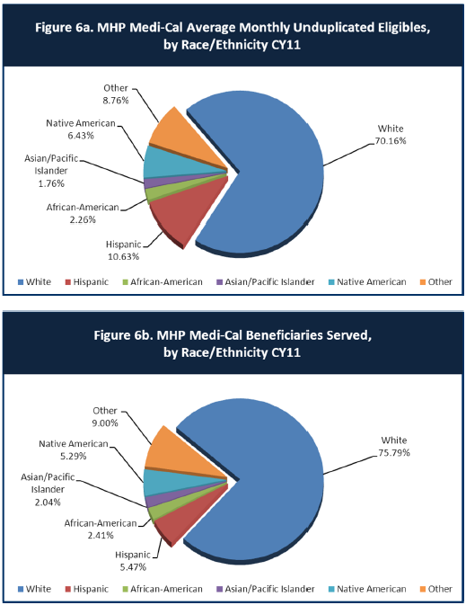
9. Is there a big difference between the race/ethnicity breakdown on the two charts? Do you feel that the group(s) that need services in your county are receiving services?
Based upon the data provided above, Siskiyou County is serving ethic/racial/underserved communities in proportion to the number of Medi-Cal eligibles in all groups with the exception of the Hispanic population. In the past year, the MHP has hired a translator and certified her through the County Personnel process to provide translation services. In addition, a bi-lingual Spanish speaking Clinician has been hired who will be providing services in East County where the majority of Spanish speaking/Hispanics reside.
The MHP conducted a focus group in Tulelake to solicit input from the Hispanic community into the development of the MHSA three-year plan. All written materials were translated into Spanish for the MHSA surveys, and translation was available at the focus group.

10. What outreach efforts are being made to reach minority groups in your community?
The new bi-lingual Clinician on staff will begin making outreach efforts in East County to the Hispanic communities there. The MHP contracts with the 10 FRCs in the county for Prevention and Early Intervention services, and they provide outreach to various un/underserved populations throughout the county. We also have on staff an outreach worker who provides outreach services to the homeless community.

11. Do you have suggestions for improving outreach to and/or programs for underserved groups?
See p.9-2: Exercise, nutrition, healthy cooking, stress management, quitting smoking, managing chronic disease, and maintaining social connectedness are all areas presently addressed through classes and activities at the 10 FRCs in Siskiyou County. Greater cooperation with the FRCs would greatly increase the level of service and the number of un/underserved reached through the BHS system.
Recent BHS budget cuts have reduced BHS staff, so creative “out of the box” thinking needs to replace the insular “we can do it ourselves” thinking that prevents other qualified entities from providing many services that do not require licensed clinicians.
There is a need to think ‘decentralization’ since Siskiyou County’s size prohibits un/underserved clients from traveling to Yreka for services. South County has fairly close communities near the Mt. Shasta City BHS office. North County has Happy Camp 70 miles west of Yreka; Dorris and Tulelake even further east of Yreka. This creates a roadblock for outlying clients to easily use Yreka services. Even the new proposed Wellness Center to be located in Yreka cannot possibly serve these distant areas.
Similarly, increased collaboration with Probation, Sheriff’s Dept, Veteran’s office, local medical facilities and clinics located in outlying areas would multiply the number of un/underserved clients who could be served.

CLIENT ENGAGEMENT IN SERVICES
One MHSA goal is to connect individuals to services they need to be successful. Clients who stop services too soon may not achieve much improvement, nor is it likely to last. So it is important to measure not only who comes in for treatment, but also how long they stay in services. Here we are considering individuals with high service needs, not someone who just needs a ‘tune-up.’ Although not every individual needs the same amount of services, research shows that when someone with severe mental illness continues to receive services over time, their chances of recovery increase.
Engagement in services, also called ‘retention rate’, is important to review. If individuals come in, receive only one or two services and never come back, it may mean the services were not appropriate, or that the individual did not feel welcome, or some other reason that should be explored. Again, we recognize that some individuals only need minimal services, but here we are looking at those with severe mental illness. Ultimately, the goal is to ensure they are getting needed services and are on the road to recovery. But we would not know that unless we look at how many services individuals received over time.
The chart below shows the number of Medi-Cal beneficiaries in your county who received 1, or 2, or 3, or 4, or 5, or more than15 mental health services during the year. For individuals experiencing severe mental illness, the more engaged they are in services, the greater the chance for lasting improvements in mental health.

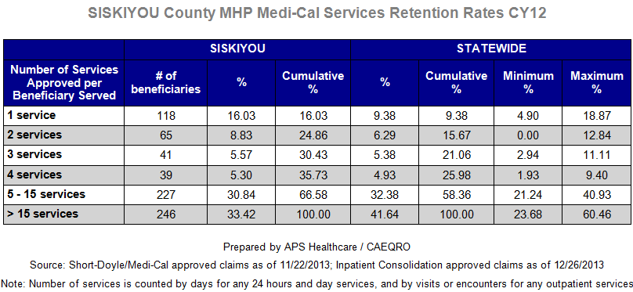
12. Do you think your county is doing a good job at keeping clients engaged in services? If yes, how? If not, why?
The data above illustrates that Siskiyou County does not perform as well as the statewide average in keeping clients engaged in services. Significantly more clients drop out of services after only one or two visits, and this trend is seen across the service levels.
The data reported above is from CY12 when the MHP was undergoing significant changes, and the data reflects this. By comparison, in CY09, 59% of clients received in excess of 15 services, and only 8% dropped out of services after only one visit.
Several factors, including staffing cuts, difficulty retaining qualified staff, limited programs, inadequate engagement strategies, access issues, programmatic changes among others may contribute to poor engagement.

13. For those clients receiving less than 5 services, what is your county doing to follow-up and re-engage those individuals for further mental health services?
Clients are contacted if they drop out of services and attempts are made to re-engage them in treatment. Transportation services are offered, and attempts are made to address other potential barriers.
This is not an area that we’ve strategized much about because we are inadequately staffed to meet the current client load. If the Board has ideas, please elaborate.

14. Looking at the previous chart of who is being served by race/ethnicity in your county, do you have any thoughts or ideas to share regarding your county’s engagement of underserved communities?
The MHP has not historically had bi-lingual Clinicians on staff to serve the Hispanic population.

CLIENT OUTCOMES: Consumer Perception Survey (August 2013)
Ultimately, the reason we provide mental health services is to help individuals manage their mental illness and to lead productive lives. We have selected two questions from the Consumer Perception Survey which capture this intention. One question is geared toward adults of any age, and the other is for children and youth under 18.
Below are the data for responses by clients in your county to these two questions.
For general comparison, statewide reference data for various sized counties are shown in the tables on page 19.
The total numbers of surveys completed for Adults or Children/Youth in your county are shown separately in the tables below, under the heading “Total.”

Q1. Adults. As a direct result of the services I received, I deal more effectively with daily problems.
 | Strongly Disagree | Disagree | Neutral | Agree | Strongly Agree | Total
Number of Responses | 1 | 1 | 6 | 21 | 12 | 41
Percent of Responses | 2.4 % | 2.4 % | 14.6 % | 51.2 % | 29.3 % | 100.0 %

Q2. Children/Youth. As a result of services my child and/or family received, my child is better at handling daily life.

 | Strongly Disagree | Disagree | Neutral | Agree | Strongly Agree | Total
Number of Responses | 0 | 0 | 14 | 18 | 15 | 47
Percent of Responses | 0 % | 0 % | 29.8 % | 38.3 % | 31.9 % | 100.0 %

15. Are the data consistent with your perception of the effectiveness of mental health services in your county?
While there are big improvements, public perception would probably indicate lower ratings. BHS Board perceptions vary.

16. Do you have any recommendations for improving effectiveness of services?
A recent audit indicated that the BHS staff continue to have problems with record keeping, although big improvements have been made. This is a fundamental issue.
There is a genuine effort on the part of top leadership to improve staff effectiveness, but that is still a work in progress.
One problem not easily addressed: staff salaries need to encourage qualified, competent persons to want to work in Siskiyou County.

17. Many counties experience very low numbers of surveys completed. Do you have suggestions to increase the response rate? Some indication that answering the survey actually makes a difference.

18. Lastly, but perhaps most important overall, with respect to delivery of services, do you have suggestions regarding any of the following:
- Specific unmet needs or gaps in services

There are unmet needs in the outlying areas which we are working on, addressing both by sending staff to those areas now that we’ve hired additional staff, and through contracts with the HC and Tulelake FRCs to hire Peer Partners/Providers.

There is an unmet need for services to consumers who previously received Day Treatment services.

The TAY (transitional age youth) are underserved in a coordinated way.

BHS Board answer:
- Clinical service in East County.
- Provide adequate service delivery beyond the I-5 corridor.
- More “out of the box” services from community organizations.

- Improvements to, or better coordination of, existing services

There is a need for better coordination between primary care and Behavioral Health. There needs to be more education across the system regarding what services are available and to whom. There are issues with the referral process from prevention/early intervention services to higher levels of care.

BHS Board answer:
- Better communication to avoid duplication of services.
- Decide who can “do things” the best.
- Quarterly coordination meetings with community and county organizations to share info and improve services.
- Before starting new BHS programs, get a good inventory of what is already available in the County. (Note local efforts of the Probation Dept.)
- Localized “Day Centers” for Mental Health clients.
- Work programs to develop self- esteem and independence.

- New programs that need to be implemented to serve individuals in your county

- Evidence-based service delivery models need to be implemented.

- The MHP must develop a Wellness Center and develop and hire peer providers.

<END>
REFERENCE DATA: for general comparison with your county MHP results

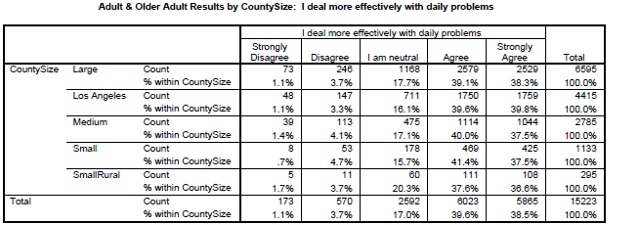

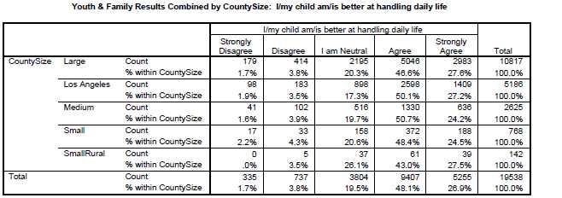

County Mental Health Plan Size: Categories are based upon DHCS definitions by county population.
o Small‐Rural MHPs = Alpine, Amador, Calaveras, Colusa, Del Norte, Glenn, Inyo, Lassen, Mariposa, Modoc, Mono, Plumas, Siskiyou, Trinity
o Small MHPs = El Dorado, Humboldt, Imperial, Kings, Lake, Madera, Mendocino, Napa, Nevada, San Benito, Shasta, Sutter/Yuba, Tehama, Tuolumne
o Medium MHPs = Butte, Marin, Merced, Monterey, Placer/Sierra, San Joaquin, San Luis Obispo, San Mateo, Santa Barbara, Santa Cruz, Solano, Sonoma, Stanislaus, Tulare, Yolo
o Large MHPs = Alameda, Contra Costa, Fresno, Kern, Orange, Riverside, Sacramento, San Bernardino, San Diego, San Francisco, Santa Clara, Ventura
o Los Angeles’ statistics are excluded from size comparisons, but are included in statewide data.
Total Values (in Tables above) = include all statewide data received by CiMH for these survey items.

REMINDER:

Thank you for your participation in completing your Data Notebook report.
Please feel free to provide feedback or recommendations you may have to improve this project for the following year. We welcome your input.

Please submit your Data Notebook report by email to:
DataNotebook@CMHPC.CA.GOV

Or, you may submit a printed copy by postal mail to:
- Data Notebook Project
- California Mental Health Planning Council
- 1501 Capitol Avenue, MS 2706
- P.O. Box 997413
- Sacramento, CA 95899-7413

For information, you may contact either email address above, or telephone:
(916) 449-5249, or
(916) 323-4501

Serious Mental Disorder, term used for adults 18 and older.
Severe Emotional Disorder, term used for children 17 and under.

