San Francisco: Data Notebook 2014
for California
Mental Health Boards and Commissions
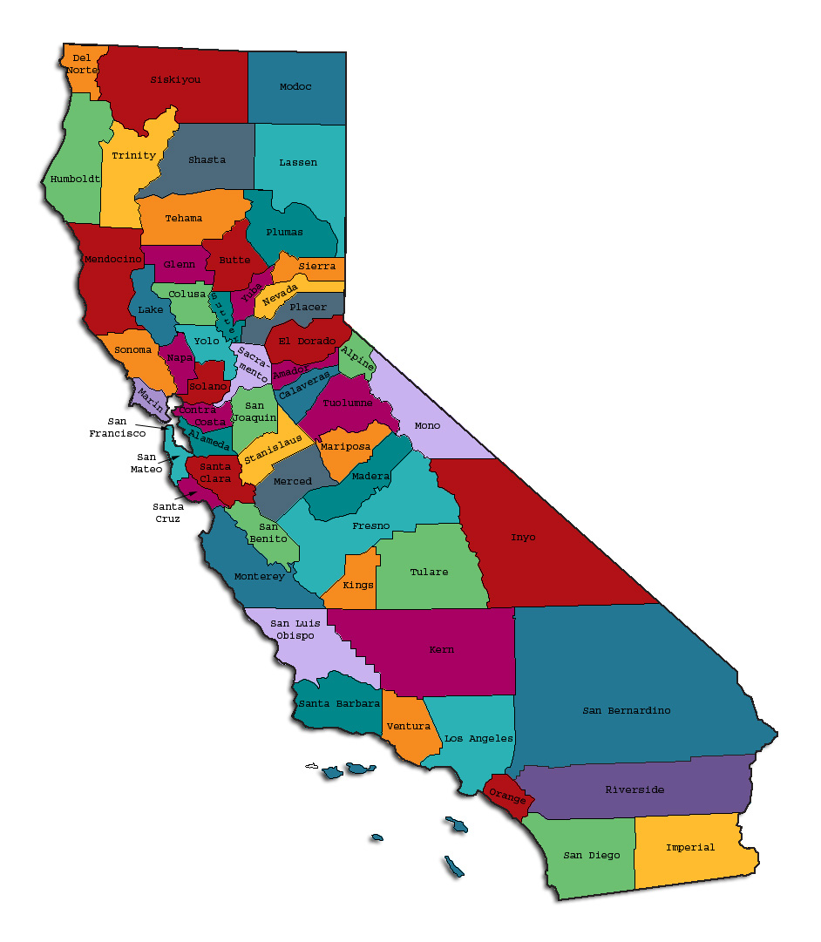
Prepared by California Mental Health Planning Council, in collaboration with: California Association of Mental Health Boards/Commissions, and APS Healthcare/EQRO
This Page Intentionally Left Blank.

San Francisco Mental Health Board
Mental Health Boards and Commissions

County Name: San Francisco Population (2013): 831,156
Website for County Department of Mental Health (MH) or Behavioral Health: http://www.sfdph.org
Website for Local County MH Data and Reports: http://www.sfdph.org
Website for local MH Board/Commission Meeting Announcements and Reports: http://www.sfgov.org/mental_health and http://www.mhbsf.org

Specialty MH Data from review Year 2013-2014: http://caeqro.com/webx/.ee85675
Total number of persons receiving Medi-Cal in San Francisco (2012): 166,789
Average number Medi-Cal eligible persons per month: 142,626
Percent of Medi-Cal eligible persons who were:
Children, ages 0-17: 27.8 %
Adults, ages 18-59: 39.4 %
Adults, Ages 60 and Over: 32.8 %
Total Medi-Cal eligible persons with SMI or SED who received Specialty MH services (2012): 14,443
Percent of Specialty MH service recipients who were:
Children 0-17: 20.3 %
Adults 18-59: 57.6 %
Adults 60 and Over: 22.1 %
INTRODUCTION: Purpose, Goals, and Data Resources
This Data Notebook has been developed for the use by the local mental health (MH) boards and commissions by a yearlong workgroup comprised of members from:
- California Mental Health Planning Council (CMHPC)
- California Association of Local Mental Health Boards and Commissions (CALMHB/C)
- APS Healthcare/EQRO (External Quality Review Organization)
Our plan is for the Data Notebook to meet these goals:
- Assist local boards to meet their mandates to review the local county mental health systems, identify unmet needs, and recommend improvements.
- Provide a professional format for submitting reports to their local Board of Supervisors, and/or their county Director of Mental Health Services.
- Function as an educational tool for local boards, whose members have varying levels of skills, frequent turnover, and need ‘refresher’ training about using data.
- Help the CMHPC fulfill its mandates to review and report on the public mental health system in California, which also helps provide evidence for advocacy.
Data reporting drives policy, and policy drives funding for programs. But the data must be both recent and available to the public, or else it is not useful. So, the CMHPC will provide examples of local data from current public reports. We focus on two broad areas: (1) evaluation of program performance, and (2) indicators of client outcomes.
We recognize that each county has a unique population, resources, strengths, and needs. Thus, there is no single perfect data source to answer all the important questions one might ask about mental health services. However, the following data resources will help board members answer questions in this Data Notebook:
- experience and opinions of the local mental health board members
- recent reports about county MH programs from APS Healthcare/EQRO
- data you request from your county QI Coordinator and/or Mental Health Director (because CMHPC does not have that data, and it’s not in other public reports)
- client outcomes data provided by California Institute of Mental Health (CiMH) in their analysis of the most recent Consumer Perception Survey.
Some of our data comes from APS Healthcare/EQRO, which kindly gave permission to use their figures and tables, prepared for review of each county’s Medi-Cal Specialty Mental Health services. Those reviews are at: www.CAEQRO.com. You may find the full-length EQRO reports helpful because they summarize key programs and quality improvement efforts for each county. They also describe strengths, opportunities for improvement, and changes in mental health programs since the last year.
Understanding changes in local programs can help consumers because of the massive re-organization of mental health services statewide. Some changes have been confusing to clients. The old state Department of Mental Health was eliminated in 2012 and many functions were moved to the Department of Health Care Services. Other changes due to federal health care reform and the Affordable Care Act affect how mental health services are provided, funded, and linked to primary health care or substance use treatment. Also, local counties have adjusted to major challenges.
Remember, this report is about your community, and what you and your stakeholders choose to discuss. Examining the data can indeed “Tell a Human Story.” But quantitative data (numbers) provides only part of the picture, for example:
- measures of whether the quality of program services improve over time
- whether more people from different groups are receiving services
- how many clients got physical healthcare or needed substance use treatment.
The other part of the story gives human context to the numbers. Such qualitative data (narrative, descriptions, or stories) tells more of the story, because we can:
- describe special programs targeted for outreach to specific groups
- examine how the programs are actually implementing their goals
- list concrete steps that are taken to improve services, and
- tell what is being done to increase client engagement with continued treatment.
We hope this project contributes to ongoing quality improvement (QI) in mental health services. We seek constant improvement in our approach to quality because:
- needs change over time,
- all human endeavors are by nature imperfect,
- creativity gives rise to new ideas, and
- we can share examples of successful programs to help other communities.

TREATING THE WHOLE PERSON:
Integrating Behavioral and Physical Health Care:
Studies have shown that individuals with serious mental illness die, on average, 25 years earlier than the general population. This information makes improving the physical health of clients of great importance and should be a goal of county mental health departments along with providing effective and appropriate mental health services. Coordination of care for mental health, substance abuse and physical health is one way of accomplishing the goal.

The California Mental Health Planning Council does not have any data to provide to show how your county’s programs connect clients of mental health services with necessary physical health care. We ask that the local mental health board request information from your county mental health department for any data on numbers (or percent) of total mental health clients who are referred to, or connected with, physical health providers to assess, treat and monitor physical health issues.

County efforts to improve the physical health of clients.
Community Behavioral Health Services (CBHS) recognizes the importance of integrating mental health and physical health care and has developed plans to have somatic health care delivered by co-locating a nurse practitioner at four mental health clinic sites this year.
The Office-Based Opiate Treatment (OBOT) program celebrated ten years of service in San Francisco. The novel OBOT program, which served as a pilot program for the State of California, provided a licensed narcotic treatment program with methadone fully integrated into three San Francisco Department of Public Health Primary Care clinics: Tom Waddell Urban Health Clinic, Potrero Hill Health Center and San Francisco General Hospital Ward 86.
The program allows individuals who are addicted to opiates like heroin to receive treatment from their primary care provider- treating all their health conditions in a holistic way. This is important because many drug users have co-occurring medical conditions that can be complex and dangerous if their medical provider lacks knowledge of their drug use or participation in drug treatment. The OBOT clients have built positive relationships with the pharmacy staff and also with substance abuse counselors, nurses and physicians at their primary care homes.
Community Behavioral Health Services in collaboration with Rally Family Visitation Services, Saint Francis Memorial Hospital, was awarded a three year grant from the Office on Violence Against Women for the Safe Havens: Supervised Visitation and Safe Exchange Grant Program.
CBHS PHARMACY and OUTPATIENT MONITORING:
Subutex (Buprenorphine) programs are on-going for treatment of addiction
SAN FRANCISCO Department of Public Health (DPH) DRUG OVERDOSE EDUCATION PROJECT:
Narcan is co-prescribed for opioid patients at DPH Clinics. Data indicates 1,000 lives saved over the 10 years.

Primary Behavioral Health Care Integration grant at the California Innovations Summit on May 22, 2013, panel presentation with CBHS Director Jo Robinson and Dr. Deborah Borne. The Summit highlighted San Francisco's model of integrating health care into a behavioral health program at South of Market Mental Health.
The San Francisco Hep C Task Force held a meeting August 8, 2013 with pharmaceutical reps to explore strategies to use innovations to reduce hepatitis related health outcome disparities.

Wellness programs to engage and motivate clients to take charge of improving their physical health
- Managing chronic disease/addiction: Patients who are just starting on buprenorphine at OBIC or who require more intensive monitoring can receive their medication from the CBHS Pharmacy. CBHS pharmacists work closely with patients and prescribers to coordinate care, monitor for changes in psychiatric symptoms, assess substance use, and support adherence. Patients interested in treatment of opioid addiction are referred to OBIC

- Stress Management/Social connectedness Linea de Crisis - The San Francisco Suicide Prevention Partnership launched its new Spanish Language Crisis Hotline “Linea de Crisis” that provides Spanish language crisis support in the Bay Area.

- Mission Family Center is located in the heart of the Mission and focuses on serving children, youth and families that live in the district and/or the bicultural/bilingual Spanish speaking community.

- Smoking cessation Youth Leadership Institute’s (YLI's) Tobacco Use Reduction Force (TURF) is a group of San Francisco youth leaders working to reduce the impact of tobacco on their city's low-income neighborhoods. In a significant new development, TURF has built an unlikely partnership with the powerful Arab American Grocers Association (AAGA), the City's largest association of small independent markets with more than 400 separate retailers. Though most Association members sell Tobacco, AAGA is now supporting TURF's efforts to reduce tobacco retailer density and improve community health. In their second meeting, AAGA took this partnership a step forward, asking TURF to help them in their efforts to pass an ordinance to help sustain small independent retailers in SAN FRANCISCO. Given that TURF has secured more than 600 individual and organizational supporters for its ordinance, AAGA realized TURF could be an important ally to them as well. With support from AAGA, TURF is now working draft a policy that will cap the number of tobacco retail permits per district to 45 and create a mechanism to reduce permits over time without taking permits directly from existing merchants. TURF estimates that this mechanism will significantly reduce the number of stores selling tobacco over the next ten years.

- Nutrition Alleviating Atypical Antipsychotic Induced Metabolic Syndrome is a MHSA-Innovations pilot program led by the Housing and Urban Health Clinic. This program adapted an existing nutrition and exercise protocol into a community mental health setting and integrated shopping and cooking skills training. This program educates consumers prescribed atypical antipsychotics about the connection between diet and health, how to shop based on what is locally available, healthy cooking, and how to exercise to improve fitness and health.

- Consumer and Family Conference: Food, Mood & Move July 19, 2013 St. Mary's Cathedral Conference Center. The workshop training was on healthy eating, assisting clients in assessing their overall diet quality, tips and resources on how to eat on a budget and how to reduce intake of foods and beverages of low nutritional value. Also discussed, low cost ways to promote physical activity to clients as a way to improve their physical and mental health.

NEW CLIENTS: One Measure of Access
Definition of 'new’ clients
Behavioral health clients are considered new when they open a new episode of care within a fiscal year.
County data on the number of 'new' clients last year.
# New children/youth (0-17 yrs): 3,425
Of these, how many (or %) are ‘brand new’ clients: 2,149 (63 %)

# New adults (18-59 yrs): 14,826
Of these, how many (or %) are ‘brand new’ clients: 8,147 (55%)

# New older adults (60+ yrs): 1,714
Of these, how many (or %) are ‘brand new’ clients: 848 (49%)
REDUCING RE-HOSPITALIZATION: Access to Follow-up Care
Sometimes, an individual experiences acute symptoms of mental illness or substance abuse which can result in a brief stay in an acute care hospital. Receiving follow-up services after discharge from a short-term (3-14 day) hospitalization can be critical to preventing a return to the hospital.
The chart below shows the percentage of people discharged in your county who received at least one service within 7 days of discharge. Also shown is the percentage of those same people who were readmitted to the hospital. The chart also shows the same information for receiving services and being readmitted to the hospital within 30 days. Red indicates the numbers for your county and the blue indicates the percentage for the State of California. (MHP = county mental health plan, CY = calendar year).

San Francisco:

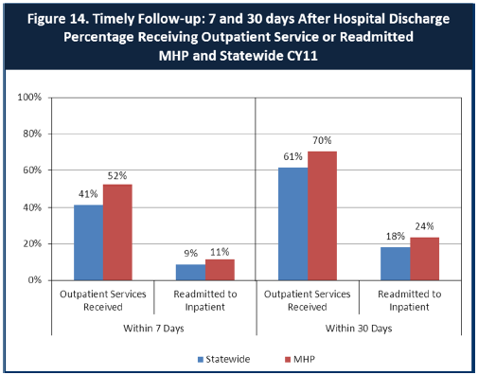
How San Francisco County compares to state outcomes.
San Francisco had 52% outpatient services within 7 days versus 41% for CA and 11% readmitted to inpatient versus 9% for CA. San Francisco had 70% outpatient services within 30 days versus 61% for CA and 24% readmitted to inpatient versus 18% for CA. San Francisco County has provided more Outpatient Services versus the State within 7 and 30 days; therefore, the County is doing better in terms of timely follow-up. Slightly more San Francisco County patients are readmitted to Inpatient hospitalization versus the State in these two time frames.
The County hospital works closely with Community Programs and families of patients to assure a warm handoff to programs.
There are also 400 clients served by Assertive Community Treatment programs. These clients have 24/7 access to a case manager which has resulted in a reduction of hospitalizations over the years.

Ways San Francisco can improve follow-up and reduce re-hospitalizations.
We need to take a closer look at connections to community services. Patients are sometimes referred to family members’ care, even though the family may not be obliged to take in an older (non-minor) adult patient. The family’s inability to provide for such patients could result in an increase in readmissions. Therefore, we need to ensure follow-up programs are consistent and available throughout the system.
CBHS was awarded a four year grant from MHSA to augment crisis response services and volunteers. The focus will be on prevention and resource navigation.
Component two will be the establishment of a child, youth and family friendly triage space for children and youth experiencing acute psychiatric issues. This will give San Francisco County an alternative to evaluating youth in emergency rooms and adult facilities. In addition we will be able to increase our capacity to divert youth from being hospitalized in out of county facilities.
The third component will be the development of four community based teams that will provide focused treatment to children, youth and family members who are experiencing trauma due to community violence and/or experiencing psychiatric and behavioral issues in their homes, after-school programs, schools or other community settings. The teams will be staffed with clinical, behavioral and peer staff starting in summer 2014

CHART REVIEWS for Quality Improvement:
The CYF and Adult/Older-Adult CBHS Systems-of-Care are initiating a planning process to redesign the PURQC process within CBHS mental health outpatient programs. PURQC (Program Utilization Review and Quality Committee). PURQCs meet weekly in order to authorize requested levels-of-service utilization for clients, review charts for compliance with regulations and standards for documentation set by Medi-Cal and CBHS, and review charts for quality-of-care.
It is not certain whether the results of the reviews of their charts by the PURQC are adequately brought to the attention of clinicians, and that adequate follow-up on compliance or quality-of-care issues, to foster improvement in areas of weaknesses, are done with clinicians.
The results of the PURQC review of charts in the area of compliance need to be followed up, and necessary improvement in the clinician’s practice monitored and ensured. Quality-of-Care chart reviews and discussions with the clinicians may be lacking in the PURQC weekly chart audits. A quality-oriented chart review looks for indicators of a Wellness-Recovery approach to providing care.

Three most significant barriers to service access:
1) Cultural, i.e., reluctance to obtain services because of the stigma of needing mental health services in these communities;
2) Lack of psychiatrists which limits the number of patients that can be seen; and
3) Numbers of therapists.

ACCESS BY UNSERVED AND UNDER-SERVED COMMUNITIES

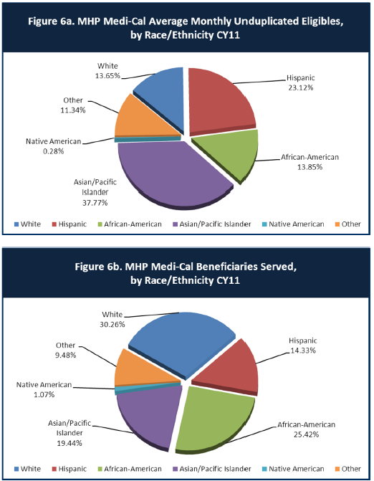

Assessment of the percentage of Medi-Cal eligible that have an actual need for mental health services.

Community programs serve nearly 40,000 people. The Data Notebook suggests it would be good to assess the percentage of Medi-Cal eligible that have an actual need for mental health services. The planned integration of primary care with mental health and substance abuse is expected to increase the number of people eligible for Medi-Cal who will be treated for mental health and substance as they enter the system through primary care and are referred for services. It appears there is a higher percentage of White and African Americans served by Medi-Cal (30.2 and 25.4%) vs. Asian/Pacific and Hispanic (19.4 and 14.3). Large numbers of eligible Asians are not receiving services, as the percentage served is half of those eligible (19% vs. 37% of eligible). There may be some cultural factors to account for a reluctance to receive mental health services. A similar drop-off is seen with Hispanics (14% vs. 23% of eligible.) It is not known as this point if all of those who are eligible for mental health or substance abuse services through Medi-Cal are actually in need of those services.

 | Asian/  Pacific | African-American | Hispanic | White | Other | Native American
Medi-Cal Eligible | 37.7 % | 13.8 % | 32.1 % | 13.6 % | 11.3 % | 0.3 %
Medi-Cal MH Services | 19.4 % | 25.4 % | 14.3 % | 30.3 % | 9.5 % | 1.1 %

Outreach efforts being made to reach minority groups in San Francisco

- Linea de Crisis - The San Francisco Suicide Prevention Partnership launched its new Spanish Language Crisis Hotline “Linea de Crisis” that provides Spanish language crisis support to the Bay Area.

- CalMHSA Stigma and Discrimination Reduction contractor, Runyon Saltzman & Einhorn, recently released two Spanish-language videos at www.EachMindMatters.org. Counties, community-based organizations and CalMHSA grantees can use these short videos to help reduce stigma and discrimination among community members and decision makers.

- Two clinicians at the Chinatown Child Development Center, Dr. Hang L. Ngo and Grace Fung, were recently awarded a small grant from the Chinese Community Health Care Association (CCHCA) for a grant proposal entitled "Linguistically and Culturally Appropriate Group Therapy Treatment for Chinese Children with ADHD and Their Caregivers Based on a Modified Version of the Family STARS Program.”

- Iraqi Refugees Support Group: MHSA has begun funding the Arab Cultural and Community Center of San Francisco (www.arabculturalcenter.org) to provide culturally sensitive mental health support to Iraqi refugee females struggling with depression, anxiety and isolation. Since the start of the war in Iraq, 14,000 settled in California. The Bay Area has seen a dramatic influx of refugees these past five years, mainly from Iraq and more recently a few from Syria. Many of these refugees are suffering from extreme symptoms associated with the traumas of war, relocation to dangerous neighborhoods, loneliness, lack of community, etc. The support group aims to provide a space where refugee women can receive mental health support within a culturally acceptable channel without the worry of acquiring the stigma associated with going to see a therapist. The support group is a safe place for the women to bond with each other, share with each other, cook together, and learn essential life skills together. It provides a place where they can learn about topics such as depression, PTSD, health and wellness in a supportive environment. This support group is also a safe space where women can seek help confidentially about mental health services and other needed health referrals.

- Children’s System of Care (CSOC) works with families impacted by the gun violence that claims the lives of San Francisco youth, the developed a five-day “healing from community violence” workshop for transitional age youth who have lost friends and family to gun violence. In this workshop, youth learn to identify their personal symptoms from trauma, how to seek treatment, and receive coping/healing tools that will help them begin the process of healing and maintaining a healthy mental well-being.

- Expanded health coverage screening: The Human Services Agency is providing help to those who are low income but not eligible to Medi-Cal to purchase affordable private health insurance offered by Covered California.

Mental Health Board suggestions for improving outreach to, and for, programs for underserved groups
- Add street signage to all community mental health clinics to inform their neighborhoods and those travelling through of the free and/or low cost mental health services available.
- Run a public education campaign to inform all of the availability of free and/or low cost community mental health services. This should occur through multiple ways. These can include advertising on billboards, flyers handed out at street fairs and outdoor public events as well as radio spots. All flyers should include a phone number and a website to learn more.
- Expand and improve mobile outreach by including multi-disciplinary teams with peers. Have them canvas areas of high need such as the Tenderloin, Western Addition and South East sectors of the city.
- Decrease the wait time to be connected to mental health treatment after initial intake, assessment or triage.
- Each community mental health clinic should have a mobile outreach team that canvases the surrounding neighborhood to inform and engage residents. Each team of at least three should include a peer.
- Create a citywide mental health resource list made available through a website, phone number and an Android and iPhone app.

CLIENT ENGAGEMENT IN SERVICES
One MHSA goal is to connect individuals to services they need. Clients who stop services too soon may not achieve much improvement, nor is it likely to last. So it is important to measure not only who comes in for treatment, but also how long they stay in services. Here we are considering individuals with high service needs, not someone who just needs a ‘tune-up.’ Although not every individual needs the same amount of services, research shows that when someone with severe mental illness continues to receive services over time, their chances of recovery increase.

Engagement in services, also called ‘retention rate’, is important to review. If individuals come in, receive only one or two services and never come back, it may mean the services were not appropriate, or that the individual did not feel welcome, or some other reason that should be explored. Again, we recognize that some individuals only need minimal services, but here we are looking at those with severe mental illness. Ultimately, the goal is to ensure they are getting needed services and are on the road to recovery. But we would not know that unless we look at how many services individuals received over time.

The chart below shows the number of Medi-Cal beneficiaries in our county who received 1, or 2, or 3, or 4, or 5, or more than15 mental health services during the year. For individuals experiencing severe mental illness, the more engaged they are in services, the greater the chance for lasting improvements in mental health.

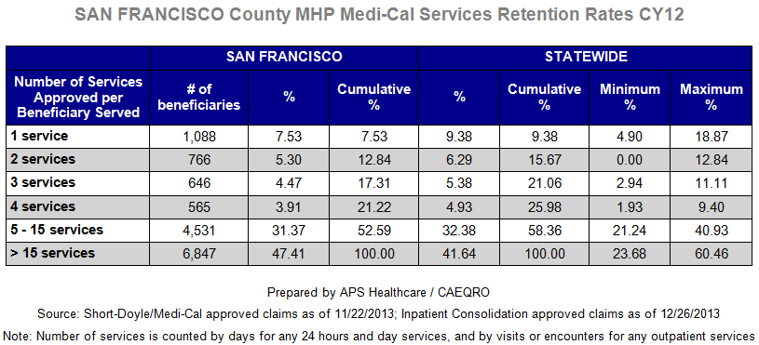

San Francisco County is doing well with retention rates.

According to the chart of San Francisco County MHP Medi-Cal Services Retention Rates, San Francisco is somewhere in the middle versus the statewide averages for Retention. Based on an assumption that more services could mean long-term engagement of the clients, San Francisco is closer to the highest retention rates statewide for those beneficiaries receiving 5-15 (31.4% vs 40% maximum statewide) or >15 services per year (47.4% vs. 60.4% maximum statewide). This could reflect a greater number of individuals with severe mental illness or higher service needs in San Francisco County, requiring more services, and could also represent better retention.

For those clients receiving less than 5 services, San Francisco is in the process of developing plans to re-engage those individuals for further mental health services.

Mayor Lee tasked the San Francisco Department of Public Health (DPH) with convening a community process to determine how to engage and maintain in appropriate behavioral health treatment severely mentally ill, and often with co-occurring diagnosis, individuals that current programs have failed to successfully treat or adequately engage. The website for this task force is:

http://www.SanFranciscodph.org/dph/comupg/knowlcol/CARE/default.asp

Engagement of underserved communities

Recognition by San Francisco Health Plan Tom Waddell Urban Health was given the Excellence in Member Services and Cultural Awareness award in recognition of their excellent service to special populations/transgender population, (higher rates of mental health diagnoses, psychiatric medications, higher rate of physical health problems, meth use, according to UCSAN FRANCISCO studies, greater HIV testing rates, greater needle use, but no difference in service utilization, indicating a possible need to treat a greater percentage of these patients for substance abuse).

Southeast Health Center was recognized with the Commitment to Health Improvement award for making dramatic improvements in patient access to care.

Culturally sensitive programs and recruitment of experienced ethnic professionals will help. In many cultures, receiving mental health services often carries a negative stigma for the client. Many clients are afraid of seeking mental health services as they will be stigmatized by their community as being crazy. Some clients worry this could affect their chances of marriage and/or chances of marriage for their children as it may be construed that the therapist is dealing with a problem that might be genetic and thus can be inherited.

The Comprehensive Crisis Services team crisis calls have surged, teams continued to work diligently to provide culturally competent, responsive services to help support the safety and wellness of the children, adults, and families experiencing acute behavioral health crises in San Francisco.

Support services were provided to the staff at the new Sunnydale Wellness Center as the staff reached out to the community.

San Francisco Foster Care Mental Health: Currently developing child and family teams working with a specific clinician for co-ordination of care, to support the health of youth and families in foster care, special education, and probation, and including plans for culturally modified treatments. This group is composed of high number of various ethnicities.

CLIENT OUTCOMES: Consumer Perception Survey (August 2013)

Ultimately, the reason we provide mental health services is to help individuals manage their mental illness and to lead productive lives. We have selected two questions from the Consumer Perception Survey which capture this intention. One question is geared toward adults of any age, and the other is for children and youth under 18.

Below are the data for responses by clients in your county to these two questions.

The total numbers of surveys completed for Adults or Children/Youth in your county are shown separately in the tables below, under the heading “Total.”

Q1. Adults. As a direct result of the services I received, I deal more effectively with daily problems.
 | Strongly Disagree | Disagree | Neutral | Agree | Strongly Agree | Total
Number of Responses | 4 | 4 | 43 | 101 | 116 | 268
Percent of Responses | 1.5 % | 1.5 % | 16.0 % | 37.7 % | 43.3 % | 100.0 %

Q2. Children/Youth. As a result of services my child and/or family received, my child is better at handling daily life.

 | Strongly Disagree | Disagree | Neutral | Agree | Strongly Agree | Total
Number of Responses | 1 | 1 | 21 | 59 | 34 | 116
Percent of Responses | 0.9 % | 0.9 % | 18.1 % | 50.9 % | 29.3 % | 100.0 %

Ideas regarding county’s engagement of underserved

Health Fairs: For example LEGACY group (Lifting, Empowering Generations of Adults, Children, and Youth) Peer support through fairs at Housing Developments, Middle Schools.

New Mental Health Resources for Asian Pacific Community Prop 63 Funding. Documentation now in Hmong, Lao, Khmer, and Mien with vocabulary index of common mental health terms and cultural myths fact sheets (www.speakourminds.org/resource-categories/to-say/)
Effectiveness of mental health services in our county
- 81% of adult clients agreed or strongly agreed [(101 + 116)/268 surveyed] that they dealt more effectively with daily problems as a result of receiving county mental health services.
- 80.2% of families agreed or strongly agreed [(59+34)/116 surveyed] that youth were handling daily life better.

Recommendations for improving effectiveness of services
Continued/expanded professional training programs such as:
- TRAUMA INFORMED TRAINING SESSIONS, including community programs and education for health care workers

- SUPERIOR COURT Behavioral Health Programs: Directing those incarcerated for untreated mental health issues to community programs instead, therefore reducing the harm that comes to these prisoners for lack of treatment

- DPH School Programs Training of Workforce: Special Coordinator helps to develop curriculums for training.

- College programs: UCSF Pharmacy school is incorporating Mental Health Awareness training for students.

- NAMI National Alliance on Mental Illness, S.F. Peer Outreach program to high schools, and promotion of Art and Video student projects promoting awareness.

- Group Intervention programs for patients with common problems to expand reach beyond individual sessions.

- Outreach and information to multiple SRO hotels (single room) residents. Many elderly and isolated clients in need of services.

Suggestions to increase the response rate for questionnaires.
Increase the methods in which the survey is implemented. Social Media (i.e. Facebook page), telephone questionnaires, email to clients, return postcard, etc.
Suggestions regarding:
- Specific unmet needs or gaps in services
- Improvements to, or better coordination of, existing services
- New programs that need to be implemented to serve individuals in your county

Medi-Cal Patients: Incorporate medication reviews for senior patients, particularly those psychiatric prescription clients who may need to avoid Antihistamines, Anti-Parkinson (Cogentin), Tricyclics (Elavil, Doxepin), and avoid Benzodiazepines for insomnia (Valium, Ativan, Restoril, Klonopin).
Encourage “Brown Bag Review” sessions with clinicians or clinics/pharmacies to reduce the above medications as well as over-the-counter interactions.
Use BEERS LIST for psychiatric prescribing (especially, reduction in doses for the elderly).
Caution in doses of Antidepressants and Antipsychotics.

<END>
REFERENCE DATA: for Consumer Perception Survey items (August 2013)

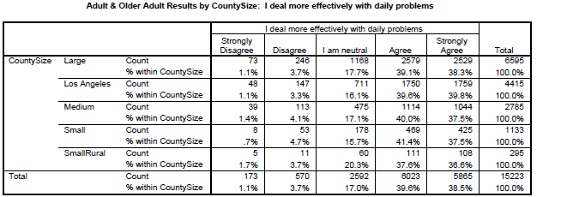

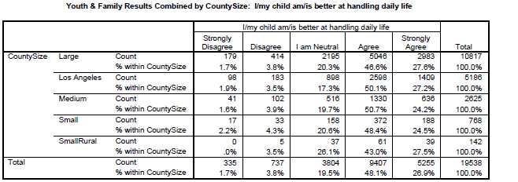

County Mental Health Plan Size: DHCS categories defined by county population.
o Small‐Rural MHPs = Alpine, Amador, Calaveras, Colusa, Del Norte, Glenn, Inyo, Lassen, Mariposa, Modoc, Mono, Plumas, Siskiyou, Trinity
o Small MHPs = El Dorado, Humboldt, Imperial, Kings, Lake, Madera, Mendocino, Napa, Nevada, San Benito, Shasta, Sutter/Yuba, Tehama, Tuolumne
o Medium MHPs = Butte, Marin, Merced, Monterey, Placer/Sierra, San Joaquin, San Luis Obispo, San Mateo, Santa Barbara, Santa Cruz, Solano, Sonoma, Stanislaus, Tulare, Yolo
o Large MHPs = Alameda, Contra Costa, Fresno, Kern, Orange, Riverside, Sacramento, San Bernardino, San Diego, San Francisco, Santa Clara, Ventura
o Los Angeles’ statistics are excluded from size comparisons, but are included in statewide data.
Total Values (in Tables above) = include all statewide data received by CiMH for those survey items.
For further information about this project contact:
DataNotebook@cmhpc.ca.gov
Or, by mail:
- Data Notebook Project
- California Mental Health Planning Council
- 1501 Capitol Avenue, MS 2706
- P.O. Box 997413
- Sacramento, CA 95899-7413

Telephone:
(916) 449-5249, or
(916) 323-4501
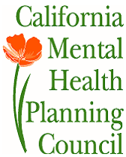

Serious Mental Illness, term used for adults 18 and older.
Severe Emotional Disorder, term used for children 17 and under.
http://www.empr.com/beers-list-potentially-inappropriate-drugs-for-elderly/article/125908/

