Sacramento County: Data Notebook 2014
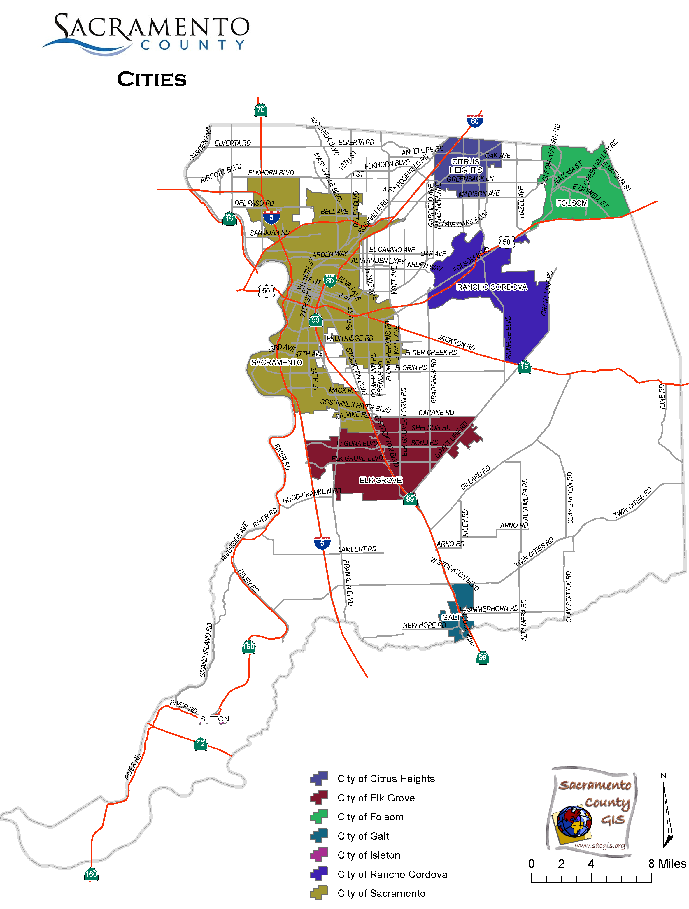
Submitted by the Sacramento County Mental Health Board
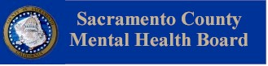

The Sacramento County Mental Health Board thanks the Division of Behavioral Health services for their assistance and support, and the California Mental Health Planning Council for the opportunity to submit observations and comments regarding Sacramento County’s mental health services.
Additionally, thank you to the Data Notebook Ad Hoc Committee, Chris Hunley, Leoma Lee, and Sarah Jain, for volunteering to complete this assignment and for their service to the Sacramento County mental health community.

Sacramento County Mental Health Board

Sacramento County: Data Notebook 2014
for California
Mental Health Boards and Commissions

County Name: Sacramento Population (2013): 1,447,759
Website for County Department of Mental Health (MH) or Behavioral Health:
http://www.dhhs.saccounty.net/BHS/Pages/BHS-Home.aspx

Website for Local County MH Data and Reports:
http://www.dhhs.saccounty.net/BHS/Pages/BHS-Home.aspx

Website for local MH Board/Commission Meeting Announcements and Reports:
http://www.dhhs.saccounty.net/BHS/Pages/Advisory-Boards-Committees/Mental-Health-Board/BC-Mental-Health-Board.aspx

Specialty MH Data from review Year 2013-2014: http://caeqro.com/webx/.ee85675

Total number of persons receiving Medi-Cal in your county (2012): 408,481
Average number Medi-Cal eligible persons per month: 336,514
Percent of Medi-Cal eligible persons who were:
Children, ages 0-17: 45.3 %
Adults, ages 18-59: 42.0 %
Adults, Ages 60 and Over: 12.7 %
Total persons with SMI or SED who received Specialty MH services (2012): 18,988
Percent of Specialty MH service recipients who were:
Children 0-17: 46.8 %
Adults 18-59: 46.9 %
Adults 60 and Over: 6.3 %
TREATING THE WHOLE PERSON: Integrating Behavioral and Physical Health Care

Studies have shown that individuals with serious mental illness die, on average, 25 years earlier than the general population. This information makes improving the physical health of clients of great importance and should be a goal of county mental health departments along with providing effective and appropriate mental health services. Coordination of care for mental health, substance abuse and physical health is one way of accomplishing the goal.

The California Mental Health Planning Council does not have any data to provide to show how your county’s programs connect clients of mental health services with necessary physical health care. We ask that the local mental health board request information from your county mental health department for any data on numbers (or percent) of total mental health clients who are referred to, or connected with, physical health providers to assess, treat and monitor physical health issues.

If your county has data on numbers or percentages of clients who are also receiving physical health care, please include it in your Data Notebook you submit to the Council.

___ Check here if your county does not have such data or information.

- Please describe any efforts in your county to improve the physical health of clients.

The Sacramento County Mental Health Board (MHB) requested the Division of Behavioral Health Services (DBHS) to report back on this question. Below is DBHS’ response.

DBHS participated in a performance improvement project (PIP) workgroup beginning in December 2010. The focus of this project was “Primary Care.” There was impressive data to support the fact that there was a high mortality associated with severe mental illness. Clients who received services at the adult outpatient Regional Support Teams (RSTs) providers experience many chronic conditions, most often hypertension, high cholesterol, diabetes, and chronic pain. Over 50 % of the clients report having two or more medical conditions.

DBHS embarked on a multifaceted plan to increase the access to coordinated and/or integrated care for persons with mental illness and co-occurring physical health needs. The PIP workgroup decided to obtain data from the medical records to include documented medical issues, Primary Care Physician (PCP), and PCP appointments. The January 2011 medical record data results revealed that documentation of medical conditions was inconsistent and did not address the impact the medical condition was having on the client. It was the general consensus by the workgroup that if the primary care provider, medical issues and follow-up were documented in the case file it would lead to better coordination of care and better mental and physical health outcomes for the client.

DBHS, along with the Primary Health Division, collaborated to co-sponsor Primary Care Coordination trainings after meeting with service providers to identify some key areas of concern for mental health consumers in obtaining access to and receiving primary health care services. The staff trainings provided education about physical health issues and how to address issues that are identified during routine PCP office visits. The training also addressed the importance and need for coordinated/integrated mental and physical health care. Trainings for consumers focused on education about common health issues and the importance of taking care of them. The topics were similar to what the service providers were trained on and provided an opportunity to hear from the consumers on their needs through a question and answer forum.

Medical record data was obtained in August 2012 revealed an 80% improvement in PCP information documented in the Service Plan and significant increase in the documentation of medical condition in the service plan and progress notes. Documentation of coordination of care improved 35%. PCP appointment documentation decreased by 10%.

The PIP was very successful in terms of identifying and documenting PCP, medical conditions and coordination of care/addressing medical conditions in both the case record and electronic files. It brought a heightened awareness to provider staff and it became apparent through chart reviews and data extracts that some of the PIP interventions had influenced non-PIP chart and electronic file documentation. The PIP was successful in changing the documentation process, but efforts to coordinate with the PCP fell short. This is an area that the Sacramento County Mental Health Plan (MHP) continued to work on with the Adult PIP during Fiscal Year (FY) 2012-2013. New strategies will be utilized to improve the coordination of care on behalf of clients between mental health and PCP’s in the community.

In October 2012, the PIP workgroup began the planning and analysis of “Changing the Culture of Mental Health to Increase Coordination with Primary Care” as a continuation of the 2011-12 PIP. After brainstorming, it was agreed that while the previous year’s PIP was successful in changing a documentation process, additional efforts were needed in order to improve the coordination of care with the PCP. The goal of this PIP was to change the culture of the RST clinics to include primary care, put systems for close coordination in place, and increase staff and clients’ awareness, knowledge and comfort around physical health issues.

Survey of clients suggested that clients need additional education and assistance in managing their health condition in order to feel better. Staff surveys revealed they were aware of the importance of physical health issues and 80% agree they are comfortable discussing and have knowledge about these issues. Moreover, almost 40% of staff are neutral or do not perceive it to be in their scope to provide assistance with physical health care issues. It was evident an increase in staff comfort level and confidence in dealing with primary care issues would be valuable.

Primary care dually boarded doctors provided staff trainings on topics such as: COPD, Asthma, Hypertension, Nutrition, and Smoking Cessation. Following training, staff implemented client groups on Smoking Cessation and Nutrition. Overall, this PIP achieved a significantly higher awareness of how mental health affects the physical health of our clients.

- How does your county address wellness programs to engage and motivate clients to take charge of improving their physical health? Examples:
- Exercise
- Nutrition
- Healthy cooking
- Stress management
- Quitting smoking
- Managing chronic disease
- Maintaining social connectedness

The MHB held ten general public meetings during 2013, where a variety of wellness programs were discussed throughout the year. Additionally, the MHB requested the DBHS to report back on this question. Below is DBHS’ response.

DBHS supports and encourages wellness and recovery with our clients and their families, with the purpose of improving their quality of life at all levels. To achieve such an important area, the DBHS had been supporting our providers by offering them the technical and professional support as needed. The essential goal is to develop and to fulfill an array of support groups for clients. We believe that by covering the most important areas that focus on wellness and recovery, it could motivate and engage the client to take charge of improving their mental and physical health. For that purpose, the DBHS made a commitment to assist providers by assigning two dually licensed medical doctors to help them develop a series of trainings with clinical staff around issues related to coordination of care between mental health and primary health, and by developing curriculums focusing on health areas such as nutrition and smoking cessation groups.

As a result, currently all of our providers offer a variety of groups that cover different topics that goes from, nutrition through maintaining social connectedness in the community. Following, is a comprehensive list of the various groups offered, many of them in different languages, by our mental health providers on each of the sites at all levels (Intermediate level of care Regional Support Team’s/County clinics - Adult Psychiatric Support Clinic’s), the Wellness and Recovery Centers, as well as, intensive MHSA Full Service Partnership programs. It is essential to comment that clinical and medical staff, peers support, and family members facilitate several of these groups:

• Nutrition
• Smoking Cessation
• Life and Leisure Skill Building
• Stress Management
• Wellness Hmong
• Wellness Mien & Laotian
• Discovering Life and Liberty in the Pursuit of Happiness
• Symptom Management
• Recreation and Leisure
• Vietnamese Life Skills

NEW CLIENTS: One Measure of Access

One way to evaluate the quality of mental health services outreach is to measure how many clients receive services who have never been part of the service system before (“brand new” clients). Another measure is how many clients return for services after a period of time with no services (“new” clients).

The California Mental Health Planning Council is exploring how each county mental health department defines “new” clients, and how a client is labelled when they return for additional services. This information is important in determining whether your county has a “revolving door,” that is, clients who are in and out of mental health services repeatedly. This data is one indicator of the success of your county’s programs in closing cases appropriately and providing adequate discharge planning to clients.

This data is not currently reported by the counties to the state. The Council does not have data to provide to you. This information should be requested from your county mental health department.

____ Check here if your county does not have this information.

- How does your county define 'new' client for those individuals who have previously received services, but who have not received services for a while? (e.g., 6 months, 12 months, 2 years?)

The MHB requested the DBHS to report back on this question. Below is DBHS’ response.

New clients are defined as not having an open outpatient episode in 1,095 days or more or never having an open episode. Brand new is a subcategory of “new” and are individuals that have no record of an outpatient episode in our system. These were guidelines determined by a Reducing Disparities Learning Collaborative in 2008.

- Please provide any data your county has on the number of 'new' clients last year. And if you have it, how many of those new clients were brand new clients? You may need to ask your county mental health department for this data.

The MHB requested the DBHS to report back on this question. Below is DBHS’ response.

# new children/youth (0-17 yrs) 5680
of these, how many (or %) are ‘brand new’ clients 3545

# new adults (18-59 yrs) 4504
of these, how many (or %) are ‘brand new’ clients 2421

# new older adults (60+ yrs) 296
of these, how many (or %) are ‘brand new’ clients 175

- There is no question #5.
REDUCING RE-HOSPITALIZATION: Access to Follow-up Care

Sometimes, an individual experiences acute symptoms of mental illness or substance abuse which can result in a brief stay in an acute care hospital. Receiving follow-up services after discharge from a short-term (3-14 day) hospitalization can be critical to preventing a return to the hospital.

The chart below shows the percentage of people discharged in your county who received at least one service within 7 days of discharge. Also shown is the percentage of those same people who were readmitted to the hospital. The chart also shows the same information for receiving services and being readmitted to the hospital within 30 days. Red indicates the numbers for your county and the blue indicates the percentage for the state of California.

Sacramento County:
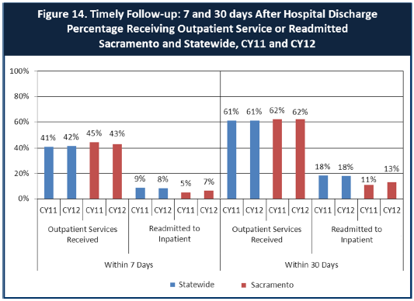

- Looking at the chart, is your county doing better or worse than the state? Discuss why (e.g., your county has programming available that specifically ensures a warm handoff for follow-up services).

In comparing “Re-admittance to Inpatient Treatment” percentage rates at both the 7-day mark and 30-day mark, the MHB observes that Sacramento County’s performance is better than the statewide averages.

For “Outpatient Service Received” percentage rates, Sacramento County is slightly higher than the state at the 7-day mark, and only 1% higher at the 30-day mark.

Of note, Figure 14 only accounts for Medi-Cal paid claims only, and doesn’t reflect the services provided to the indigent community nor Medi-Cal claims that have been deemed not reimburseable. Next year, we request that County specific information be included for analysis and comment.

- Do you have any suggestions on how your county can improve follow-up and reduce re-hospitalizations?

The MHB requested the DBHS to report back on this question. Below is DBHS’ response.

DBHS is in the process of implementing a Triage Navigator program and a Mobile Crisis Support Team with the expectation it will reduce the need for hospitalization and provide appropriate crisis intervention. These programs are currently in the development stage and implementation is planned for 2015.

DBHS strives to improve follow-up by assuring clients discharged from the hospital are provided with an appointment for follow-up care. The Community Support Team (CST) follows up on new clients discharged from the hospital, encourages compliance with appointments, and assists in reducing barriers that prevent consumers from receiving quality mental health care.

- What are the three most significant barriers to service access? Examples:
- Transportation
- Child care
- Language barriers or lack of interpreters
- Specific cultural issues
- Too few child or adult therapists
- Lack of psychiatrists or tele-psychiatry services
- Delays in service
- Restrictive time window to schedule an appointment

The MHB requested the DBHS to report back on this question. Below is DBHS’ response.
1. Transportation
2. Workforce capacity in key areas of discipline (e.g. medical professionals, clinical staff)
3. Providing an array of services that meets the cultural and linguistic needs of diverse communities

ACCESS BY UNSERVED AND UNDER-SERVED COMMUNITIES

One goal of the Mental Health Services Act (MHSA) is to reach unserved and underserved communities, especially communities of color. The MHSA promotes outreach into these communities to engage these communities in services. If individuals and families in these communities are not accessing services, then we may need to explore new ways of reaching them. Or, we may need to change our programs to meet their mental health needs in ways that better complement their culture.
From data the counties report to the state, we can see how many individuals living in your county are eligible for Medi-Cal, and of those individuals, how many received mental health services. Are you serving the Medi-Cal clients who need your services?
Sacramento County Data:
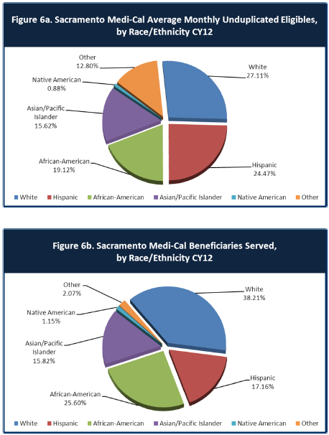
- Is there a big difference between the race/ethnicity breakdown on the two charts? Do you feel that the group(s) that need services in your county are receiving services?
After review of the above charts, the MHB observes that the two largest differences between the Medi-Cal eligible numbers in 6a, versus the actual number of beneficiaries served in 6b, are a higher percentage of White consumers (27.11% v. 38.21%) receiving services and a lower number of Hispanic consumers (24.47% v. 17.16%) receiving services. Answers to both questions 10 and 11 provide a detailed account of how the County strives to serve all segments of our community.

Of note, both figures 6a and 6b show Medi-Cal paid claims only, and do not reflect services provided to the uninsured nor unreimbursed Medi-Cal claims.

- What outreach efforts are being made to reach minority groups in your community?
The MHB requested the DBHS to report back on this question. Below is DBHS’ response.

DBHS is committed to eliminating mental health disparities for all unserved, underserved and inappropriately served cultural, ethnic and racial groups. “Building Partnerships: Key Considerations When Engaging Underserved Communities Under the MHSA,” a report by the UC Davis, Center for Reducing Health Disparities, defines historically unserved and underserved communities to be (1) geographically isolated from services providers; (2) linguistically isolated from service providers; (3) are culturally and socially isolated from county and state agencies; and/or (4) have limited social and economic resources to access available care. It is important to address access issues and develop outreach efforts designed to engage these communities, foster trust and partner with them and their leaders to develop strategies to improve service utilization, and improve penetration and retention rates. With the formation of the Cultural Competence Committee in 1997, DBHS worked with mental health stakeholders including individuals and families from diverse cultures and ethnicities with lived experience, community leaders, staff and contract providers to develop a plan to implement culturally and linguistically competent practices and policies including those that address access throughout the mental health system. The Cultural Competence Committee (CCC) advises DBHS on cultural competence issues including but not limited to: outreach, accessibility, linguistic requirements, human resources, and strategies to improve utilization/penetration rates. The CCC reviews data to identify under/unserved/inappropriately served cultural, racial, and ethnic communities in need of targeted outreach to remove barrier to service. A sub-committee to the CCC, the System-wide Community Outreach and Engagement Committee (System-wide Committee), was formed in 2002 and is charged with developing and implementing outreach strategies to the identified communities.

The System-wide Committee’s participation in events throughout Sacramento County is based on data that demonstrated low utilization/penetration rates and/or evidence of historical disparities and is linked to the penetration rate goals in the Annual Cultural Competence Plan. The System-wide Committee, in conjunction with the Cultural Competence Committee, participates in the annual review of utilization/penetration data and develops culturally appropriate strategies for outreach to identified communities using targeted and tailored interventions including participation in cultural community events, outreach, and education at locations that are accessible and most frequented by members of the identified communities.

In FY 12-13, there were a total of 633 events, an increase of 192% from FY 11-12. The increase in outreach may reflect refined strategies to identify cultural, or health fairs and other community based events as a way to outreach to communities to provide information and basic healthcare such as screening and referrals to behavioral health and other healthcare services. In FY 13-14, there were 804 outreach activities by the System-wide Committee and by community agencies, an increase of 27% from FY 12-13.

A strategy to engage underserved and unserved communities as recommended by the System-wide Community Outreach and Engagement Committee is to go to various community friendly locations such as Laundromats, beauty salons, bakeries, bus stops, book fairs, health fairs, schools and other cultural events such as Hmong New Year, Juneteenth, Sweet Potato Festival, Gathering of Native Americans, Slavic Health, Safety and Job Fair, Latino Behavioral Health Week, Chinese New Year, Tet Festival and Sacramento Pride Festival. Another strategy is providing written material translated in the language of the ethnic community as well as having available bilingual, bicultural staff at the outreach events reflective of the community, and who are familiar of the Mental Health System and/or have lived experience. Finally, outreach events are opportunities to share with the community the available resources of skilled bilingual/bicultural staff as well as the culturally appropriate services.

Integral to the System-wide outreach efforts, the MHSA “Suicide Prevention Project: Supporting Community Connections” includes outreach Activities to assess the community’s need for specific support services such as suicide prevention service strategies and promote community building. Nine programs were awarded to “create a system of suicide prevention by expanding services by providing cultural and ethnic specific services with the goal of suicide prevention”. Supporting Community Connections programs provided outreach to the following communities: African Americans, Native Americans, Latino/Spanish Speaking, Cantonese/Hmong/Vietnamese speaking, Russian-speaking /Slavic, Transitional Age Youth and Older Adults.

Additionally, in keeping with the community development strategy of engaging individual and community resources, DBHS staff have been cultivating meaningful relationships with key community leaders and cultural brokers from racial, cultural and ethnic communities and have reached out to leaders and community based organizations that serve newly arriving refugee groups and immigrants who have relocated to Sacramento after their arrival to the United States. DBHS has become more engaged with key leaders in the faith community through various initiatives such as the Mental Health and Spirituality Initiative and Mental Health Friendly Churches/Congregations through the statewide mental illness stigma and discrimination reduction project.

- Do you have suggestions for improving outreach to and/or programs for underserved groups?
The MHB requested the DBHS to report back on this question. Below is DBHS’ response.

Outreach occurs on many levels ranging from a macro community level to a micro individual level. Meaningful outreach is impacted by the depth of the relationship between DBHS and the community. DBHS has had a long history of building relationships with key community leaders from racially, culturally and ethnically diverse communities. As with any relationship, it is important to have open communication and a shared balance of power. It is also important to continue to cultivate these relationships and strive for a deeper level of engagement and commitment. These are some of the strategies being used by DBHS that are working well and that can be improved upon by drilling deeper into the community.

DBHS promotes the inclusion of diverse consumer and family member voice in all committees and planning processes. Consumers and family members from racial, cultural and ethnic communities are actively recruited to serve on program development teams when DBHS designs a new mental health program or serve on Request For Proposal evaluation panels. DBHS monitors the diversity of committees, boards, youth and family advocates and all other staff through the administration of the Human Resource Survey. Although DBHS actively recruits participation from diverse community members, a variety of factors have led to low participation in public planning processes for many consumers and family members, especially from cultural, racial and ethnic communities.

The first is that of stigma, in which some persons with lived experience of mental illness feel uncomfortable presenting themselves as advocates at public forums. Consumer self-advocacy is a largely Western concept and is not shared equally across the cultures represented in Sacramento County. Some communities have differing concepts of mental illness and the causes and courses of treatment. In many ethnic communities, the traditional values often dictate the community and an individual’s reaction to illnesses. Many of the diverse consumers and family members living in Sacramento County are from communities that have historically been unserved, underserved, or inappropriately served, as evidenced by the penetration rate, utilization rate and retention rate. Therefore statistically speaking there are fewer consumers from diverse communities that have accessed culturally and linguistically competent mental health services over a long period of time. Identifying oneself as a consumer in a public setting may bring a deep sense of shame to that individual and their family in some communities. Finally, in some cultures, sharing of one’s story in public is considered a betrayal and goes against traditional values.

In a similar vein, DBHS has learned that using online surveys that have been translated or holding large public meetings to gather community input are not sufficient for gathering meaningful feedback from cultural, racial and ethnic communities. Recognizing that data collection methods need to be culturally and linguistically appropriate, the DBHS has additionally used a variety of methods to gather input from the community: hard copy surveys developed in consultation with community members that are translated into the threshold languages and shared in person with individuals, focus groups with cultural leaders and other cultural brokers, and focus groups within existing meetings held in the community. DBHS staff have found it necessary to build in more time during community planning processes to allow sufficient time for community engagement and participation (for example considering the time needed for translation of materials and scheduling community focus groups, etc).

The DBHS worked closely with the Cultural Competence Committee and other key community leaders from historically unserved, underserved and inappropriately served communities to help inform messaging to make it culturally and linguistically meaningful and appropriate for its universal mental illness stigma and discrimination reduction multimedia campaign entitled, “Mental Illness: It’s not always what you think.” Ethnic specific media outlets that are recognized by the diverse communities are also utilized in order to get the messaging out to communities in the respective language. The project team has continued to incorporate feedback from the community in order to further tailor project messaging since some cultural groups conceptualize mental illness very differently from how mainstream society describes it. In addition, given the communication styles and worldviews of the cultural groups living in Sacramento County, it was necessary to re-format some of the translated materials so that the intended audience would be able to read the message within the appropriate cultural context.

Training the workforce is vital to improving outreach and engagement for unserved, underserved and inappropriately served groups. To assist staff in more effectively working with cultural, racial and ethnic communities, DBHS offers cultural competence trainings at no cost to agencies in the public behavioral health system. One of the cultural competence foundational trainings offered is a training that uses curriculum based on the California Brief Multicultural Competence Scale. In addition, the Mental Health Interpreter Training for behavioral health interpreters and the companion training for providers who utilize interpreter services in behavioral health settings is offered system-wide to staff employed in the public behavioral health setting. Other trainings related to underserved or inappropriately served communities that have been provided include the Latino Behavioral Health Week special presentation (focused on reducing behavioral health disparities for Latinos), Refugee Behavioral Health training, and various LGBTQ-focused trainings.

DBHS has purchased interpreting equipment that enables participants to hear the information in their native language when it is spoken by an interpreter. At the recent Latino Behavioral Health Week special presentation, this arrangement enabled everyone present to hear the presenters whether the communication was in Spanish or in English. DBHS attempts to hold public meetings in community based settings when possible. Holding public meetings in community based settings or participating in outreach events that are held in the community are also ways of improving outreach to community members that may be reluctant to approach behavioral health settings to request services for themselves or their family members.

In keeping with the nature of a mutual relationship, DBHS staff made personal calls to key community leaders and cultural brokers to encourage their attendance and participation in important community planning meetings and helped them navigate the planning processes. These strategies were intentionally implemented to assist agencies in expanding their community capacity. Their active involvement in all phases of the process helped familiarize them with the County expectations, thus making them more competitive to apply for new funding opportunities. As mentioned in the response to question 10, awards were made to cultural and ethnic specific agencies to provide culturally and linguistically appropriate suicide prevention outreach and support services. These agencies have demonstrated a long history of serving their respective communities and often work closely with key community leaders. Since these programs have been in operation, outreach to diverse communities has greatly increased.

A suggestion to improve outreach to underserved groups, many of which are centered on extended family is to participate in events geared to multi-generations rather than reaching out to separate age groups. DBHS has been working with culturally diverse high schools with established health profession career pathways to integrate behavioral health into these pathways. Through this arrangement with the high schools, DBHS and cultural specific community based partners volunteer to provide mentorship to the students who may be exploring career options in behavioral health. The youth can share what they learned from their coursework and mentoring sessions with their family at home or at a community outreach event. A youth may also act as a navigator by assisting their family to access and understand information about mental health available online and through various social media channels. The outreach information may be available but it is made understandable to the elder by the youth. In this manner, outreach becomes an interactive activity between the elder and younger person(s); and less stigmatizing because the approach is learning how to use technology, which also provides information on mental health and access to mental health.

CLIENT ENGAGEMENT IN SERVICES

One MHSA goal is to connect individuals to services they need to be successful. Clients who stop services too soon may not achieve much improvement, nor is it likely to last. So it is important to measure not only who comes in for treatment, but also how long they stay in services. Here we are considering individuals with high service needs, not someone who just needs a ‘tune-up.’ Although not every individual needs the same amount of services, research shows that when someone with severe mental illness continues to receive services over time, their chances of recovery increase.
Engagement in services, also called ‘retention rate’, is important to review. If individuals come in, receive only one or two services and never come back, it may mean the services were not appropriate, or that the individual did not feel welcome, or some other reason that should be explored. Again, we recognize that some individuals only need minimal services, but here we are looking at those with severe mental illness. Ultimately, the goal is to ensure they are getting needed services and are on the road to recovery. But we would not know that unless we look at how many services individuals received over time.

The chart below shows the number of Medi-Cal beneficiaries in your county who received 1, or 2, or 3, or 4, or 5, or more than15 mental health services during the year. For individuals experiencing severe mental illness, the more engaged they are in services, the greater the chance for lasting improvements in mental health.

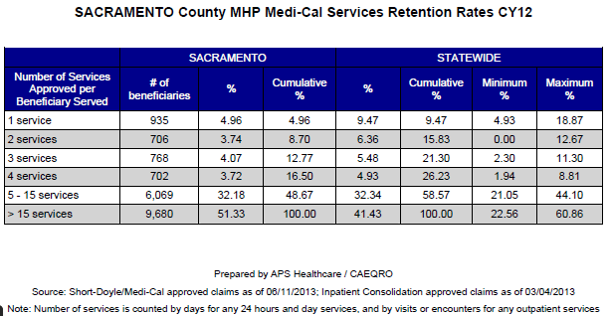

- Do you think your county is doing a good job at keeping clients engaged in services? If yes, how? If not, why?
The MHB requested the DBHS to report back on this question. Below is DBHS’ response.

All clients have a single point-of-contact (service coordinator, case manager, or therapist) whom they can refer to for support, services, questions, and/or help with navigating other systems. Clients and families can often be very engaged with their service provider and appreciate the continuity of care they receive with a single provider agency. The existence and development of engagement skills is an ongoing focus of human resource development and training.

This includes providing appropriate cultural competence training to help staff be more sensitive and responsive to the needs of the diverse communities they serve. Creating a welcoming environment and designing services that are meeting the needs of the community are also important factors that help keep clients engaged.

- For those clients receiving less than 5 services, what is your county doing to follow-up and re-engage those individuals for further mental health services?
The MHB requested the DBHS to report back on this question. Below is DBHS’ response.

Sacramento County’s client driven services would support that the volume or number of services does not necessarily indicate a deficit in services. The expectation is that those clients receiving less than “5” services would be communicated with to evaluate their needs or interests on either a monthly basis, but no less than quarterly. One of the ways to communicate with clients is through peer mentors, family partners, and trusted community members/leaders that often have more success in engaging clients. They often provide outreach to individuals who may be hesitant to engage.

- Looking at the previous chart of who is being served by race/ethnicity in your county, do you have any thoughts or ideas to share regarding your county’s engagement of underserved communities?
The MHB requested the DBHS to report back on this question. Below is DBHS’ response.

Figures 6a and 6b reflect disparities in a number of areas. They suggest that White and African Americans are served at a higher percentage than their Medi-Cal eligibility reflects. Conversely, Hispanics/Latinos are served in lower numbers than is reflected in their Medi-Cal numbers. While Asian/Pacific Islanders are served in approximately the same percentage as their Medi-Cal eligibility reflects, because the information is not disaggregated, it may not reveal where disparities exist. And finally, DBHS has been hearing from community leaders in Native American communities that due to the fact that there are inaccuracies in how Native American individuals are reported in various databases, they have been historically underserved. Additionally, an important overall consideration is when reviewing the data in the charts many underserved cultural, racial and ethnic communities are being served in MHSA Prevention and Early Intervention (PEI) programs. Data from these programs are collected at the local level but not by the state and therefore are not reflected in the statewide data sources from which the aforementioned charts were created.

Given the diversity of Sacramento County, one of the strategies DBHS is following in order to make services more culturally and linguistically competent and thereby improve engagement with and services to clients is to monitor how the system is performing against the Cultural Competence Plan objectives.

Since behavioral health services is provided primarily through the relationship between the client and the provider, the behavioral health workforce plays a key role in engaging clients from underserved, unserved or inappropriately served communities. DBHS is committed to hiring bilingual and bicultural staff that are reflective of the diverse population residing in Sacramento County. Additionally, staff development and training is critical to improving services (see Question 12 for more information about available cultural competence trainings).

Through a variety of outreach and promotion efforts, the social environment has been impacted by the convergence of several social marketing campaigns. During the past few years, DBHS’s mental illness stigma and discrimination reduction project entitled, “Mental Illness: It’s not always what you think” and CalMHSA statewide stigma and discrimination reduction efforts have been implemented in Sacramento County. In FY 11/12, the Supporting Community Connections (SCC) suicide prevention programs began operating. SCC programs conduct culturally and linguistically competent outreach and suicide prevention activities to members of their specific communities. Through contracting with cultural-specific community based agencies who have well established relationships with members of their community, DBHS has been able to reach more individuals through various prevention and early intervention outreach/activities.

CLIENT OUTCOMES: Consumer Perception Survey (August 2013)

Ultimately, the reason we provide mental health services is to help individuals manage their mental illness and to lead productive lives. We have selected two questions from the Consumer Perception Survey which capture this intention. One question is geared toward adults of any age, and the other is for children and youth under 18.
Below are the data for responses by clients in your county to these two questions.
For general comparison, statewide reference data for various sized counties are shown in the tables on page 19.
The total numbers of surveys completed for Adults or Children/Youth in your county are shown separately in the tables below, under the heading “Total.”

Q1. Adults. As a direct result of the services I received, I deal more effectively with daily problems.
 | Strongly Disagree | Disagree | Neutral | Agree | Strongly Agree | Total
Number of Responses | 7 | 38 | 165 | 297 | 276 | 783
Percent of Responses | 0.9 % | 4.9 % | 21.1 % | 37.9 % | 35.2 % | 100.0 %

Q2 Children/Youth. As a result of services my child and/or family received, my child is better at handling daily life.

 | Strongly Disagree | Disagree | Neutral | Agree | Strongly Agree | Total
Number of Responses | 24 | 75 | 393 | 858 | 483 | 1,833
Percent of Responses | 1.3 % | 4.1 % | 21.4 % | 46.8 % | 26.4 % | 100.0 %

- Are the data consistent with your perception of the effectiveness of mental health services in your county?
The MHB reviewed the data provided for “Client Outcomes” and observes that it is in-line with information and public comments provided to the MHB. Importantly, the MHB would like to point out that over 73% of adult and children/youth respondents report that they are better equipped to handle daily problems and life as a result of receiving County based MH services.

The MHB recognizes and applauds DBHS’ commitment to continually improving service delivery for our community.

- Do you have any recommendations for improving effectiveness of services?
The MHB requested the DBHS to report back on this question. Below is DBHS’ response.
- Continuous quality improvement projects that can provide data to support various interventions that affect service delivery
- Revising contractual outcome requirements can also provide an opportunity for data driven decision making for improving or selecting effective service delivery providers
- It is imperative to have a clear and focused vision of “effective” service delivery and a reliable means to measure it

- Many counties experience very low numbers of surveys completed. Do you have suggestions to increase the response rate?
The MHB requested the DBHS to report back on this question. Below is DBHS’ response.
Sacramento County has a 65% response rate (providers submit surveys on 65% of the individuals served during the survey period) and a 70% completion rate (70% of the received surveys are completed). Some of the things we do to increase response rates are:
- provide training for providers that are distributing the survey;
- provide a one page bullet list of how to distribute the survey;
- provide copies of the survey to all of our providers - requiring all providers to come into the county during the training times to pick up their forms;
- ensure the survey is available to all providers in all threshold languages; and
- encourage providers to utilize volunteers or peer mentors to distribute and assist individuals with completing the form.

- Lastly, but most important overall, with respect to delivery of services, do you have suggestions regarding any of the following:
The MHB requested the DBHS to report back on this question. Below is DBHS’ response.
- Specific unmet needs or gaps in services
- Prevention services for all ages
- Family-focused service delivery models for youth
- An array of integrated services for Transition Age Youth
- Forensic population – community integrated access to behavioral health services

- Improvements to, or better coordination of, existing services
  - Streamline information sharing practices without negating confidentiality laws or regulations
  - Implementation of triage navigators at various access points
  - Develop venues to coordinate access to care with the local Geographic Managed Care plans (GMC’s)
  - Continue ongoing efforts to tailor outreach and engagement activities to underserved, unserved and inappropriately served cultural, racial and ethnic communities

- New programs that need to be implemented to serve individuals in your county
- Programs serving transition age youth
- Triage Navigators
- Mobile Crisis Support Team
- Fund a dedicated team of behavioral health staff, probation officer, public defender, district attorney to support Mental Health Court

Serious Mental Disorder, term used for adults 18 and older.
Severe Emotional Disorder, term used for children 17 and under.

