PLACER & SIERRA COUNTIES: DATA NOTEBOOK
2014 FOR CALIFORNIA

MENTAL HEALTH BOARDS AND COMMISSIONS

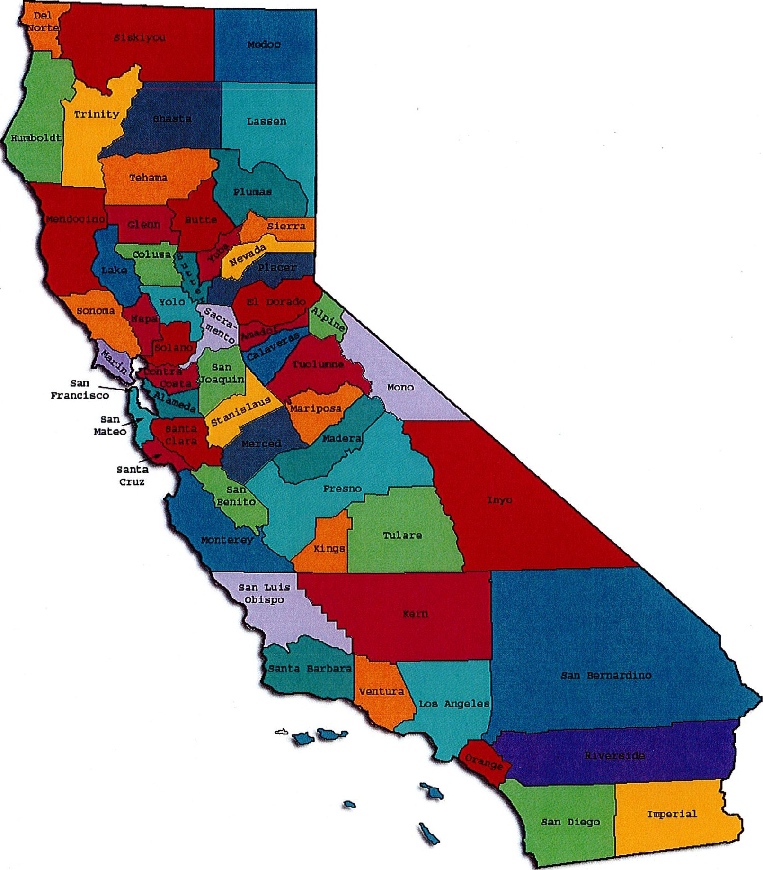

<Preparea 6y Ca[ijornia :M.enta{ Jfea fth <Pfanning Council in co[fa6oration with: Ca[ijornia }lssociation of :M.enta[Jfea[tfi <Boaras/Commissions, anaJlPS Jfea ft ficare/EQ <J\O,

This Page Intentionally Left Blank.

Date: April 20, 2014

California Mental Health Planning Council

To: Chairpersons and/or Directors

Local Mental Health Boards and Commissions From: California Mental Health Planning Council Subject: Instructions for Data Notebook 2014

We ask that this report be prepared by the MH Board or Commission members. You are the most important resources for identifying program strengths and needs in your community .

On the first page, please fill in the requested information for your county websites:

- Department of Behavioral Health/ Mental Health
- Public reports about your county's MH services .

Please send a copy of the filled-in first page to the Planning Council along with your final report which contains your answers to the questions in the Data Notebook. Please submit your report within 60 days by email to:

DataNotebook@cmhpc .ca.gov.

Or, you may mail a printed copy of your report to:

- Data Notebook Project
- California Mental Health Planning Council
- 1501 Capitol Avenue, MS 2706
• P.O. Box 997413 Sacramento, CA 95899-7413

Please examine the enclosed information, which will help you discuss the questions in the Data Notebook. We provide examples of recent mental health data for your county. In some figures, the term "MHP" is used to refer to your county's Mental Health Plan.

Some data comes from APS Healthcare/EQRO , which gave permission to use their figures and tables , prepared for review of each county's Medi-Cal Specialty Mental Health services . Data in this packet came from the following review cycle:

X Fiscal Year 2013 -- 2014: http://caeqro .com/webx/ .ee85675/ Fiscal Year 2012 -- 2013 : http://caeqro .com/webx/.ee851 c3/
For some questions, you will need to consult your local county Quality Improvement Coordinator, and/or Mental Health Director. If you are not able to address all of the questions , just answer the ones you can.

Thank you for your participation in the Data Notebook Project.

This Page Intentionally Left Blank

PLACER & SIERRA COUNTIES: DATA NOTEBOOK
2014 FOR CALIFORNIA

MENTAL HEALTH BOARDS AND COMMISSIONS

County Name: Placer & Sierra | Population (2013): Placer County: | 365,107
 | Sierra County: | 3,053

Website for County Department of Mental Health (MH) or Behavioral Health: Adult System of Care and Children's System of Care
Website for Local County MH Data and Reports:

http://www.placer.ca.gov/departments/hhs/children/leadership-vision-mission Website for local MH Board/Commission Meeting
Mental Health Alcohol Drug Board

and Reports: Behavioral Health Managed Care Network

Specialty MH Data from review Year 2013-2014 : http://caeqro.com/webx/.ee85675

Total number receiving Medi-Cal in your counties, combined (2012): | 43 ,745
Average number Medi-Cal eligible persons per month: | 33,527
Percent of Medi-Cal eligible persons who were :

Children , ages 0-17: 44.2 % Adults, ages 18-59: 40 .7 % Adults, Ages 60 and Over: 15.1 %

Total persons with SMl1 or SED2 who received Specialty MH services (2012): Percent of Specialty MH service recipients who were : 1,735

Children 0-17 : 35.3 %
Adults 18-59: 58.0 %
Adults 60 and Over: 6.7 %

1 Serious Mental Disorder, term used for adults 18 and older.
2 Severe Emotional Disorder, term used for children 17 and under.

This Page Intentionally Left Blank

INTRODUCTION: Purpose, Goals, and Data Resources

This Data Notebook has been developed for the use by the local mental health (MH) boards and commissions by a yearlong workgroup comprised of members from:

- California Mental Health Planning Council (CMHPC)
- California Association of Local Mental Health Boards and Commissions (CALMHB/C)
- APS Healthcare/ EQRO (External Quality Review Organization) Our plan is for the Data Notebook to meet these goals:
- assist local boards to meet their mandates to review the local county mental health systems, identify unmet needs, and recommend improvements.
- provide a professional format for submitting reports to their local Board of Supervisors, and/or their county Director of Mental Health Services.
- function as an educational tool for local boards, whose members have varying levels of skills, frequent turnover, and need 'refresher' training about using data.
- help the CMHPC fulfill its mandates to review and report on the public mental health system in California, which also helps provide evidence for advocacy.

Data reporting drives policy, and policy drives funding for programs. But the data must be both recent and available to the public, or else it is not useful. So, the CMHPC will provide examples of local data from current public reports. We focus on two broad areas: (1) evaluation of program performance, and (2) indicators of client outcomes.

We recognize that each county has a unique population, resources, strengths, and needs. Thus, there is no single perfect data source to answer all the important questions one might ask about mental health services. However, the following data resources will help board members answer questions in this Data Notebook:

- experience and opinions of the local mental health board members
- recent reports about county MH programs from APS Healthcare/EQRO
- data you request from your county QI Coordinator and/or Mental Health Director (because CMHPC does not have that data, and it's not in other public reports)
- client outcomes data provided by California Institute of Mental Health (CiMH) in their analysis of the most recent Consumer Perception Survey.

Some of our data comes from APS Healthcare/EQRO, which kindly gave permission to use their figures and tables, prepared for review of each county's Medi-Cal Specialty Mental Health services . Those reviews are at: www .CAEQRO .com. You may find the full-length EQRO reports helpful because they summarize key programs and quality improvement efforts for each county. They also describe strengths, opportunities for improvement, and changes in mental health programs since the last year.

Understanding changes in local programs can help consumers because of the massive re-organization of mental health services statewide. Some changes have been confusing to clients. The old state Department of Mental Health was eliminated in 2012 and many functions were moved to the Department of Health Care Services. Other changes due to federal health care reform and the Affordable Care Act affect how mental health services are provided, funded, and linked to primary health care or substance use treatment. Also, local counties have adjusted to major challenges.

Remember, this report is about your community, and what you and your stakeholders choose to discuss. Examining the data can indeed "Tell a Human Story." But quantitative data (numbers) provides only part of the picture, for example:

- measures of whether the quality of program services improve over time
- whether more people from different groups are receiving services
- how many clients got physical healthcare or needed substance use treatment.

The other part of the story gives human context to the numbers. Such qualitative data (narrative, descriptions, or stories) tells more of the story, because we can:

- describe special programs targeted for outreach to specific groups
- examine how the programs are actually implementing their goals
- list concrete steps that are taken to improve services, and
- tell what is being done to increase client engagement with continued treatment.

We hope this project contributes to ongoing quality improvement (QI) in mental health services. We seek constant improvement in our approach to quality because:

- needs change over time,
- all human endeavors are by nature imperfect,
- creativity gives rise to new ideas, and
- we can share examples of successful programs to help other communities.

One question is whether local boards are permitted to provide additional information, besides that requested in this Notebook. We always welcome supplemental reports about successful projects, or which the county administration uses to inform the public. Any additional reports may be attached in an "Appendix," with the website address (if available). However, we emphasize such extra reports are not required.

Thank you for participating in this project. We hope this Data Notebook serves as a springboard for your discussion about all areas of the mental health system, not just those topics highlighted by our questions.

TREATING THE WHOLE PERSON:

Integrating Behavioral and Physical Health Care

Studies have shown that individuals with serious mental illness die, on average, 25 years earlier than the general population. This information makes improving the physical health of clients of great importance and should be a goal of county mental health departments along with providing effective and appropriate mental health services. Coordination of care for mental health, substance abuse and physical health is one way of accomplishing the goal.

The California Mental Health Planning Council does not have any data to provide to show how your county's programs connect clients of mental health services with necessary physical health care. We ask that the local mental health board request information from your county mental health department for any data on numbers (or percent) of total mental health clients who are referred to, or connected with, physical health providers to assess, treat and monitor physical health issues.

If your county has data on numbers or percentages of clients who are also receiving physical health care, please include it in your Data Notebook you submit to the Council.

_ Check here if your county does not have such data or information.

1) Please describe any efforts in your county to improve the physical health of clients.

The efforts that Placer/Sierra County Mental Health Plan has taken to improve the physical health of clients includes participation in the CalMEND project which resulted in Placer County moving an outpatient psychiatrist to the County's medical clinic (PCMC), located in western Placer County, as the first step of developing a health home for Placer County residents. This project also resulted in over 600 adult clients with severe and persistent mental illness being able to transfer from the formal system based mental health services which are perceived to be more stigmatizing, and receive their ongoing mental health services in the newly developed "health home model" which is community based.
In addition to the relocation of a psychiatrist and the transfer of stable adult clients to the PCC, Placer County, also began to provide a portion of the psychiatry services for children and youth through a local federally qualified health clinic (Chapa De Indian Health Center) where other services were also available, getting closer to the home health model here as well.
Recent Quality Improvement Performance Improvement Projects (Administrative Performance Improvement Projects for FY12/13 and FY13/14) were focused on

improving systematic changes within the adult mental health direct service delivery that would increase care coordination between behavioral health and primary care. These systematic changes included identifying barriers that have impeded the development of consistent practices, and ensuring that systematic changes have been made to improve the identification, tracking and care coordination pertaining to the significant health issues of diabetes, hypertension, hyperlipidemia, obesity and heart disease.

Youth Empowerment Services, an Organizational provider for Placer County has developed a secure web-based system entitled "Health Shack" that allow Transition Age Youth (TAY) to store vital information in one location as, unfortunately, so many of TAY experience ongoing disruptions and potential homelessness due to the multiple moves related to being in foster care. Health Shack offers TAY a confidential site to secure vital information such as: birth certificate, immunization records, medical information, etc. and allows for easy access regardless of the multiple disruptions a TAY may experience in foster care or as they transition out of foster care.
Current data indicates that during FY 13/14 3,277 clients (2,328 adults and 949 children/youth) have received mental health services directly from the County. Of the 2,328 adults, 472 (20%) receive primary care services through Placer County's Medical Clinic (PCMC). The County records and tracks primary care providers for individuals receiving specialty mental health services and are currently in the process of developing reports within the electronic health record. When this report is complete, the County will be able to quickly identify individual's primary care providers who are outside of the PCMC clinic.

In addition, 9.5% (516 of 5,477) of Placer County Primary Care Medical Clinic clients receive psychiatric services directly from the clinic.

How does your county address wellness programs to engage and motivate clients to take charge of improving their physical health?

Examples:

  - Exercise
  - Nutrition
  - Healthy cooking
  - Stress management
  - Quitting smoking
  - Managing chronic disease
  - Maintaining social connectedness

NEW CLIENTS: One Measure of Access

One way to evaluate the quality of mental health services outreach is to measure how many clients receive services who have never been part of the service system before ("brand new" clients). Another measure is how many clients return for services after a period of time with no services ("new" clients).

The California Mental Health Planning Council is exploring how each county mental health department defines "new" clients, and how a client is labelled when they return
for additional services. This information is important in determining whether your county has a "revolving door," that is, clients who are in and out of mental health services repeatedly. This data is one indicator of the success of your county's programs in
closing cases appropriately and providing adequate discharge planning to clients.

This data is not currently reported by the counties to the state. The Council does not have data to provide to you. This information should be requested from your county mental health department.

Check here if your county does not have this information.

How does your county define 'new' client for those individuals who have previously received services, but who have not received services for a while? (e.g., 6 months, 12 months, 2 years?)
Placer/Sierra County defines "new" clients for those individuals who have previously received services as individuals who have been discharged from services for at least 12 months.

Please provide any data your county has on the number of 'new' clients last year. And if you have it, how many of those new clients were brand new clients? You may need to ask your county mental health department for
this data.
# new children/youth (0-17 yrs) 95
of these, how many (or %) are 'brand new' clients _83
# new adults (18-59 yrs) _37--6'-
of these, how many (or %) are 'brand new' clients 269
# new older adults (60+ yrs) 28
of these, how many (or %) are 'brand new' clients 17

REDUCING RE-HOSPITALIZATION: Access to Follow-up Care

Sometimes, an individual experiences acute symptoms of mental illness or substance abuse which can result in a brief stay in an acute care hospital. Receiving follow-up services after discharge from a short-term (3-14 day) hospitalization can be critical to preventing a return to the hospital.

The chart below shows the percentage of people discharged in your county who received at least one service within 7 days of discharge. Also shown is the percentage of those same people who were readmitted to the hospital. The chart also shows the same information for receiving services and being readmitted to the hospital within 30 days. Red indicates the numbers for your county and the blue indicates the percentage for the state of California.

Placer-Sierra County MHP:

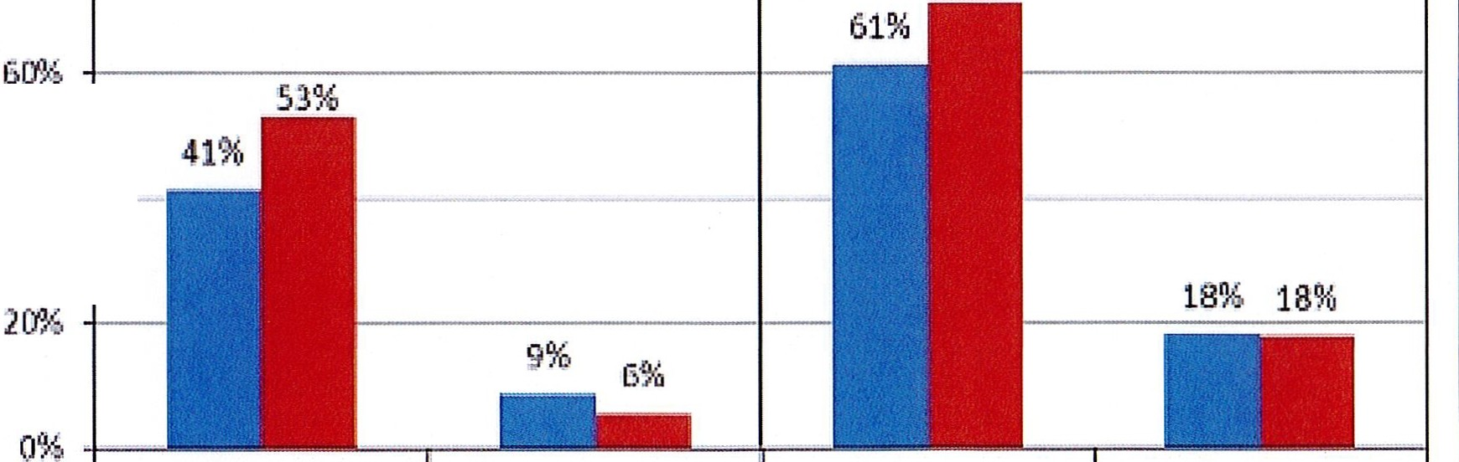
F gure 14.Timely Foilow up; 7 and 30 days After Hospitail Discharge
Percentage Receiving Outpatient Service or Read m itted
Mil-IP and Statewide CYll
11'.>.:l'}: -...---------------0 1
80'% --------------•--
--7H --
----- 1
· 0% - --
·OUt[J:laUer" t siervict..s
lte.ceivecl
Readmitted to
Inpatient
Orutpa tiNkt ':lentk:cs
Re{eh1ed
Readrnittcd to
11 pati e nt
- MHP

Looking at the chart, is your county doing better or worse than the state? Discuss why (e.g., your county has programming available that specifically ensures a warm handoff for follow-up services).

In reviewing the chart in Figure 14, it appears as if Placer/Sierra Counties MHP is doing better than the state average in providing outpatient services to individual's post hospitalization within both the 7 and 30 day timelines. The MHP is doing slightly better than the statewide average for decreasing hospitalizations within 7 days of discharge and is consistent with the state average for re-hospitalization within 30 days of discharge.

Contributing factors to the MHPs outcomes for post hospitalization services includes the Children's System of Care (CSOC) Follow Up Services; the Adult System of Care (ASOC) Aftercare Group, and Crisis Residential Services. The Systems of Care (SOC) have clear expectation that clinical staff within both the SOC (ASOC and CSOC) are to re-engage clients into services and provide additional post crisis support and linkage to individuals to assist with ongoing psychiatric stabilization. A brief description of these services is provided below:

  - Follow-Up Services: Involve clinical staff and/or peer advocates to contact individuals within 48 to 72 business hours of discharge to offer additional support post crisis services This service is provided to children and youth.
  - After Care Group: Is provided on a weekly basis and allows for adults who are not open to services but have recently been hospitalized to be seen by medical support staff to ensure ongoing support and ensures that any concerns or issues related to discharge are addressed in a timely manner. This service is provided to all adult clients.
  - Clinical staff within the Systems of Care (includes both Adult System of Care and ChildrenNouth System of Care) are expected to contact every ongoing client within 48 business hours and schedule medical appointment with a prescriber (MD or NP) within 7 days of discharge.
  - Crisis Residential Services: These services may be extended to adults being discharge from an inpatient psychiatric hospitalization to allow for further stabilization.

Do you have any suggestions on how your county can improve follow-up and reduce re-hospitalizations?
The Board's suggestions on how the MHP can improve follow up and reduce re­ hospitalizations include:

  - Implementation of a respite center through the SB82 grant (Adult)
  - Implementation of the Triage Personnel Grant (SB82)
  - Expanding the capacity of the Crisis Resolution Center (ChildrenNouth)

  - Development of Post Hospital discharge binders for individuals to include community resources, tools for tracking warning signs/self-monitoring, psycho­ educational information and crisis resource information.
  - Development of Post Hospital discharge binders for family/support persons to include community resources, tools for tracking warning signs/self-monitoring, psycho-educational information and crisis resource information.
  - Development of a Peer Sponsor/Recovery Buddy program
  - Increase the involvement of family/support systems in the discharge planning process.
- What are the three most significant barriers to service access? Examples:

  - Transportati on
  - Child care
  - Language barriers or lack of interpreters
  - Specific cultural issues
  - Too few child or adult therapists
  - Lack of psychiatrists or tele-psychiatry services
  - Delays in service
  - Restrictive time window to schedule an appointment

The Board identifies significant barriers to service access are: For Adults:
    - Transportation
    - Lack of co-occurring services and untreated substance use issues
    - Homelessness
    - Retention of Psychiatrist
    - Lack of Insight into illness and Stigma
    - Timeliness to services
    - Medication side effects and efficacy For Children/Youth:
    - Child care services (caregivers with multiple children)
    - Transportation

ACCESS BY UNSERVED AND UNDER-SERVED COMMUNITIES

One goal of the Mental Health Services Act (MHSA) is to reach unserved and underserved communities, especially communities of color. The MHSA promotes

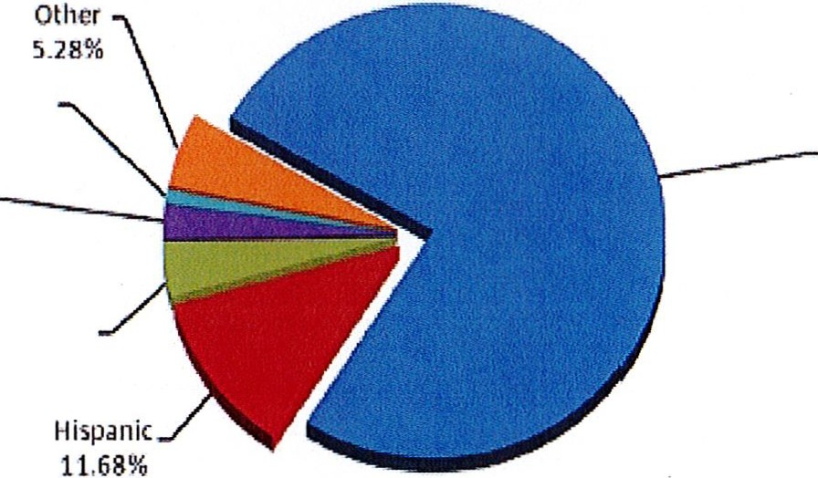outreach to engage these communities in services. If individuals and families in these communities are not accessing services , then we may need to explore new ways of reaching them. Or, we may need to change our programs to meet their mental health needs in ways that better complement their culture.
Native Ameritan
1.00%
White
75,82%
Asl<lll/P dflc .
!la nder
2 .35%

African.American
3.87%

From data the counties report to the state, we can see how many individuals living in your county are eligible for Medi-Cal, and of those individuals , how many received mental health services . Are you serving the Medi-Cal clients who need your services?

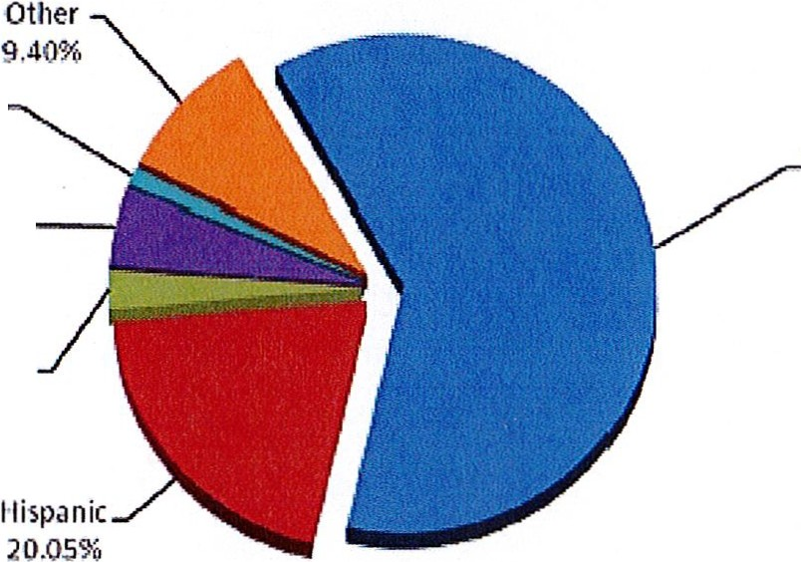Placer-Sierra County MHP
W hite
61.90%
Mian/Pa.::ifk____,
Islander
4 .99%

African.Amer ic;in
2.53%

Figure 6a. MHP Medi-cal Average Monthly Unduplicated Eligibles,
by Race/Eth nicity CYll

N;iti1•e Amerlc;in
1.13%
• White • Hisp:mit; • Afr iC;iiJ.Anierir:m •ASin/P<tt if it lsl nt1111 • Native A 1r1erir:a11 •Olh<>r

Figure 6b. MHP Medi-Cal Beneficiaries Served,
by Race/Ethnicity CYll
•White • His 11.tnic • Afrka n·A rnerica n •Asian/Pacific lslandoe r • Native American •Other
I

Is there a big difference between the race/ethnicity breakdown on the two charts? Do you feel that the group(s) that need services in your county are receiving services?

In reviewing the charts in Figure 6a and 6b, there are some significant differences between the race/ethnicity break down on the two charts. This difference surrounds the penetration rates/eligible rates for beneficiaries who identify as Caucasian and those who identify as Hispanic. In reviewing the charts, Caucasians receive more services (over-served) while Hispanics are underserved. With the MHSA programs
implemented by the MHP, the MHP is ensuring that the underserved communities (Hispanic, Native American, TAY and Homeless) are being outreached to and receive services in a culturally responsive manner. These services are not reflected in the penetration rates as they are not Medi-Cal billable services. The MHP would like to explore more ways to outreach to the API communities to determine if service needs exist.

In exploring penetration rates and the implementation of the MHSA programs that are designed for prevention/ early intervention and outreach to underserved communities, it should be noted again that comparing penetration rates does not encompass the plethora of services offered through MHSA funding, and community services which are operating through such funding is not reflected in state indicators which are used to determine if a population is underserved.

What outreach efforts are being made to reach minority groups in your community?

Historically through a SAMHSA grant and now with MHSA funding, outreach efforts have been consistently made to engage identified underserved minority communities. For Placer County, the underserved minority communities identified for this outreach have included: Native Americans, Hispanic, Homeless and Transitional Age youth, including former foster care youth. Through both SAMSHA and MHSA funds, the County has developed partnerships with contract providers to outreach and engage the underserved communities. This includes an array of services being provided by the Sierra Native Alliance, the Latino Leadership Council; Whole Person Learning (Transitional Age Youth), Mental Health America and homeless outreach services. All of these programs embrace employing individuals from diverse backgrounds, who have varied life experience within the programs they are working and who are bilingual and cultural brokers.

Limited efforts have been made to engage individuals' who identify as Asian Pacific Islanders. The County will need to explore and identify opportunities to engage this underserved community.

Do you have suggestions for improving outreach to and/or programs for underserved groups?

The MHP and MHADB would like to explore ways to engage the API community and will need to begin identifying community leaders and include leaders in the Campaign for Community Wellness Process. The County will also discuss suggestions for improving outreach to and/or programs for these underserved groups through the Cultural and Linguistic Competency Committee (CLC). The CLC committee is comprised of county and community partners.

CLIENT ENGAGEMENT IN SERVICES

One MHSA goal is to connect individuals to services they need to be successful.
Clients who stop services too soon may not achieve much improvement, nor is it likely to last. So it is important to measure not only who comes in for treatment, but also how long they stay in services . Here we are considering individuals with high service needs,
not someone who just needs a 'tune-up.' Although not every individual needs the same amount of services, research shows that when someone with severe mental illness continues to receive services over time, their chances of recovery increase.

Engagement in services, also called 'retention rate', is important to review. If individuals come in, receive only one or two services and never come back, it may mean the services were not appropriate, or that the individual did not feel welcome , or some other reason that should be explored. Again , we recognize that some individuals only need minimal services , but here we are looking at those with severe mental illness.
Ultimately, the goal is to ensure they are getting needed services and are on the road to recovery. But we would not know that unless we look at how many services individuals received over time.

The chart below shows the number of Medi-Cal beneficiaries in your county who received 1, or 2 , or 3, or 4, or 5, or more than15 mental health services during the year. For individuals experiencing severe mental illness, the more engaged they are in services , the greater the chance for lasting improvements in mental health.

PLACER/SIERRA County MHP Medi-Cal Services Retention Rates CY12
Number of Services
Aapproved per

 |  | PLACER/SIERRA |  |  |  |  |  | STATEWIDE |  |  | Maximum  %
# of % Cumulative % Cumulative Minimum Beneficiary Served beneficiaries % % %
1service | 181 |  | 10.43 | 10.43 |  | 9.38 | 9.38 |  | 4.90 |  | 18.87
2 services | 119 |  | 6.86 | 17.29 |  | 6.29 | 15.67 |  | 0.00 |  | 12.84
3 services | 113 |  | 6.51 | 23.80 |  | 5.38 | 21.06 |  | 2.94 |  | 11.11
4 services | 70 |  | 4.03 | 27.84 |  | 4.93 | 25.98 |  | 1.93 |  | 9.40
5 - 15 services | 568 |  | 32.74 | 60.58 |  | 32.38 | 58.36 |  | 21.24 |  | 40.93
> 15 services | 684 |  | 39.42 | 100.00 |  | 41.64 | 100.00 |  | 23.68 |  | 60.46

Prepared by APS Healthcare I CAEQRO
Source: Short-DoylelMedi-Cal approved claims as of 11122/2013 ; Inpatient Consolidation approved claims as of 12/2612013
Note: Number of services is counted by days for any 24 hours and day services , and by visits or encounters for any outpatient service s

Do you think your county is doing a good job at keeping clients engaged in services? If yes, how? If not, why?

It is difficult to ascertain as to the MHP effectiveness of providing services to Medi-Cal beneficiaries in reviewing this data as this data could be interpreted in different ways.

The first way to interpret this data would be to say that perhaps the MHP is not doing as well as the state as individuals are receiving slightly more services than the statewide average. Through outreach and engagement, early prevention and early intervention activities, belief in recovery and resiliency and the expansion of psychiatric services through the managed care plans, if the MHP was being effective, the MHP should see a decrease in the amount of services being provided.

The second way to interpret the data would be to state that the MHP is doing a slightly better job than the statewide average on engaging individuals in services.

For those clients receiving less than 5 services, what is your county doing to follow-up and re-engage those individuals for further mental health services?
For clients who receive less than 5 services, the MHP has a multitude of services available to follow up and re-engage these individuals. Some of the activities that the MHP uses to engage/follow up with clients is though the following services:

  - Follow-Up Services (ChildrenNouth): Involving clinical staff and/or peer advocates to contact individuals within 48 to 72 business hours of discharge from Crisis Services to offer additional support.
  - Follow-Up Services (Adults): Involve clinical staff and/or peer advocates to contact individuals within 48 business hours of a crisis intervention service being provided that did not result in an inpatient hospitalization to provide additional support.
  - Co-Occurring Full Service Partnership (Adults): developed to outreach and engage individuals' with co-occurring disorders who have experienced multiple hospitalizations within a year and have not engaged in outpatient mental health services.
  - After Care Group: Is provided on a weekly basis and allows for adults who are not open to services but have recently been hospitalized to be seen by medical support staff to ensure ongoing support and ensures that any concerns or issues related to discharge are addressed in a timely manner. This service is provided to all adult clients. Approximately one year ago the frequency of the aftercare group was changed from bimonthly to weekly. As a result of this change, more clients are following up and attending this service.

  - Clinical staff within the Systems of Care (includes both Adult System of Care and Children/Youth System of Care) are expected to contact every ongoing client within 48 business hours and schedule medical appointment with a prescriber (MD or NP) within 7 days of discharge.
  - Crisis Residential Services: These services may be extended to adults being discharge from an inpatient psychiatric hospitalization to allow for further stabilization.
  - Addressing No Shows: Prescribers are reaching out to clients during and after their scheduled appointment times when they do not arrive to attempt to engage them into services and determine barriers to appointment follow through.
  - Service coordinators/Clinical Staff are expected to attempt to contact individuals within two business days of a missed appointment to re-engage into to services
· and to address any clinical factors that may have prevented the individual with attending their appointments.
  - Bus passes/vouchers are made available.
  - Homeless Outreach programs that assist with housing, engagement and transportation are available.
  - Transportation is available to clients receiving mental health services under the Lanterman-Petris-Short Act and/or who may be residing in a licensed care facility.
  - Clinical staffs are encouraged to provide field based services. Most children's Wraparound and Functional Family Therapy (FFT) services are all field based in the family home or in the community.
  - Clinical staffs are encouraged to monitor their client case loads. Reports have recently been developed within the electronic health record (EHR) that will allow clinical staff to more easily monitor their case loads including last med appointment and non-medical appointment.
  - Continue to work with developing reports within the Electronic Health Record
  - Clerical staff members provide appointment reminder calls.

Looking at the previous chart of who is being served by race/ethnicity in your county, do you have any thoughts or ideas to share regarding your county's engagement of underserved communities?
In looking at the previous chart, the MHP is providing more services than the penetration rate for Caucasians and African-Americans. In regards to individuals who identify as Native American penetration rates are slightly under the Medi-Cal eligible rates. For individuals who identify as Hispanic the penetration rates are slightly above 50% of the number of Medi-Cal eligible individuals. It is the MHP belief that efforts through first the SAMHSA grant and then MHSA including services provided through the

Sierra Native Alliance, Latino Leadership Council, Transitional Age Youth Services, Senior Peer Services and Post Crisis Services will decrease the penetration rates. The MHP MHSA underserved populations were identified as Native American, Latinos, TAY and Homeless. It is the belief of the MHP that these MHSA programs are having a positive impact on reducing the penetration rates. In addition, other community services, such as Parent Child Interaction Therapy (PCIT), services through the Crisis Resolution Center, Parent Project, Chapa De, and others will not be reflected in Medi-Cal claims data and therefore have contributed to a lowering of penetration rates. These changes have been planned, and conducted with a desire to bring services to the community in the manner in which the community prefers which is through less official system delivery practices. An area of possible concern is the Asian Pacific Islander population. The MHP and the MHSA stakeholder process (Campaign for Community Wellness) will
need to explore options on how to further engage this underserved population for service delivery need and preferences.

CLIENT OUTCOMES: Consumer Perception Survey (August 2013)

Ultimately, the reason we provide mental health services is to help individuals manage their mental illness and to lead productive lives. We have selected two questions from the Consumer Perception Survey which capture this intention. One question is geared toward adults of any age, and the other is for children and youth under 18.

Below are the data for responses by clients in your county to these two questions. The total numbers of surveys completed for Adults or Children/Youth in your county are shown separately in the tables below, under the heading "Total."

For general comparison, statewide reference data for various sized counties are shown in the tables on page 19.

Note: Adult data below are all from Placer County, as received by CiMH.

- Adults. As a direct result of the services I received, I deal more effectively with daily problems.

 | Strongly Disagree | Disagree | Neutral | Agree | Strongly Agree | Total
Number of Responses | 2 | 1 | 25 | 53 | 51 | 132
Percent of Responses | 1.5 % | 0.8 % | 18.9 % | 40.2 % | 38.6 % | 100.0 %

Note: Zero responses were received by CiMH for your county(s) for the following item. Therefore, summary data are presented from counties of similar size3 to Placer county.
- Children/Youth. As a result of services my child and/or family received, my child is better at handling daily life.

 | Strongly Disagree | Disagree | Neutral | Agree | Strongly Agree | Total
Number of Responses | 41 | 102 | 516 | 1330 | 636 | 2,625
Percent of Responses | 1.6 % | 3.9 % | 19.7 % | 50.7 % | 24.2 % | 100.0 %

3 Medium-sized County MHPs = Butte, Marin, Merced, Monterey, Placer/Sierra, San Joaquin, San Luis Obispo, San Mateo, Santa Barbara, Santa Cruz, Solano, Sonoma, Stanislaus, Tulare, Yolo.

Are the data consistent with your perception of the effectiveness of mental health services in your county?

In reviewing the data related to the Consumer Perception Survey, the data is consistent with the MHP perception of the effectiveness of the MH services within the Counties.

Do you have any recommendations for improving effectiveness of services?

Challenges pertaining to the effectiveness of services include stigma, lack of understanding mental illness and treatment service available. For the service delivery system, challenges continue to be recruitment and retention for prescribers and bilingual/bicultural staff along with ongoing development of co-occurring competent workforce.

Many counties experience very low numbers of surveys completed. Do you have suggestions to increase the response rate?

  - Decrease the number of survey questions.
  - Have the survey focus on specific areas each time. Many clients have completed the same survey year after year and no longer want to participate.
  - Provide incentives.

Lastly, but perhaps most important overall, with respect to delivery of services, do you have suggestions regarding any of the following:

- Specific unmet needs or gaps in services
  - Explore Asian Pacific Islander service needs and preferences.
  - Recruitment for ongoing psychiatric support as this is a difficult service to continue to provide given the rural nature of some of Placer-Sierra County.
Enhancing discharge information that

Improvements to, or better coordination of, existing services
  - Continue to develop the Electronic Health Record
  - Ongoing recruitment for psychiatrists.
  - Development of Post Hospital discharge binders for consumers and family/support persons to include community resources, tools for tracking warning signs/self-monitoring, psycho-educational information and crisis resource information.
  - Development of a Peer Sponsor/Recovery Buddy program
  - Increase the involvement of family/support systems in the discharge planning process.

New programs that need to be implemented to serve individuals in your county
  - Explore outreach to API residents.

<EN D>

REFERENCE DATA: for general comparison with your county MHP results

Adult & Older Adult Results by CountySize: I deal more effectively with daily problems

a
 |  |  | Ideal more ef |  | tectivelv wilh d | ilv Droblems |  | Total
 |  |  | Strongly Disree | Disallree | Iam neutral | Agree | Strcngly Agree
CountySize | Large | Count | 73 | 246 | 1168 | 2579 | 2529 | 6595
 |  | % wilhin CountySize | 1.1% | 3..7% | 17.7% | 39.1% | 38.3% | 100.0%
 | LosAngeles Count  % wilhin CountySize |  | 48  1.1% | 147  3.3% | 711  16.1% | 1750  39.6% | 1759  30.8% | 4415  100.0%
 | Medium | Count | 30 | 113 | 475 | 1114 | 1044 | 2785
 |  | % wilhin CountySize | 1.4% | 4.1% | 17.1% | 40.0% | 37.5% | 100.0%
 | Small | Count | 8 | 53 | 178 | 469 | 425 | 1133
 |  | % wilhin CountySize | .7% | 4.7% | 15.7% | 41.4% | 37.5% | 100.0%
 | SmallRural | Count | 5 | 11 | 60 | 111 | 108 | 295
 |  | % within CountySize | 1.7% | 3.7% | 20.3% | 37.6% | 36.6% | 100.0%
Total |  | Count | 173 | 570 | 2592 | 6023 | 5865 | 15223
 |  | % wilhin CounlySize | 1.1% | 3.7% | 17.0% | 39.6% | 38.5% | 100.0%

Youth & Family Results Combined by CountySize: limy child amlis better at handling daily life

 |  |  | l!mv child am/is better at handling daily life |  |  |  |  | Toca!
 |  |  | Strongly Disaaree | Disaaree | Iam Neutral | Aaree | Strongly Aaree
CountySize | Large | Count  % wilhin CountySize | 179  1.7% | 414  3.8% | 2195  20.3% | 5046  46.6% | 2983  27.6% | 10817  100.0%
 | Los Angele | s Count  % wilhin CountySize | 98  1.9% | 183  3.5% | 898  17.3% | 259ll  50.1% | 141lQ  27.2% | !5186  100.0%
 | Medium | Count  % wilhin CountySize | 41  1.6% | 102  3.9% | 516  19.7% | 1330  50.7% | 636  24.2% | 2625  100.0%
 | Small | Count  % wilhin CountySize | 17  2.2% | 33  4.3% | 158  20.6% | 372  48.4% | 188  24.5% | 7ij8  100.0%
 | SmallRural | Count  % wilhin CountySize | 0  .0% | 5  3.5% | 37  26.1% | 61  43.0% | 39  27.5% | 142  100.0%
Total |  | Count | 335 | 737 | 3804 | 9407 | 5256 | 19638
 |  | % wilhin CountySize | 1.7% | 3.8% | 19.5% | 48.1% | 26.9% | 100.0%

County Mental Health Plan Size: Categories are based upon DHCS definitions by county population.

- Small-Rural MHPs = Alpine, Amador, Calaveras, Colusa, Del Norte, Glenn, Inyo, Lassen, Mariposa,
Modoc, Mono, Plumas, Siskiyou, Trinity

- Small MHPs = El Dorado, Humboldt, Imperial, Kings, Lake, Madera, Mendocino, Napa, Nevada, San Benito, Shasta, SutterNuba, Tehama, Tuolumne

o Medium MHPs = Butte, Marin, Merced, Monterey, Placer/Sierra, San Joaquin, San Luis Obispo, San Mateo, Santa Barbara, Santa Cruz, Solano, Sonoma, Stanislaus, Tulare, Yolo

- Large MHPs = Alameda, Contra Costa, Fresno, Kern, Orange, Riverside, Sacramento, San Bernardino, San Diego, San Francisco, Santa Clara, Ventura

- Los Angeles' statistics are excluded from size comparisons, but are included in statewide data.

Total Values (in Tables above) = include all statewide data received by CiMH for these survey items.

REMINDER:
· California
Mental Health Planning Council

Thank you for your participation in completing your Data Notebook report.

Please feel free to provide feedback or recommendations you may have to improve this project for the following year. We welcome your input.

Please submit your Data Notebook report by email to: DataNotebook@CMHPC. CA.GOV

Or, you may submit a printed copy by postal mail to:

  - Data Notebook Project
  - California Mental Health Planning Council
  - 1501 Capitol Avenue, MS 2706
• P.O. Box 997413
  - Sacramento, CA 95899-7413

For information, you may contact either email address above, or telephone: (916) 449-5249, or
(916) 323-4501

