**Executive Summary**

Napa County’s Mental Health Board (MHB) has a dedicated, engaged and diverse membership that understands that mental illness is a medical condition, and cares very much about the mental health services, programs and facilities available in our county.

Along with the following pages that outline our membership and activities for the year, there are two reports attached that provide research findings and recommendations of two MHB work groups:

1. School-Based Mental Health Services Needs Assessment and Stigma Reduction 2016 Workgroup (Attachment A) – Recommendations Include:
   1. Full implementation of [AB114](http://www.schoolhealthcenters.org/start-up-and-operations/funding/mental-health/ermhs/) – Educationally-related Mental Health Services (This shifted responsibility of mental health services from county mental health departments to school districts.)
   2. Adding “Wellness Centers” to high schools, (Napa County Middle Schools now have them.) This is a place to go for any medical condition, including mental illness.
   3. Providing Youth Mental Health First Aid training to staff and administrators to ensure potential issues can be recognized, assessed, screened and treated before reaching crisis level.
2. Employment Workgroup Report (Attachment B) Recommendations include adjusting the Department of Rehabilitation Model of employment support, to incorporate training for employers, and to tailor job programs to better fit the needs of adults with mental illness.

It is also important to acknowledge the many accomplishments of the Napa County Mental Health Division, under the leadership of Mental Health Director Bill Carter (as reported in the[Recommended Budget Book FY2017-18, page 381](http://www.countyofnapa.org/WorkArea/DownloadAsset.aspx?id=4294988753)).

1. Continued work toward developing a community-wide integrated health care and service delivery model.
2. Establishment of a Crisis Stabilization Unit (providing immediate response to individuals experiencing a mental health crisis, allowing the individual to avoid hospitalization).
3. Increased collaboration with Alcohol and Drug Services, Juvenile Probation and Child Welfare Services.
4. Continued expansion of mental health services to the forensic population (providing increased assistance to the Napa Police Department, Sheriff’s Department and Public Defender’s Office).
5. Improvements to timely access to assessment and referral of ongoing mental health services, including increasing bilingual Spanish-speaking capacity.
6. Implementation of system-wide, standardized outcome measurement for adult and children’s systems of care, allowing improved monitoring and coordination of care.

*Through public meetings, site visits, work groups, speakers, and reports from MH Division Staff and contractors, the MHB works to understand and advise the Board of Supervisors and the Mental Health Director regarding Napa County’s mental health offerings and challenges. Napa County Mental Health Board members are appointed by the Board of Supervisors. It is part of our mandated duties to provide the Board of Supervisors with an annual report reviewing the needs and performance of the county’s mental health system. This report documents our membership and activities for July 2016-June 2017.*

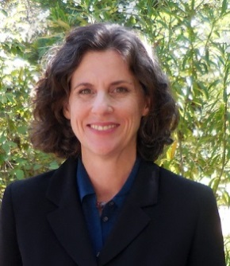

**Theresa Comstock**

**2015-2017 Chair**

#### Table of Contents:

Executive Summary 1

Status of the MHB 2

Meetings

Membership

Committees

Goals & 3

Accomplishments

Meet the Board 6

Members

Acknowledgements 10



**Napa County Mental Health Board**

**2016-2017 Annual Report 2**

**Status of the Mental Health Board**

**Meetings:** Regular MHB meetings were held on the 2nd Monday of each month. which allowed for public comment 8 100

In February, we held a hearing for review and comment on the proposed Mental Health Division’s Mental Health Services Act (MHSA) Annual Plan Update Fiscal Year (FY) 2015-16. In June, we held a public hearing for review and comment on proposed MHSA Innovation Plan Projects: 1) On The Move: Work for Wellness; 2) COPE Family Center: Adverse Childhood Experiences (ACE); 3) NVUSD: Support for Filipino Community; 4) Suscol Intertribal Council: Support for Native Americans.

We held three other special meetings in American Canyon, St. Helena and at Napa’s Innovations Community Center.

**Committees & Workgroups:**

**Executive Committee:** Theresa Comstock-Chair; Kristine Haataja-Vice Chair; Members at Large: Rowena Korobkin, Terri Restelli-Deits, Minott Wessinger.

**Data Notebook Workgroup** (2016): Terri Restelli-Deits (Chair), Theresa Comstock, Steven Gehring, Larry Kamer

**Employment Workgroup:** Dr. Rowena Korobkin (Chair), Terri Restelli-Deits, Rocky Sheridan, Dr. Robin Timm.

**School-based Mental Health Services & Stigma Reduction Workgroup**: Minott Wessinger (Chair), Kristine Haataja, Supervisor Alfredo Pedroza

**Annual Report:** Theresa Comstock, Kristine Haataja.

**Quality Improvement** (QIC): Mayra Vega.

**Stakeholders Advisory** (SAC): Rocky Sheridan.

**MHSA Innovations Planning Advisory:** Terri Restelli-Deits, Rocky Sheridan, Minott Wessinger.

**California Association of Local Behavioral Health Boards/Commissions:** Beryl Nielsen, Theresa Comstock.

**Membership:** At the close of the fiscal year, membership on the MHB consisted of 13 members.

The ethnic make-up of our board has improved, although there is still room for improvement to adequately represent the ethnic make-up of our community. We will continue to address this issue.

Members joining the board this year include: Steven Gehring, Larry Kamer, and E. Beth Nelsen. Members leaving the board were Gabriel Hernandez (end of term) and Linda Mallett (end of term). We thank them for their contributions to our board!

|  |  |  |  |
| --- | --- | --- | --- |
| **Board Member** | **District**  **at Time of Appointment** | **Appointment**  **Date** | **Term**  **Ends** |
| **Theresa Comstock** | 2 | **1/06/2016** | **1/1/2018** |
| **Kristine Haataja** | 4 | **11/3/2015** | **1/1/2019** |
| **Rowena Korobkin, M.D.** | 1 | **1/06/2015** | **1/1/2018** |
| **Sup. Alfredo Pedroza** | 4 | **1/12/2015** | **1/1/2018** |
| **Terri Restelli-Deits** | 4 | **11/3/2015** | **1/1/2019** |
| **Robin Timm, Ph.D.** | 4 | **1/06/2015** | **1/1/2018** |
| **Joseph “Minott” Wessinger** | 3 | **11/3/2015** | **1/1/2019** |
| **Mayra Vega** | 2 | **1/26/2015** | **1/1/2019** |
| **Beryl Nielsen** | 4 | **1/06/2015** | **1/1/2018** |
| **Oliver “Rocky” Sheridan** | 4 | **1/06/2015** | **1/1/2018** |
| **Steven Gehring** | 1 | **10/10/2016** | **1/1/2020** |
| **Larry Kamer** | *3* | **2/15/2017** | **1/1/2020** |
| **E. Beth Nelsen** | 1 | **5/09/2017** | **1/1/2020** |
| **OPEN** |  |  |  |
| **OPEN** |  |  |  |



**Napa County Mental Health Board**

**2016-2017 Annual Report 3**

**Goals & Accomplishments**

The following objectives and goals for 2016-2017 were developed by the MHB Executive Committee and approved by the MHB. We have detailed the work done by the MHB on each of these goals.

1. **Objective: Fulfill the Mandated Responsibilities and Core Purposes of the Mental Health Board**
2. **Goal:** *Review and evaluate the community’s mental health needs, services, facilities, and special problems [5604.2 (a)(1)] Welfare & Institutions Code (WIC)*

**Accomplishments:**

* Throughout the year, the MHB hosted a variety of speakers and panel forums related to Napa County mental health issues and services, including: homelessness and housing issues/strategic Napa County initiatives, responsibilities and duties of the Patient’s Rights Advocate, programs and services offered to the community by the Mental Health Division, veteran’s mental health issues and services, student mental health services at Napa Valley College, and mental health issues and services for older adults in Napa County.
* Conducted a public hearing for review and comment on the Mental Health Division’s Mental Health Services Act (MHSA) Annual Update Fiscal Year (FY) 2015-16.
* Reviewed and evaluated mental health facilities and services through scheduled site visits.
* Work Group In-Depth Research completed included:

Employment (Attachment A)

School-Based Mental Health Services & Stigma Reduction (Attachment B)

1. **Goal:** *Review and comment on the county’s performance outcome data and communicate its findings to the California Mental Health Planning Council (CMHPC) [5604.2 (a)(7)] WIC*

**Accomplishments:**

Completed the California Mental Health Planning Council’s 2016 Data Notebook questionnaire with reference to data from the external quality review organization (EQRO) ([www.CALEQRO.com](http://www.CALEQRO.com)). The 2016 questionnaire focused on mental health programs for youth, including:

* Mental Health Access and Engagement for Children/Youth (Age 6-15) and Transition-Aged Youth (Age 16-25).
* Strategies Used for Providing Mental Health Services to Foster Youth and LGBTQ Youth.
* County Substance Use Disorder Treatment available to Children, Youth, Incarcerated Youth, and Non-Custodial Youth in Probation/Diversion Programs.
* Suicide Prevention Programs for Children, Youth, and Transition-Aged Youth.
* Programs for Early Identification of Risks for First-break Psychosis.

The completed questionnaire is posted with the April 2017 meeting documents at:   
<http://www.countyofnapa.org/HHSA/MentalHealthBoard/> (4/10/17 Meeting Documents)

1. **Goal:** *Review and approve the procedures used to ensure citizen and professional involvement at all stages of the planning process [WIC 5604.2 (a)(4)].*

**Accomplishments:**

* The public was routinely invited to attend and participate in all monthly MHB meetings. Public comments, concerns and questions were received from mental health consumers, stakeholders, and advocates throughout the year.
* Special meetings were held at Napa’s Innovations Community Center, American Canyon City Council Chambers and Silverado Orchards Retirement Community in St. Helena.
* Meeting Agendas and Minutes are posted on the Napa County website:   
  <http://www.countyofnapa.org/HHSA/MentalHealthBoard/>

1. **Goal:** *Review any county agreement entered into pursuant to Section 5650 of the Welfare & Institutions Code.*

**Accomplishments:**

* Members Kristine Haataja, Beryl Nielsen and Dr. Rowena Korobkin participated reviewing proposals for the new Crisis Stabilization Unit.
* Members Terri Deits, Rocky Sheridan, Minott Wessinger and Dr. Rowena Korobkin participated in reviewing proposals for Round 2 MHSA Innovations Projects.
* Current contracts were reviewed prior to site visits.
* Mental Health Division Budget Overview provided by HHSA Fiscal Staff.

**Napa County Mental Health Board**

**2016-2017 Annual Report 4**

***Goals & Accomplishments cont’d…***

* The following contracts, agreements, reports and applications were provided for review during FY 2016-17:

Managed Care Agreement, Performance Agreement, Conditional Release Program (CONREP), State Hospital Bed Agreement, MH Division’s Mental Health Services Act (MHSA) Annual Plan Update Fiscal Year 2016-17, Triennial Audit, External Quality Review Evaluation of Medi-Cal Specialty MH Services in FY 2015-16, Projects for Assistance in Transition from Homelessness (PATH). The Substance Abuse and MH Services Administration (SAMHSA) Federal grant application was reviewed in June of 2016.

1. **Objective: Maintain an active, involved Mental Health Board.**
2. **Goal:** *Achieve full MHB membership that reflects the diversity of the populations served.*

**Accomplishments:**

As of June 30 2016, the MHB had 13 members, including interested/concerned citizens (46%), consumers (23%) and family members (31%). The Board is actively recruiting to fill two open positions: [www.countyofnapa.org/ceo/committeesandcommissions/](http://www.countyofnapa.org/ceo/committeesandcommissions/) .

1. **Goal:** *Maintain a high attendance and participation at all MHB meetings, including all committees and/or workgroups.*

**Accomplishments:**

* Board Meetings were held monthly without exception and a quorum was established at every meeting. Board member attendance ranged from 58% to 100%, with average attendance: 72%.
* The Executive Committee also met monthly without exception and a quorum was established at every meeting.
* Workgroups function as “Ad Hoc” Committees with membership generally ranging from 2-4 members.

1. **Goal:** *Maintain representation on appropriate local, regional and state boards, committees, councils, etc., and regular reporting to the Mental Health Board (for example: CALBHBC, QIC, etc).*

**Accomplishments:**

* Board Chair Theresa Comstock is the 2017-2018 President of the California Association of Local Behavioral Health Boards (CALBHB/C). CALBHB/C updates, newsletters, [website](http://www.calbhbc.weebly.com) access, regional meeting and MHB training dates were provided to the MHB.
* Board Chair Theresa Comstock participated on the CA Mental Health Planning Council’s Advocacy Committee Ad Hoc addressing Adult Residential Care facilities for adults with mental illness.
* Member Beryl Nielsen was the CALBHB/C Treasurer until October of 2016, and shared CA Mental Health Planning Council meeting materials with board members.
* Member Rocky Sheridan is a member of the MHSA Stakeholder’s Advisory Committee (SAC)
* Member Mayra Vega was a member of the Mental Health Division Quality Improvement Committee (QIC)

1. **Goal:**  *Complete 100% of site visits.*

**Accomplishments:**

* The MHB reported on the following site visits during 2016-17.
  + Napa State Hospital Skilled Nursing Support, Medical Unit and Acute Behavioral Unit
  + St. Helena Hospital Adult Inpatient Psychiatric and Geropsychiatric Units
  + Willow Glen & Rosewood Care Center in Yuba City
  + North Valley Behavioral Health in Yuba City
  + Mentis Satellite and Permanent Housing Programs
  + Progress Foundation’s Crisis Residential Treatment Center (Progress Place)
  + Crestwood Rehabilitation and Recovery Center in Vallejo
  + Innovations Community Center in Napa
* Written reports were submitted to the Executive Committee for review, followed by a presentation to the entire MHB and any public present at the meeting, for discussion.

**Napa County Mental Health Board**

**2016-2017 Annual Report 5**

1. **Goal:** *Provide training opportunities to MHB Members*

**Accomplishments:**

* MHB Chair Theresa Comstock provided individualized new member training for incoming board members.
* Vice Chair Kristine Haataja attended Mental Health Board and Advocacy training in Sacramento provided by CALBHB/C, taught by Susan Wilson, Chair of the CA Mental Health Planning Council.
* Member Larry Kamer attended Mental Health Board training in Woodland with the Yolo County MHB, also taught by Susan Wilson.
* Board members were notified of dates for Mental Health Board and Advocacy trainings facilitated by CALBHB/C.
* Members were encouraged to complete Ethics Training [on-line](http://localethics.fppc.ca.gov/login.aspx), or provided by Napa County on June 2,2017.

**Napa County Mental Health Board**

**2016-2017 Annual Report 6**

**Meet the Board Members**

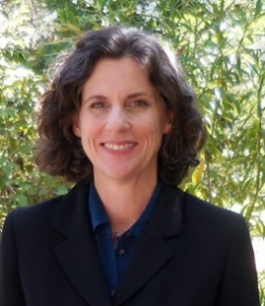

**Theresa Comstock:**  Experience with adults with mental illness began as a volunteer with Dallas County MHMR Acute Inpatient Treatment Center. Other community and leadership experience includes: President of the CA Association of Local Behavioral Health Boards & Commissions, Past Co-Chair of a Dallas-based community organizing group, Past Legislative Chair of the Houston Council of PTA’s, Past President of The Kiwanis Club of Greater Napa, Past President of New Technology High School’s Parent Club. Ms. Comstock is an artist (oil painting) and has a BA from U.C. Davis. She was appointed in 2014, chaired the Mental Health Board from 2015 - 2017, and has chaired two MH/housing-related workgroups.

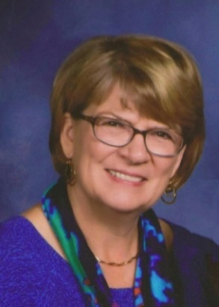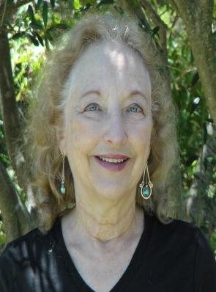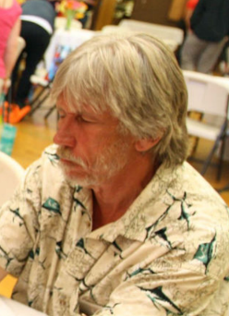

**Kristine Haataja** was a Consumer Insights & Strategy Consultant for corporations and consulting firms for over 35 years, retiring in 2015. Her career focus has been researching consumer behavior to understand unmet needs and how to address them with new/enhanced services and products. Ms. Haataja is especially passionate about mental health intervention in early childhood and adolescence, based upon her experience of raising a child with serious mental health issues. Since moving to Napa, she has been a Life Coach for Girls on the Run Napa-Solano, serves on the Development Committee for Aldea and is a graduate of Leadership Napa Valley Class 30. She was appointed to the Mental Health Board in 2015, is on the Executive Committee, is Vice Chair for 2016-2017 and served on the School-based Mental Health Services & Stigma Workgroup. Ms. Haataja has a BA in Sociology from Gustavus Adolphus College in Minnesota and an MBA from the University of North Carolina, Chapel Hill. Ms. Haataja is incoming 2017-2018 MHB Chair.

**Rowena Korobkin, M.D.** was appointed to the MHB in 2012. Dr. Korobkin is a Board Certified Physician Neurologist and Child Neurologist. She received her MD in 1971 from the University of California, San Francisco, and trained in pediatrics at Children’s Hospital in Oakland, and neurology at UCSF. She is the author of numerous journal articles and books in her field and recently consulted with the National Institute of Child Health and Development (NICHD) on a research project. Dr. Korobkin’s current main clinical interest relates to epilepsy and other neurologic issues in people with developmental disabilities, and she is a member of the Professional Advisory board of the Epilepsy Foundation of Northern California. She is the Consulting Neurologist for Sonoma Development Center, the Pediatric Neurologist for the County of San Joaquin at the San Joaquin General Hospital, and the Consultant Neurologist to North Bay Regional Center and Redwood Coast Regional Center. Because of a close family member with serious mental health issues, Dr. Korobkin has been inspired to lend her experience and expertise to assist in influencing the mental health delivery systems for Napa County.

**Steven Gehring** was appointed to the MHB in 2017, and brings to the board both a mental health consumer’s perspective, and experience as a former licensed psychiatric technician. He has years of experience working with adults and youth as a psychiatric technician in both inpatient and outpatient programs. In addition to serving on the Mental Health Board, Steven is active in the community, including volunteering with Napa’s Disability Services and Legal Center and working at the Thrive Cafeteria at the Health & Human Services campus. He has a Psychiatric Technician Certificate from Napa Valley College and a Certificate of Human Services from American River College.

**Napa County Mental Health Board**

**2016-17 Annual Report 7**

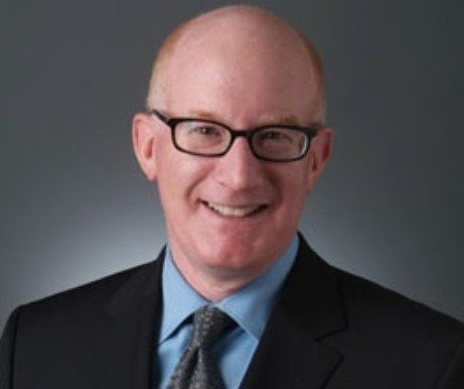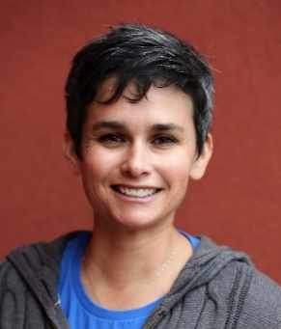

**Supervisor Alfredo Pedroza** is a lifelong Napa resident and was appointed to the Board of Supervisors by Governor Jerry Brown on December 29, 2014, and elected to the BOS in 2016. Alfredo was elected to the Napa City Council in 2012, becoming Napa’s youngest and first Latino Council member ever elected. Professionally, Alfredo has worked in the financial services industry for more than 10 years, having careers with credit unions and community banks. Alfredo’s many years of experience in the financial services industry have helped countless local families and businesses improve their finances and thoughtfully manage and sustain growth. His broad-based community leadership roles encompassing commerce, educational and social service organizations have helped facilitate job growth and economic development, provide aid for local schools, and lend support to individuals and families most in need. Alfredo is active with service clubs and nonprofit organizations. His passion for public and community service stems from his commitment to working to create a Napa County where his children and future generations of Napa citizens will live, seek jobs, start businesses, and raise their families. Alfredo is a graduate of Sonoma State University, where he holds a Bachelor’s degree in Business Administration and a minor in Economics. He and his wife, Brenda, another Napa native, attended local schools, volunteer locally, and have started their family in Napa.

**Larry Kamer** is a corporate communications and public affairs consultant and university instructor.  He is the CEO of Kamer Consulting Group and teaches at the University of San Francisco and Carnegie-Mellon University.  Additionally, he serves on the boards of directors of The Pathway Home, Dreamcatchers Empowerment Network, and the American Red Cross Bay Area.  He and his wife, Devereaux Smith, live in Yountville. Larry was appointed to the Board in 2017.

**Beryl Nielsen** has been a member of the MHB for many years, having served previously as the Chair, Vice-Chair, and Chair of the Membership and Annual Report Committees. Ms. Nielsen holds a bachelor’s degree in microbiology (with honors) from Stanford University and a master’s in social work from University of Southern California. Ms. Nielsen was previously a licensed clinical social worker. Beryl is past-Treasurer of the CA Association of Local Behavioral Health Boards and Commissions. As an interested and concerned citizen, Ms. Nielsen has been influential in getting mental health board trainings throughout the state.

**Beth Nelsen** is a local documentary filmmaker, change maker, and conscious shaker. A Napa Valley College graduate, Beth earned her BA in Philosophy from UCLA and her M.A. in Film & Television at the University of Melbourne. Beth is an international guest speaker whose films have screened all over the globe. Her passions include advocacy for mental health, Indigenous Rights, LGBTQ equality, and adoption and identity, all of which have been fodder for her storytelling. Beth seeks collaboration on projects with potential for heavy social impact, not confined to only the screen. She resides in Napa with her partner Christina and their daughter.  Beth was appointed to the Board in 2017.

**Napa County Mental Health Board**

**2016-2017 Annual Report 8**

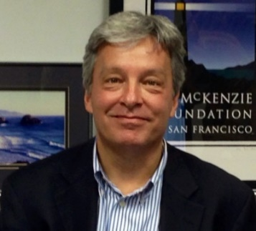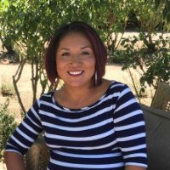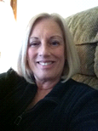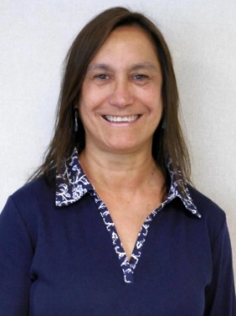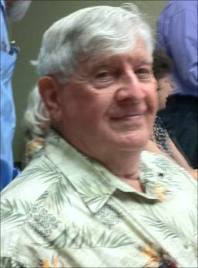

**Minott Wessinger** has had a successful career in marketing & brand development for over 30 years. Minott has several family members who have lived with mental illnesses including bi-polar disorder and schizophrenia. In 2007 he and his wife Ashley started The McKenzie Foundation, a non-profit dedicated to helping build awareness and reduce stigma associated with adolescent mental health. The McKenzie Foundation provides resources to local and national organizations primarily in the areas of early intervention, housing, peer support & counseling in addition to long term research into causes and potential treatments. Minott graduated with a B.A. from Pomona College. He and his wife have two daughters and split their time between San Francisco and the Napa Valley. He became a member of the MHB in January 2016 and chaired the School Based Mental Health Services & Stigma Workgroup.

**Mayra Vega** joined the board in 2016 with an interest in contributing and bringing forth the Latina perspective on mental health needs for young adults, families and senior populations. Mayra is currently a Regional Director, Talent Management for St. Helena Hospital Adventist Health. She has a Bachelor’s of Arts in Economics from UC Davis and an MBA from Sonoma State University.

**Robin Timm, Ph.D.**, is a Clinical Neuropsychologist and faculty member with U.C. Davis Medical Center. Dr. Timm is on medical staff at Sutter-Alta Bates, maintains a private practice in clinical neuropsychology in Napa, and is a Neuropsychological Consultant for Easter Seal’s traumatic brain injury (TBI) program and Eskaton, an adult day health care facility. For the past 10 years, Dr. Timm has been a trainer on TBI for the Placer County Law Enforcement’s Crisis Intervention Training. Dr. Timm has worked for many years in the field of rehabilitation with individuals who have disabilities including mental health issues. Dr. Timm was born and raised in the Napa Valley and joined the MHB in 2010 as a concerned citizen in order to advocate for mental health services and give back to the community.

**Terri Restelli-Deits** joined the Mental Health Board in 2016. Sheis a social worker with an MSW degree with specialization in Gerontology from UC California at Berkeley and a BA in Psychology from Dominican University of San Rafael. She is a graduate of Leadership Napa Valley, currently serves on the Napa County Commission on Aging and the Executive Board of the California Elder Justice Coalition, among various committees. Terri has a passion for serving seniors and our community and has been very involved in mental health planning efforts. She was the state’s “older adult representative” on the Mental Health Oversight Accountability Commission (MHOAC) Services Committee (2010). Terri is a member at large on the Mental Health Board’s Executive Committee and participated on the MHSA Round 2 Innovations Planning Advisory Committee.

**Oliver “Rocky” Sheridan** is a long-time Napa resident who served proudly in the U.S. Army from 1952 to 1955. Following an honorable discharge, he obtained an A.A. degree from Napa College, completed a four year apprenticeship as a marine machinist, and finished a two year course in management at Solano College. After an amazing 37 years of federal service, Mr. Sheridan retired from Mare Island in 1992 where he worked as a Production Shop Planner. Since then, Mr. Sheridan has been extremely active in community organizations and boards including the Child Abuse Council of Solano County, Volunteer Center of Solano County, National Association of Retired Federal Employees, City of Napa Senior Advisory Commission, Napa County Commission on Aging, Napa Healthy Aging Population Initiative Committee, the Children’s Nurturing Project of Solano County, Kaiser Permanente Health Council, Shamia Recovery House in Vallejo, and the Napa-Solano United Way. Mr. Sheridan joined the Napa County Mental Health Board in June 2014 and is dedicated to advocating for broader and better geriatric mental health services. He states, “I believe that awareness and education of the senior population will reduce suicide, depression, isolation, and loneliness amongst our seniors.”

**Napa County Mental Health Board**

**2016-2017 Annual Report 9**



**Mr. Gabriel Hernandez** is a Napa native who has been actively serving his community as a volunteer within various organizations, including: Napa Emergency Women's Services, the Napa County Literacy Center, and Community Action Napa Valley since 2011. Before joining the Napa County Mental Health Board he served as the Executive Vice-President and then President of the Beta Beta Sigma chapter of Phi Theta Kappa. Gabriel joined our board in 2014 as a constituent of Buckelew Programs in an effort to be both a voice and an ear for those receiving mental health services in the Napa Valley.

**Ms. Linda Mallett** is a long-time nursing instructor at Napa Valley College. In addition to teaching, Ms. Mallett serves on several health-related boards. Ms. Mallet completed her nursing education at the Mayo Clinic in Rochester, Minnesota, and at Berkeley. Ms. Mallett has been on the Napa County Mental Health Board for eight years and is a family member to a consumer. After arriving in Napa, Ms. Mallett first served on the City Planning Commission and Recreation Commission for several years. She was elected to the Board of Education of Napa Valley Unified School District in 1981 and served for 9 years. Ms. Mallett was a member of the Executive Committee.

**Members Leaving the Board during the past Year**

***Thank you for serving on the MHB!***

**Napa County Mental Health Board**

**2016-2017 Annual Report 10**

**Acknowledgements**

Thank you to Bill Carter (Mental Health Director), LuAnn Pufford (Senior Office Assistant) and to the entire Mental Health Division Staff and supporting agencies.

Thanks also to guest speakers and community members for information and support this year:

Lark Ferrell, Housing Manager, City of Napa Housing Division

Mechele Small Haggard, Consultant, Allen, Shea & Associates

Leslie Medine, Senior Fellow, On The Move

Innovations Community Center Participants, Volunteers & Staff

Frank SmithWaters, Napa County Patient’s Rights Advocate

Patrick Jolly, Napa County Veteran Services Officer

Nancy Tamarisk, Director Student Health Center, Napa Valley College

Magdalena Orr, MFT, Therapist, Napa Valley College

Jill Wood, Social Service Manager, Collabria Care

Xavia Hendriksz, Program Coordinator, Mentis

Tom Orrock, Mental Health Services Oversight & Accountability Commission Grant & Commission Support Manager

Matt Liebermann, MHSOAC Triage Grant and Commission Support

Urmi Patel, MHSOAC Consulting Psychologist

Gee Roman, Program Officer, The McKenzie Foundation of San Francisco

Silverado Orchards Retirement Community, St. Helena

Napa County Health & Human Services Mental Health Division Staff:

Jim Diel, Clinical Director

Lynette Lawrence, Provider Services Coordinator

Sandy Schmidt, Staff Services Analyst

Felix Bedolla, MHSA Project Manager

Rocio Canchola, MHSA Coordinator

Doug Hawker, Mental Health Manager

Harry Collamore, Quality Coordinator

Kate Boyd, Senior Office Assistant

Napa County Health & Human Services Staff:

Mike Mills, Supervising Mental Health Counselor, Comprehensive Services for Older Adults

Kris Brown, Deputy Director, Comprehensive Services for Older Adults

Mitch Wippern, Deputy Director of Operations & Co-Chair of the Homeless Services Planning Council

Bria Schlottman, Project Manager

Rose Hardcastle, Chief Fiscal Officer

Kimberly Danner, Deputy Chief Fiscal Officer

*Thank you to everyone in the community who works to provide the best mental health care system possible to the children and adults of Napa County!*