Imperial County: Data Notebook 2014
for California
Mental Health Boards and Commissions
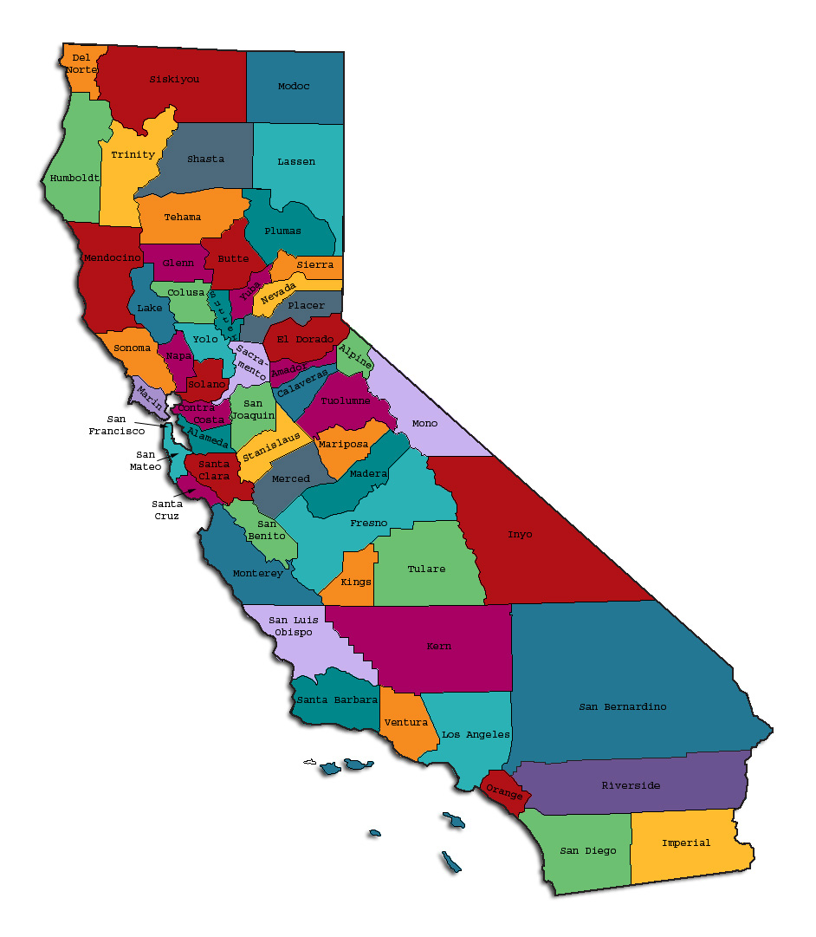
Prepared by California Mental Health Planning Council, in collaboration with: California Association of Mental Health Boards/Commissions, and APS Healthcare/EQRO
This Page Intentionally Left Blank.
Date: April 20, 2014
To: Chairpersons and/or Directors
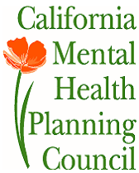
Local Mental Health Boards and Commissions
From: California Mental Health Planning Council
Subject: Instructions for Data Notebook 2014

We ask that this report be prepared by the MH Board or Commission members. You are the most important resources for identifying program strengths and needs in your community.
On the first page, please fill in the requested information for your county websites:
- Department of Behavioral Health/ Mental Health
- Public reports about your county’s MH services.
Please send a copy of the filled-in first page to the Planning Council along with your final report which contains your answers to the questions in the Data Notebook. Please submit your report within 60 days by email to:
DataNotebook@cmhpc.ca.gov.
Or, you may mail a printed copy of your report to:
- Data Notebook Project
- California Mental Health Planning Council
- 1501 Capitol Avenue, MS 2706
- P.O. Box 997413 Sacramento, CA 95899-7413
Please examine the enclosed information, which will help you discuss the questions in the Data Notebook. We provide examples of recent mental health data for your county. In some figures, the term “MHP” is used to refer to your county’s Mental Health Plan.
Some data comes from APS Healthcare/EQRO, which gave permission to use their figures and tables, prepared for review of each county’s Medi-Cal Specialty Mental Health services. Data in this packet came from the following review cycle:
__X__ Fiscal Year 2013 -- 2014: http://caeqro.com/webx/.ee85675/
_____ Fiscal Year 2012 -- 2013: http://caeqro.com/webx/.ee851c3/
For some questions, you will need to consult your local county Quality Improvement Coordinator, and/or Mental Health Director. If you are not able to address all of the questions, just answer the ones you can.
Thank you for your participation in the Data Notebook Project.
This Page Intentionally Left Blank

Imperial County: Data Notebook 2014
for California
Mental Health Boards and Commissions

County Name: Imperial Population (2013): 179,086
Website for County Department of Mental Health (MH) or Behavioral Health:
___imperial.networkofcare.org____________________________________________
Website for Local County MH Data and Reports:
___same as above________________________________________________
Website for local MH Board/Commission Meeting Announcements and Reports:
_____same as above___________________________________________
Specialty MH Data from review Year 2013-2014: http://caeqro.com/webx/.ee85675
Total number of persons receiving Medi-Cal in your county (2012): 74,381
Average number Medi-Cal eligible persons per month: 60,976
Percent of Medi-Cal eligible persons who were:
Children, ages 0-17: 43.9 %
Adults, ages 18-59: 37.2 %
Adults, Ages 60 and Over: 18.9 %
Total persons with SMI or SED who received Specialty MH services (2012): 4,084
Percent of Specialty MH service recipients who were:
Children 0-17: 48.4 %
Adults 18-59: 44.7 %
Adults 60 and Over: 6.9 %
This Page Intentionally Left Blank
INTRODUCTION: Purpose, Goals, and Data Resources
This Data Notebook has been developed for the use by the local mental health (MH) boards and commissions by a yearlong workgroup comprised of members from:
- California Mental Health Planning Council (CMHPC)
- California Association of Local Mental Health Boards and Commissions (CALMHB/C)
- APS Healthcare/ EQRO (External Quality Review Organization)
Our plan is for the Data Notebook to meet these goals:
- assist local boards to meet their mandates to review the local county mental health systems, identify unmet needs, and recommend improvements.
- provide a professional format for submitting reports to their local Board of Supervisors, and/or their county Director of Mental Health Services.
- function as an educational tool for local boards, whose members have varying levels of skills, frequent turnover, and need ‘refresher’ training about using data.
- help the CMHPC fulfill its mandates to review and report on the public mental health system in California, which also helps provide evidence for advocacy.
Data reporting drives policy, and policy drives funding for programs. But the data must be both recent and available to the public, or else it is not useful. So, the CMHPC will provide examples of local data from current public reports. We focus on two broad areas: (1) evaluation of program performance, and (2) indicators of client outcomes.
We recognize that each county has a unique population, resources, strengths, and needs. Thus, there is no single perfect data source to answer all the important questions one might ask about mental health services. However, the following data resources will help board members answer questions in this Data Notebook:
- experience and opinions of the local mental health board members
- recent reports about county MH programs from APS Healthcare/EQRO
- data you request from your county QI Coordinator and/or Mental Health Director (because CMHPC does not have that data, and it’s not in other public reports)
- client outcomes data provided by California Institute of Mental Health (CiMH) in their analysis of the most recent Consumer Perception Survey.
Some of our data comes from APS Healthcare/EQRO, which kindly gave permission to use their figures and tables, prepared for review of each county’s Medi-Cal Specialty Mental Health services. Those reviews are at: www.CAEQRO.com. You may find the full-length EQRO reports helpful because they summarize key programs and quality improvement efforts for each county. They also describe strengths, opportunities for improvement, and changes in mental health programs since the last year.
Understanding changes in local programs can help consumers because of the massive re-organization of mental health services statewide. Some changes have been confusing to clients. The old state Department of Mental Health was eliminated in 2012 and many functions were moved to the Department of Health Care Services. Other changes due to federal health care reform and the Affordable Care Act affect how mental health services are provided, funded, and linked to primary health care or substance use treatment. Also, local counties have adjusted to major challenges.
Remember, this report is about your community, and what you and your stakeholders choose to discuss. Examining the data can indeed “Tell a Human Story.” But quantitative data (numbers) provides only part of the picture, for example:
- measures of whether the quality of program services improve over time
- whether more people from different groups are receiving services
- how many clients got physical healthcare or needed substance use treatment.
The other part of the story gives human context to the numbers. Such qualitative data (narrative, descriptions, or stories) tells more of the story, because we can:
- describe special programs targeted for outreach to specific groups
- examine how the programs are actually implementing their goals
- list concrete steps that are taken to improve services, and
- tell what is being done to increase client engagement with continued treatment.
We hope this project contributes to ongoing quality improvement (QI) in mental health services. We seek constant improvement in our approach to quality because:
- needs change over time,
- all human endeavors are by nature imperfect,
- creativity gives rise to new ideas, and
- we can share examples of successful programs to help other communities.
One question is whether local boards are permitted to provide additional information, besides that requested in this Notebook. We always welcome supplemental reports about successful projects, or which the county administration uses to inform the public. Any additional reports may be attached in an “Appendix,” with the website address (if available). However, we emphasize such extra reports are not required.
Thank you for participating in this project. We hope this Data Notebook serves as a springboard for your discussion about all areas of the mental health system, not just those topics highlighted by our questions.
TREATING THE WHOLE PERSON:
Integrating Behavioral and Physical Health Care
Studies have shown that individuals with serious mental illness die, on average, 25 years earlier than the general population. This information makes improving the physical health of clients of great importance and should be a goal of county mental health departments along with providing effective and appropriate mental health services. Coordination of care for mental health, substance abuse and physical health is one way of accomplishing the goal.
The California Mental Health Planning Council does not have any data to provide to show how your county’s programs connect clients of mental health services with necessary physical health care. We ask that the local mental health board request information from your county mental health department for any data on numbers (or percent) of total mental health clients who are referred to, or connected with, physical health providers to assess, treat and monitor physical health issues.
If your county has data on numbers or percentages of clients who are also receiving physical health care, please include it in your Data Notebook you submit to the Council.
___ Check here if your county does not have such data or information.

- Please describe any efforts in your county to improve the physical health of clients.

The MHP participated in a Small County Care Integration Collaborative with California Institute of Mental Health from January 2012 through January 2013 and continued this collaborative as a performance improvement project through January 2014. The goal of this collaborative was improving physical health of clients as research indicates that persons with serious mental illness die up to 25 years earlier when compare to the general population.

As part of this collaborative we were successful in implementing the systematic collection of medical health information in the electronic record (AVATAR) to include medical health conditions, Body Mass Index, identification of Primary Care Physician, and Last Visit to the PCP, as well as Releases of Information for communicating with the appropriate PCPs. This information is available in the electronic record (AVATAR) for all members of the treatment team to assist the client with coordination of services.

- How does your county address wellness programs to engage and motivate clients to take charge of improving their physical health?

During the Initial Nursing Assessment, the assigned nurse reviews the medical health information provided by the clients, and discusses any physical health problems reported. When needed, the nurse encourages clients to make an appointment with their primary care physician (PCP), and depending on the severity of the problem the nurse sends a referral to the appropriate PCP. The nurse and assigned psychiatrist continue to follow up with the PCP, as needed.

In particular, clients attending the Recovery Center are encouraged to participate in exercise activities to include Zumba, weigh resistance, and walking. The exercise classes are provided by contracting with Fitness Oasis. In addition, the Recovery Center assists clients with nutritional information and healthy cooking classes. Clients also participate in other activities which include trips to the beach, park, zoo, etc. where clients exercise by playing a sport or simply just walking.

At the present time, this county is currently participating in the Advancing Recovery Collaborative (ARC) with the California Institute for Behavioral Health Solutions (CIBHS) formerly California Institute of Mental Health (CiMH). The goal of this collaborative is engaging clients in meaningful community activities to include volunteering, attending obtaining their GED, attending community college, and participating in other activities in their community. And, the aim is to build hope and belief that recovery is possible.
Examples:
- Exercise
- Nutrition
- Healthy cooking
- Stress management
- Quitting smoking
- Managing chronic disease
- Maintaining social connectedness

NEW CLIENTS: One Measure of Access
One way to evaluate the quality of mental health services outreach is to measure how many clients receive services who have never been part of the service system before (“brand new” clients). Another measure is how many clients return for services after a period of time with no services (“new” clients).
The California Mental Health Planning Council is exploring how each county mental health department defines “new” clients, and how a client is labelled when they return for additional services. This information is important in determining whether your county has a “revolving door,” that is, clients who are in and out of mental health services repeatedly. This data is one indicator of the success of your county’s programs in closing cases appropriately and providing adequate discharge planning to clients.
This data is not currently reported by the counties to the state. The Council does not have data to provide to you. This information should be requested from your county mental health department.
____ Check here if your county does not have this information.
3. How does your county define 'new' client for those individuals who have previously received services, but who have not received services for a while? (e.g., 6 months, 12 months, 2 years?)
A new client is one who has never received services at ICBHS. Some of our reports refer to clients as active or inactive. An active client is a client who is actively open to a team, and inactive client is one who was discharged or has never been open to a team.

4. Please provide any data your county has on the number of 'new' clients last year. And if you have it, how many of those new clients were brand new clients? You may need to ask your county mental health department for this data.
# new children/youth (0-17 yrs) __1,753___
of these, how many (or %) are ‘brand new’ clients __918___

# new adults (18-59 yrs) 1,696_____
of these, how many (or %) are ‘brand new’ clients _642____

# new older adults (60+ yrs)__204___
of these, how many (or %) are ‘brand new’ clients _95____
REDUCING RE-HOSPITALIZATION: Access to Follow-up Care
Sometimes, an individual experiences acute symptoms of mental illness or substance abuse which can result in a brief stay in an acute care hospital. Receiving follow-up services after discharge from a short-term (3-14 day) hospitalization can be critical to preventing a return to the hospital.
The chart below shows the percentage of people discharged in your county who received at least one service within 7 days of discharge. Also shown is the percentage of those same people who were readmitted to the hospital. The chart also shows the same information for receiving services and being readmitted to the hospital within 30 days. Red indicates the numbers for your county and the blue indicates the percentage for the state of California.
Imperial County:
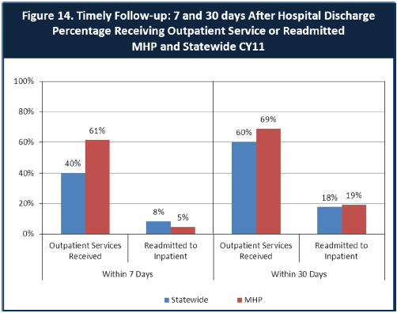

6. Looking at the chart, is your county doing better or worse than the state? Discuss why (e.g., your county has programming available that specifically ensures a warm handoff for follow-up services).
For the Timeliness of Follow up within 7 days Imperial County is at 5% and seems better than the State at 8% re-admitted rate.
For the Timeliness of Follow up within 30 days Imperial County is at 19% and seems slightly behind the State at 18% re-admit rate.
The county’s Quality Management unit monitors the timeliness of follow-up appointments after a hospitalization for active and inactive clients and prepares a report on a quarterly basis. The Quality Improvement Committee reviews the reports and makes recommendations to management as needed. In addition the County has established a benchmark to provide follow-up services within a 3 day timeframe for active clients and 7 day timeframe for inactive clients from the date of discharge from the hospital.
The reports are provided to the appropriate Deputy Directors for Adults, Children, and Youth and Young Adults Programs to follow up on the recommendations given by the Quality Improvement Committee.

7. Do you have any suggestions on how your county can improve follow-up and reduce re-hospitalizations?
For the Quality Management Unit to continue to monitor the timeliness of follow-up appointments for active and inactive beneficiaries; and, for the Quality Improvement Committee to continue to review timeliness reports and make recommendations to management, as appropriate.

8. What are the three most significant barriers to service access? Examples:
- Transportation
- Child care
- Language barriers or lack of interpreters
- Specific cultural issues
- Too few child or adult therapists
- Lack of psychiatrists or tele-psychiatry services
- Delays in service
- Restrictive time window to schedule an appointment
- Transportation

- Denial is probably one the many barriers as clients report that they can handle their mental health problem without any treatment or help.
- Transportation to services.
- Stigma associated with mental illness and myths associated with taking medications

ACCESS BY UNSERVED AND UNDER-SERVED COMMUNITIES
One goal of the Mental Health Services Act (MHSA) is to reach unserved and underserved communities, especially communities of color. The MHSA promotes outreach to engage these communities in services. If individuals and families in these communities are not accessing services, then we may need to explore new ways of reaching them. Or, we may need to change our programs to meet their mental health needs in ways that better complement their culture.
From data the counties report to the state, we can see how many individuals living in your county are eligible for Medi-Cal, and of those individuals, how many received mental health services. Are you serving the Medi-Cal clients who need your services?
Imperial County:
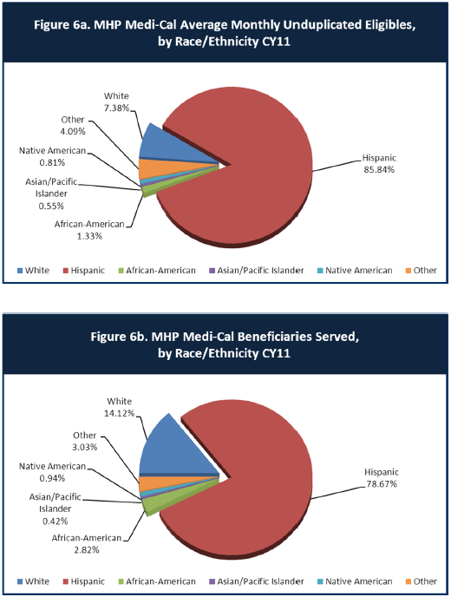

9. Is there a big difference between the race/ethnicity breakdown on the two charts? Do you feel that the group(s) that need services in your county are receiving services?
Imperial County’s Population is predominantly Hispanic. The tables show a large number of Hispanics being served (78.67%). However, the question “Are you serving the Medi-Cal clients who need your services?” cannot be answered without having the penetration rates for each particular ethnic group. The penetration rates for Imperial County are normally higher than Statewide for the Hispanic population.

10. What outreach efforts are being made to reach minority groups in your community?
The county has a Community Education and Outreach Plan which is prepared by the Outreach Unit. In addition the county has an Outreach Taskforce consisting of representatives of the County’s Behavioral Health Services units. The taskforce meets quarterly to discuss and strategize outreach efforts in the community which are focused on meeting the needs of the underserved, hard to reach, and homeless populations identified in the Community Education and Outreach Plan. The outreach effort includes targeting the ethnic groups and populations identified as under-served based and in need of continued outreach services based on the recommendations of the Penetration Rates Reports.
Outreach efforts utilized the following means to educate the community on topics related to mental health and treatment services:
Instructional Outreach: Includes any teaching activity, such as presentations or small group sessions that is aimed at serving a population. Instructional outreach is to be coordinated by the staff Development Unit.
School-Based Outreach: Includes any outreach presentation or forum conducted in a school setting for the benefit of students, parents/legal guardians of students, and school personnel. School based outreach efforts are to be coordinated by either Staff Development Unit, the Children Services Unit, or the Youth and Young Adults Services Unit.
Committee member Attendance Outreach: Includes any teaching activity, presentation, or forum conducted during a committee meeting. Committee member attendance outreach efforts may be coordinated by any of the units.
Media Outreach: Includes any teaching activity, presentation, or forum conducted through the use of local media, such as newspaper articles, print ads, radio shows, etc. Media Outreach efforts are to be coordinated by the Staff Development Unit
Community-Based Outreach: Includes any outreach efforts, such as health fair boots, that incorporates the dissemination of materials to the community. Community –based outreach efforts may be coordinated by any unit.

11. Do you have suggestions for improving outreach to and/or programs for underserved groups?
Continue to follow the Community Education and Outreach Plan which provides the target populations identified in need of continued outreach services including the underserved, unserved, and hard to reach populations by ethnicity, age group, city of residence, geographical area, and language.

CLIENT ENGAGEMENT IN SERVICES
One MHSA goal is to connect individuals to services they need to be successful. Clients who stop services too soon may not achieve much improvement, nor is it likely to last. So it is important to measure not only who comes in for treatment, but also how long they stay in services. Here we are considering individuals with high service needs, not someone who just needs a ‘tune-up.’ Although not every individual needs the same amount of services, research shows that when someone with severe mental illness continues to receive services over time, their chances of recovery increase.
Engagement in services, also called ‘retention rate’, is important to review. If individuals come in, receive only one or two services and never come back, it may mean the services were not appropriate, or that the individual did not feel welcome, or some other reason that should be explored. Again, we recognize that some individuals only need minimal services, but here we are looking at those with severe mental illness. Ultimately, the goal is to ensure they are getting needed services and are on the road to recovery. But we would not know that unless we look at how many services individuals received over time.
The chart below shows the number of Medi-Cal beneficiaries in your county who received 1, or 2, or 3, or 4, or 5, or more than15 mental health services during the year. For individuals experiencing severe mental illness, the more engaged they are in services, the greater the chance for lasting improvements in mental health.

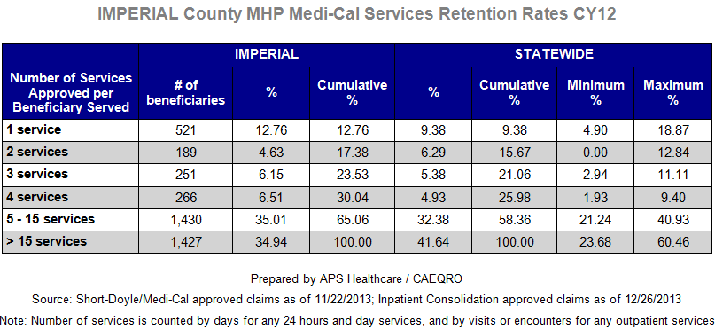
12. Do you think your county is doing a good job at keeping clients engaged in services? If yes, how? If not, why?
Our county is doing a good job at keeping clients engage. A large percentage of clients, close to 70%, received 5-15 services and more than 15 services.
The table above reflects that 521 (12.76%) of clients received only one service. However, on a given year a large number of those clients are screened out due to not meeting medical necessity criteria and were referred somewhere else for services.
The county examines retention rates and prepares a Retention Rates Report on a yearly basis. The report is reviewed by the Quality Improvement Committee, and recommendations are made to management as appropriate. The purpose of the report is to examine retention rates data for clients who received services in during the fiscal year. Service retention information is provided by the Avatar System and does not include beneficiaries who were screened out after the initial intake appointment.
It is important to note that there is no benchmark for the appropriate amount of services to be provided to an individual, but when considerable group differences exist in the amount of services provided, those differences represent an opportunity for improvement. Those opportunities for improvement are identified in the Retention Rates Report and recommendations are given to management, as appropriate.
13. For those clients receiving less than 5 services, what is your county doing to follow-up and re-engage those individuals for further mental health services?
For clients who missed an Intake Appointment, a Community Service Worker follows-up with the clients to find out the reason why they did not make them to their appointments. The Community Service Worker re-schedules the appointments and encourages clients to make it to the next appointment and provides information as needed. In addition, transportation services are offered.
All of the programs/teams do retention calls to remind clients of the scheduled appointments, and if needed teams staff re-schedules clients for later appointments, as needed.
In addition, some programs also offer transportation to services to those clients in need of transportation. When the programs are not able to provide transportation, a bus voucher is given to the client.
14. Looking at the previous chart of who is being served by race/ethnicity in your county, do you have any thoughts or ideas to share regarding your county’s engagement of underserved communities?
Continue to follow the Community Education and Outreach Plan which provides the target populations identified in need of continued outreach and engagement services including the ethnic groups who are underserved, unserved, and hard to reach populations.

CLIENT OUTCOMES: Consumer Perception Survey (August 2013)
Ultimately, the reason we provide mental health services is to help individuals manage their mental illness and to lead productive lives. We have selected two questions from the Consumer Perception Survey which capture this intention. One question is geared toward adults of any age, and the other is for children and youth under 18.
Below are the data for responses by clients in your county to these two questions.
For general comparison, statewide reference data for similar-sized counties are shown in the tables on page 19.
The total numbers of surveys completed for Adults or Children/Youth in your county are shown separately in the tables below, under the heading “Total.”
Q1. Adults. As a direct result of the services I received, I deal more effectively with daily problems.
 | Strongly Disagree | Disagree | Neutral | Agree | Strongly Agree | Total
Number of Responses | 0 | 4 | 19 | 58 | 41 | 122
Percent of Responses | 0 % | 3.3 % | 15.6 % | 47.5 % | 33.6 % | 100.0 %

Q2. Children/Youth. As a result of services my child and/or family received, my child is better at handling daily life.

 | Strongly Disagree | Disagree | Neutral | Agree | Strongly Agree | Total
Number of Responses | 4 | 5 | 22 | 55 | 29 | 115
Percent of Responses | 3.5 % | 4.3 % | 19.1 % | 47.6 % | 25.2 % | 100.0 %

15. Are the data consistent with your perception of the effectiveness of mental health services in your county?
Yes, our county makes every effort to engage and provide appropriate services to clients and the majority are able to benefit or maintain functioning in the different areas of life functioning. There is a small percentage of individuals where improvement may not be immediate, significant or possible. However, the county continues to provide training to staff in efforts to improve outcomes and client satisfaction.
16. Do you have any recommendations for improving effectiveness of services?
The County has been investing significant amount of resources, including hiring additional staff to meet the increasing demand of caseloads, and providing training in the areas of engagement, motivation and evidence-based models which will improve the effectiveness of services being provided.
Initial steps have taken place in locating buildings in other cities in order to provide services throughout the county for all three clinical divisions. Regionalizing in this way is expected to increase the accessibility of services so that we are reaching the unserved population.
17. Many counties experience very low numbers of surveys completed. Do you have suggestions to increase the response rate?
The following methodology has proved to be successful in Imperial County when conducting the annual Consumer Satisfaction Survey. In total there were five hundred ninety five (595) consumers who participated in this fiscal year’s survey. Consumers who received a face to face service are offered the opportunity to participate in the survey at all MHP Adult, Children and Youth and Young Adult’s clinics.
Prior to the date of the survey Quality Management staff visits Children Services, Adult Services, and Youth and Young Adult Services Supervisors’ meetings (also attended by managers) to inform them of the upcoming survey dates, the importance of the survey and the need to maintain a high level of consumer participation. Behavioral Health Management, Program Supervisors, Office Staff and Quality Management staff work as a team to make the survey a success.
At the beginning of the survey each clinic is provided with a sealed survey box which consumers can utilize in order to ensure anonymity/confidentiality of beneficiary feedback. Clinics are also provided with sufficient bi-lingual (English and Spanish) surveys for the two week period.
In order to promote consumer participation, flyers are posted during the survey period encouraging consumers to assist the MHP in finding ways to better serve their treatment needs. Furthermore the flyer assures consumers of their confidentiality/anonymity during the survey process as it informs them of the sealed survey boxes and of the option to mail their completed survey in the self-addressed envelopes to the Quality Management Unit.
At the end of the survey period Quality Management staff retrieved and tracks the number of completed surveys deposited into sealed boxes. Quality Managements analyses data and creates the Consumer Satisfaction Survey Report which is presented at the Quality Improvement Committee. In addition, a survey overview is presented to all MHP staff at each MHP Divisions’ staff meeting.

18. Lastly, but perhaps most important overall, with respect to delivery of services, do you have suggestions regarding any of the following:
a. Specific unmet needs or gaps in services
Because of the geographic and cultural composition of our county, over the years, our county has been working on identifying and implementing different strategies to address the unmet needs of our population. This includes the following:
- Thorough analysis of populations in our community and unmet needs and gap in services.
- Opening clinics in different geographic areas in our community – Calexico, El Centro, Brawley, and Winterhaven.
- Division of services into three distinct units: Children and Adolescents; Youth and Young Adults; and Adults and Older Adults
- Specialized clinics for the treatment of anxiety and depression and Full Service Partnership (FSP) teams for the higher-risk population in need of accessing a full range of integrated community services and supports.
- Providing services in non-traditional settings such as schools and community.
- Increase workforce with bilingual and bicultural staff representative of our community.
- Outreach and engagement activities throughout the community in English and Spanish which include: radio, newspaper and local magazine advertisement; participation in health fairs; community presentations on mental health issues and services; brochures in clinics and community agencies; radio show addressing mental health topics;
b. Improvements to, or better coordination of, existing services
The department is continuously evaluating service delivery practices and obtains feedback from beneficiaries and staff on ways to improve services. Beneficiaries participate in the Quality Improvement Committee where they present their recommendations. Other recommendations are directly provided at the different clinics.

c. New programs that need to be implemented to serve individuals in your county
The department is planning to continue to expand services in the different geographic areas and to continue to implement evidence-base models to address the needs of individuals served in our county. Some of the new models will include:
- Treatment for children with ADHD
- Parenting program
- Identification and early referral for individuals in the prodromal phase of psychosis and for those experiencing their first psychotic break
- Depression treatment for adults
- Implementation of a Performance Improvement Project (PIP) which targets improving services to the LGBTQQIAA population. This PIP will consist of:
- General training for all staff on the LGBTQQIAA population issues and workplace etiquette, general understanding and sensitivity
- Specific LGBTQQIAA training for clinical staff on proper terminology and on providing clinical services/treatment for the LGBTQQIAA populations
- Monthly consultation calls with the LGBTQQIAA consultant to monitor progress with the PIP and provide feedback to ensure goals are being met.

<END>
REFERENCE DATA: for Consumer Perception Survey items (August 2013)

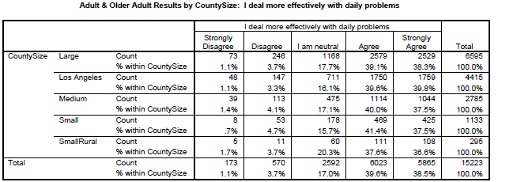

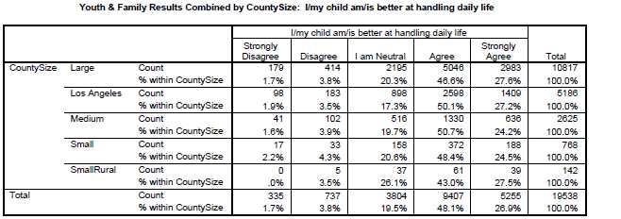

County Mental Health Plan Size: DHCS categories defined by county population.
o Small‐Rural MHPs = Alpine, Amador, Calaveras, Colusa, Del Norte, Glenn, Inyo, Lassen, Mariposa, Modoc, Mono, Plumas, Siskiyou, Trinity
o Small MHPs = El Dorado, Humboldt, Imperial, Kings, Lake, Madera, Mendocino, Napa, Nevada, San Benito, Shasta, Sutter/Yuba, Tehama, Tuolumne
o Medium MHPs = Butte, Marin, Merced, Monterey, Placer/Sierra, San Joaquin, San Luis Obispo, San Mateo, Santa Barbara, Santa Cruz, Solano, Sonoma, Stanislaus, Tulare, Yolo
o Large MHPs = Alameda, Contra Costa, Fresno, Kern, Orange, Riverside, Sacramento, San Bernardino, San Diego, San Francisco, Santa Clara, Ventura
o Los Angeles’ statistics are excluded from size comparisons, but are included in statewide data.
Total Values (in Tables above) = include all statewide data received by CiMH for those survey items.

REMINDER:

Thank you for your participation in completing your Data Notebook report.
Please feel free to provide feedback or recommendations you may have to improve this project for the following year. We welcome your input.

Please submit your Data Notebook report by email to:
DataNotebook@CMHPC.CA.GOV

Or, you may submit a printed copy by postal mail to:
- Data Notebook Project
- California Mental Health Planning Council
- 1501 Capitol Avenue, MS 2706
- P.O. Box 997413
- Sacramento, CA 95899-7413

For information, you may contact either email address above, or telephone:
(916) 449-5249, or
(916) 323-4501

Serious Mental Disorder, term used for adults 18 and older.
Severe Emotional Disorder, term used for children 17 and under.

