Data Appendix III. Substance Use Providers for Counties, FY 12-13.
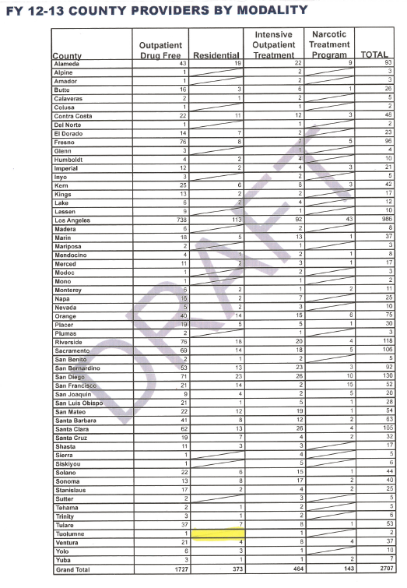

Source: 2015 California Substance Use Disorder Block Grant & Statewide Needs Assessment and Planning Report. Draft version, August 2015

