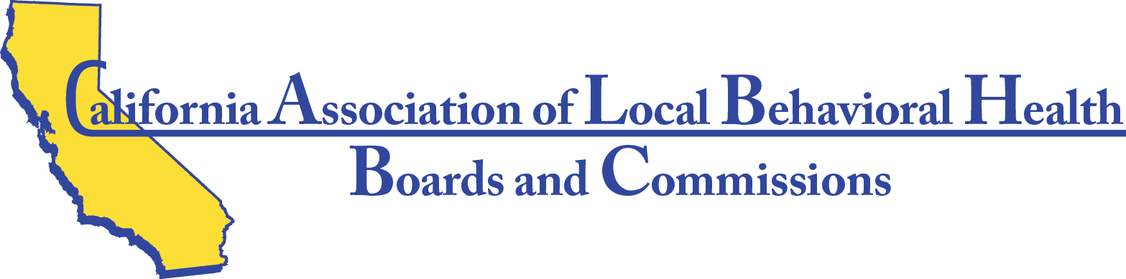

Minutes for Thursday April 6th 2017

The meeting was called to order at 5:00pm by President Cary Martin.
Roll was taken by Secretary Mae Sherman.
Members and Alternates Present: Cary Martin, Leslie Wilson, Alisa Chatprapachai, Mae Sherman, Keng Cha, Carole Marasovic, Maria Correia, Duane Chapman, Debra Allen, May Farr, Mohamed Asiad, Karyn Bates,James Cavener, Kate Gaston, Leon Polk.
Members Absent: Beryl Nielsen, Luvenia Jones
Excused Absence: Lyndal-Marie Armstrong, Susie Martin
Guests Present: Consultant, Steven Dambeck, Finance Manager, Theresa Comstock, Sherry Weyers, Sonoma County
Reports by members attending representing 18 counties shared what each county was doing and what kind of training each local board needs.
Steven Dambeck reviewed accomplishments of a discussion of next steps to actualize our action plan..

Minutes for Friday April 7th 2017

The meeting was called to order at 8:30am by President Cary Martin
Roll was taken by Secretary Mae Sherman
Members Present: Cary Martin, Leslie Wilson, Alisa Chaprapachai, Mae Sherman, Keng Cha, Carole Marasovic, Maria Correia, Duane Chapman, Debra Allen, May Farr, Mohamed Asiad, Karyn Bates,James Cavener, Kate Gaston, Leon Polk
Members Absent: Beryl Nielsen, Luvenia Jones

Friday April 7th minutes con’t
Excused Absence: Lyndal-Marie Armstrong, Susie Martin
Guests Present: Consultant, Steven Dambeck, Finance Manager, Theresa Comstock, Sherry Weyers, Sonoma County, Ellen Eggers-Brinson, Trinity County, Executive Director of the California Mental Health Planning Council, Jane Adcock, President of the California Mental Health Planning Council, Susan Morris Wilson
The October 2016 minutes were approved unanimously with a motion by Mohamed Asiad and second by Debra Allen.
The January 2017 minutes were approved unanimously with a motion by Debra Allen and second by Kate Gaston.
Financial Controller, Theresa Comstock gave the financial report. A Statement of Financial Income and Expenses dated July 2016-March 2017 was handed out and explained in detail. The balance sheet total of liabilities & equity was $155, 450.15.
Carole Marasovic, James Cavener, Duane Chapman, Theresa Comstock, met with Consultant, Steven Dambeck to work on proposed bylaws changes.
Jane Adcock and Susan Morris Wilson facilitated a session on Priorities, Visibility, Vision and an action plan for the Association to be implemented in the next quarter.
A proposed CALBHB/C Bylaws update was distributed to all Directors
Superior Region guests were welcomed and we all went to dinner, compliments of the CALBHB/C.

Minutes for Saturday April 8th 2017

The meeting was called to order by President Cary Martin.
Roll call was taken by Secretary Mae Sherman
Members Present: Cary Martin, Leslie Wilson, Alisa Chatprapachai, Mae Sherman, Keng Cha, Carol Marasovic, Maria Correia, Duane Chapman, Debra Allen, May Farr, Mohamed Asiad, Karyn Bates, James Cavener, Kate Gaston, Leon Polk
Members Absent: Beryl Nielsen, Luvenia Jones
Excused Absence: Lyndal-Marie Armstrong, Susie Martin
Saturday minutes con’t

Guests Present: Consultant, Steven Dambeck, Finance Manager, Theresa Comstock, Sherry Weyers, Sonoma Co., Trainer and Planning Council President, Susan Morris Wilson, Lois Lockhart, Mendocino C., Jan McGourdy, Mendocino Co., Sheila Shockley, Glenn Co., Donald Salyer, Glenn Co., Ellen Eggers-Brinson, Trinity Co., Cliff Lantz, Siskiyou Co., John Fenley, Trinity Co., Amanda Flowers Peterson, Shasta Co., Ashley Dominic, Yuba/Sutter Co., Touresa Vang, Yuba/Sutter Co., Sam Major, Shasta Co., Bill Kehoe, Butte Co., Daniel Cavanaugh, Butte Co., Patty McReynolds, Butte Co., Dean True, Shasta Co., Donelle Ewert, Shasta Co.
Susan Morris Wilson presented training in the morning on Responsibility and Reality of Behavioral Boards. Site visits, Data Notebook, Community Partnerships, reports to Supervisors, and new member orientation handbooks, were some of the topics discussed.
After lunch Susan Morris Wilson presented training on Community Advocacy. Some of the topics discussed were: Meeting with Legislators, and staying informed on new policy issues.
The CALBHB/C Bylaws update was presented for vote. Motion was made by James Cavener to accept the updated Bylaws with two additional changes (1) Change MHB to “MHB/BHB” throughout the document. (2) Add provisions for special election for Directors who may have to leave the board. Leon Polk seconded the motion. The motion carried unanimously.
Superior Region met and had annual elections. The top three candidates who received the most votes were: John Fenley, Trinity Co., Leslie Wilson, Lake Co., and Mae Sherman, Lassen Co. There was a tie for fourth: James Cavener, Siskiyou Co. & Don Salyer, Glenn Co. Other Regional Team members who came forward: Leon Polk, Shasta Co., Ellen Eggers-Brinson, Trinity Co., and Lois Lockhart, Mendocino Co.

Meeting was adjourned at 3:30pm
The Annual Meeting is in Irvine June 15, 16, 17 at the Atrium Hotel, 18700 MacArthur Blvd.

