Calaveras County: Data Notebook 2018
for California
Behavioral Health Boards and Commissions
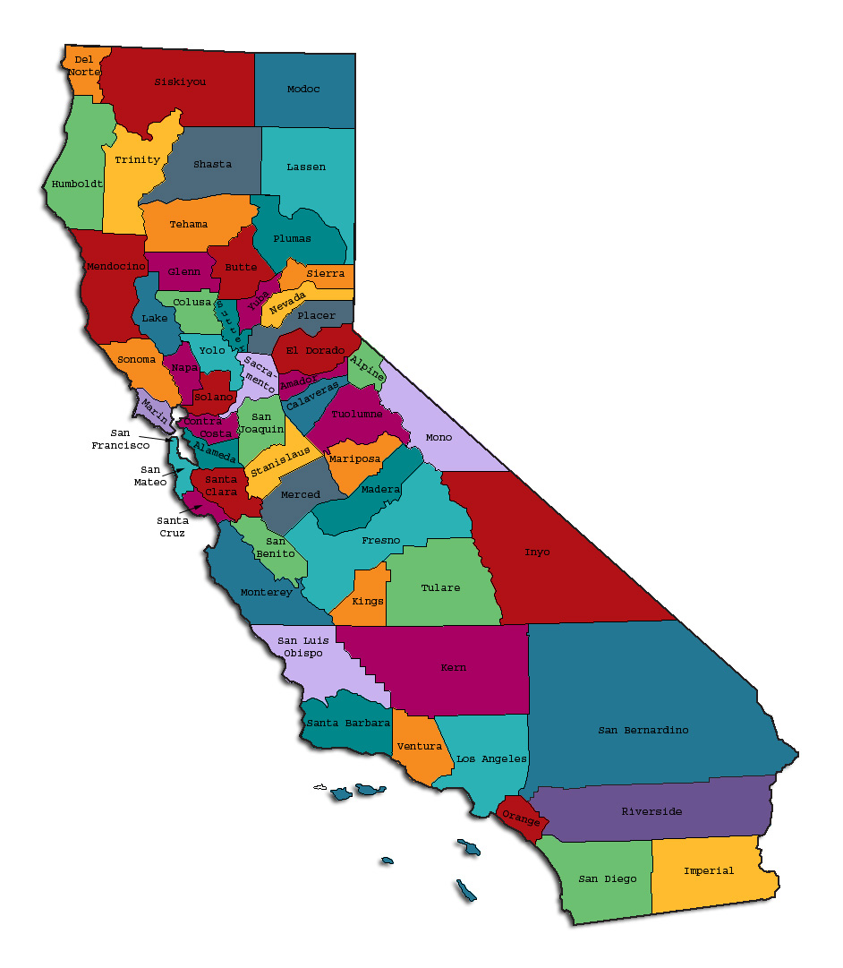
Prepared by California Behavioral Health Planning Council, in collaboration with: California Association of Local Behavioral Health Boards/Commissions
The California Behavioral Health Planning Council (Council) is under federal and state mandate to advocate on behalf of adults with severe mental illness and children with severe emotional disturbance and their families. The Council is also statutorily required to advise the Legislature on behavioral health issues, policies and priorities in California. The Council advocates for an accountable system of seamless, responsive services that are strength-based, consumer and family member driven, recovery oriented, culturally and linguistically responsive and cost effective. Council recommendations promote cross-system collaboration to address the issues of access and effective treatment for the recovery, resiliency and wellness of Californians living with severe mental illness.

Table of Contents
Introduction: Purpose and Goals
Continuum of Care: What BH Services are Counties Required to Provide?
Your County: Evaluation of Services, Barriers to Access, and Unmet Needs
Mental Health Services Act (MHSA) and its Program Components
Questionnaire: How Did Your Board complete this Data Notebook?
Reminder: Where to submit your Data Notebook before March 31, 2019
Appendix

This page intentionally left blank.

Introduction: Purpose and Goals

What is the “Data Notebook?”

The Data Notebook is a structured format for reviewing information and reporting on specific mental health services in each county. The goal of our 2018 Data Notebook is to survey types of services and needs in the behavioral health systems of care for children, adults, and older adults. This topic follows our yearly practice of focusing on different parts of the behavioral health system. However, this year we are taking a survey approach to collect data as the foundation for an overall needs review.

Local behavioral health boards/commissions are required annually to review performance data for mental health services in their county and to report their findings to the CBHPC. To provide structure for the report and to make the reporting easier, each year we create a Data Notebook for local behavioral health boards to complete and submit to the CBHPC. Afterward, the responses are compiled and analyzed by our staff to create a yearly report for policy makers, stakeholders and the general public.
The Data Notebook structure and questions are designed to meet important goals:
- To assist local boards to meet their legal mandates to review performance data for their county mental health services and report on performance every year,
- To serve as an educational resource on behavioral health data for local boards,
- To obtain opinion and thoughts of local mental health boards on specific topics,
- To identify unmet needs and make recommendations.

We encourage members of all local behavioral health boards to participate in reviewing and developing the responses for the Data Notebook. This is an opportunity for the local boards and their county behavioral health departments to work together to identify critical issues that are most important to your county. Your work will help inform county and state leadership plans for behavioral health programs.
We thank everyone for your interest and continued participation.
We are taking a somewhat different approach for the 2018 Data Notebook (DN). The 2018 DN does not include county-specific data but rather is a brief general survey about mental health services and needs in the counties to guide our advocacy in the coming year. It is anticipated that we will resume our practice of presenting county-specific data in the 2019 Data Notebook.

System of Care: What BH Services are CA Counties Required to Provide?

California’s Welfare and Institutions Code (WIC) sets forth a number of definitions, responsibilities and requirements for the public mental health system. Below are a few excerpts from the WIC to provide context for some questions in this Data Notebook.

WIC Section 5600.1
The mission of California's mental health system shall be to enable persons experiencing severe and disabling mental illnesses and children with serious emotional disturbances to access services and programs that assist them, in a manner tailored to each individual, to better control their illness, to achieve their personal goals, and to develop skills and supports leading to their living the most constructive and satisfying lives possible in the least restrictive available settings.

WIC 5600.4
Community mental health services should be organized to provide an array of treatment options in the following areas, to the extent resources are available:
(a) Precrisis and Crisis Services. Immediate response to individuals in precrisis and crisis and to members of the individual's support system, on a 24-hour, seven-day-a-week basis. Crisis services may be provided offsite through mobile services. The focus of precrisis services is to offer ideas and strategies to improve the person's situation, and help access what is needed to avoid crisis. The focus of crisis services is stabilization and crisis resolution, assessment of precipitating and attending factors, and recommendations for meeting identified needs.
(b) Comprehensive Evaluation and Assessment. Includes, but is not limited to, evaluation and assessment of physical and mental health, income support, housing, vocational training and employment, and social support services needs. Evaluation and assessment may be provided offsite through mobile services.
(c) Individual Service Plan. Identification of the short- and long-term service needs of the individual, advocating for, and coordinating the provision of these services. The development of the plan should include the participation of the client, family members, friends, and providers of services to the client, as appropriate.
(d) Medication Education and Management. Includes, but is not limited to, evaluation of the need for administration of, and education about, the risks and benefits associated with medication. Clients should be provided this information prior to the administration of medications pursuant to state law. To the extent practicable, families and caregivers should also be informed about medications.
(e) Case Management. Client-specific services that assist clients in gaining access to needed medical, social, educational, and other services. Case management may be provided offsite through mobile services.
(f) Twenty-four Hour Treatment Services. Treatment provided in any of the following: an acute psychiatric hospital, an acute psychiatric unit of a general hospital, a psychiatric health facility, an institute for mental disease, a community treatment facility, or community residential treatment programs, including crisis, transitional and long-term programs.
(g) Rehabilitation and Support Services. Treatment and rehabilitation services designed to stabilize symptoms, and to develop, improve, and maintain the skills and supports necessary to live in the community. These services may be provided through various modes of services, including, but not limited to, individual and group counseling, day treatment programs, collateral contacts with friends and family, and peer counseling programs. These services may be provided offsite through mobile services.
(h) Vocational Rehabilitation. Services which provide a range of vocational services to assist individuals to prepare for, obtain, and maintain employment.
(i) Residential Services. Room and board and 24-hour care and supervision.
(j) Services for Homeless Persons. Services designed to assist mentally ill persons who are homeless, or at risk of being homeless, to secure housing and financial resources.
(k) Group Services. Services to two or more clients at the same time.

WIC Section 5600.5
The minimum array of services for children and youth meeting the target population criteria established in subdivision (a) of Section 5600.3 should include the following modes of service in every geographical area, to the extent resources are available:
(a) Precrisis and crisis services.
(b) Assessment.
(c) Medication education and management.
(d) Case management.
(e) Twenty-four-hour treatment services.
(f) Rehabilitation and support services designed to alleviate symptoms and foster development of age appropriate cognitive, emotional, and behavioral skills necessary for maturation.

WIC 5600.6
The minimum array of services for adults meeting the target population criteria established in subdivision (b) of Section 5600.3 should include the following modes of service in every geographical area, to the extent resources are available:
(a) Precrisis and crisis services.
(b) Assessment.
(c) Medication education and management.
(d) Case management.
(e) Twenty-four-hour treatment services.
(f) Rehabilitation and support services.
(g) Vocational services.
(h) Residential services.

WIC 5600.7
The minimum array of services for older adults meeting the target population criteria established in subdivision (b) of Section 5600.3 should include the following modes of service in every geographical area, to the extent resources are available:
(a) Precrisis and crisis services, including mobile services.
(b) Assessment, including mobile services.
(c) Medication education and management.
(d) Case management, including mobile services.
(e) Twenty-four-hour treatment services.
(f) Residential services.
(g) Rehabilitation and support services, including mobile services.

Your County: Evaluation of Services, Barriers to Access, and Unmet Needs
Below we ask a series of questions about the above services in your county regardless of fund source. We ask whether there are barriers to service access, unmet needs, or lack of continued or sustainable funding for a particular service or program.

- Please indicate (X) any service areas for which your county has identified that persons are substantially underserved or experience substantial unmet BH needs.
For each age Group: |  |  | Child | TAY (age 16-25) | Adult | Older Adult
(a) Pre-crisis and crisis services. |  |  | X
(b) Assessment
(c) Medication education & management
(d) Case management |  |  |  |  | X
(e) Twenty-four-hour treatment services |  |  | X | X | X | X
(f) Rehabilitation and support services |  |  |  |  | X
(g) Vocational services |  |  |  | X | X
(h) Residential services |  |  | X | X | X | X

- What are the major barriers to BH service access for persons who are in need of these services? Indicate any reasons; mark as many as apply.
For each age Group: |  |  |  |  | Child | TAY (age 16-25) | Adult | Older Adult
A: Lack of Program Funding
B: Lack specialized prof. expertise
C: Lack BH workforce/providers |  |  |  |  | X
D: Clients dispersed outlying areas |  |  |  |  | X | X | X | X
E: Transportation problems (bus, etc.) |  |  |  |  | X | X | X | X
F: Lack available appointment times |  |  |  |  | X | X | X | X
G: Fear government involvement |  |  |  |  |  | X | X | X
H: Linguistic needs (translation, etc.) |  |  |  |  | X | X | X | X
J: Culturally relevant needs
K: Other barrier, specify:  1) In- person psychiatrist (vs. telepsychiatry)  2) Outreach post-hospitalization |  |  |  |  | X | X | X | X

Comments: In general, there is a shortage of services for persons with private insurance, especially child psychiatry. Closure of two local pharmacies has had a significant impact. There is no funding for services for persons with SMI who need more than private insurance provides.

- Please indicate (X) any areas for which your county has implemented new programs within the last 3 years.
For each age Group: |  |  | Child | TAY (age 16-25) | Adult | Older Adult
(a) Pre-crisis and crisis services. |  |  | X | X | X | X
(b) Assessment
(c) Medication education & management
(d) Case management
(e) Twenty-four-hour treatment services
(f) Rehabilitation and support services
(g) Vocational services |  |  |  | X | X
(h) Residential services |  |  |  | X | X

Comments: Crisis Team, Triage Worker (stationed at Sheriff’s office), Merced CRU is pending, partnership with Vocational Rehab, Vision House transitional housing (for men).

- Indicate (X) whether any of the following services are funded with temporary (one-time, time-limited) funding for which you are seeking a sustainable fund source to continue services?
For each age Group: |  |  | Child | TAY (age 16-25) | Adult | Older Adult
(a) Pre-crisis and crisis services. |  |  | X | X | X | X
(b) Assessment
(c) Medication education & management
(d) Case management
(e) Twenty-four-hour treatment services
(f) Rehabilitation and support services
(g) Vocational services
(h) Residential services |  |  |  | X | X

Comments: Triage worker is grant funded, CRU funds were for startup, Vision House contract using MHSA funds expires in 5.5 years.

- If you could have one new program or facility or resource within the next three years, what would be your highest priority need?
Please limit your response to 25 words or less.
Bring on staff an in-person Medical Director (psychiatrist) is a realistic and achievable goal in a three year outlook.
Mental Health Services Act (MHSA) Components
Background and Definitions of the MHSA (below) are excerpted from a description contained in the Executive Summary of a 2018 Report by NAMI California.
Proposition 63, the Mental Health Services Act, was passed by voters in 2004. At the time, California was struggling to meet the mental health needs of its residents. A 2003 report by the California Mental Health Planning Council estimated that as many as 1.7 million Californians were not receiving the mental health services they needed. As many as 80% of children with mental health needs were undiagnosed or unserved. The consequences of untreated mental illness were seen through health systems, school systems, and the criminal justice system. Therefore, the Act was designed to reduce homelessness, incarceration, and preventable hospitalizations, and to increase access to behavioral health services.

The Act imposes a 1% tax on personal income over $1 million and places revenues into the Mental Health Services Fund. Counties receive annual distributions from the Fund, and are responsible for providing community-based mental health services. Program expenditures align with the five core components of the Act:

Community Services and Support (CSS) is the largest component of the MHSA. The CSS component is focused on community collaboration, cultural competence, client and family driven services and systems, and wellness focus. This programming applies concepts of recovery and resilience, integrated service experiences for clients and families, as well as serving the unserved and underserved. Housing is also a large part of the CSS component. [Full Service Partnerships are another example of CSS-funded programs].

Prevention and Early Intervention (PEI) is intended to help counties implement services that promote wellness, foster health, and prevent the suffering that can result from untreated mental illness. The PEI component requires collaboration with consumers and family members in the development of PEI projects and programs.

Innovation (INN) projects aim to increase access to underserved groups, increase the quality of services, and promote interagency collaboration and increase access to services. Counties select one or more goals and use those goals as the primary priority or priorities for their proposed Innovation plan.

Capital Facilities and Technological Needs (CFTN) works toward the creation of facilities that are used for the delivery of MHSA services to mental health consumers and their families or for administrative offices. Funds may also be used to support an increase in peer-support and consumer-run facilities, development of community-based settings, and the development of a technological infrastructure for the mental health system to facilitate the highest quality and most cost-effective services and supports for clients and their families.

Workforce Education and Training (WET) is intended to develop a diverse workforce. Clients and families/caregivers are given training to help others by providing skills to promote wellness and other positive mental health outcomes. They work collaboratively to deliver client- and family-driven services, provide outreach and services that are linguistically and culturally competent and relevant, and include the viewpoints and expertise of clients and their families/caregivers.

The CSS, PEI and INN components are funded through ongoing revenue into the MHSA Fund. Per provisions of the MHSA, the Workforce Education and Training, Capital Facilities and Technological Needs components were initially funded up front in the early years and are not currently actively funded through MHSA revenues. Although counties can transfer some CSS funds for these purposes each year, essentially, the availability of that upfront funding for Workforce Education and Training, Capital Facilities and Technological Needs ended on June 30, 2018.
- Is there still a need for any of these three components in your county?
Yes__X_ No___.

If yes, please rank the following in priority order of need, #1 being highest.

__1__ Workforce Education and Training
__3_ Capital Facilities
__2__ Technological Needs

Optional: In 25 words or less, please specify what those needs are.
Top priority will always be ongoing staff development/trainings for Behavioral Health staff and consumers/families. Second and third in importance is capital facilities and technological needs.

- Do you have a particularly successful program funded by CSS, Innovation, or PEI funds that you would like to share with us? Yes_X__ No___.

If yes, please describe briefly (maximum one paragraph, 150 words or less).
First 5 Strengthening Families Program:
Based on the independent evaluation report for FY 2017/2018, the First 5 Calaveras MHSA-PEI Countywide Education & Support Program for Parents, Caregivers and Educators for all services offered in FY 17/18, 445 adults (unduplicated) participated. (66% parents/caregivers/grandparents and 34% educators or other service providers). This program continues to provide strong leadership in program planning, coordination, and implementation. The program met and exceeded the service expectations while continuinig to build on fresh and interesting approaches to keep parents and educators engaged. The leadership demonstates a high degree of effort and capacity in coordination. This program continues to be a valuable investment in mental health prevention and early intervention with a broad and deep community coverage in Calaveras County.

QUESTIONAIRE: How Did Your Board Complete the Data Notebook?

Completion of your Data Notebook helps fulfill the board’s requirements for reporting to the California Mental Health Planning Council. Questions below ask about operations of mental health boards, behavioral health boards or commissions, regardless of current title. Signature lines indicate review and approval to submit your Data Notebook.
- What process was used to complete this Data Notebook? Please check all that apply.
___ MH Board reviewed W.I.C. 5604.2 regarding the reporting roles of mental health boards and commissions.
___ MH Board completed majority of the Data Notebook
_X_ County staff and/or Director completed majority of the Data Notebook
_X_ Data Notebook placed on Agenda and discussed at Board meeting
___ MH Board work group or temporary ad hoc committee worked on it
_X_ MH Board partnered with county staff or director
___ MH Board submitted a copy of the Data Notebook to the County Board of Supervisors or other designated body as part of their reporting function.
___Other; please describe: _______________________________________.

- Does your Board have designated staff to support your activities?
Yes__X_ No___
If yes, please provide their job classification: Office Technician, Administrative Support, Behavioral Health Services, Calaveras HHSA
- What is the best method for contacting this staff member or board liaison?
REMINDER: Please submit this Data Notebook by March 31, 2019.

Thank you for your participation in completing your Data Notebook report.
Please feel free to provide feedback or recommendations you may have to improve this project for next year. As always, we welcome your input.

Please submit your Data Notebook report by email to:
DataNotebook@CMHPC.ca.gov .

For information, you may contact the email address above, or telephone:
(916) 327-6560

Or, you may contact us by postal mail to:
- Data Notebook
- California Mental Health Planning Council
- 1501 Capitol Avenue, MS 2706
- P.O. Box 997413
- Sacramento, CA 95899-7413
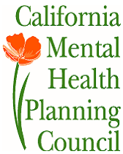

APPENDIX
WIC 5600.3
To the extent resources are available, the primary goal of the use of funds deposited in the mental health account of the local health and welfare trust fund should be to serve the target populations identified in the following categories, which shall not be construed as establishing an order of priority:
(a)(1) Seriously emotionally disturbed children or adolescents.
(2) For the purposes of this part, “seriously emotionally disturbed children or adolescents” means minors under the age of 18 years who have a mental disorder as identified in the most recent edition of the Diagnostic and Statistical Manual of Mental Disorders, other than a primary substance use disorder or developmental disorder, which results in behavior inappropriate to the child's age according to expected developmental norms. Members of this target population shall meet one or more of the following criteria:
(A) As a result of the mental disorder, the child has substantial impairment in at least two of the following areas: self-care, school functioning, family relationships, or ability to function in the community; and either of the following occur:
(i) The child is at risk of removal from home or has already been removed from the home.
(ii) The mental disorder and impairments have been present for more than six months or are likely to continue for more than one year without treatment.
(B) The child displays one of the following: psychotic features, risk of suicide or risk of violence due to a mental disorder.
(C) The child has been assessed pursuant to Article 2 (commencing with Section 56320) of Chapter 4 of Part 30 of Division 4 of Title 2 of the Education Code and determined to have an emotional disturbance, as defined in paragraph (4) of subdivision (c) of Section 300.8 of Title 34 of the Code of Federal Regulations .
(b)(1) Adults and older adults who have a serious mental disorder.
(2) For the purposes of this part, “serious mental disorder” means a mental disorder that is severe in degree and persistent in duration, which may cause behavioral functioning which interferes substantially with the primary activities of daily living, and which may result in an inability to maintain stable adjustment and independent functioning without treatment, support, and rehabilitation for a long or indefinite period of time. Serious mental disorders include, but are not limited to, schizophrenia, bipolar disorder, post-traumatic stress disorder, as well as major affective disorders or other severely disabling mental disorders. This section shall not be construed to exclude persons with a serious mental disorder and a diagnosis of substance abuse, developmental disability, or other physical or mental disorder.
(3) Members of this target population shall meet all of the following criteria:
(A) The person has a mental disorder as identified in the most recent edition of the Diagnostic and Statistical Manual of Mental Disorders, other than a substance use disorder or developmental disorder or acquired traumatic brain injury pursuant to subdivision (a) of Section 4354 unless that person also has a serious mental disorder as defined in paragraph (2).
(B)(i) As a result of the mental disorder, the person has substantial functional impairments or symptoms, or a psychiatric history demonstrating that without treatment there is an imminent risk of decompensation to having substantial impairments or symptoms.
(ii) For the purposes of this part, “functional impairment” means being substantially impaired as the result of a mental disorder in independent living, social relationships, vocational skills, or physical condition.
(C) As a result of a mental functional impairment and circumstances, the person is likely to become so disabled as to require public assistance, services, or entitlements.
(4) For the purpose of organizing outreach and treatment options, to the extent resources are available, this target population includes, but is not limited to, persons who are any of the following:
(A) Homeless persons who are mentally ill.
(B) Persons evaluated by appropriately licensed persons as requiring care in acute treatment facilities including state hospitals, acute inpatient facilities, institutes for mental disease, and crisis residential programs.
(C) Persons arrested or convicted of crimes.
(D) Persons who require acute treatment as a result of a first episode of mental illness with psychotic features.
(5) California veterans in need of mental health services and who meet the existing eligibility requirements of this section, shall be provided services to the extent services are available to other adults pursuant to this section. Veterans who may be eligible for mental health services through the United States Department of Veterans Affairs should be advised of these services by the county and assisted in linking to those services.
(A) No eligible veteran shall be denied county mental health services based solely on his or her status as a veteran.
(B) Counties shall refer a veteran to the county veterans service officer, if any, to determine the veteran's eligibility for, and the availability of, mental health services provided by the United States Department of Veterans Affairs or other federal health care provider.
(C) Counties should consider contracting with community-based veterans' services agencies, where possible, to provide high-quality, veteran specific mental health services.
(c) Adults or older adults who require or are at risk of requiring acute psychiatric inpatient care, residential treatment, or outpatient crisis intervention because of a mental disorder with symptoms of psychosis, suicidality, or violence.
(d) Persons who need brief treatment as a result of a natural disaster or severe local emergency.

W.I.C. 5604.2, regarding mandated reporting roles of MH Boards and Commissions in California.
See attached Appendix for presentation of the full definition of the target population criteria set forth in Welfare and Institutions Code Section 5600.3.
2018 MHSA County Programs: Services That Change Lives. A report created by NAMI California 2018, pages iii-iv. Downloaded from: https://static1.squarespace.com/static/5ab2d59489c1724bd8a2ca78/t/5b7de7d370a6adca27a8a959/1534978017856/NAMI+CA+2018+MHSA+Rept_072318_03_FINAL.pdf

